Touch Sensor Project for School Students

1. Introduction
Touch sensors are simple yet powerful components that detect physical contact or proximity. They are widely used in modern electronics, from smartphones to lamps. This project introduces students to the basic principles of touch sensing using transistors and optionally an Arduino. It provides hands-on experience with electronics, logic, and circuit design.

2. Circuit Diagram Without Arduino
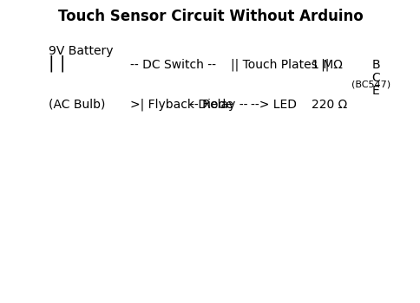
This version uses only basic electronic components without any microcontroller.
Working Principle: When a person touches the plates, their body introduces a small capacitance and resistance. This biases the base of the BC547 transistor via the 1 MΩ resistor. The transistor conducts, allowing current to flow from collector to emitter, which lights the LED or activates the relay to switch an AC bulb.
What does it do: Demonstrates how human touch can control an LED or AC bulb using a transistor.

3. Circuit Diagram With Arduino
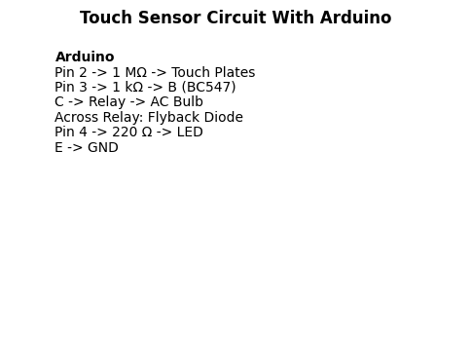
This version integrates an Arduino for digital control and logic.
Working Principle: The touch plates are connected to an Arduino digital input via a 1 MΩ resistor and a 10 kΩ pull-down. When touched, the Arduino detects the signal, applies software debouncing, and toggles a digital output. This output drives a BC547 transistor, which activates the relay to switch the AC bulb. A status LED can also be toggled to indicate the touch detection.
What does it do: Allows students to see how Arduino can process touch input and control external devices.

4. Materials Required
- 9V battery and clip
- DC switch
- Touch plates (metal foil or conductive pads)
- Resistors: 1 MΩ, 10 kΩ, 1 kΩ, 220 Ω
- BC547 NPN transistor (×2)
- LED (×2)
- Relay module (5V)
- Flyback diode (1N4007 or 1N4148)
- AC bulb with holder and safe wiring
- Arduino board (for Arduino version)
- Breadboard and jumper wires

5. Step-by-Step Assembly Guide
Without Arduino:
1. Connect the 9V battery to the DC switch.
2. Connect the switch output to the touch plates.
3. Connect a 1 MΩ resistor from the plates to the base of the BC547 transistor.
4. Connect the emitter to ground.
5. Connect the collector to one end of the relay and LED circuit.
6. Add a flyback diode across the relay coil.
7. Connect the AC bulb through the relay contacts.
With Arduino:
1. Connect touch plates to Arduino pin 2 via 1 MΩ resistor.
2. Add a 10 kΩ pull-down resistor to ground.
3. Connect Arduino pin 3 to base of BC547 via 1 kΩ resistor.
4. Connect collector to relay and flyback diode.
5. Connect emitter to ground.
6. Connect Arduino pin 4 to LED via 220 Ω resistor.
7. Upload the Arduino code and test.

6. Testing and Debugging
- Verify power supply and switch operation.
- Check transistor base voltage when touching plates.
- Confirm LED lights up or relay clicks.
- For Arduino version, use Serial Monitor to debug input and output states.
- Common Issues:
- LED not lighting: Check LED polarity and resistor value.
- Relay not switching: Verify transistor drive and diode orientation.
- False triggering: Add pull-down resistor or small capacitor to base.
- Arduino not detecting touch: Adjust resistor values or use INPUT_PULLUP mode.

7. Sample Arduino Code
const int touchPin = 2;
const int relayPin = 3;
const int ledPin = 4;
bool relayState = false;
void setup() {
pinMode(touchPin, INPUT);
pinMode(relayPin, OUTPUT);
pinMode(ledPin, OUTPUT);
digitalWrite(relayPin, LOW);
digitalWrite(ledPin, LOW);
Serial.begin(9600);
}
void loop() {
int touchValue = digitalRead(touchPin);
if (touchValue == HIGH) {
delay(50);
if (digitalRead(touchPin) == HIGH) {
relayState = !relayState;
digitalWrite(relayPin, relayState);
digitalWrite(ledPin, relayState);
Serial.println(relayState ? "Relay ON" : "Relay OFF");
while (digitalRead(touchPin) == HIGH);
}
}
}

8. Conclusion
This project introduces students to the fundamentals of touch sensing using transistors and optionally Arduino. It demonstrates how simple components can be combined to create interactive systems. Students gain practical experience in circuit design, debugging, and digital logic, preparing them for more advanced electronics projects.

