This program is designed for 3-15 year olds and will be held from 9:00 am to 1:00 pm, Monday through Friday. We encourage the children to try a variety of different art mediums. We place great emphasis on the process of making art, not just the final product itself.

*This year's Summer Art Camp will take place at Raynor Park - 1500 Partridge Avenue in Sunnyvale, Ca. Raynor Park is opposite the Full Belly Farm in Sunnyvale. We want to offer our young artists an opportunity to express themselves in an open, fun and exciting outdoor atmosphere. Our contact numbers for the Summer Camp are : 408-255-5520 or 408-391-1483.*

For a more detailed description of the program, please visit us at our website: [www.njerismorningglory.com](http://www.njerismorningglory.com)

Some of the art activities we offer are:

* Clay projects involving sculpturing, the use of a potter’s wheel, slab work, extruding and paper clay.
* Textile activities includes fabric painting, hand sewing and machine sewing.
* Weaving with a loom to create table runners and vests.
* Cooking activities such as baking and making preserves and jam.
* Glass Fusion to create decorative objects of art.

Please complete the registration form to secure your place in this summer’s program. The forms must be completed and returned to us a week before your class start. Once we receive your registration, you will receive confirmation of your enrollment.

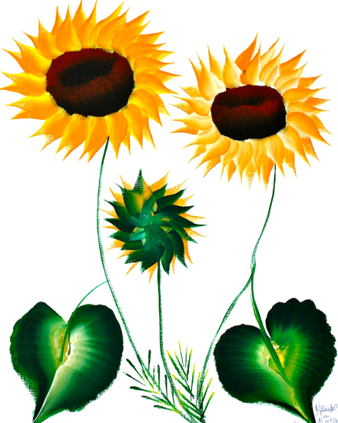The Hands on Art Summer Program runs for 13 weeks, beginning the week of June 2-6 (Week 1) through August 25-29 (Week 13).

Please make checks payable to:

Njeri's Morning Glory School and Art Center

P.O. Box 2479, Santa Clara, CA 95055

This program is designed for 3-15 year olds and will

be held from 9:00am to 1:00pm, Monday through Friday.

Sign up for 1 week or more, depending on your child’s

schedule.

CHILD’S NAME: DATE OF BIRTH: AGE: _

PARENT’S NAME:

ADDRESS: HOME PHONE: CELL PHONE:

E-MAIL ADDRESS:

|  |  |  |  |  |  |
| --- | --- | --- | --- | --- | --- |
| WEEK | DATES | FEE | YOUR  SELECTION | DEPOSIT OF $50 | BALANCE |
| 1 | June 2 - 6 | $250 |  |  | $ |
| 2 | June 9 - 13 | $250 |  |  | $ |
| 3 | June 16 - 20 | $250 |  |  | $ |
| 4 | June 23 – June 27 | $250 |  |  | $ |
| 5 | *June 30 – July 3 | $225 |  |  | $ |
| 6 | July 7 – July 11 | $250 |  |  | $ |
| 7 | July 14 – July 18 | $250 |  |  | $ |
| 8 | July 21 – July 25 | $250 |  |  | $ |
| 9 | July 28 – August 1 | $250 |  |  | $ |
| 10 | August 4 – August 8 | $250 |  |  | $ |
| 11 | August 11 – August 15 | $250 |  |  | $ |
| 12 | August 18 – August 22 | $250 |  |  | $ |
| 13 | August 25 - August 29 | $250 |  |  | $ |
| TOTAL | | $ |  | $ | $ |

**\*Friday, July 4 2014 - No School** TOTAL # OF WEEKS __

-The materials fee is included.

-Please submit a non-refundable $50 deposit to secure your child’s spot in eachsession.

-The balance, $200, is due on Monday of each session.

-Please bring a healthy snack, a healthy lunch,

change of clothes, an apron and a towel to class.

Please make checks payable to:

Njeri's Morning Glory School and Art Center

P.O. Box 2479, Santa Clara, CA 95055