

The Construction World Systems
Functional Specification Document

Company : SCHNELL Enterprises
Document Name : Complete reference to The Construction World Systems (TCWS).
Version : 1.0
Content : This document contains description about TCWS.
Revision

VERSION | AUTHORS | DESCRIPTION OF  VERSION | DATE COMPLETED
Draft | Ashish | 1.0 | 13th;June’2008
Preliminary | Prashant | 1.1
Final
Revision 1
Revision 2

Legal Notice

This document contains trade secrets of Fuzze Labs Software Solutions. No part may be reproduced or transmitted in any form by any means or for any purpose without the express written permission of Fuzze Labs Software Solutions.
Index:

Document Name | Page No
Introduction | 5
Functional Specifications
- Executive Summary | 6
- Screen shot for module and sub-modules | 7
- Module and Sub-module Description | 8
- Screen shot for Login screen | 9
- Login screen Field Description | 10
- Screen shot for New / Edit User | 12
- New / Edit User screen Field Description | 13
- Screen shot for View Screen | 15
- View Screen Field Description | 16
Guidelines for Developer | 18

Introduction

This document contains all the information regarding the basic framework of this project, viz:

- Functional Specification: It contains information regarding the guidelines of requirements and methodologies.

Functional Specification

Executive summary:

This document gives a comprehensive idea of “TCWS-The Construction World System”
This document gives a description about all the functional specifications for each module.
The various modules to be included in TCWS are as follows:
1.5.2 Setting Module
1.5.2.1 User Module
1.5.2.2 Password Module
1.5.2.3 Login Module
1.5.2.4 Configuration Module
1.5.3 Resources Module
1.5.3.1 News Module
1.5.3.2 Events Module
1.5.3.3 Software Module
1.5.4 Construction Module
1.5.4.1 Supplier Module
1.5.4.2 Tender Module
1.5.4.3 Technology Module
1.5.5 Customer Module
1.5.5.1 Enroll Module
1.5.5.2 Seller Module
1.5.5.3 Buyer Module
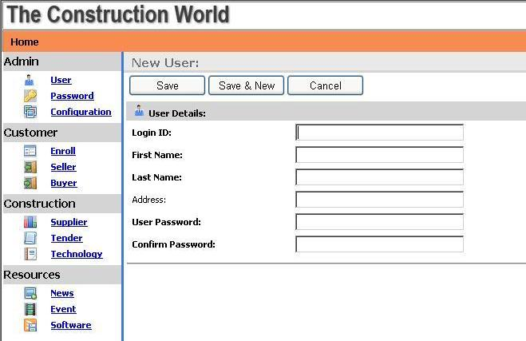
SREENSHOT FOR MODULES AND SUB-MODULES:
THIS PANEL SHOWS THE VARIOUS MODULES AND SUBMODULES
MODULE AND SUB-MODULE DESCRIPTION:
MOD. NO. | MAIN MODULE | SUB MODULE | FUNCTION
1.5.2.1 | Admin | User | Enables the user to create, view or edit the user related information.
1.5.2.2 | Admin | Password | Enables the user to change the password.
1.5.2.3 | Admin | Configuration Module | Enables the user to configure according to state, city or industry.
1.5.3.1 | Resource | News | Enables the user to publish new or edit his earlier published articles.
1.5.3.2 | Resource | Events | Enables the user to publish information regarding upcoming event.
1.5.3.3 | Resource | Software | Enables the user to keep a record of all software’s related to construction industry.
1.5.4.1 | Construction | Supplier | Enables the user to view, update or create record of suppliers.
1.5.4.2 | Construction | Tender | Enables the user to view, update or create record of tenders.
1.5.4.3 | Construction | Technology | Enables the user to view, update or create record of the technologies used.
1.5.5.1 | Customer | Enroll | Enables the administrator to view, update or create new records.
1.5.5.2 | Customer | Buyer | Enables the user to view, update or create record of the Sellers.
1.5.5.3 | Customer | Seller | Enables the user to view, update or create record of the Buyers
1.5.2.3 LOG-IN SCREEN

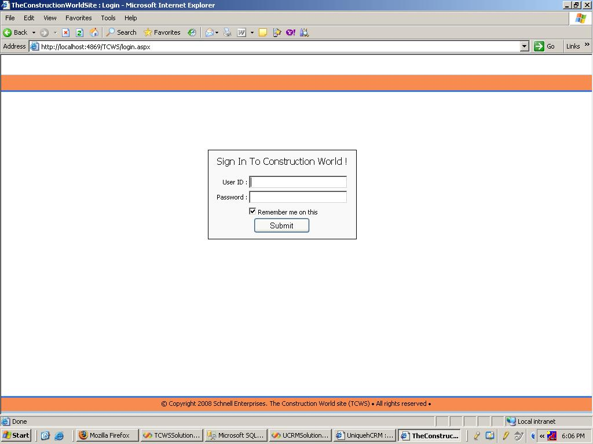
LOGIN PANEL

FIELD DESCRIPTION FOR LOGIN SCREEN:

REF | FIELD TEXT | DESCRIPTIONS | FIELD TYPE | CONTROL | MAX  SIZE | MANDATORY/  OPTIONAL | TABLE | COLUMN
1.5.2.3.1 | User Id | Specific and unique name for user recognition. | varchar | Textbox | 255 | Mandatory | ADMIN_USER | EMAIL
1.5.2.3.2 | Password | Specific value for security purpose of registered user. | varchar | Textbox | 255 | Mandatory | ADMIN_USER | USER_PASSWORD
 | Remember-me | Determined whether a given password should be automatically remembered when the user logins next time. | Numeric | Check-box | 1 | Optional

FIELD VALIDATION FOR LOGIN SCREEN:

REF | FIELD TEXT | TYPE | VALIDATION | ERROR MESSAGE
1.5.2.3.1 | User Id | Error | User id should be unique for each user and should match with a registered user. | Invalid Username.
1.5.2.3.2 | Password | Error | User password should match with the authenticated password. | Invalid Password.

BUTTON LOGIC FOR LOGIN SCREEN:

BUTTON | LOGIC
Submit | Clicking on this button submits the given user name And password and checks if it matches with the registered user’s data .If it doesn’t match then “Invalid username and password” is displayed , else will move to user access screen

1.5.2.1 NEW / EDIT USER SCREEN:
BUTTON PANEL
NEW PANEL
FIELD DESCRIPTION FOR NEW / EDIT USER SCREEN:

REF | FIELD TEXT | DESCRIPTIONS | FIELD TYPE | CONTROL | MAX  SIZE | MANDATORY/  OPTIONAL | TABLE | COLUMN
1.5.2.3.1 | Login id | Log in Id of the user is given here. | varchar | Textbox | 255 | Mandatory | ADMIN_USER | EMAIL
1.5.2.1.1 | First Name | First name of the user. | varchar | Textbox | 255 | Mandatory | ADMIN_USER | FIRST_NAME
1.5.2.1.2 | Last Name | Last name of the user. | varchar | Textbox | 255 | Mandatory | ADMIN_USER | LAST_NAME
1.5.2.1.3 | Address | Address of the user. | varchar | Textbox | 255 | Optional | ADMIN_USER | ADDRESS
1.5.2.3.2 | User Password | Specific value of user password for a registered used. | varchar | Textbox | 255 | Mandatory | ADMIN_USER | USER_PASSWORD
1.5.2.3.2 | Confirm Password | Checks whether the entered value of password is same as the user password entered. | Varchar | Textbox | 255 | Mandatory | ADMIN_USER | USER_PASSWORD
 | Search option-category | Helps the user to search for specific category | Varchar | dropdown | 10 | Optional | ADMIN_USER
 | Search option-keyword | Checks for a file or field according to keyword or part of file name. | Varchar | Textbox | 255 | Optional | ADMIN_USER

FIELD VALIDATION FOR NEW/ EDIT USER SCREEN:

REF | FIELD TEXT | TYPE | VALIDATION | ERROR MESSAGE
1.5.2.3.2 | Confirm password | Error | Input should match with the user password. | Mismatching user password and confirm password. Re-enter password.

BUTTON LOGIC FOR NEW/ EDIT USER SCREEN:

BUTTON | LOGIC
Save | Clicking on this button saves the entered data in specific table for entry.
Save & New. | Clicking on this button saves the entered data in specific table for entry and displays page for new entry.
Cancel | Clicking on this button cancels the entered data and displays screen for entering data again.

1.5.2.1.2 VIEW SCREEN:

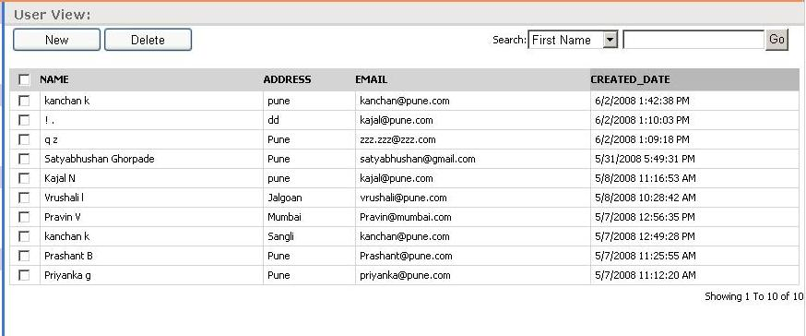

BUTTONS
SEARCH PANEL.

GRID VIEW

FIELD DESCRIPTION FOR VIEW SCREEN:

REF | FIELD TEXT | DESCRIPTIONS | FIELD TYPE | CONTROL | MAX  SIZE | MANDATORY/  OPTIONAL | TABLE | COLUMN
1.5.2.1.2.1 | Name | Gives the name of the specific user. | varchar | Textbox | 255 | Mandatory | ADMIN_USER | FIRST_NAME  ,LAST_NAME
1.5.2.1.2.2 | Address | Gives the address of the user. | varchar | Textbox |  | Optional | ADMIN_USER | ADDRESS
1.5.2.1.2.3 | Email | Gives the email id of the user | Varchar | Textbox |  | Optional | ADMIN_USER | EMAIL
1.5.2.1.2.4 | Created date | Gives the date of creation of the User id | datetime | Textbox |  | Mandatory | ADMIN_USER | USER_CREAT  ED_DATE
 | Search option-category | Helps the user to search for specific category | Varchar | dropdown | 10 | Optional | ADMIN_USER
 | Search option-keyword | Checks for a file or field according to keyword or part of file name. | Varchar | Textbox | 255 | Optional | ADMIN_USER

FIELD VALIDATION FOR VIEW SCREEN:

Ref | Field Text | Type | Validation | Error Message
1.5.2.3.1 | User Id | Error | User id should be unique for each user and should match with a registered user. | User name mismatching.
1.5.2.3.2 | Password | Error | User password should match with the authenticated password. | Username and password mismatching.

BUTTON LOGIC FOR VIEW SCREEN:

Button | Logic
New | Clicking on this button Takes the user to new user screen to enter new data.
Delete | Clicking on this button delete a particular record.
Search | Clicking on this button searches for the specific category or keyword in every field.

Guidelines For Developer

Commenting:
Commenting should be written such that the non-technical person can review the code and understand how it works and what it is doing without necessarily understanding the code itself.

- Page Commenting:
Page Header should contain.
Option Explicit On

' ---------------------------------------------------------------------
' <copyright file="……………….." company="……….">
' Copyright (c) ………………………. . All rights reserved.
' </copyright>
' ---------------------------------------------------------------------
'Imports namespaces

- Function Commenting:
Function Commenting should reveal all of the necessary details about the function. This includes parameters, return values, and any logic quirks or decisions that were made.
  - Above the Fuction:
''' <summary>
''' function name
''' </summary>
''' <Description>
''' function Description
''' </Description>
''' <devdoc>Document.doc referance</devdoc>
''' <TODO>How Code can be Improved</TODO>
''' <param name="sender">parameter description</param>
''' <param name="e"> parameter description</</param>
''' <remarks>
''' Author : ……………
''' Created Date : 8 Sep 2006
''' Modified By : ……………
''' Modified Date : ……………
''' </remarks>

  - Error Handling Block:
Sub/Function Name()
Variable declaration
Try
Variable declaration

Code

Catch ex As Exception 'Log Errors into File
Error file
Finally -optional
code
End Try
  - Inline commenting:
If necessary inline commenting should be there.

- If commenting:
- Select commenting:
- Variable commenting:

- Variable Declaration:
  - Naming Conventions:

Control | Prefix
Button | btn
ComboBox | cbo
CheckBox | chk
Label | lbl
ListBox | lst
MainMenu | mnu
RadioButton | rdb
PictureBox | pic
Panel | pnl
GridView | glb
Wizard | IEWizard
WizardStep | WZPage
Datagrid | glb
DropDownList | lst
HiddenField | hf
TextBox | txt

  - Use Hungarian notations:

Data Type | Prefix
Integer | i
String | str
Boolean | bln
Double | dbl

GUI Checks:

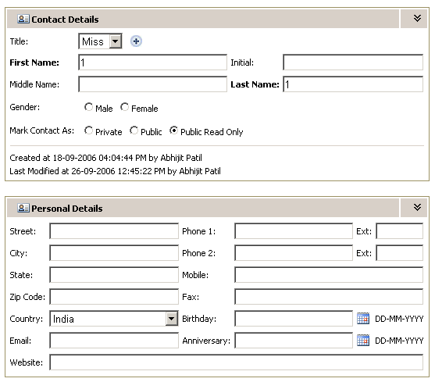
Proper Alignment of components
Mandatory Field in Bold &
Colon (:) immediately after field name
Alignment of data in the grid:
- For Numeric Data & Date-Time:
Column Heading: Aligned Right
In the Table: Data aligned Right

- For Other type of Data:
Column Heading: Aligned Center
In the Table: Data aligned left

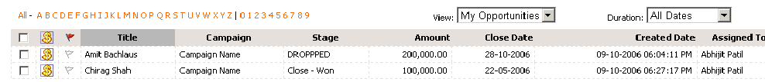
For Other type of Data:
Column Heading: Aligned Center
In the Table: Data aligned left

Date-time:
Column Heading: Aligned Right
In the Table: Data aligned Right

Numeric Data:
Column Heading: Aligned Right
In the Table: Data aligned Right

Default Sorting Focus in the Grid:

Sorting Focus

Sorting of records in the Grid:
- On first click on column heading record should get sorted in Descending order (Z to A then 9 to 0 then Specific Characters).
- On second click on same Column Heading records should get sorted in Ascending order (Specific Characters then 0 to 9 then A to Z).

Default Focus and Tab Sequence:
- On the form Default Focus or Cursor should be on top-leftmost editable field.
- Tab Sequence – Cursor or Focus should move left to right and top to bottom.

