NegevSat – Programmer’s Reference Manual (PRM)

**NegevSat satellite supports the following commands from the ground station (can be found in** data_protocol/CMDDictionary.hpp**):**

#define MOVE_TO_SAFE 1

#define MOVE_TO_STANDBY 2

#define MOVE_TO_OP 3

#define FORMAT_ENERGY 4

#define FORMAT_TEMP 5

#define FORMAT_STATIC 6

#define FORMAT_MIXED 7

#define SBAND_ON 8

#define SBAND_OFF 9

#define PAYLOAD_ON 10

#define PAYLOAD_OFF 11

#define THERMAL_CRTL_ON 12

#define THERMAL_CRTL_OFF 13

**MOVE_TO_SAFE**  Switches satellites state to SAFE_MODE.

**MOVE_TO_STANDBY**  Switches satellites state to STANDBY.

**MOVE_TO_OP** Switches satellites state to OPERATIONAL.

**FORMAT_ENERGY** Changes satellites sending format to Energy, now the satellite will send only Energy packets.

**FORMAT_TEMP** Changes satellites sending format to Temperature, now the satellite will send only Temperature packets.

**FORMAT_STATIC** Changes satellites sending format to Static, now the satellite will send only Static packets.

**FORMAT_MIXED** Changes satellites sending format to Mixed, now the satellite will send Energy and Temperature packets, one after another.

**SBAND_ON** Satellite turns on the SBAND module.

**SBAND_OFF**  Satellite turns off the SBAND module.

**PAYLOAD_ON** Satellite turns on the PAYLOAD (Camera) module.

**PAYLOAD_OFF** Satellite turns off the PAYLOAD (Camera) module.

**THERMAL_CTRL_ON** Satellite turns on the THERMAL_CTRL module.

**THERMAL_CTRL_OFF** Satellite turns off the THERMAL_CTRL module.

**NegevSat satellite has 6 modules:**

* SBAND module
* TEMPERATURE module
* ENERGY module
* SOLAR PANELS module
* PAYLOAD module (Camera)
* THERMAL CTRL module

**Each NegevSat module can be in the following state:**

* **OK** – The module is in proper state and works as expected.
* **CRIT** – The module is in critical state but still operating, further actions should be taken.
* **OFF** – The module is turned off, might be from various reasons: broken or was turned off directly from the ground station.
* **STANDBY** – The module has turned off most of unnecessary parts, mostly will happened for Energy saving.

**There are three kinds of packets which the satellite can send:**

**Static Packet:** contains satellite’s state machine’s current state, state of each Module and timestamps.

**For example:**

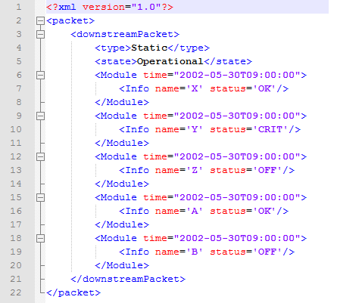

**Energy Packet:** contains satellite’s Energy data: voltage and current of the butteries and timestamps.

**For example:**

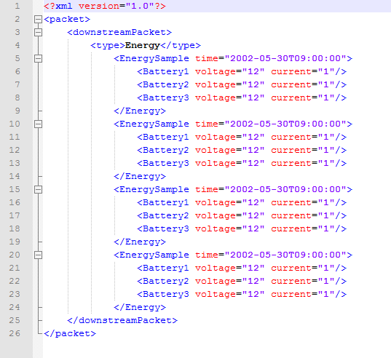

**Temp Packet:** contains satellite’s sensors Temperature data and timestamps.

**For example:**

