AI-Powered SME Compliance & Audit Assistant
Macro Project-I — Milestone 1 Progress Report

1. Project Overview
The SME Compliance & Audit Assistant is an AI-powered system that helps small and medium businesses (SMEs) understand and check their regulatory compliance requirements. A business owner interacts with an AI assistant (initially via web chat, with WhatsApp planned as a future interface) and provides information or documents about their business. The system then identifies applicable regulations, analyzes uploaded documents such as invoices or registration papers, detects potential compliance issues, and explains findings in simple language with evidence and citations from the relevant regulation. The project supports UN SDG 8 (Decent Work and Economic Growth) by making regulatory compliance more accessible to small businesses.
This project has replaced GeoStat as Macro Project-I for the current semester; GeoStat has moved to Macro Project-II. It is being built by a two-person team over a one-month timeline.

2. Scoping Decision
The original concept (WhatsApp interface, hybrid RAG, knowledge graph, entity resolution, ML anomaly detection, continuous monitoring, agentic investigation) was too broad for a one-month MVP — several of these components could individually be full research projects. The team chose to scope down to a smaller set of genuinely working components rather than claim an unimplemented architecture. The full original vision is retained as documented future work.
In Scope — 1-Month MVP | Deferred — Future Work
Regulatory RAG (30-50 real regulatory docs/excerpts) | Full entity resolution across bank/tax/accounting records
Hybrid search (vector + BM25) | ML-based anomaly detection
Business profile + rules engine (structured thresholds) | Continuous compliance monitoring & automated alerts
Document/invoice analysis via vision LLM | Full Neo4j-based knowledge graph
Agentic tool-calling (search_regulations, query_business_data, check_requirement, generate_report) | Full production WhatsApp Business API integration
Evidence-grounded output (Finding -> Reason -> Evidence -> Business data used)

3. Chosen Methodology
The MVP is built around four core techniques:
- Regulatory RAG: Government/regulatory documents are chunked, embedded, and stored in a vector database; relevant chunks are retrieved for a user's query and passed to the LLM as grounding context.
- Hybrid Retrieval: Vector similarity search is combined with BM25 keyword search, since regulatory text often depends on exact legal terms, section names, and thresholds that pure semantic search can miss.
- Business Profile + Rules Engine: Structured business data (turnover, employee count, location, registration status) is evaluated against simple threshold rules (e.g., GST registration required above Rs. 40 lakh turnover) — a practical substitute for a full knowledge graph within the one-month scope.
- Agentic Tool-Calling: An LLM agent decides which tool to call (search regulations, query business data, check a requirement, generate a report) rather than answering everything in one shot, and grounds every finding in retrieved evidence before responding.

4. Technology Stack
Component | Technology
LLM | Google Gemini (gemini-2.5-flash)
Embeddings | Google text-embedding-004
Vector Database | Chroma
Retrieval | Hybrid — vector similarity + BM25 keyword search
Backend | Python
Document Analysis | Gemini Vision (multimodal — image/PDF to structured JSON)
Agent / Tool-Calling | Gemini native function calling
Interface | Web chat (initial), WhatsApp Cloud API (planned)

5. Work Completed So Far
- Initial regulatory knowledge base: 10 real regulatory snippets covering GST registration thresholds, the Composition Scheme, Udyam/MSME enterprise classification, Shops & Establishments requirements, and PF/ESI applicability thresholds — sourced from CGST Act provisions, Ministry of MSME notifications, and State Shops & Establishments Acts.
- Working RAG retrieval prototype — hybrid vector + BM25 search over the regulatory knowledge base, tested against a realistic SME query.
- Working agent/tool-calling prototype — a 3-tool agent (search_regulations, query_business_data, check_requirement) that decides which tool to call, chains multiple tool calls, and produces an evidence-grounded final answer.
- Entity-Relationship diagram for the underlying data model (Business, User, RegulatoryDocument, ComplianceRequirement, DocumentUpload, Finding, QuerySession, ToolCallLog) — see Section 7.
- Both prototypes run with or without a live Gemini API key, so the pipeline logic can be verified independently of API access.

6. Example Run
Sample query used to test both prototypes:
“My business has an annual turnover of 50 lakh rupees and 8 employees. What registrations or compliances apply to me?”

6.1 RAG Mini-Demo Output
Hybrid retrieval correctly surfaced the GST goods threshold, Udyam Micro classification, and Shops & Establishments requirement as the most relevant regulations for this query.
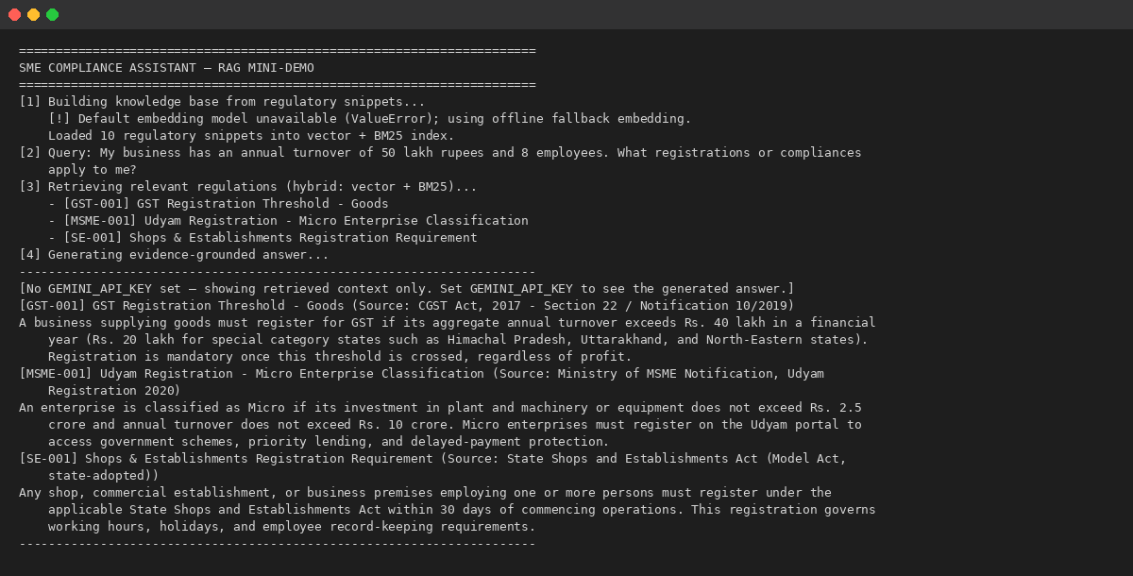

6.2 Agent Mini-Demo Output
The agent chained four tool calls — checking business data, evaluating GST and Shops & Establishments requirements against thresholds, and retrieving supporting regulatory evidence — before producing a structured Finding → Reason → Evidence answer.
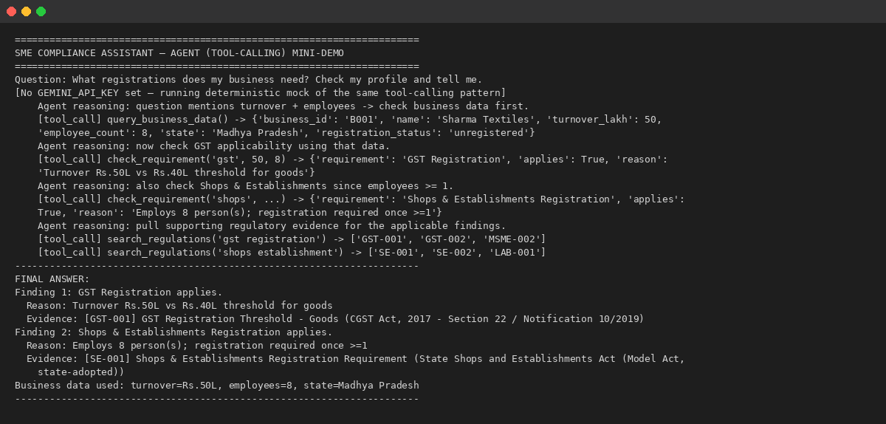

7. Data Model — Entity-Relationship Diagram
Business is the central entity, linked to Users, Document Uploads, Findings, and Query Sessions. Regulatory Documents feed Compliance Requirements and are cited as evidence within Findings. Each Query Session is linked to a Tool Call Log, making the agent's tool-calling behavior fully traceable.
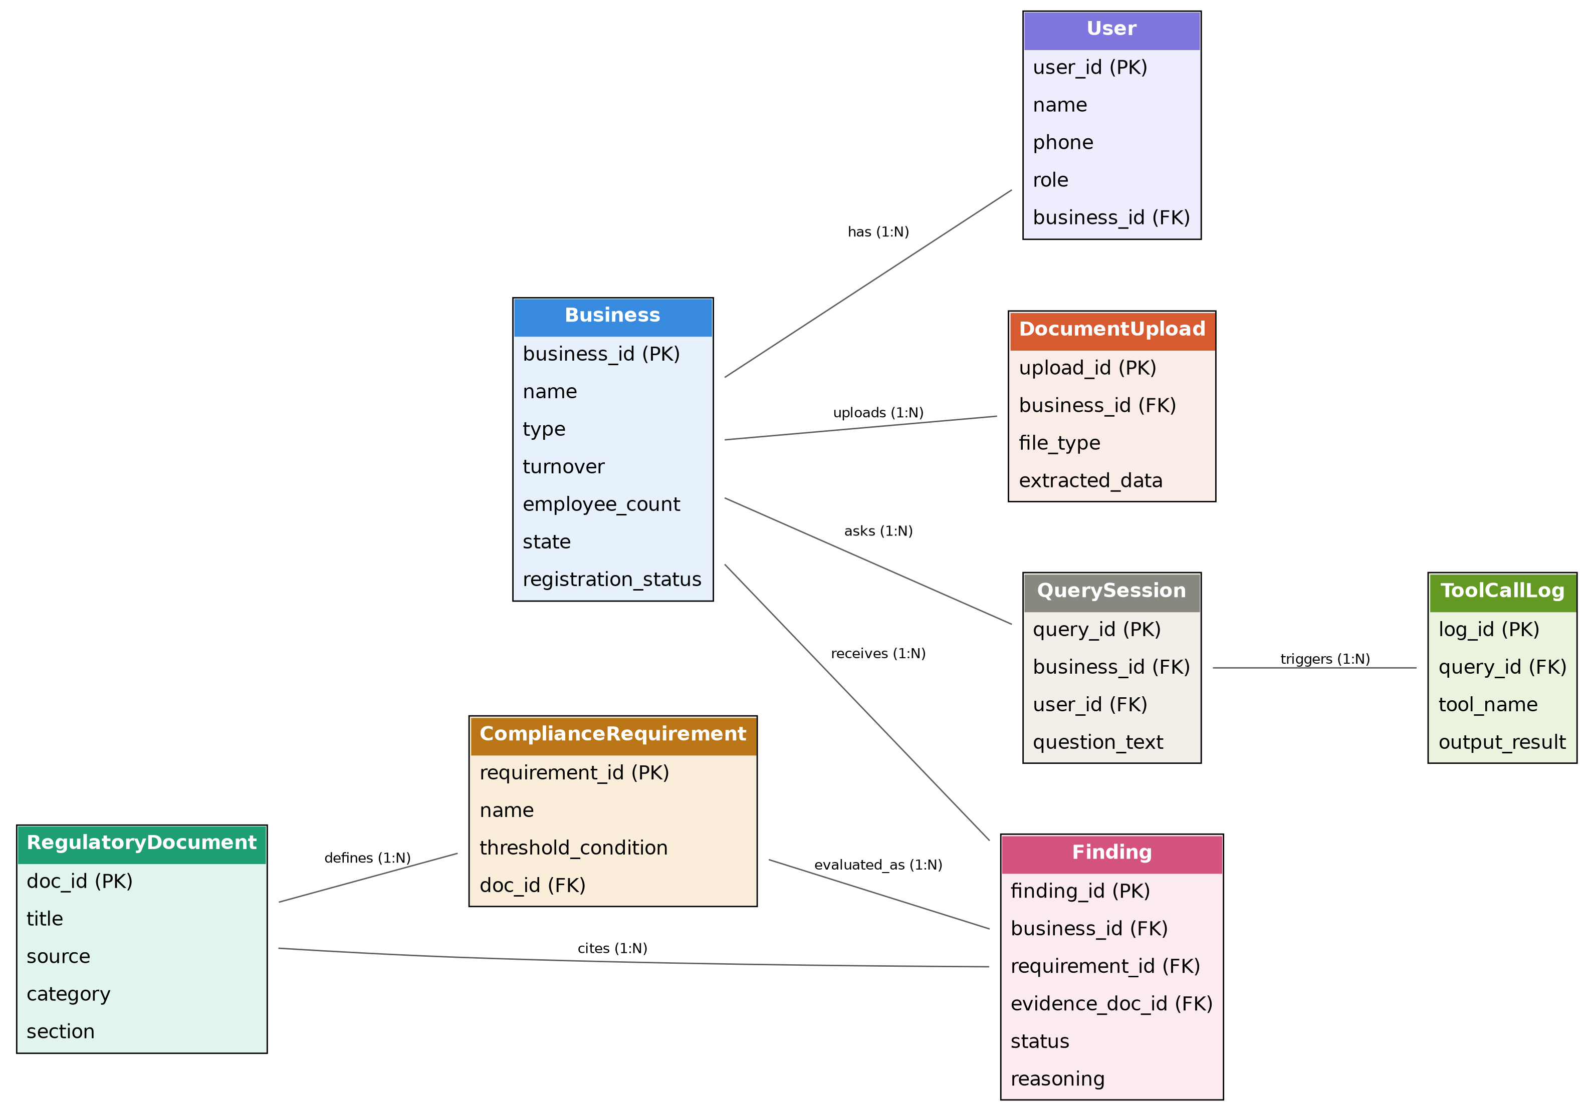

7.1 Relationship Types
- BUSINESS to USER: 1:N (one business has zero or many users)
- BUSINESS to DOCUMENT_UPLOAD: 1:N (one business has zero or many uploads)
- BUSINESS to FINDING: 1:N (one business has zero or many findings)
- BUSINESS to QUERY_SESSION: 1:N (one business has zero or many sessions)
- COMPLIANCE_REQUIREMENT to FINDING: 1:N (one requirement has zero or many findings)
- REGULATORY_DOCUMENT to COMPLIANCE_REQUIREMENT: 1:N (one document defines zero or many requirements)
- REGULATORY_DOCUMENT to FINDING: 1:N (one document is cited by zero or many findings)
- QUERY_SESSION to TOOL_CALL_LOG: 1:N (one session has zero or many tool calls)

8. Four-Week Development Plan
Week | Focus
Week 1 | Partner A: regulatory document collection, chunking, embeddings, Chroma setup, RAG pipeline. Partner B: WhatsApp/API investigation, basic chat interface, business profile schema, backend structure.
Week 2 | Rules engine, business profile implementation, document/PDF/image extraction, vision-model integration.
Week 3 | Agent loop and function/tool calling (search_regulations, query_business_data, check_requirement, generate_report); connect User -> Agent -> Tools -> RAG/Rules -> Answer.
Week 4 | Full integration, testing, bug fixing, UI/demo polish, evidence/citations, 2-3 realistic SME scenarios, final report, presentation/demo prep.

9. Next Steps
- Expand the regulatory corpus from 10 snippets toward the target of 30-50 real documents/excerpts.
- Implement the full business profile schema and connect it to a persistent store.
- Build out the rules engine to cover PF/ESI, Composition Scheme eligibility, and additional state-specific rules.
- Integrate Gemini Vision for document/invoice field extraction (image/PDF to structured JSON).
- Connect the agent to a generate_report() tool producing a full compliance report per business.
- Build the web chat interface and wire it to the RAG + rules + agent backend.
- Test against 2-3 realistic SME scenarios ahead of final integration and demo.

