Comprehensive Manual for S-1 SAR Calibration Toolbox

This document outlines the important steps that need to be followed in order to successfully exploit it’s radiometric calibration capabilities.This tool is developed purely in Python3 and will work well with Python 3.5+ versions. Further, the following packages need to be pre-installed in order to run this toolbox successfully and has been tested with their respective versions :

1) GDAL ( ver. 2.0.3)

2) Numpy( ver. 1.11.1)

3) matplotlib(ver. 1.5.3)

4)scipy (ver. 0.18.1)

5)mpldatacursor(ver. 0.6.2)

6)tkinter (ver. 8.5.18)

7)scikit-image(ver. 0.12.3)

**1.1 Introduction**

Standardization and quality assessment of radar data is the prime essential.The process of radiometric calibration of SAR images involves comparison of the backscattered radar reflectivity signal from a ground resolution element containing a calibration target of known signal response, such as Corner reflector (CR). CR’s are considered to be reliable targets for SAR calibration because the magnitude of the returned signal is large relative to the size of the target, their signal response is insensitive to errors in alignment (unlike dihedral reflectors), and they are relatively cheap to manufacture and maintain (unlike transponders).

**1.2 Sentinel-1 SAR data**

Sentinel-1 is equipped with a SAR sensor operating at C-band (5.405 GHz). The dataset used for this demonstration was acquired in Interferometric Wide Swath mode having resolution of 5mX 20m.

**1.3 Radiometric Calibration**

**1.3.1.1Point Target**

Radiometric calibration of **Point Target** involves two key steps [1]:

**a)Calculation of Background Corrected Power:**The user is prompted with a window displaying the **Power or Intensity** image. The background corrected power is calculated by selecting the brightest pixel **(**pixel with the **highest** intensity**)** amongst all the pixels of the corner reflector and the clutter centres of all the pixels. Here, 4 clutter centres are chosen by the user which belong to dark background i.e. belonging to very **weak** intensity.

After the user has selected the four clutter centres and a bright pixel of Corner reflector, the user enters the window size for the corner reflector and 4 clutters.

Suppose, the user selects pixel **A** with coordinates **(a, b)** (where **a** represents row and **b** represents column)as brightest pixel of corner reflector and then selects pixels **B, C,D,E** as clutter centres with coordinates **(c, d ), (e ,f ), (g, h),( u ,v)** respectively.

After giving a window size of **m*n** pixels for corner reflector and **k*k** pixels (k should be odd). The total Intensity of the corner reflector and the clutter is calculated as[8][9]:

**Total Intensity of corner reflector** (**Ip**)=

**Total Intensity of all clutters** (**Ic)**=

here,

represents a pixel of a corner reflector

,,, are the pixels of each of the four clutters.

After the total Intensity calculation, the average clutter power is calculated as:

**Average Clutter Intensity per pixel** (**Iav)=**

**Total clutter present in Corner reflector (Iccr)= Total no. of CR pixels * average clutter intensity per pixel**

**= m*n* Iav**

**Background corrected Power or Intensity**(**Ibc)**= **Ip- Iccr**

**Signal to Clutter Ratio =**

**b)Calculation of Calibration Constant:**The calibration constant is calculated by the following formula[7][21]

For SLC Products,

For GRD products,

here,

**K** represents Calibration Constant,

**Ibc** represents Background Corrected Power

**area** represents area of each pixel in sq.m,

**RCSth** represents Maximum Theoretical Radar Cross Section (in dBsm.)

represents Incidence angle at the point target

represents Incidence angle at the scene centre

Area for each pixel is calculated as a product of range spacing (in m.) and pixel spacing (in m.).

The theoretical RCS for each type of Corner reflector is different depending on its shape, size and wavelength of the SAR sensor.

The following table illustrates the Theoretical RCS for different shapes of corner reflectors [10] :

**Table 1. RCS of various Corner Reflectors**

|  |  |  |
| --- | --- | --- |
| **S.No.** | **Corner Reflector Type** | **Theoretical RCS (RCSth) (in dBsm.)** |
| 1. | Triangular Trihedral |  |
| 2. | Flat Square Plate |  |
| 3. | Circular Trihedral |  |
| 4. | Dihedral |  |
| 5. | Square Trihedral |  |

**5.3.1.2 Distributed Target**

The toolbox encompasses calibration of distributed targets with the help of calculation of average gamma naught or slope normalized radar cross section over any area selected by the user. The formula for calculation of Gamma naught( varies from sensor to sensor.The calculation of gamma naught for Sentinel-1 and ALOS-2 PALSAR is given as follows:

**Sentinel-1**

The calculation of gamma naught for Sentinel-1 follows the following formula[2]:

where,

DN represents Digital Number i.e. the actual value of each pixel in the Amplitude or Intensity image

represents the gain value obtained from the Gamma gains LUT present inside the Calibration.xml file that comes with the product.

**1.4 Working**

1.) After running the **sentinel_calibration.py** file, the GUI is prompted.

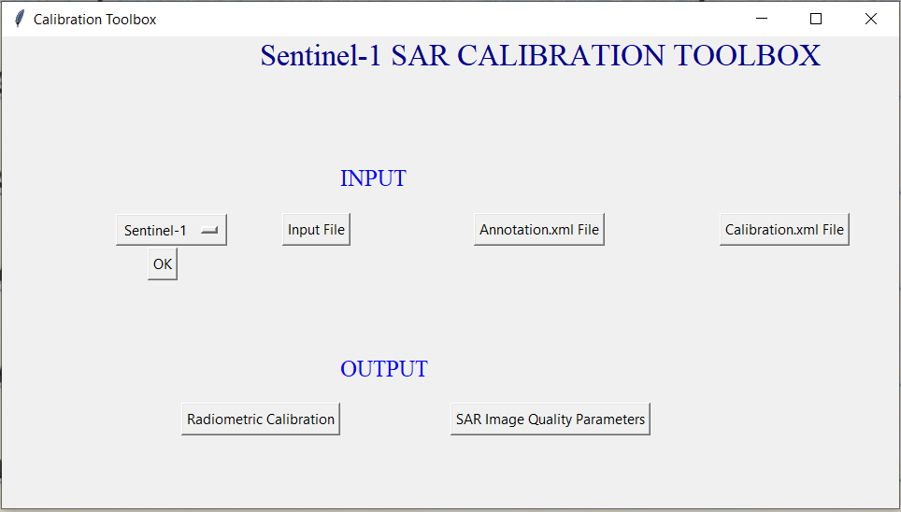

After selecting the Sentinel-1 Sensor click on **Ok** button which will prompt the user with a window which will provide instructions for further processing.

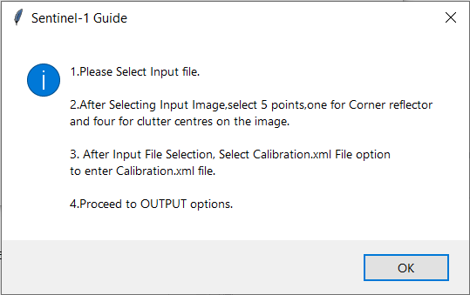

2) The user clicks on Input File. Now, the user should already extract the required Sentinel-1 data into a folder and go to measurement folder to open a co-pol(HH or VV tiff file)

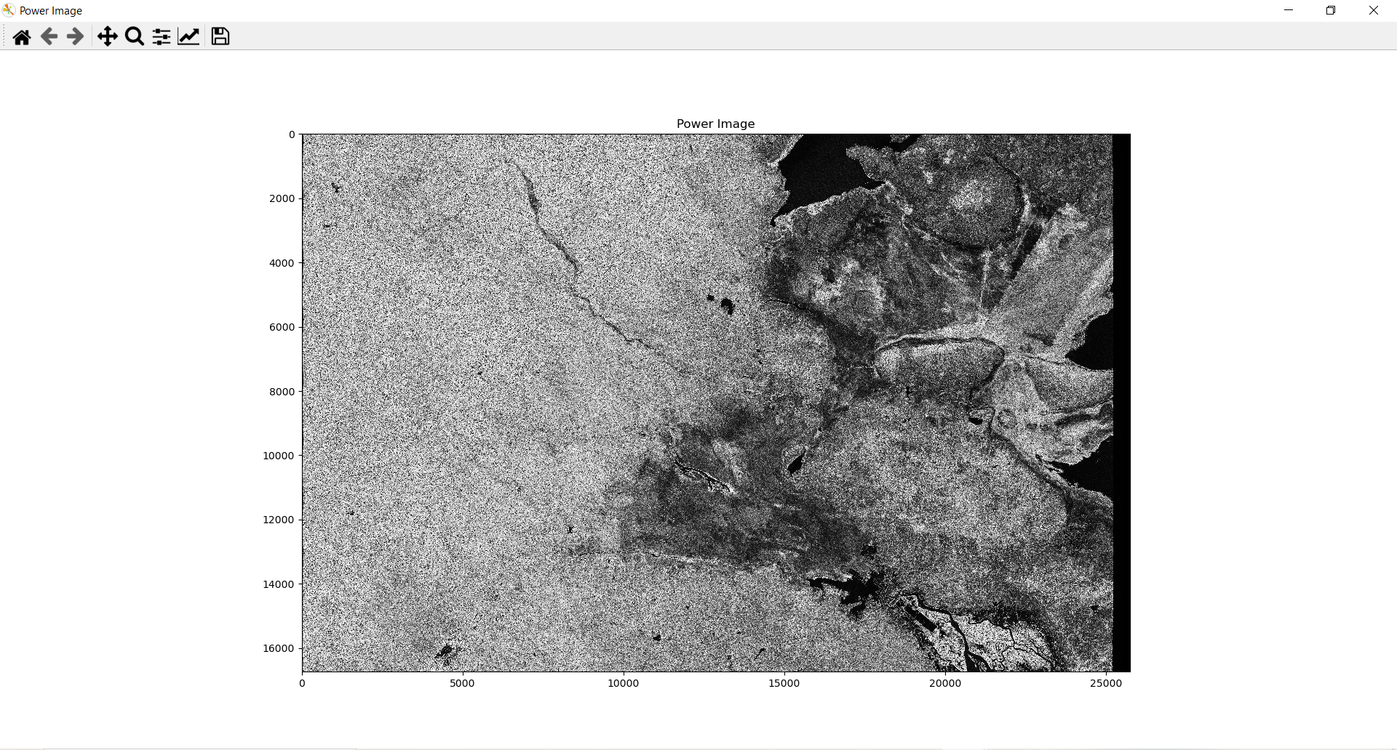

3) The user should zoom in to the portion of corner reflectors and select 5 points (one for the center of corner reflector and four for the clutter centres),after which the window will automatically close.

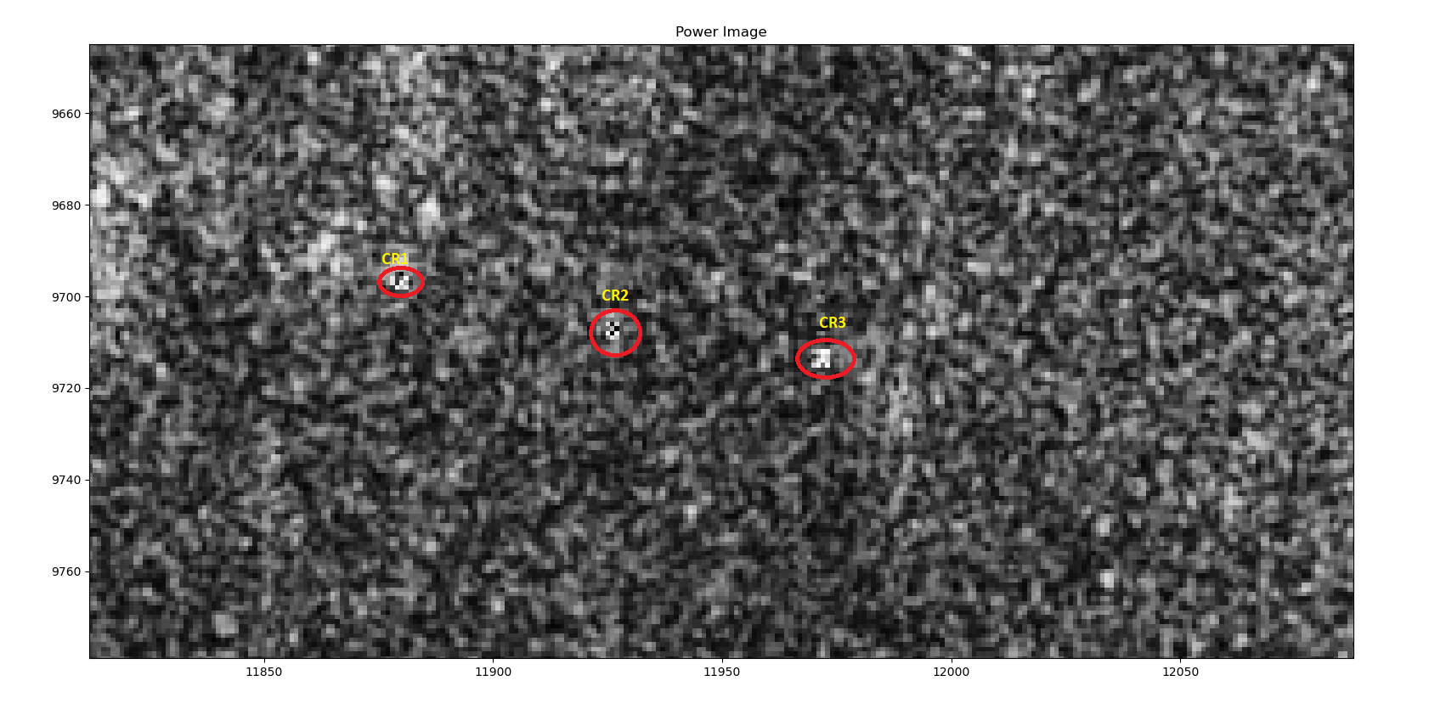

4) Enter Annotation.xml File.

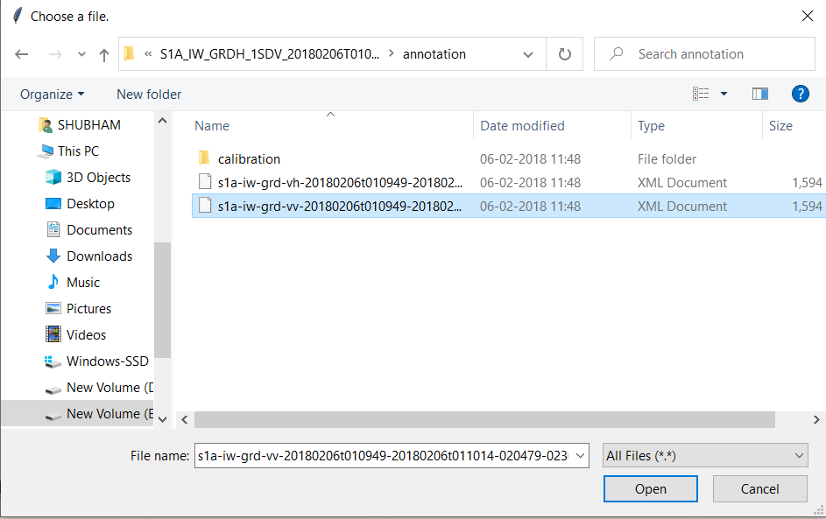

5.) Enter Calibration.xml file.

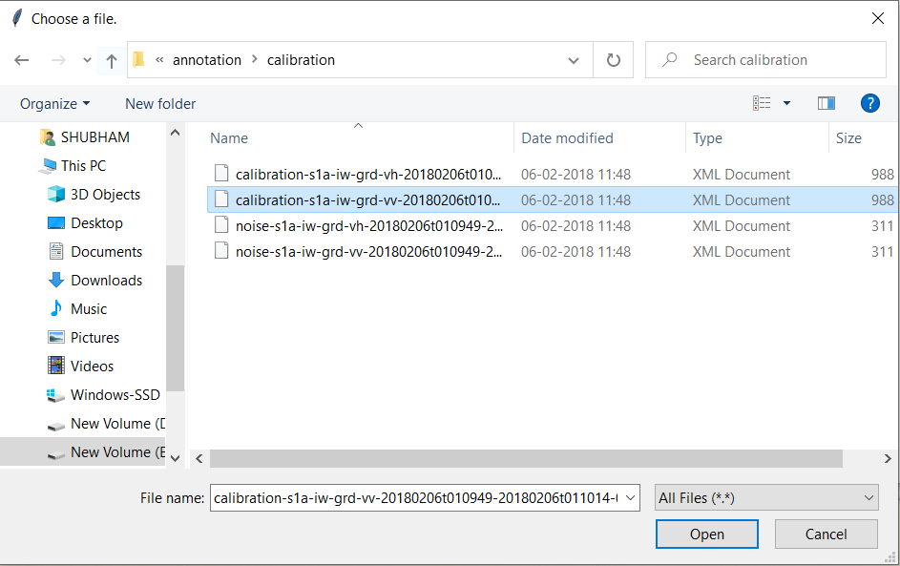

6) The user has to select **Radiometric calibration** button from OUTPUT option.

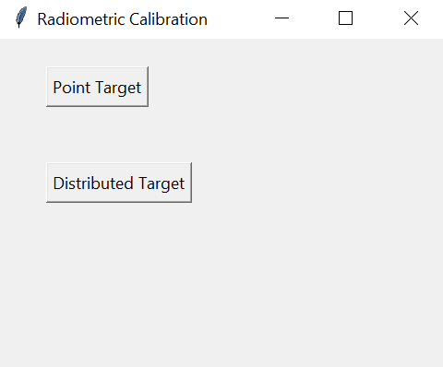

7) After inputting all the details, the user has to click OK on the Information tab.

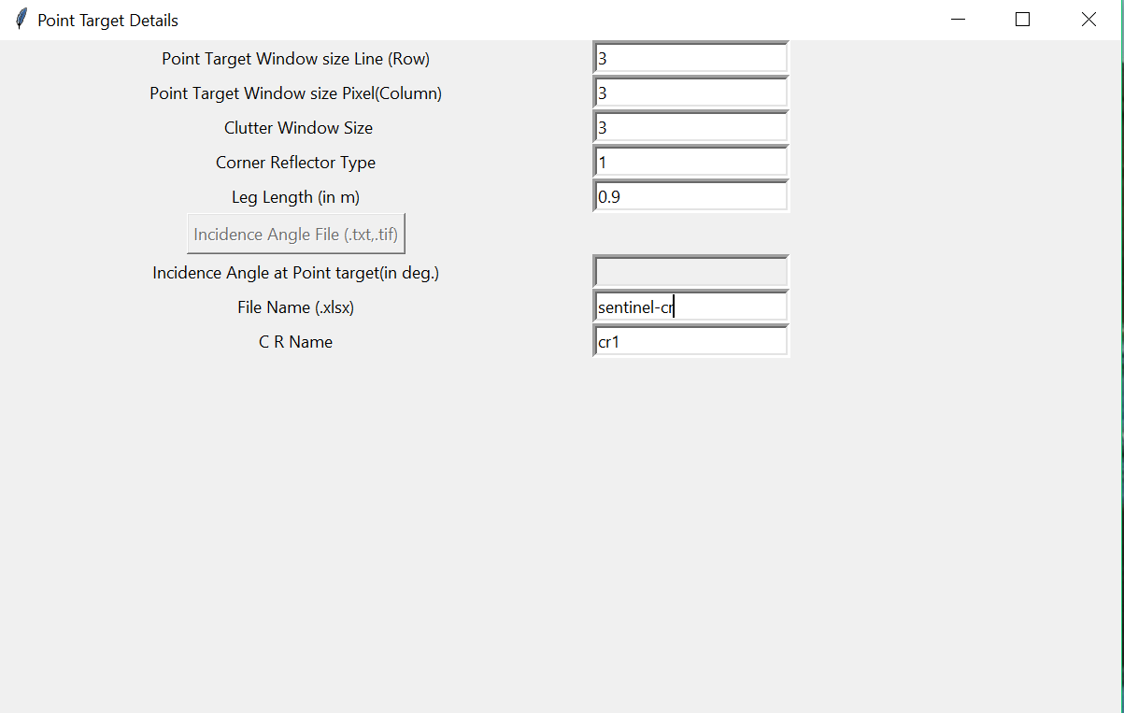

8) An instruction window also opens up for giving information.

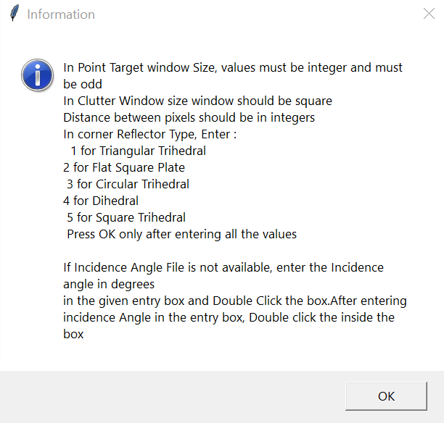

9) The background Corrected Sigma Naught, clutter Sigma Naught , Theoretical RCS, Calculated RCS and Difference in RCS is reported.

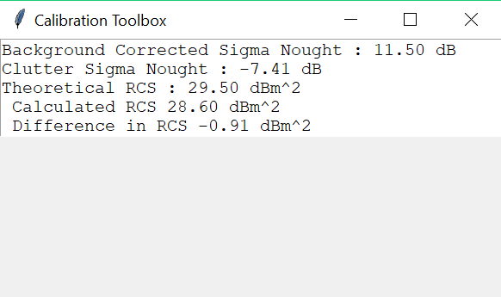

**Radiometric Calibration Parameters**

10) The user can now proceed for **SAR Image Quality parameter** button.

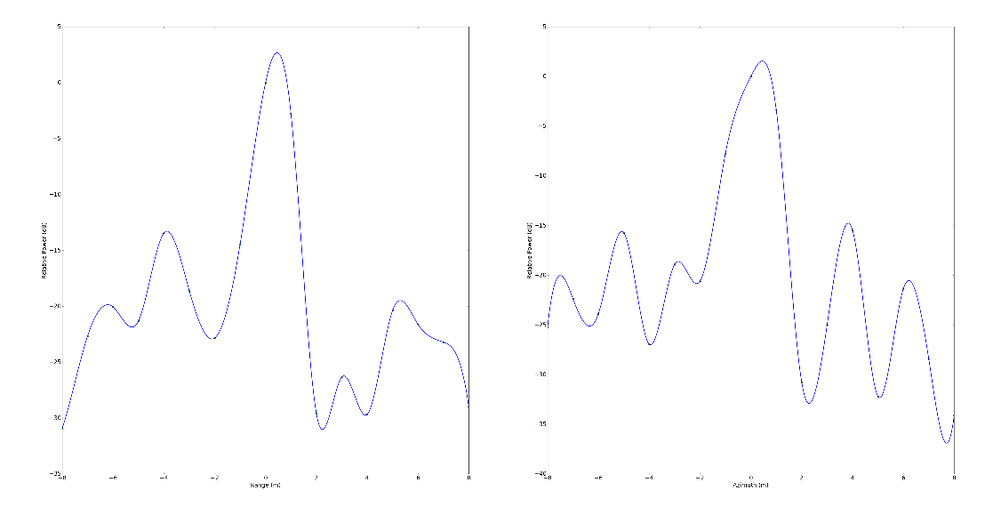

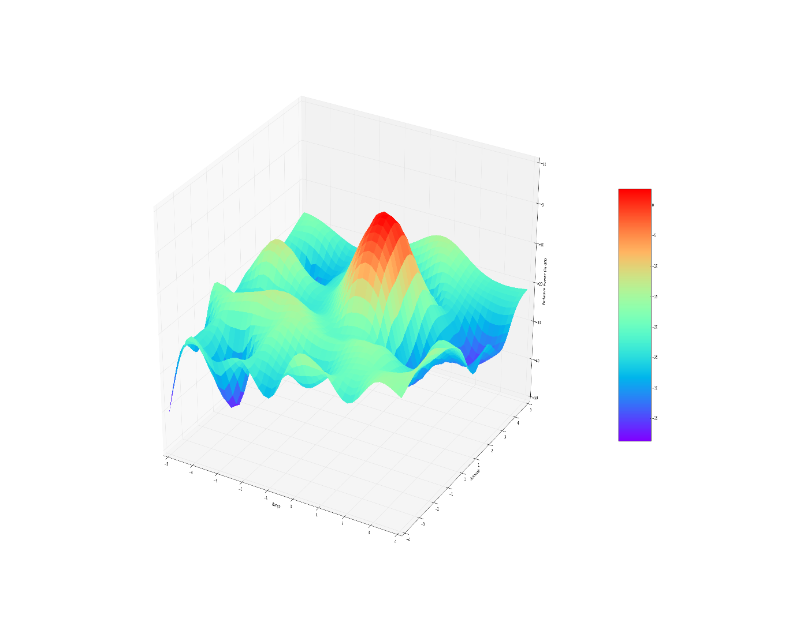

***Impulse Response Function***

NOTE : Distributed Target functionality is disabled as of now.

References

[1]Gautam Dadhich,Shweta Sharma,Mihir Rambhia,Aloke K. Mathur,P. R. Patel,Alpana Shukla. (2018)"Image quality characterization of fine resolution RISAT-1 data using impulse response function".*Geocarto International,*0:0, pages 1-11.

[2]European Space Agency, "Radiometric calibration of S-1 Level-1 Products generated by the S-1 IPF, Technical Note ,2015