31/08/2016

Data Pipeline for Producing Plots

* On bragg: Run /home/geo047/MWAM/SimStudy/Timing/Results/extract_time.bash
* On bragg: Run /home/geo047/MWAM/SimStudy/Timing/Results/extract_mem.bash
* On bragg: Run /home/geo047/MWAM/SimStudy/Timing/Results/form_results.R to create files: cputimes.dat, abscputimes.dat, and memory.dat
* ftp files onto my mac into ~/AM+/Plots_for_Paper/
* Get into Rstudio and run time_and_mem_plot_for_paper.R to prodce

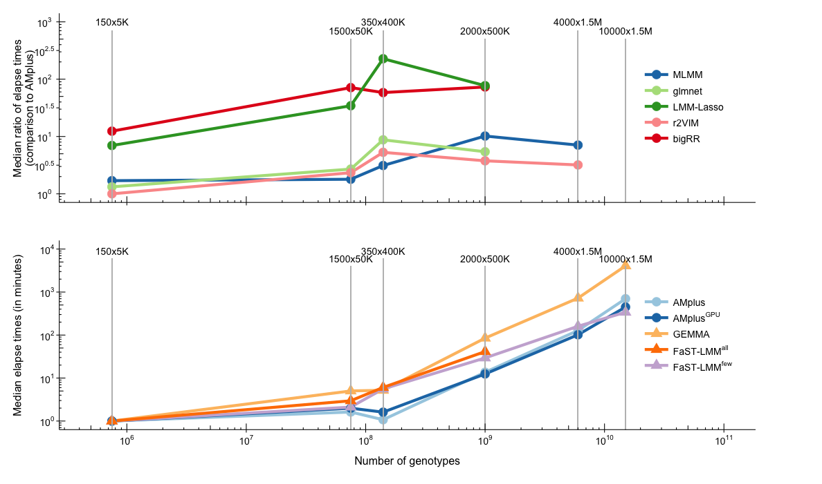

* On bragg: run /home/geo047/MWAM/SimStudy/Timing/RScripts/results.R by the command: R CMD BATCH –fam=”W” ./results and repeat for each family (W, L, S, HS, A, HL). Creates files /home/geo047/MWAM/SimStudy/Timing/Results/res?.RData
* Ftp res?.RData onto mac into ~/AM+/Plots_for_Paper/
* Get into Rstudio and run powerplots.R to prodce

recallplot

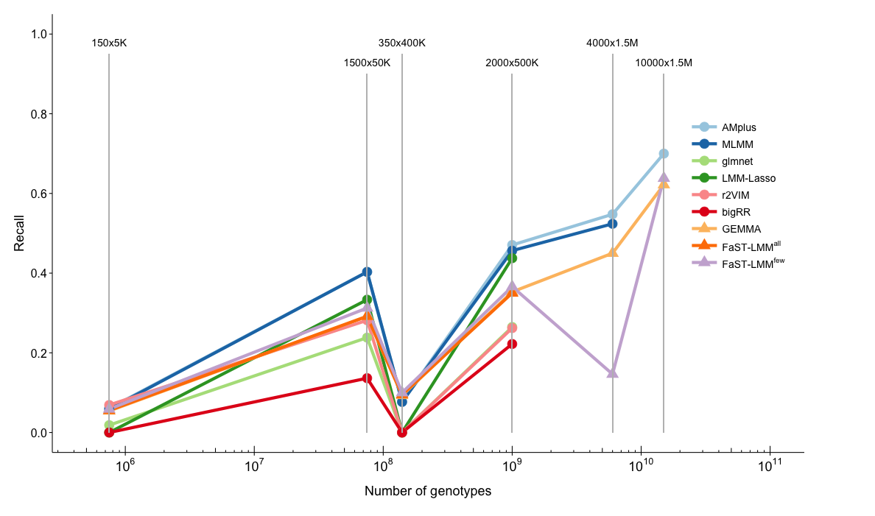

precisionplot

