HapSampler - a Metropolis sampler to calculate the probability that a haplotype contains a QTL allele of interest

HapSampler for calculating the probability that a haplotype contains a QTL allele of interest

Andrew George¹, John M. Henshall^{2,3}, Laercio R. Porto-Neto², Yutao Li², Sigrid A. Lehnert², Antonio Reverter^{2,*} and William Barendse²

¹CSIRO Data61, 41 Boggo Road, Dutton Part, Queensland 4102, Australia.
²CSIRO Agriculture & Food, 306 Carmody Road, St. Lucia, Queensland 4067, Australia.
³Present Address, Cobb-Vantress Inc., Siloam Springs, Arkansas 72761-1030, USA.

*To whom correspondence should be addressed

Abstract

Background: Here, we build on the opportunity that comes from being able to collect dense snp data on a genome-wide scale, to map QTL with high precision, and to form haplotypes from unphased genotype data. We have developed HapSampler. HapSampler takes the set of haplotypes in a region known to contain a QTL and calculates the probability that a marker haplotype carries a certain QTL allele. Haplotypes found to carry QTL allele of know effect increase our genetic understanding of heritable traits and have commercial value.
Methods: HapSampler is based on a Bayesian paradigm. Parameters are sampled stochastically via a Metropolis sampler. The posterior probability of a haplotype carrying a QTL allele is calculated from the output from the Metropolis sampler.
Results: Based on simulated data, we showed that …
Conclusions: HapSampler …
Availability: HapSampler is an R package that is freely available on GitHub.
Contact: tony.reverter-gomez@csiro.au

Motivating Example

Suppose disease status (aff/unaff) has been observed on five individuals as shown in Figure 1. Let’s also assume a region known to house a quantitative trait locus (QTL) has been identified, and the snp genotypes recorded in this region have been phased via a suitable phasing program (say BEAGLE …. ). If, as in Figure 1, the relationship between trait and QTL genotype is assumed to follow a fully penetrant, dominant model, then it is easy to assign QTL alleles q,Q,q, and q to unique haplotypes g1, g2, g3, and g4, respectively. Any other assignment would not be consistent with the data Y and G, and the fully penetrant model. However, suppose we don’t have a fully penetrant model. Suppose there is uncertainty in the relationship between the disease status and QTL genotype QQ. Then, it can be shown that there are four possible allelic configurations that are consistent with this new penetrance model, keeping in mind that these configurations are not all equally probable. Here, calculating the probability of a haplotype carrying a particular QTL allele has become more complicated. In practice, there may be a large number of haplotypes segregating in a population. The relationship between trait and QTL genotype is usually unknown. The trait and/or maker genotypes may be measured with error. A method is needed to cope with these complexities while returning the probability a haplotype carries a certain QTL allele.

Bayesian Model

Suppose trait data Y^{(nx1)} are observed on n individuals along with phased marker data G^{(nx2)} =[(h¹₁,h²₁), (h¹₂,h²₂), …, (h¹_{n}, h²_{n})]^{T} where (h¹_{i}, h²_{i}) are the two m-locus haplotypes for the ith individual. Here, the maternal/paternal origin of a haplotype is not important. The m marker loci span a genomic region known to house a QTL. We assume a biallelic QTL with alleles A and a. Let u be the number of unique marker haplotypes in G. Let Φ^{(ux1)} be the vector of QTL alleles being carried by the u unique haplotypes.

Our Bayesian model for calculating the probability of the u unique haplotypes carrying either A or a is

$$π\left(Φ,θ | Y, G\right) ∝P\left(Y,G | Φ,θ\right)π\left(Φ,θ\right)$$

where $π\left(Φ,θ | Y, G\right)$ is the joint posterior probability of Φ and θ given the observed data, and θ ^{(px1)} is a vector of penetrance parameters. We can further simply this model by using the conditional dependence structure between the variables

$$∝P_{θ}(Y|G,Φ)π(G)π(Φ)π(θ)$$

where P_{θ}(.|.) is the likelihood and π(.) are prior distributions.

The likelihood is calculated as $\prod_{i=1}^{n}{P_{θ}\left(y_{i} | h_{i}^{1},h_{i}^{2},Φ\right)}=\prod_{i=1}^{n}{P_{θ}\left(y_{i} | Q_{i}\right)}$ where Q_{i} is the ith individual’s QTL genotype formed from its haplotypes (h¹_{i}, h²_{i}) carrying A or a, as determined by Φ. Non-informative priors are placed on the variables in the form of uniform distributions for discrete variables and over-dispersed normal densities for continuous variables.

MCMC algorithm

Simulation Study

Results

Conclusion

Haplotypes have the potential to provide greater information about the identity of quantitative trait loci (QTL) until all the main causative mutations in a genomic segment are identified. DNA markers in a haplotype will maintain linkage disequilibrium (LD) for longer to a QTL allele than would a single DNA marker, because double recombinants are rare events. However, in the era of plentiful DNA markers in high density SNP arrays and Bayesian methods that knockdown most of the associations in a region (Bolormaa et al. 2015) haplotype methods have been largely neglected. Furthermore, haplotype methods have an arbitrary component, viz., which SNP should be included in the haplotype, what method of analysis should be used, should all the haplotypes be compared or should an index haplotype be compared to the others (Barendse 2011), and there are implications of these choices on multiple testing. Nevertheless, a method that could reliably identify the haplotypes that contain the QTL from those that do not would be useful in identifying causative mutations and could inform prediction equations well before the causative mutations are identified.

Here we implement a Metropolis-Hastings sampler to calculate the probability that a haplotype is associated with QTL alleles. Samplers implementing the Metropolis-Hastings algorithm can explore the entire probability landscape of an unknown distribution (Tierney 1994; Chib and Greenberg 1995). These tools are recursively used to explore the probability space of a series of haplotypes. Our effort is not the first use of these samplers and Markov Chain Monte Carlo (MCMC) methods in the analysis of haplotypes, see also (Niu et al. 2002; Tong and Thompson 2008), although a search of the literature failed to find a new method for genetic analysis of haplotypes using a Metropolis-Hastings Sampler published in the last 5 years.

- MCMC model

Let us postulate a trait of presence or absence of horns in a species, presence being the phenotype horned, absence being the phenotype polled, with a third phenotype scurred in which hornlike structures are seen due to a second locus. Further, the phenotype horned is recessive to polled, and scurred usually occurs in heterozygous polled animals. Then, assume that a haplotype, say hap1, is found in a horned animal. If hap1 is seen in a polled animal then the animal’s other haplotype, hap2, must contain the allele responsible for polled. Under complete penetrance and no errors in phenotyping or genotyping then by applying such rules one could work out the QTL genotype for each haplotype with sufficient data. However, the most likely vector of haplotypes would not be much more likely than the second most likely, and one would assign polled or horned to a haplotype even when the evidence was not strong. It would be better to have an estimate of the probability that each haplotype was polled, which can be obtained using a Metroplis-Hastings sampler.

To implement a Metroplis-Hastings sampler our method starts with a penetrance function, for our example this would be a matrix where one edge would be the phenotypes (horned, scurred, polled) and the other edge would be the genotypes (PP, PH, and HH) of the gene for the polled/horned phenotype (Table 1). The body of the matrix would contain the conditional probabilities of observing a particular genotype given a phenotype. Secondly, there would be a table of individuals scored for phenotype and DNA marker genotypes arranged into the two autosomal haplotypes (Table 2). Thirdly, to initiate the Metropolis-Hastings Sampler, each of the possible haplotypes would be assigned a genotype at random and the resulting vector would be the first sample (S1 in Table 3). The likelihood of the first sample would be calculated from the penetrance function and observed data (Table 4). Fourthly, a sequence of candidate samples would be generated for the Metropolis-Hastings Sampler (S2 to S6, Table 3). In each sample, randomly chosen haplotypes would be assigned new genotypes. Candidate samples would be either accepted, in which case they replace the existing sample, or rejected, in which case the existing sample would be retained. Candidate samples are accepted when the likelihood of the candidate sample is greater than the likelihood of the existing sample, or if the ratio of the likelihoods is greater than a random number drawn from a uniform (0,1) distribution. The existing sample, which is always the most recently accepted sample, would then be added to the table of accumulated samples. At the end of the iteration, the proportion of times that a haplotype was assigned to polled would be calculated from the table of accumulated samples (Table 5). Over time the penetrance function could be updated as part of the iteration. Additional samples and new haplotypes would automatically be added to the sampler and be assigned a probability of containing the polled gene. To apply the method to quantitative traits, the genotype sampler would be the same. The effects, instead of being discrete, would be sampled from a normal distribution while the variance would be sampled from an inverse chi-squared distribution.

- Model Evaluation

We used generic de-identified genotypes from a large dataset of 32,538 broiler chickens from a selection line in Cobb-Vantress Inc. that were genotyped with a Cobb-Vantress custom-designed chip containing 52,232 SNPs. We used the genotype data as a base to simulate phenotypic data, rather than simulating genotypes and phenotypes across the whole genome, because of the difficulty of simulating linked genotypes at genome scale using the coalescent where the sample might be inbred or subject to artificial genetic selection. One section of a chromosome was chosen for the template where a single SNP in the middle of the set of SNPs was selected to make the phenotypes. Genotypes of the project were analysed using Beagle version 3.3 (Browning and Browning 2009) consisting of 17 SNP spread over 886 kb to identify haplotypes. Haplotypes were coded as a string of 0 and 1 from proximal to distal along the chromosome yielding a pseudo-binary number, which was then translated to decimal numbers after which they were shrunk down to remove empty haplotype spaces. To generate the simulated linked phenotype, one of the homozygous genotypes of a SNP in the middle of the section was chosen to have a phenotypic value of 1 while the other genotypes were chosen to have a phenotypic value of 0. Random Gaussian noise was added to the phenotypic value of each genotype at a range of sizes, equivalent to reducing the heritability of the phenotype (Figure 1). A range of heritabilities was chosen, from h² = 0.33 to h² = 0.9. An unlinked phenotype was also simulated in the same way, using a SNP from a different chromosome that showed no linkage disequilibrium to the index section.

HapSampler recovered the size of the simulated phenotypic effect at all tested heritabilities (Table 6). Despite the large phenotypic effect size, for the unlinked simulated phenotype HapSampler did not recover the effect size. The contents of the table are the size of the phenotypic effect, the amount of Gaussian noise added to the phenotype, the actual genetic variance due to the SNP genotype modelled as a phenotype, the total expected variance given the size of the noise, the observed difference between homozygous genotypes identified by HapSampler for the QTL, and the observed standard deviation of the sample of individuals separated into haplotype groups. The difference in genetic variance between the two phenotypes is due to different allele frequencies at the two SNP.

HapSampler gave clear probabilities of 0 or 1 for the simulated phenotypes in the same linkage group as the SNP whereas it gave probabilities near 0.5 for the unlinked simulated phenotypes (Figure 2). The simulated linked phenotype has h² = 0.33 and the simulated unlinked phenotype had h² = 0.5. The heritability of the simulated phenotype did not affect the probability of a haplotype being associated with the QTL. In the figure, the individual haplotypes were sorted by haplotype probability for the linked phenotype. The corresponding probability for the unlinked phenotype was also plotted for the same haplotype, which explains the wobble in the red line. Among the individual haplotypes there were two major and 35 minor haplotypes. The two major haplotypes, numbers 11 and 27, had haplotype probabilities of 0 and 1 with no discrepancies.

- Software availability

We have implemented this method as a draft HapSampler R package which is under development and is available from GitHub (https://github.com/geo047/HapSampler). The Metropolis-Hastings sampler is coded in Fortran 90. The data flow control and generation of graphs is implemented in R. This software is particularly useful in its current state for samples containing a few hundred individuals that segregate a major gene which is not currently identified.

Acknowledgements

Early versions of the software were trialled on data of polled and horned cattle through the University of Queensland Animal Genetics Laboratory directed by R.E. Lyons.

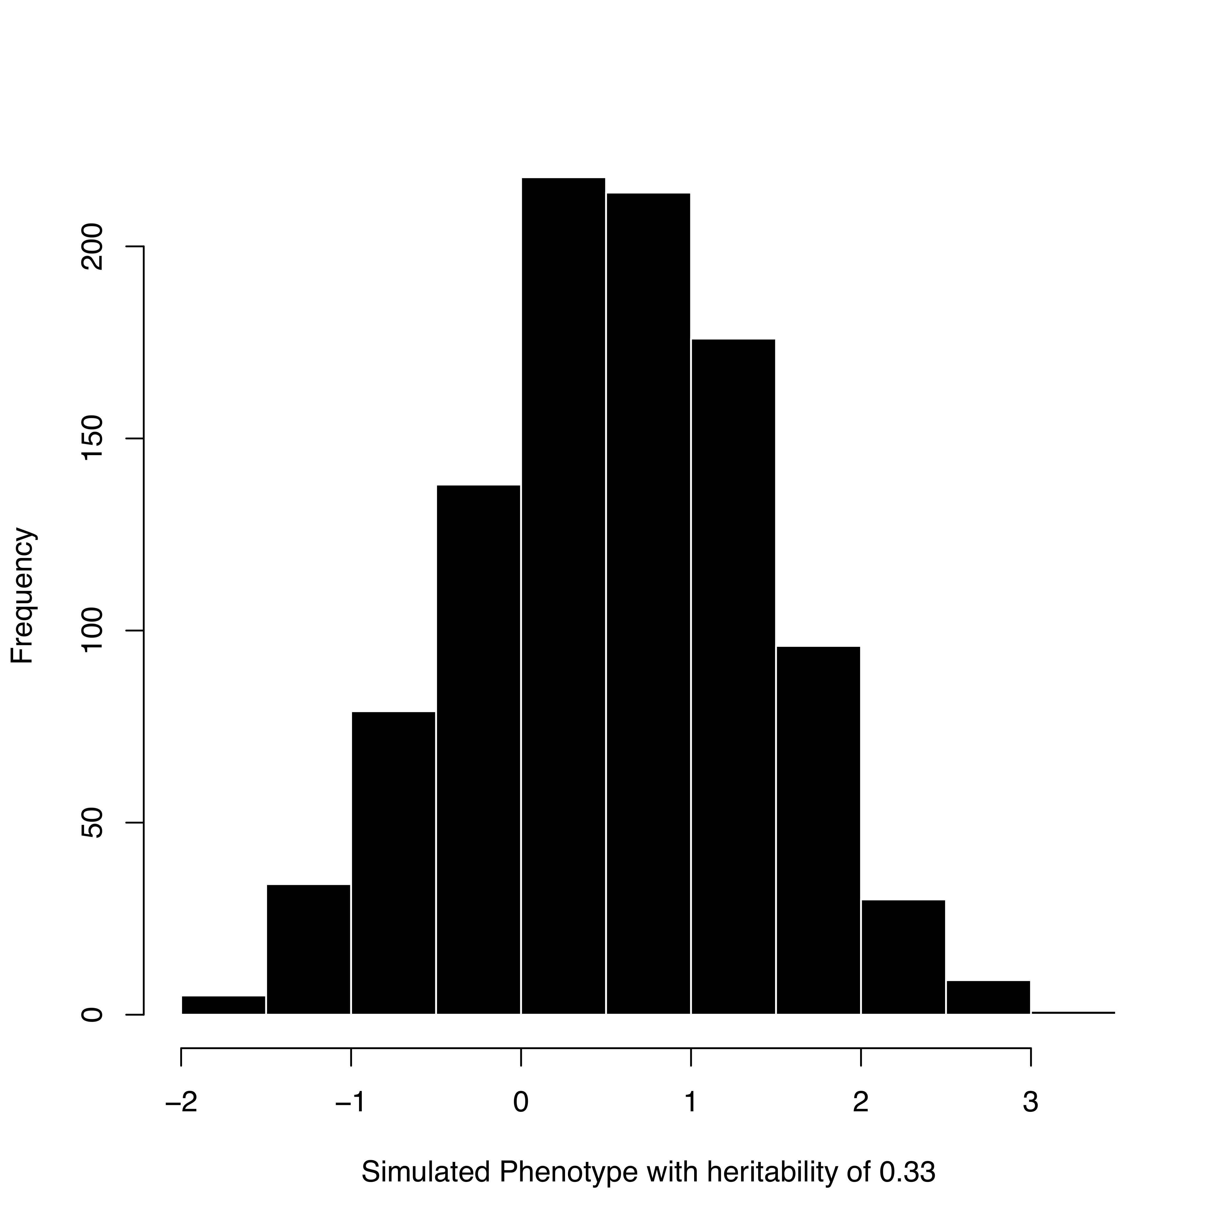
Figure 1. Distribution of the phenotype simulated from a single SNP

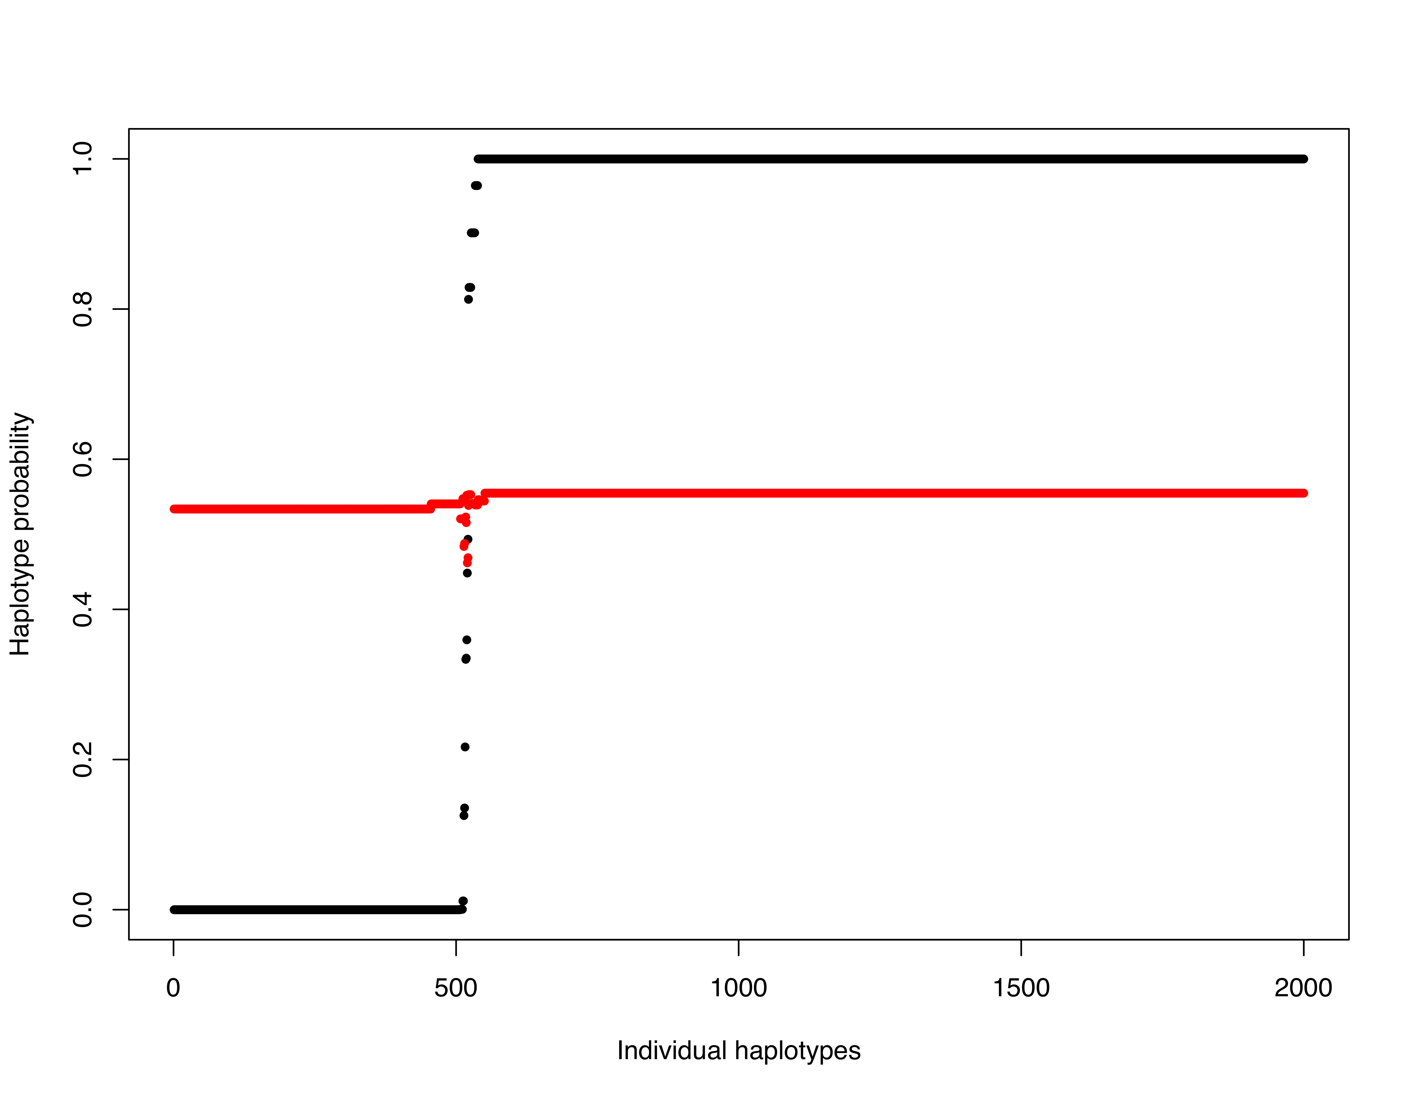
Figure 2. Haplotype probabilities for individual haplotypes for the simulated linked (black) and unlinked (red) phenotypes

Table 1. Example of a penetrance function for Polled phenotypes and genotypes

 | Diploid Genotype
Phenotype | PP | PH | HH
Horned | 0.05 | 0.10 | 0.85
Polled | 0.49 | 0.49 | 0.02
Scurred | 0.20 | 0.79 | 0.01

Table 2. Example of an input datafile of haplotypes of animals of Polled and horned phenotypes

ID | Phen | hap1 | hap2
1 | horned | 0000 | 1111
2 | polled | 1111 | 1010
3 | scurred | 1010 | 0101
4 | polled | 0000 | 1010

Table 3. Example of a set of candidate samples given the input datafile in Table 2

 | Candidate Samples
Hap | S1 | S2 | S3 | S4 | S5 | S6
0000 | H | H | P | H | H | H
1111 | H | H | H | H | H | H
1010 | P | P | P | P | H | P
0101 | P | H | H | P | P | P
Lkld | 0.04 | 0.16 | 0.02 | 0.04 | 0.00 | 0.04

Table 4. Candidate sample likelihoods given the penetrance function and the phenotypes and haplotypes given the set of candidate samples in Table 3

Candidate Sample Likelihoods
L1 | L2 | L3 | L4 | L5 | L6
0.85 | 0.85 | 0.10 | 0.85 | 0.85 | 0.85
0.49 | 0.49 | 0.49 | 0.49 | 0.02 | 0.49
0.20 | 0.79 | 0.79 | 0.20 | 0.49 | 0.20
0.49 | 0.49 | 0.49 | 0.49 | 0.02 | 0.49

Table 5. Accumulated samples and their probability given the candidate sample likelihoods in Table 4

 | Accumulated Samples
Hap |  |  |  |  |  |  | Prob(P)
0000 | H | H | H | H | H | H | 0/6
1111 | H | H | H | H | H | H | 0/6
1010 | P | P | P | P | P | P | 6/6
0101 | P | H | H | H | H | P | 2/6

Table 6. Genetic and phenotypic variance of the simulated phenotypes

Trait | Size | Noise_{SD} | Var_{g} | Var_{p} | Diff | S.D._{sample}
S1.1 | 1.0 | 0.10 | 0.26 | 0.27 | 0.998 | 0.511
S1.2 | 1.0 | 0.51 | 0.26 | 0.52 | 0.946 | 0.729
S1.3 | 1.0 | 0.71 | 0.26 | 0.78 | 1.107 | 0.855
S2.1 | 1.0 | 0.10 | 0.08 | 0.09 | 0.159 | 0.381
S2.2 | 1.0 | 0.29 | 0.08 | 0.17 | 0.174 | 0.498

The contents of the table are the size of the phenotypic effect, the amount of Gaussian noise added to the phenotype, the actual genetic variance due to the SNP genotype modelled as a phenotype, the total expected variance given the size of the noise, the observed difference between homozygous genotypes identified by HapSampler for the QTL, and the observed standard deviation of the sample of individuals separated into haplotype groups. The difference in genetic variance between the two phenotypes is due to different allele frequencies at the two SNP.
References

Barendse W. 2011. Haplotype Analysis Improved Evidence for Candidate Genes for Intramuscular Fat Percentage from a Genome Wide Association Study of Cattle. PLoS ONE 6: e29601.
Bolormaa S, Pryce JE, Zhang YD, Reverter A, Barendse W, Hayes BJ, Goddard ME. 2015. Non-additive genetic variation in growth, carcass and fertility traits of beef cattle. Genetics Selection Evolution 47.
Browning BL, Browning SR. 2009. A unified approach to genotype imputation and haplotype-phase inference for large data sets of trios and unrelated individuals. American Journal of Human Genetics 84: 210-223.
Chib S, Greenberg E. 1995. UNDERSTANDING THE METROPOLIS-HASTINGS ALGORITHM. American Statistician 49: 327-335.
Niu TH, Qin ZHS, Xu XP, Liu JS. 2002. Bayesian haplotype inference for multiple linked single-nucleotide polymorphisms. American Journal of Human Genetics 70: 157-169.
Tierney L. 1994. MARKOV-CHAINS FOR EXPLORING POSTERIOR DISTRIBUTIONS. Annals of Statistics 22: 1701-1728.
Tong LP, Thompson E. 2008. Multilocus lod scores in large pedigrees: Combination of exact and approximate calculations. Human Heredity 65: 142-153.

