Carbon Dioxide Concentrations at Mona Loa Observatory

Bowei Zhao

10/24/2020

## Plot the temporal trend of annual mean carbon dioxide concentrations

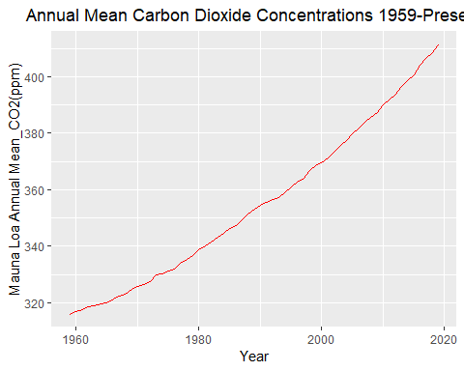

## Show the annual mean carbon dioxide concentrations in the last five years

