Carbon Dioxide Concentrations at Mona Loa Observatory

Weishan Bai

10/27/2020

# Annual Mean Carbon Dioxide Concentrations 1959-Present

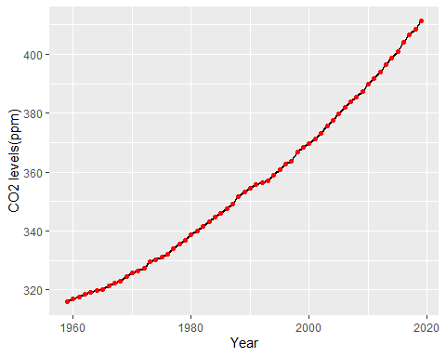

# Top Five Annual Mean Carbon Dioxide Concentrations at Mona Loa

