Case Study 08: Annual Mean CO2

Zaque Evans

October 29, 2020

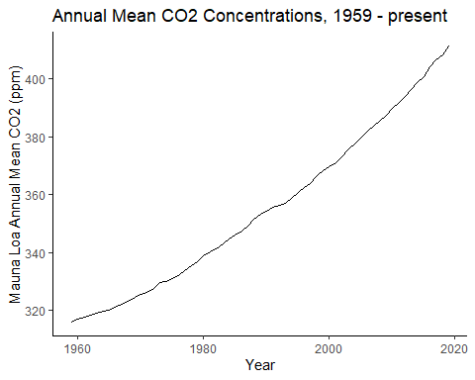

## Annual Mean CO2 (ppm) 2010-2019, Muana Lao Observatory

