Case Study 8

Brendan Kunz

11/3/2020

## R Markdown

This is an R Markdown document. Markdown is a simple formatting syntax for authoring HTML, PDF, and MS Word documents. For more details on using R Markdown see <http://rmarkdown.rstudio.com>.

When you click the **Knit** button a document will be generated that includes both content as well as the output of any embedded R code chunks within the document. You can embed an R code chunk like this:

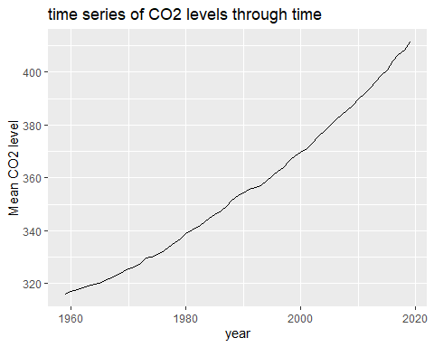

## Including Plots

You can also embed plots, for example:

Top 5 Annual Mean Carbon Dioxide Concentrations

year

mean

2019

411.43

2018

408.52

2017

406.55

2016

404.22

2015

400.83

Note that the echo = FALSE parameter was added to the code chunk to prevent printing of the R code that generated the plot.