One Script, Many Products

Erik Woyciesjes

10/29/2020

# Mauna Loa CO2 Annual Mean Data

## Parsed with column specification:  
## cols(  
## `#` = col_logical(),  
## year = col_double(),  
## mean = col_double(),  
## unc = col_double()  
## )

# Data Plotted

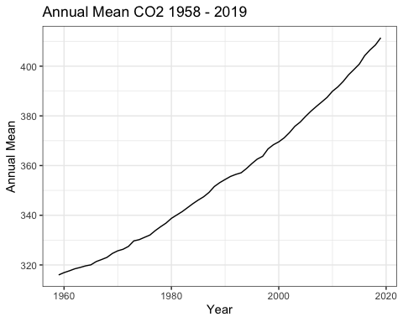

# Arrage Data for Table

## Selecting by unc

# Data Table

Annual Means for the Last Decade

|  |  |  |  |
| --- | --- | --- | --- |
| # | year | mean | unc |
| NA | 2019 | 411.43 | 0.12 |
| NA | 2018 | 408.52 | 0.12 |
| NA | 2017 | 406.55 | 0.12 |
| NA | 2016 | 404.22 | 0.12 |
| NA | 2015 | 400.83 | 0.12 |
| NA | 2014 | 398.64 | 0.12 |