GEO511_CS_08

Marko Lazin

10/27/2020

Setup

library(tidyverse)

Data

cs8_data<-read_table("ftp://aftp.cmdl.noaa.gov/products/trends/co2/co2_annmean_mlo.txt",skip=56)  
cs8_data<-cs8_data[,2:4]

Graph

ggplot(cs8_data,aes(x=year,y=mean))+  
 geom_line()+  
 labs(title="Mauna Loa CO2 Annual Mean",x="Year",y="Mean CO2 PPM")

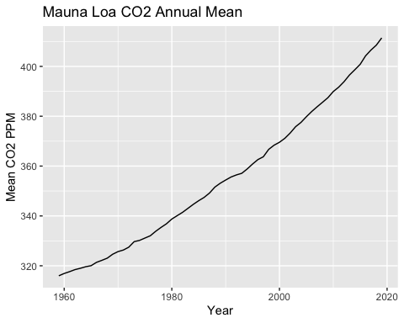 Table

knitr::kable(head(arrange(cs8_data,desc(mean))),format="simple",align="c",caption="Mauna Loa CO2 Top Annual Mean")

Mauna Loa CO2 Top Annual Mean

|  |  |  |
| --- | --- | --- |
| year | mean | unc |
| 2019 | 411.43 | 0.12 |
| 2018 | 408.52 | 0.12 |
| 2017 | 406.55 | 0.12 |
| 2016 | 404.22 | 0.12 |
| 2015 | 400.83 | 0.12 |
| 2014 | 398.64 | 0.12 |