Carbon Dioxide Concentrations at Mona Loa Observatory

Sandra Notaro

10/26/2020

# Annual Mean Carbon Dioxide Concentrations 1959-Present

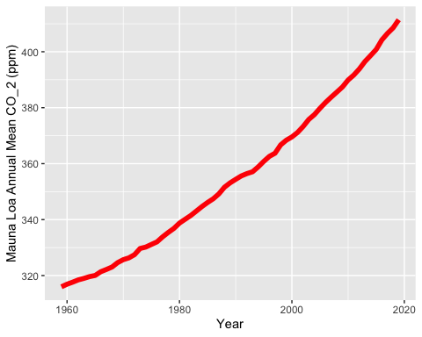

# Top Five Annual Mean Carbon Dioxide Concentrations at Mona Loa

|  |  |
| --- | --- |
| year | mean |
| 2019 | 411.43 |
| 2018 | 408.52 |
| 2017 | 406.55 |
| 2016 | 404.22 |
| 2015 | 400.83 |

### Tina and Betsy helped me make my table look properly by combining different ideas