Carbon Dioxide Concentrations at Mauna Loa

Ting Chang

October 26, 2020

## Annual Mean Carbon Dioxide Concentrations 1959-Present

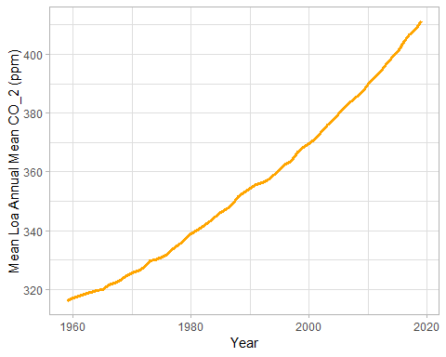

## Top 10 Annual Mean Carbon Dioxide Concentrations

