Case Study 8

Adrian Elie

10/25/2022

library(tidyverse)  
library(ggplot2)  
library(kableExtra)  
  
CO <- read_table("ftp://aftp.cmdl.noaa.gov/products/trends/co2/co2_annmean_mlo.txt", skip = 56)

##   
## -- Column specification --------------------------------------------------------  
## cols(  
## `#` = col_double(),  
## year = col_double(),  
## mean = col_double(),  
## unc = col_character()  
## )

## Warning: 63 parsing failures.  
## row col expected actual file  
## 1 -- 4 columns 3 columns 'ftp://aftp.cmdl.noaa.gov/products/trends/co2/co2_annmean_mlo.txt'  
## 2 -- 4 columns 3 columns 'ftp://aftp.cmdl.noaa.gov/products/trends/co2/co2_annmean_mlo.txt'  
## 3 -- 4 columns 3 columns 'ftp://aftp.cmdl.noaa.gov/products/trends/co2/co2_annmean_mlo.txt'  
## 4 -- 4 columns 3 columns 'ftp://aftp.cmdl.noaa.gov/products/trends/co2/co2_annmean_mlo.txt'  
## 5 -- 4 columns 3 columns 'ftp://aftp.cmdl.noaa.gov/products/trends/co2/co2_annmean_mlo.txt'  
## ... ... ......... ......... ..................................................................  
## See problems(...) for more details.

CO  
  
print(CO, n = 60)  
  
Workplease <- ggplot(CO, aes(x = `#`, y = year))+   
geom_line()+  
labs(x = "Year", y = "CO2 concentration")+  
ggtitle("Rise in CO2 levels since 1959") +  
theme(plot.title = element_text(hjust = 0.5))   
  
Workplease

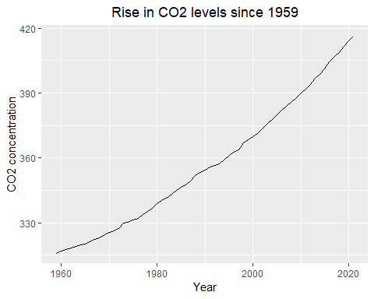

table <- knitr::kable(CO, formal = "pipe",)   
  
table

#

year

mean

unc

1959

315.98

0.12

NA

1960

316.91

0.12

NA

1961

317.64

0.12

NA

1962

318.45

0.12

NA

1963

318.99

0.12

NA

1964

319.62

0.12

NA

1965

320.04

0.12

NA

1966

321.37

0.12

NA

1967

322.18

0.12

NA

1968

323.05

0.12

NA

1969

324.62

0.12

NA

1970

325.68

0.12

NA

1971

326.32

0.12

NA

1972

327.46

0.12

NA

1973

329.68

0.12

NA

1974

330.19

0.12

NA

1975

331.13

0.12

NA

1976

332.03

0.12

NA

1977

333.84

0.12

NA

1978

335.41

0.12

NA

1979

336.84

0.12

NA

1980

338.76

0.12

NA

1981

340.12

0.12

NA

1982

341.48

0.12

NA

1983

343.15

0.12

NA

1984

344.87

0.12

NA

1985

346.35

0.12

NA

1986

347.61

0.12

NA

1987

349.31

0.12

NA

1988

351.69

0.12

NA

1989

353.20

0.12

NA

1990

354.45

0.12

NA

1991

355.70

0.12

NA

1992

356.54

0.12

NA

1993

357.21

0.12

NA

1994

358.96

0.12

NA

1995

360.97

0.12

NA

1996

362.74

0.12

NA

1997

363.88

0.12

NA

1998

366.84

0.12

NA

1999

368.54

0.12

NA

2000

369.71

0.12

NA

2001

371.32

0.12

NA

2002

373.45

0.12

NA

2003

375.98

0.12

NA

2004

377.70

0.12

NA

2005

379.98

0.12

NA

2006

382.09

0.12

NA

2007

384.02

0.12

NA

2008

385.83

0.12

NA

2009

387.64

0.12

NA

2010

390.10

0.12

NA

2011

391.85

0.12

NA

2012

394.06

0.12

NA

2013

396.74

0.12

NA

2014

398.81

0.12

NA

2015

401.01

0.12

NA

2016

404.41

0.12

NA

2017

406.76

0.12

NA

2018

408.72

0.12

NA

2019

411.66

0.12

NA

2020

414.24

0.12

NA

2021

416.45

0.12

NA