CS_08

Yue Ma

9/20/2022

## Data collection

read the txt data from the website

## draw the figures

Make the line plot of CO2 emission

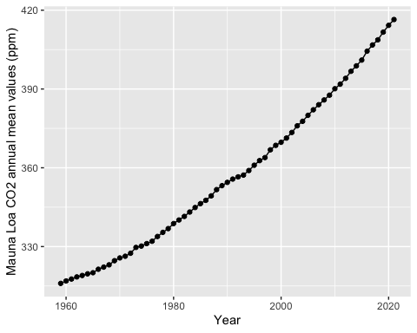

## get the top five years for CO2 emission

draw the table

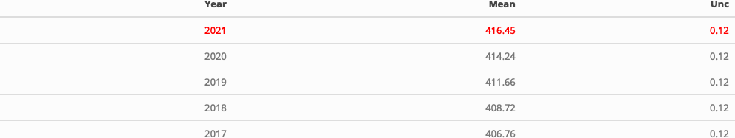

Note that the echo = FALSE parameter was added to the code chunk to prevent printing of the R code that generated the plot.