Case Study 08

Ehsan Ul Hoque Tanim

Ocober 25,2022

##   
## ── Column specification ──────────────────────────────  
## cols(  
## year = col_double(),  
## mean = col_double(),  
## uncertainty = col_double()  
## )

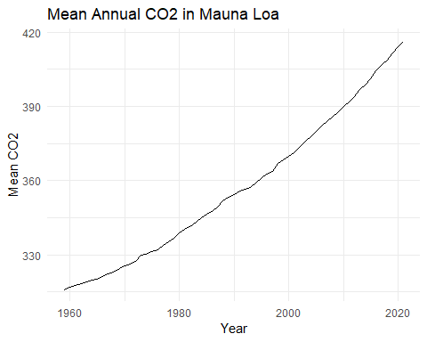

year

mean

uncertainty

2021

416.45

0.12

2020

414.24

0.12

2019

411.66

0.12

2018

408.72

0.12

2017

406.76

0.12