Case Study 08

Hang Tian

August 1, 2020

library(ggplot2)  
suppressPackageStartupMessages(library(tidyverse))  
dataurl="ftp://aftp.cmdl.noaa.gov/products/trends/co2/co2_annmean_mlo.txt"  
temp=read_table(dataurl, skip=57,col_names = c('year','mean','unc'))

##   
## ── Column specification ────────────────────────────────────────────────────────────────────────────  
## cols(  
## year = col_double(),  
## mean = col_double(),  
## unc = col_double()  
## )

ggplot(temp,aes(year,mean))+  
 geom_line()+  
 theme_bw()+  
 xlab('Year')+  
 ylab('CO2 Mean Value')+  
 ggtitle('CO2 Mean ~ Year plot')

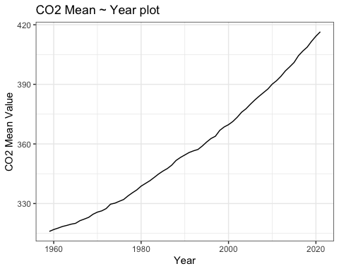

library(dplyr)  
processed=temp%>%arrange(desc(mean))%>%select(year,mean)%>%slice(1:5)  
knitr::kable(processed,'simple')

| year | mean |
| --- | --- |
| 2021 | 416.45 |
| 2020 | 414.24 |
| 2019 | 411.66 |
| 2018 | 408.72 |
| 2017 | 406.76 |

# rmarkdown::render("week_08/case_study_08.Rmd",output_format = "all")