Case Study 08

Bobby Decker

10/27/2022

#install.packages(“kableExtra”) #install.packages(“magick”)

##   
## -- Column specification -------------------------------------------------------------------------------------------------------  
## cols(  
## year = col_double(),  
## mean = col_double(),  
## unc = col_double()  
## )

ggplot(mauna_mean, aes(year, mean))+  
 geom_line(color="red", size=1.75)+  
 labs(  
 title="Annual Mean Carbon Dioxide Concentration",  
 subtitle = "1959 - Present",  
 )+  
 xlab("Year")+  
 ylab("Mauna Loa Annual Mean CO_2 (ppm)")

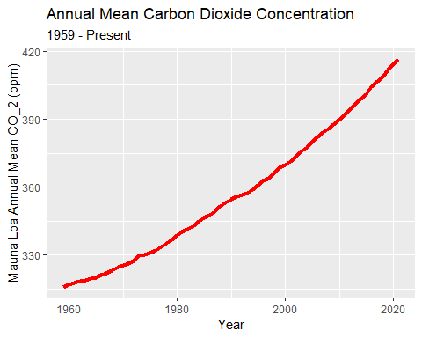

top5_table<-arrange(mauna_mean, desc(mean))[1:5, ]  
knitr::kable(top5_table, caption = 'Top Five Annual Mean Carbon Dioxide Concentrations at Mona Loa',  
col.names = c("year", "mean", "unc")) %>%  
as_image(width = 10,file = "table.png")

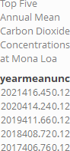

#rmarkdown::render(“path/to/file.Rmd”,output_format = “all”)