Case Study 08

Willow Flood

October 25, 2022

library(tidyverse)  
co2_data = read_table(file = ('ftp://aftp.cmdl.noaa.gov/products/trends/co2/co2_annmean_mlo.txt'), skip = 57, col_names = c("year", "mean", "unc"), comment = "#")

##   
## ── Column specification ────────────────────────────────────────────────────────  
## cols(  
## year = col_double(),  
## mean = col_double(),  
## unc = col_double()  
## )

library(ggplot2)  
ggplot(co2_data, aes(x=year, y=mean)) +  
 geom_line(aes(color = "red")) +  
 labs(title = "Mean CO2 Over Time",  
 y = "Mean CO2",  
 x = "Years",  
 caption = "From Mauna Loa CO2 annual mean data")

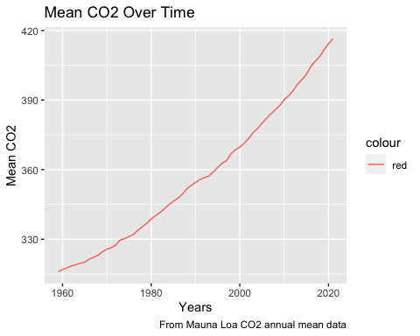

knitr::kable(head(arrange(co2_data[,1:3], desc(year))), format = "simple", col.names = c("Year", "Mean", "UNC"), caption = "Mauna Loa CO2 Annual Mean")

Mauna Loa CO2 Annual Mean

| Year | Mean | UNC |
| --- | --- | --- |
| 2021 | 416.45 | 0.12 |
| 2020 | 414.24 | 0.12 |
| 2019 | 411.66 | 0.12 |
| 2018 | 408.72 | 0.12 |
| 2017 | 406.76 | 0.12 |
| 2016 | 404.41 | 0.12 |