Case Study 08

Yixuan Zhao

10-25-2022

min_year = df$year %>% min()  
max_year = df$year %>% max()  
df %>%   
 mutate(sd = sd(mean)) %>%   
 as_tibble() %>%   
 ggplot(., aes(x = year, y = mean)) +  
 geom_line(color = "black", lwd = 1) +  
 geom_point(size = 2, color = "red") +  
 scale_x_continuous(breaks = seq(min_year, max_year, 5)) +  
 theme_bw() +  
 labs(x = "Year", y = "Mean",   
 title= "Trends in Atmospheric Chemical Compound")

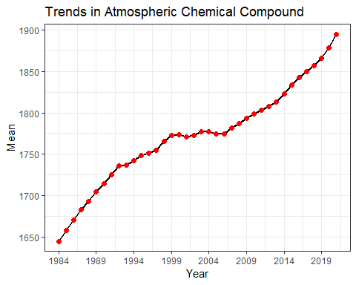

summ = df %>%   
 slice(-1) %>%   
 mutate(Years = case_when(  
 year %in% seq(1960, 1969) ~ "1960 - 1969",   
 year %in% seq(1970, 1979) ~ "1970 - 1979",   
 year %in% seq(1980, 1989) ~ "1980 - 1989",   
 year %in% seq(1990, 1999) ~ "1990 - 1999",   
 year %in% seq(2000, 2009) ~ "2000 - 2009",   
 year %in% seq(2010, 2019) ~ "2010 - 2019",   
 year %in% seq(2020, 2029) ~ "2020 - "  
 )) %>%   
 group_by(Years) %>%   
 dplyr::summarise(Mean = mean(mean),   
 S.D. = sd(mean),   
 Min = min(mean),   
 Max = max(mean))  
knitr::kable(summ,'simple')

| Years | Mean | S.D. | Min | Max |
| --- | --- | --- | --- | --- |
| 1980 - 1989 | 1681.548 | 18.597033 | 1657.29 | 1704.54 |
| 1990 - 1999 | 1744.591 | 17.728495 | 1714.42 | 1772.39 |
| 2000 - 2009 | 1778.246 | 7.115024 | 1771.20 | 1793.52 |
| 2010 - 2019 | 1829.700 | 23.950969 | 1798.90 | 1866.59 |
| 2020 - | 1887.125 | 11.589480 | 1878.93 | 1895.32 |