A report on the

**“Leeds Footfall Predictor”**

A web tool for forecasting footfall rates at the Leeds City Centre, Leeds, United Kingdom

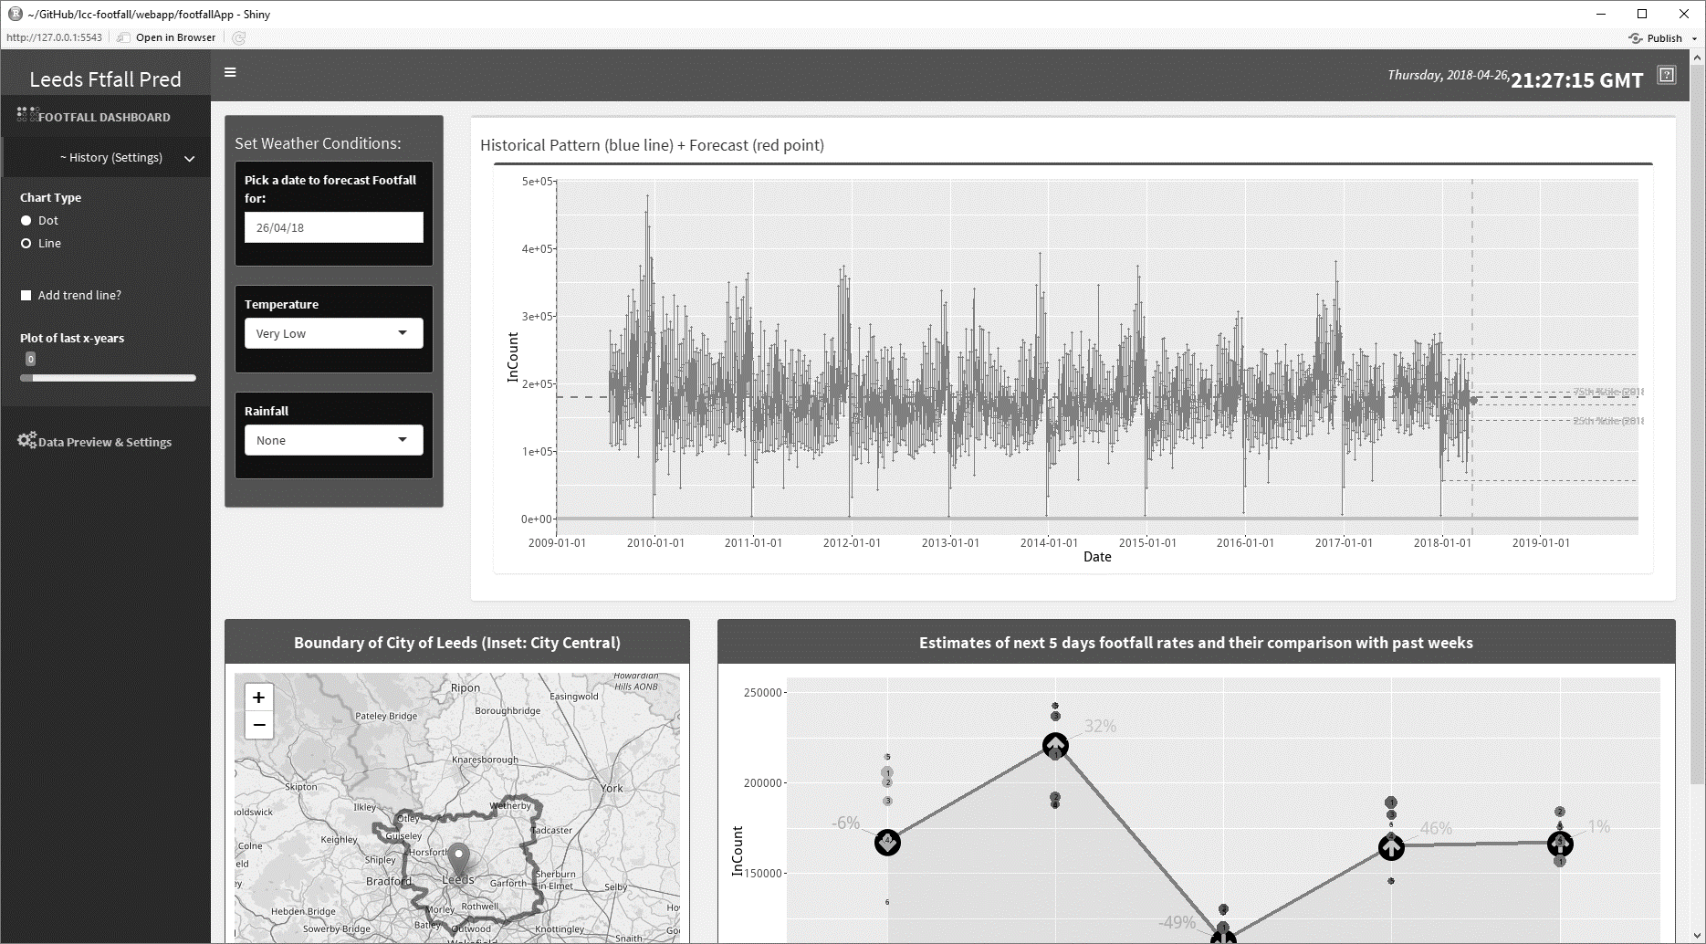

Prepared by:

**Monsuru Adepeju**

28/04/2018

**1. OBJECTIVES**

The objectives of this document are as follow:

* To provide details of the various resources (files and folders) that underlie the functionalities of the web tool, and to also explain how they are related.
* To provide short descriptions of the various components of the web tools and how they are used.

This web tool is based on an already completed work (<https://github.com/nickmalleson/lcc-footfall/blob/master/LCC_Footfall.ipynb>) which focussed on forecasting footfall at the Leeds City Centre based on external predictors such as temperature, rainfall and holidays. The project involved experimenting with different machine learning algorithm and comparing their accuracies. It established that the ‘Random Forest’ algorithm is most accurate amongst the ten algorithms used. The *Random Forest* algorithm is therefore adopted as the underlying predictive algorithm of this web tool.

**Notice**: This document is meant to support the comments already provided inside the scripts ‘*ui.R*’ and ‘*server.R*’ of the web tool.

**2. RESOURCES**

1. The GitHub resources associated with the web tool can be downloaded from here: <https://github.com/nickmalleson/lcc-footfall>.
2. Given any root directory (e.g. ROOT_DIR = "C:/Users/geomad/Documents/GitHub/") in which the ‘lcc-footfall’ folder above has already been downloaded, the following files can be located:
   1. “***twentyFour_HoursAggregation_DoNot_REMOVE_or_ADD_ToThisDirectory.csv***” - Contains daily aggregated footfall datasets. It’s location is defined in ‘*server.R*’ as “file_here <- paste0(ROOT_DIR,"lcc-footfall/webapp/downloaded_footfall dataset/aggregated_historical_HF/")”
   2. *“****predictors_info.csv****”* – Contains records of predictors required to predict the footfall rates. The predictors (i.e. fields) are of two types, namely:
3. *Sourced predictors*: These are two – the *mean temperature* and the *rainfall rates.*
4. *Auto-generated predictors*: These are 83 in total. They include information which can be determined in advance, such as holidays and days-of-the-week information.

The path to *“****predictors_info.csv****”* file is defined in ‘*server.R*’ as parameter_directory <- paste0(ROOT_DIR,"lcc-footfall/webapp/downloaded_footfall dataset/predictors_INFO/").

In the *“****predictors_info.csv****”* file, the ‘*Auto-generated predictors’* fields have already been updated up to 31/12/2019. However, the ‘*source predictors’* fields (i.e. ‘*mean_temp*’ and ‘*rain*’) have to be updated through the web tool.

* 1. ***“random_forest_model.rda” –*** Contains the trained model (parameters) based on the last three years records of *“****predictors_info.csv****”* whose ‘sourced predictors’ fields have been updated. The ‘*status*’ field of the *“****predictors_info.csv****”* indicates the records whose ‘sourced predictors’ fields have been updated (i.e. entry is “1” if updated, “0” if otherwise).

Note: None of these files is to be moved or deleted. Also, they should not be opened in window while update is being made.

**3. LEEDS FOOTFALL PREDICTOR**

‘FOOTFALL DASHBOARD’ PAGE. The components of this page are described as follows:

1. **SideBar** -
2. **Weather Scenarios** –
3. **Footfall Plot** -

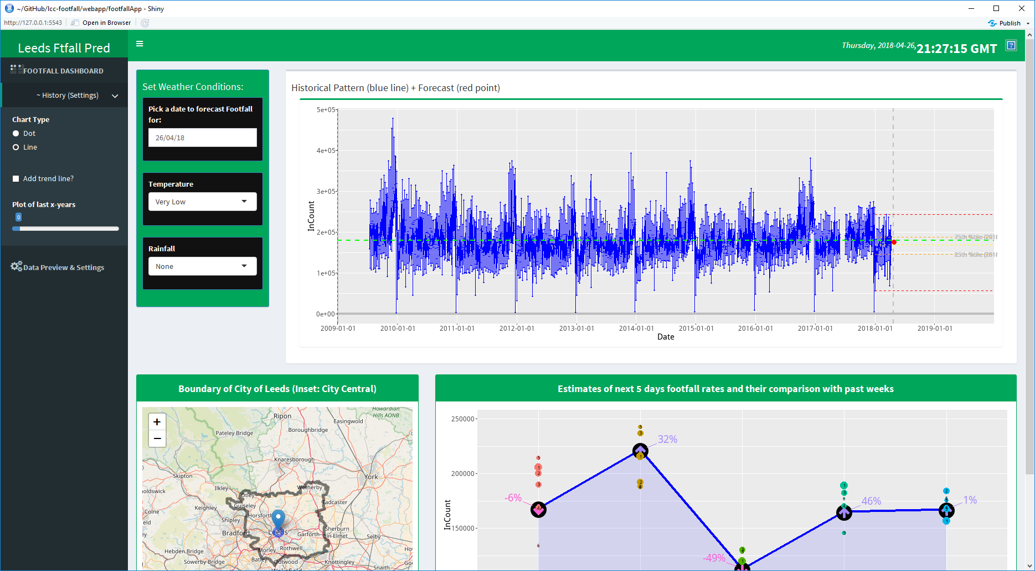

Temperature: ‘Very low’, ‘Low’, ‘Moderate’, ‘High’

Rainfall: ‘None’, ‘Light’, ‘Heavy’

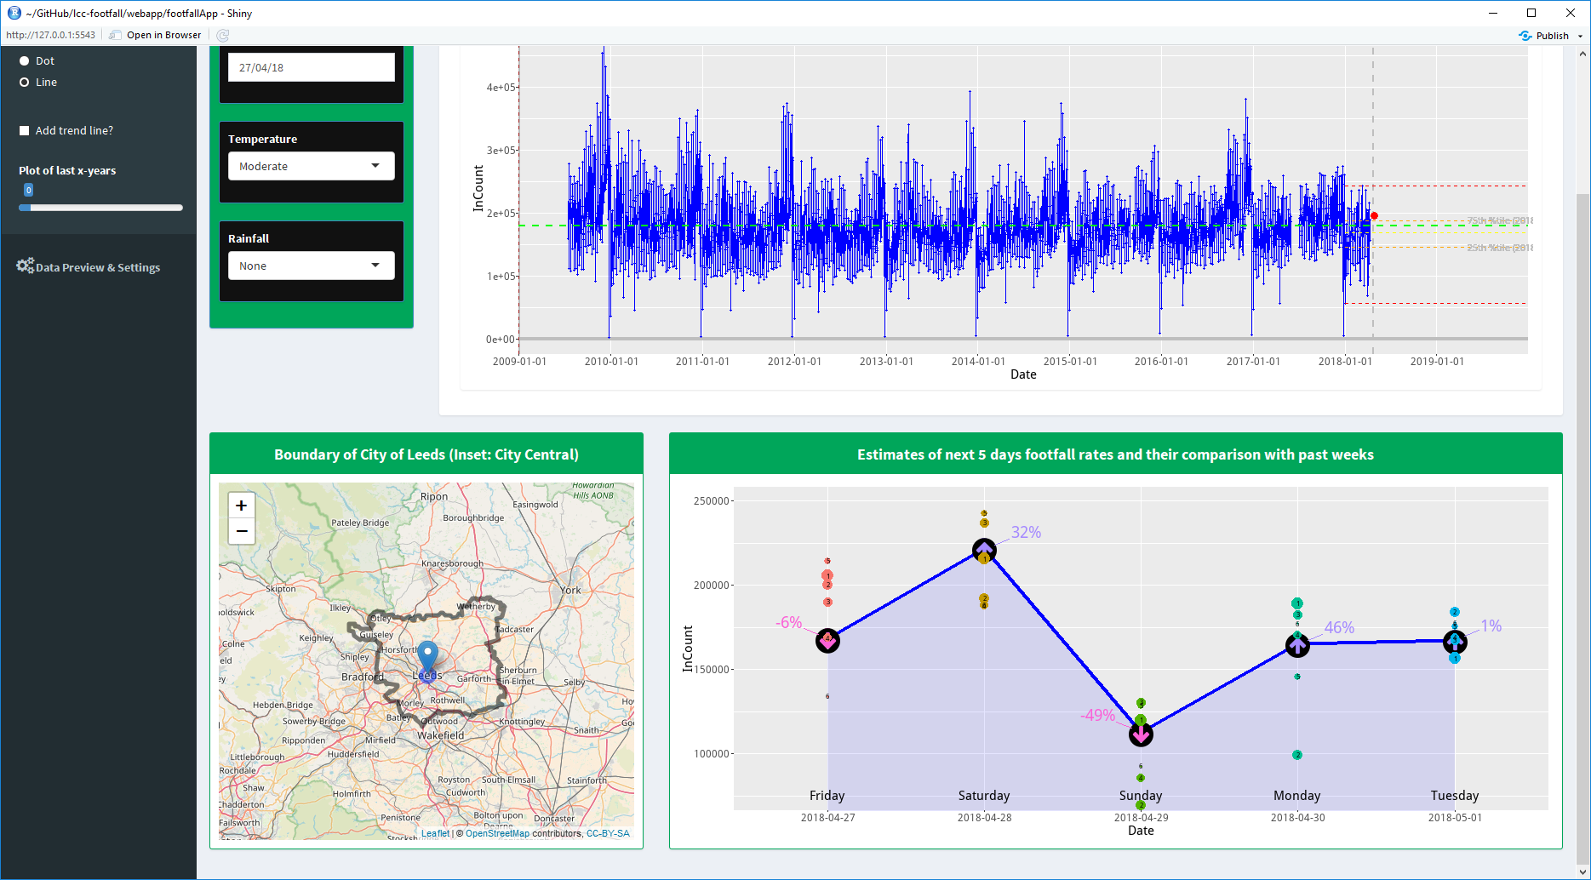

‘DATA PREVIEW AND SETTINGS’ PAGE

This menu provide the opportunity to update view the footfall dataset,

D Map – This simply shows the overlay of Leeds City boundary on an OpenStreetMap. A marker indicate a location of one of the eight camera locations with a buffer of 500m around it. The map allows the user to adjust the zoom level of the map.

E Next 5-day Footfall Forecast – Using the weather forecast provided

