Programming Documentation

main()
is still a test-driver at this point, so it is changed very often. It pretty much guides you through what it’s doing as you run it.
One thing I will say that should stay the same is that the general plan of attack will be to
First generate distribution consistent random sample spaces (in the form of vectors) for each parameter, store them according to their user-defined names in a lookup table (in the form of a map), and Then, perform the function(s)/test(s) on the sample spaces. This post-processing step will ultimately entail parsing and evaluating the user-input expression (function on the parameters).

Globals:

stats(vector<double> vect, double& mean, double& median, double& stdDev, double& lowBound,
double& highBound, double percentile = 100)
is a function for calculating a number of common statistics for a data set.
Mean, Median, Standard Deviation, Lower Bound, and High Bound are passed in as reference parameters and after the call to stats, they will have the correct values. Mean, Median, and Standard Deviation are what you would expect them to be. Lower Bound and Upper Bound are the boundaries that contain the middle “Percentile” percent of the values in Vect. If no value is input for Percentile, 100 is the default value, in which case, the absolute minimum and maximum values in Vect will be returned in LowBound and HighBound.
The vector for which the statistics are calculated is passed by value, so it will be copied. This could be costly, but I have my reasons… I did it because the vector must be sorted in order to calculate the median and the percentile bounds and the user may wish to use the original vector as a (unsorted) sample space after the stats call.

histogramize(const vector<double>& vect, int boxes, char output, const char* fylName,
double onlyMiddlePercent = 100)
is a function to divide the range of values in Vect into evenly sized contiguous intervals which also span the range of Vect. Histogramize then calculates the portion of the Vect elements which fit in each interval. “boxes” is how many intervals we divide the range into. “output” declares the desired output form (‘e’ for .csv Excel file, ‘s’ for numerical on-screen display). The char array pointed to by fylName is the name the Excel file will be saved to.
We can imagine certain circumstances where a vector will have the vast majority of its values in a contained in a relatively small interval and yet have a few extreme values very far from that dense central interval. In this case, the absolute range of the values in Vect could make it such that nearly all values fall into a single histogram interval. This would cause a large amount of information about the distribution near the mean to be hidden. For this reason, histogramize has a fifth parameter which allows the user to specify that he only wishes to histogramize the middle x% of the values in Vect and disregard the rest. The default value for onlyMiddlePercent is 100 which means all values will be represented in the histogram.

Classes:

DistTyp
is the abstract base class for all the derived actual distribution types. Each derived class’ constructor take as inputs the relevant factors to completely determine the distribution of a parameter of their particular type.

All distribution types share the common public functions “sample” and “batch.” These are the only functions the user need be aware of. Sample returns a floating point (double) number drawn pseudo-randomly from the object’s particular distribution. Batch takes a (double)vector by reference as input and fills the vector with random samples from the distribution via repeated calls to sample.

Sample works by generating a uniformly distributed pseudo-random number over the interval [0,1] and plugging that number into the inverse cumulative distribution function belonging to the object. The result is a new number somewhere in the range of the parameter. This transformation will transform uniformly distributed random variates on the interval [0,1] to new random variates conforming to the parameter’s distribution.

To generate the uniformly distributed random variate on the interval [0,1], we use a Random::Uniform object which makes use of the Mersenne Twister algorithm for pseudo-random number generation. To achieve this, DistTyp has a static class variable randNum. This is a Uniform object pointer. It defaults to point to nothing. Upon calling distTyp::seed(int) with an odd integer, a new Random::Uniform object is created (I don’t think this ever gets deleted, which might be a problem) and the Mersenne Twister is seeded with the input. From this point on, we can just call the Random::Uniform object’s next() function to get the next pseudo-random number on the interval [0,1]

uniform
is not particularly interesting. To describe a uniform distribution parameter, all we need is an upper and lower bound, so that’s what the constructor asks for. To convert a uniform random number [0,1] to a uniform random number over a different interval, we simply take the original random number, multiply it by the range of the parameter and add the result to the lower bound of the parameter. This is just a textual description of the inverse CDF (a simple y = mx + b) of a uniform distribution.

negative exponential
parameters can have their distributions described by two numbers – lower bound, and standard deviation. Again, these are the numbers the constructor takes. The inverse CDF of a negative exponential distribution is
x = lower bound – (standard deviation * ln(1 – p))

triangular
distributions are described by three numbers, the lower bound, upper bound, and mode. Triangular distributions actually have two different inverse CDFs depending on whether the input probability, p, is greater than or less than the probability of a number being less than the mode. This probability is
p_{m} = (mode – lower bound) / (upper bound – lower bound)
If p < p_{m}, the Inverse CDF is
x = lower bound + square root(x * (upper bound – lower bound)(mode – lower bound))
If p > p_{m}, the Inverse CDF is
X = upper bound – square root( x * (lower bound – upper bound)(upper bound – mode)
+ (upper bound) ²
- lower bound * (upper bound – mode)
- (upper bound * mode) )

normal
a normal curve is entirely determined by its mode and its standard deviation. Unfortunately, no clean and simple equation has been found for the inverse CDF of a normal distribution. So instead, we approximate it. We do this by approximating cumulative area under the graph of the normal curve's PDF (by summing the area of discrete rectangles whose lids have centers on the PDF curve (just as your high school math teacher illustrated approximate area under the curve)) at evenly spaced intervals. We store all these approximated CDF values and the associated rectangle locations in vectors. When it comes time to use the CDF, we search for the closest CDF value to our desired probability, p, and return that. There are some additional fields in the constructor that have to do with this approximation. "discrete_intervals" is the number of rectangles we use for the approximation. Larger numbers are more accurate, but also slower. 100,000 seems to be acceptably fast and sufficiently accurate to me. Since the normal curve has infinitely long tails, we cannot approximate its integral over its entire range. The double "stdDevRange" tells us the range over which we will approximate the integral – i.e. “stdDevRange” standard deviations above and below the median. We default to 4, because that encompasses 99.997% (<https://courseware.vt.edu/users/holtzman/STAT5605/normaltable.html>) of the area under the PDF, and that should be more than adequate for the intended purposes.

Libraries:

vector_ops
This is a library that defines some vector operations (+,-,*,/,^). Really pretty simple. Each one takes two vectors, to perform the operation on, and an answer vector to store the answers in. The i’th element of the answer vector is formed by performing the operation on the i’th elements of the two operands. It is important to note that illegal math operations do exist and we need to deal with them gracefully. What do we do when the user tries to divide by zero or take (–5) ^{0.5226}?
correlation_stuff
This is a library with methods for correlating data. There are a number of important things to note about these functions:
- They only generate bivariate or bivariate chain (not true multivariate) correlation.
- Two functions create rankCorrelation in two existent parameters, x & y, of a sample space by altering the order of y’s samples relative to x’s samples. Thus x’s samples remain in their initial order. This allows us to correlate y with x and then z with y. This gets us closer to multivariate generation, but in the above x-y-z scenario, correlation between z and x cannot be simulated. Thus, we can have correlation chains, but no loops. Furthermore (and very importantly) the values of the samples in x and y DO NOT change in a correlation – only their order changes. This is what we mean by post-generation correlation.
- No claims are made about the distribution of correlated y relative to x. In other words, if two uniform distributions are post-generation correlated, I make no claim that (x,y) pairs are normally distributed about the least squares regression line.

rank(const vector& vect, vector<int>& rankVect)
When rank returns, rankVect will be altered such that if vect_{i} is the j^{th} largest sample in vect, then rankVect_{i} = j.
rankCorrelation(const vector& a, const vector& b)
returns the Spearman’s rank correlation for the parameters a and b. The formula for rankCorrelation is
r_{rank} = 1 – 6 * (Σ (rank(a_{i}) – rank(b_{i}))² ) / (N(N² – 1))
In calculating this, we have to know the ranks of the samples in a and b, so we make to calls to “rank”. Since rank is a somewhat expensive call and some functions which call rankCorrelation may also wish to know the rankVects, there is another version of rankCorrelation with two more input by reference parameters which will be returned with the rankVects. In fact, the former version calls the latter with two temporary rankVects.
rankCorrelate(const vector<double>& x, vector<double>& y, double requestedRankCor)
This was my first attempt at post-correlating and it is more complicated and less efficient than the one that followed. Nevertheless, it has features that may be desirable in certain circumstances. The basic algorithm is:
Start with independently generated parameters from a sample space and
While rankCorrelation < requestedRankCorrelation,
Find the xRank-yRank pairing which is worst (most mismatched), and then look for the next worst xRank-yRank pairing for which rankCorrelation will be increased by the two x-y pairs swapping y-values. Then swap y-values.

To do this, we assume a sorted x, but don’t actually sort it. We then partially sort y (relative to an assumed sorted x array) by swapping y-values as above until the desired rankCorrelation (relative to an assumed sorted array) is obtained. Then we rearrange y relative to the actual (unsorted) order of x. Not sorting x spares us from having to re-randomize the order of the samples in x while maintaining links to y.
So that we don’t have to continually query for the worst pair in the sample space, we maintain a mapping, deltaMap, of lists of elements which are not in their correct sorted places (relative to a sorted array). The map is accessed by delta, the distance a y-value is above (so we can have negative numbers) its sorted location, and the list is of the indexes at which y-values with that delta are found.

A scatter-plot of x & y reveals that the result of calling rankCorrelate is a distinctly bordered region wherein all x-y pairs are found and they are relatively uniformly distributed. This does not look much like real data, but may be useful in some applications.
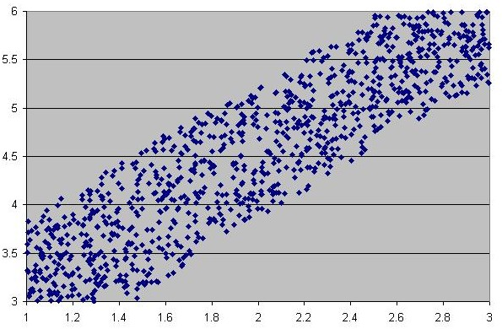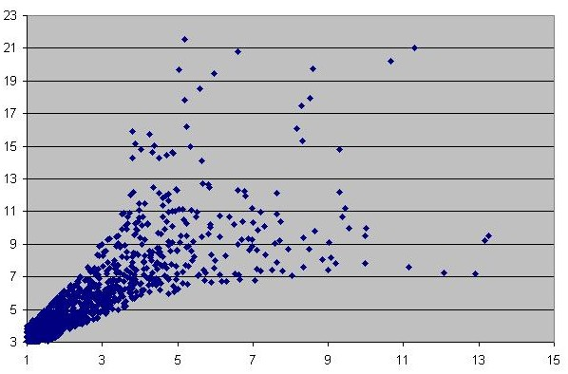
A further limitation/weird feature of this method is that whereas for rankCorrelated uniform distributions (above), where there seem to be two linear bounds that enclose the data, for non-uniform correlated distributions, the bounds may not be linear. A scatter-plot of the ranks of the samples will always maintain the linear-type bounds, but the values may not. While our other method doesn’t have the same crisp bounds with quasi-uniform distribution of points, it does have the same general spread shape. Below, we have two rankCorrelated negative exponential distributions.

decayRankCorrelate(const vector<double>& x, vector<double>& y, double
requestedRankCor)
Takes the opposite approach rankCorrelate does. Instead of starting with unsorted values and then pseudo-sorting them, decayRankCorrelate perfectly sorts y and then incrementally does things to mess up the order until rankCorrelation gets below the requestedRankCor. Specifically, we randomly pick an (implied sorted) x index trade y values with its neighbor. My initial approach was to define “neighbor” as the element one to the left or right of our random x. Repeated neighbor swapping would result in y getting progressively more and more out of order as time went on. While I still suspect that this is true, the time constants involved in such a literal definition of “neighbor” make the algorithm run very slowly for large sample spaces. I therefore change the definition of “neighbor” as the algorithm runs. NeighborDistance starts out as 1 (so the literal neighbor), but after every (2 * (sample space size)) swaps I do, I double neighborDistance. I do this until neighborDistance exceeds (sample space size / 8) at which point, I no longer increase neighborDistance. I somewhat arbitrarily chose the constants 2 and 8 and these numbers could probably be optimized. As is, they tend to perform acceptably. Here are some graphs of rankCorrelation vs y-swaps (red bars are where we doubled neighborDistance):
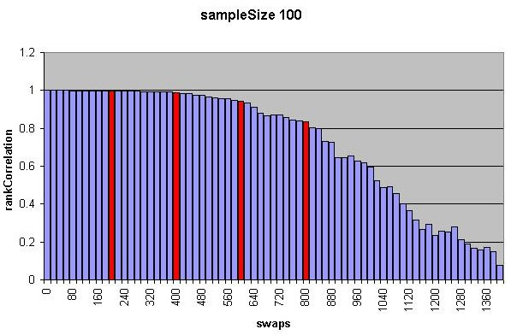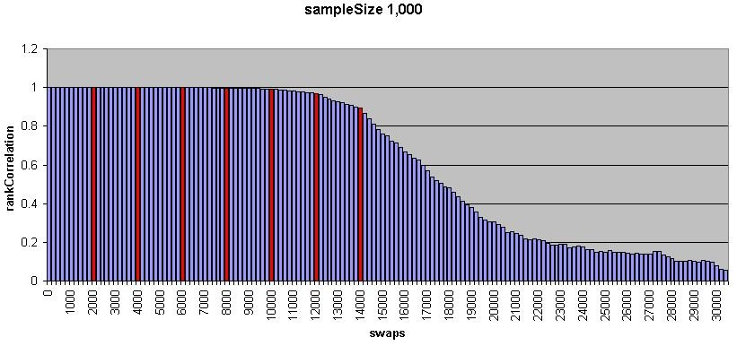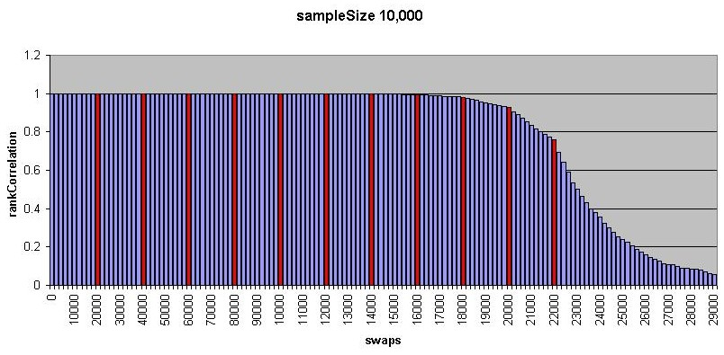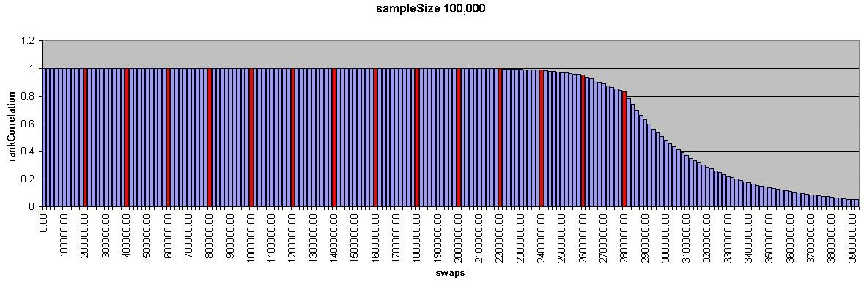
These graphs were all taken from decayRankCorrelate calls with requestedRankCorrelation 0.05 which is about as low as we should ever. Since we’re using an algorithm with stochastic elements, the worst case run-time is actually O(∞), however the chances of such a large run-time are proportionately small. The graphs and other test runs seem to suggest that there will be no more (or at least not much more) than 2((sampleSize*2)*ln(sampleSize/8)) swaps made and thus O(n*lg(n)) performance. Since we have to sort one array, this is actually not all that bad. Note, however, that the above estimate is only an estimate and that I have not yet done a rigorous analysis of time complexity.

DecayRankCorrelate’s main advantage over rankCorrelate is in the spread seen in a scatter-plot.
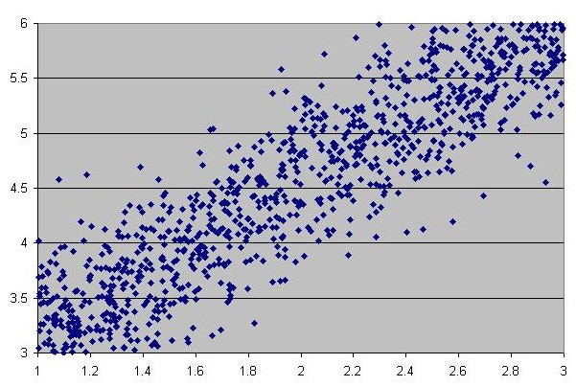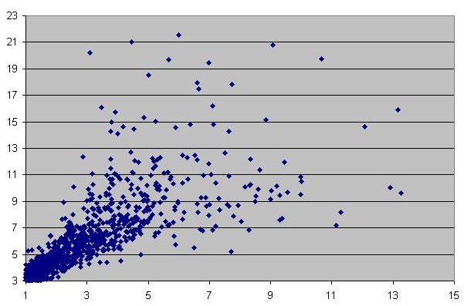
While not a true normal distribution about the least squares regression, the data at least looks more “real” in that the points aren’t uniformly distributed between clear bounding lines as with rankCorrelate. Instead, we see a few stray points, but more lying close to the middle. There is still bizarre tail behavior with non-uniform distributions (as in the negative exponential shown above) that in most cases will not be wanted.

Notes:
- In generating a random sample space from a continuous distribution, the probability of having any value more than once should be zero. This assumes infinite precision floating point numbers. We don’t have infinite precision on a computer. Even more limiting (at this point) than the inherent round-off in computer representation of floating point numbers is the fact that we’re generating random floating point numbers for different distributions via random integer numbers from a uniform distribution over the range [0, RAND_MAX]. It is easy to see that as our sample space size approaches RAND_MAX, we will become more and more likely to have repeat elements. Once we exceed RAND_MAX, we are guaranteed to have repeats. This may or may not be a problem, but the user should be aware of this limitation. (Note, I have just switched from using c++ rand() to the mersenne twister. This may have ameliorated the problem.
- Currently .csv files may be overwritten each time uncertainty estimator is run.
- Currently, a raw.csv file containing the raw numbers is created only if the sample space is <= 50,000
- Visual C++ weirdness: the keyword “export” is not recognized in Visual C++. This makes our template definitions non-standard because Visual C++ (presumably) automatically exports them. If not using Visual C++, the keyword “export” will have to be added in front of all template definitions.
- rankDeltaSquared has a problem in that it gets to be very large for large vectors. I am going to try using a double instead of an int for its type. I will likely have to do something similar inside rankCorrelate because it also deals with a rankDeltaSquared-like number. Namely, the double “c” is equal to roughly 6/(size cubed) which has a very large denominator for large vector sizes. The double fix made things better, but we still must be able to do better. We can deal with vectors up to size 46,000 but 46,500 makes it wig-out. It can no longer calculate rankCorrelation accurately.

