5th assignment Neo4j Graph Databases (Neo4j)

Team Members:

Αρτόπουλος Γεώργιος (8200016)

Θεόδωρος Μαλικούρτης (8200097)

1 ) Show a small portion of your graph database (screenshot)

MATCH (n) RETURN n LIMIT 25

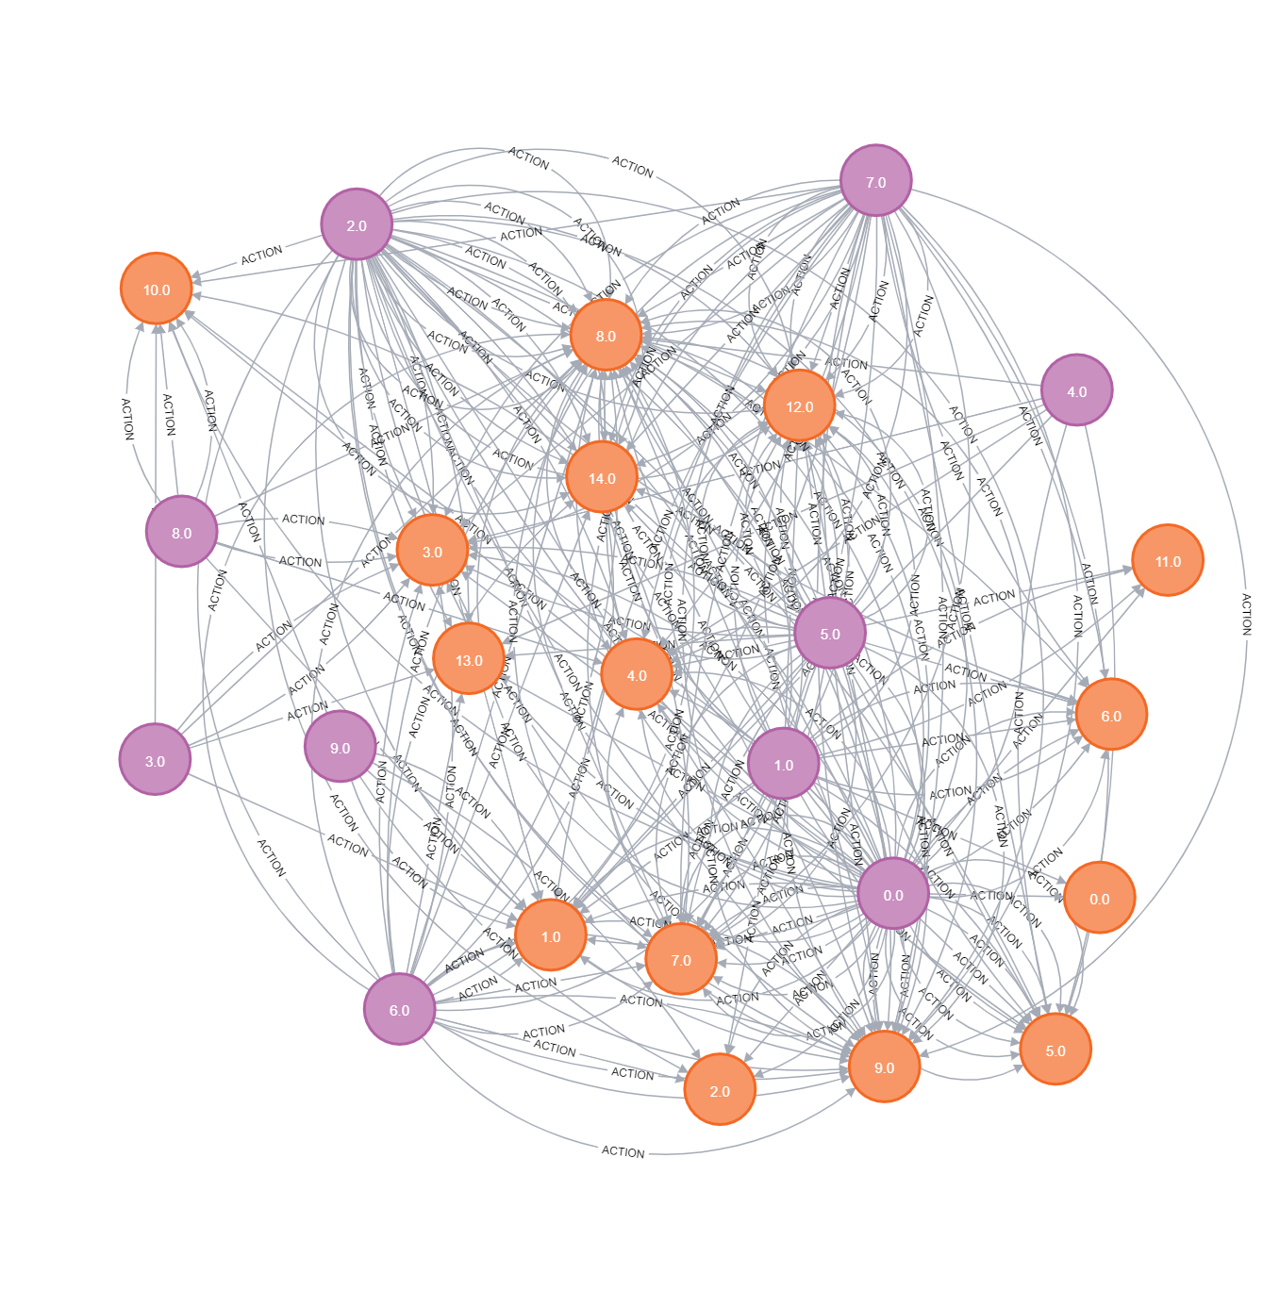

2) Count all users, count all targets, count all actions

MATCH(u:User) RETURN COUNT (u)

MATCH(t:Target) return count (t)

MATCH (u:User)-[a:ACTION]->(t:Target) RETURN COUNT(a)

3) Show all actions (actionID) and targets (targetID) of a specific user (choose one)

 MATCH (u:User {user_id: 3})-[a:ACTION]->(t:Target) RETURN a.action_id, t.target_id

4) For each user, count his/her actions

MATCH (u:User)-[a:ACTION]->(t:Target) RETURN u.user_id, COUNT (a)

5) For each target, count how many users have done this target

MATCH (u:User)-[a:ACTION]->(t:Target) RETURN t.target_id, COUNT(DISTINCT u)

6) Count the average actions per user

MATCH (u:User)-[a:ACTION]->(t:Target)

WITH COUNT(a) AS totalActions, COUNT (DISTINCT u) AS totalUsers

RETURN totalActions / totalUsers AS averageActionsPerUser

7) Show the userID and the targetID, if the action has positive Feature2

MATCH (u:User)-[a:ACTION]->(t:Target) WHERE a.action_feature2 > 0 RETURN u.user_id, t.target_id

8)For each targetID, count the actions with label “1”

MATCH (u:User)-[a:ACTION{action_label:1}]->

(t:Target) return t.target_id, count(a) order by t.target_id

