SQL Injection

1. Clone the repository and start from the “sqlinjection-before” branch  
   git clone <https://github.com/geobarteam/toh.git>

cd toh

git checkout sqlinjection-before

1. Setup your local SqlExpress Database

Open SqlManagement Studio, Right-Click on the Databases node, New Databases, TourOfHeroes

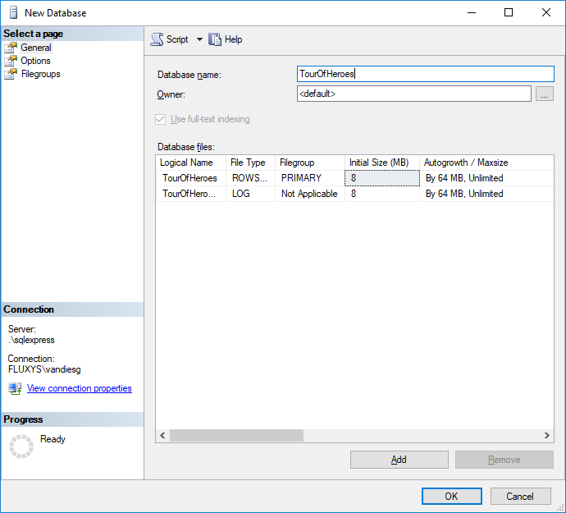

Open de query: \toh\toh-db\CreateTables.sql and execute it on your TourOfHeroes DB.

1. Launch the bakend & frontend

toh\toh-webapi> dotnet run

toh\toh-client> npm install

toh\toh-client> npm start