Problem 1:

Part a:

9.739e+07 2.8217e+07 -1.8626e-09 2.5466e-11 -4.0359e-12 -1.3642e-12

2.8217e+07 9.739e+07 -1.8626e-09 -4.0359e-12 -1.5461e-11 -1.3642e-12

-1.8626e-09 -1.8626e-09 3.4586e+07 -1.3642e-12 -1.3642e-12 -3.8654e-12

2.5466e-11 -4.0359e-12 -1.3642e-12 34.273 5.0843 2.0935

-4.0359e-12 -1.5461e-11 -1.3642e-12 5.0843 9.1513 2.0935

-1.3642e-12 -1.3642e-12 -3.8654e-12 2.0935 2.0935 6.443

Part b:

1.1209e-08 -3.2476e-09 4.2876e-25 -9.509e-21 3.9398e-21 3.4953e-21

-3.2476e-09 1.1209e-08 4.2876e-25 1.3724e-21 1.7781e-20 -4.5377e-21

4.2876e-25 4.2876e-25 2.8913e-08 4.8029e-23 3.447e-22 1.7218e-20

-9.509e-21 1.3724e-21 4.8029e-23 0.031946 -0.016608 -0.0049835

3.9398e-21 1.7781e-20 3.447e-22 -0.016608 0.12668 -0.035766

3.4953e-21 -4.5377e-21 1.7218e-20 -0.0049835 -0.035766 0.16845

Part c:

Ex = 5.57591e+10, Ey = 5.57591e+10, Gxy = 2.16165e+10, vxy = 0.289736, etax,xy = 3.82512e-17

Problem 2:

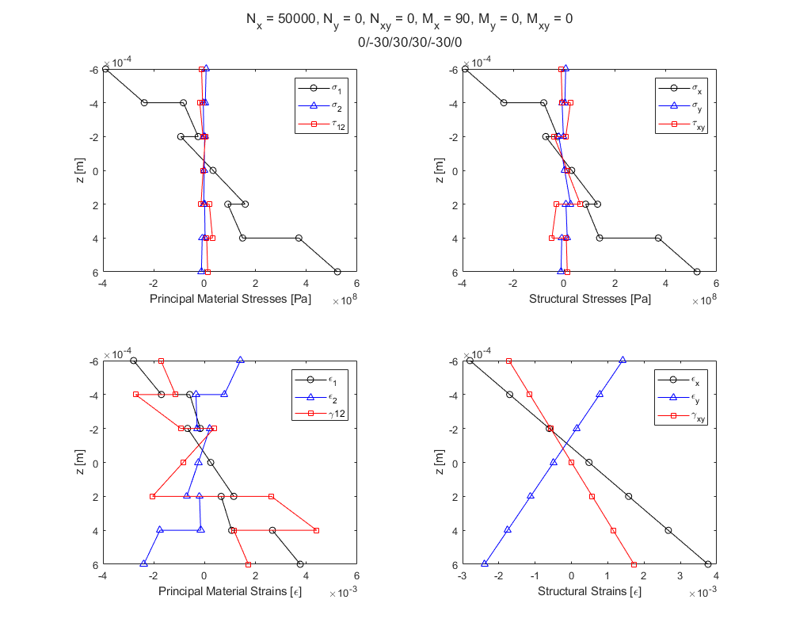

Problem 3:

Maximum Stress Theory FoS = 1.0304 Lamina Does Not Fail

Maximum Strain Theory FoS = 1.06227 Lamina Does Not Fail

Tsai-Hill FoS = 0.994632 Lamina Fails

Tsai-Wu FoS = 0.997101 Lamina Fails

Problem 4:

Part a:

Nx = 60400, Ny = 2400, Nxy = 0, Mx = 12.08, My = 0.48, Mxy = 0

Part b:

εx0 = 0.00100021

Problem 5:

Lamina longitudinal tensile failure strength, SL+ = 1680 MPa

Lamina longitudinal tensile strain to failure is equal to tensile fiber strain to failure, ef = 0.015

Code:

Main:

%% Exam 2

clc;clear;close all;

%% Problem 1

laminate = [140e9,10e9,7e9,0.3,0.0002,0,0,0,0,0,0;...

140e9,10e9,7e9,0.3,0.0002,45,0,0,0,0,0;...

140e9,10e9,7e9,0.3,0.0002,-45,0,0,0,0,0;...

140e9,10e9,7e9,0.3,0.0002,90,0,0,0,0,0;...

140e9,10e9,7e9,0.3,0.0002,90,0,0,0,0,0;...

140e9,10e9,7e9,0.3,0.0002,-45,0,0,0,0,0;...

140e9,10e9,7e9,0.3,0.0002,45,0,0,0,0,0;...

140e9,10e9,7e9,0.3,0.0002,0,0,0,0,0,0];

ABDmatrix = laminateStiffnessMatrix(laminate);

ABDmatrixINV = laminateStiffnessMatrixINV(laminate);

[Ex,Ey,~,~,Gxy,vxy,~,etax_xy,~]=laminateEngineeringConstants(laminate);

fprintf(2,'Problem 1: \n\n')

fprintf('Part a: \n')

disp(array2table(ABDmatrix));

fprintf('\n')

fprintf('Part b: \n')

disp(array2table(ABDmatrixINV));

fprintf('Part c: \n')

fprintf('Ex = %g, Ey = %g, Gxy = %g, vxy = %g, etax,xy = %g\n\n',Ex,Ey,Gxy,vxy,etax_xy)

%% Problem 2

clear;

laminate = [140e9,10e9,7e9,0.3,0.0002,0,0,0,0,0,0;...

140e9,10e9,7e9,0.3,0.0002,-30,0,0,0,0,0;...

140e9,10e9,7e9,0.3,0.0002,30,0,0,0,0,0;...

140e9,10e9,7e9,0.3,0.0002,30,0,0,0,0,0;...

140e9,10e9,7e9,0.3,0.0002,-30,0,0,0,0,0;...

140e9,10e9,7e9,0.3,0.0002,0,0,0,0,0,0];

Nx=50000;

Ny=0;

Nxy=0;

Mx=90;

My=0;

Mxy=0;

forces2StressStrainLaminate(laminate,Nx,Ny,Nxy,Mx,My,Mxy);

fprintf(2,'Problem 2: \n\n')

%% Problem 3

clear;

laminate = [140e9,10e9,7e9,0.3,0.0002,30,1448e6,1172e6,48.3e6,248e6,62.1e6];

Nx=15000;

Ny=7500;

Nxy=0;

Mx=0;

My=0;

Mxy=0;

FS1=maximumStressTheory(laminate,Nx,Ny,Nxy,Mx,My,Mxy);

FS2 = maximumStrainTheory(laminate,Nx,Ny,Nxy,Mx,My,Mxy);

FS3=tsaiHillFailure(laminate,Nx,Ny,Nxy,Mx,My,Mxy);

FS4=tsaiWuFailure(laminate,Nx,Ny,Nxy,Mx,My,Mxy);

fprintf(2,'\nProblem 3: \n\n')

fprintf('Maximum Stress Theory FoS = %g Lamina Does Not Fail\n',FS1)

fprintf('Maximum Strain Theory FoS = %g Lamina Does Not Fail\n',FS2)

fprintf('Tsai-Hill FoS = %g Lamina Fails\n',FS3)

fprintf('Tsai-Wu FoS = %g Lamina Fails\n',FS4)

%% Problem 4

clear;

laminate = [140e9,10e9,7e9,0.3,0.0002,0,0,0,0,0,0;...

140e9,10e9,7e9,0.3,0.0002,90,0,0,0,0,0;...

140e9,10e9,7e9,0.3,0.0002,90,0,0,0,0,0;...

140e9,10e9,7e9,0.3,0.0002,0,0,0,0,0,0];

sigmax=[140.9e6,140.9e6,10.1e6,10.1e6,10.1e6,10.1e6,140.9e6,140.9e6];

sigmay=[3e6,3e6,3e6,3e6,3e6,3e6,3e6,3e6];

tauxy=[0,0,0,0,0,0,0,0];

[Nx,Ny,Nxy,Mx,My,Mxy] = structuralStress2ForceResultants(laminate,sigmax,sigmay,tauxy);

[epsx0,~,~,~,~,~] = midPlaneStrainsCurvature(Nx,Ny,Nxy,Mx,My,Mxy,laminate);

fprintf(2,'\nProblem 4: \n\n')

fprintf('Part a: \n')

fprintf('Nx = %g, Ny = %g, Nxy = %g, Mx = %g, My = %g, Mxy = %g\n',Nx,Ny,Nxy,Mx,My,Mxy)

fprintf('\n')

fprintf('Part b: \n')

fprintf('\x03b5x0 = %g\n',epsx0)

%% Problem 5

clear;

vf=0.7;

Sf=2400e6;

Sm=170e6;

ef=0.015;

em=0.035;

SL=Sf*vf;

fprintf(2,'\nProblem 5: \n\n')

fprintf('Lamina longitudinal tensile failure strength, SL+ = %g MPa\n',SL/10^6)

fprintf('Lamina longitudinal tensile strain to failure is equal to tensile fiber strain to failure, ef = %g \n',ef)

Functions:

function [ABDmatrix,distances,Qbars,Sbars] = laminateStiffnessMatrix(laminate)

[E1s,E2s,G12s,v12s,thicknesses,thetas] = laminateReader(laminate);

A=zeros(3);

B=zeros(3);

D=zeros(3);

N=length(thicknesses);

thickness=sum(thicknesses);

distances=zeros(1,length(thicknesses)+1);

distances(1)=-thickness/2;

distances(end)=thickness/2;

for i=2:N

distances(i)=distances(i-1)+thicknesses(i-1);

end

Qbars{1}=[];

Sbars{1}=[];

for k=1:N

Qbar = transReducedStiffnessMatrix(E1s(k),E2s(k),G12s(k),v12s(k),thetas(k));

Qbars{k}=Qbar;

end

for i=1:3

for j=1:3

for k=1:N

A(i,j)=A(i,j)+(Qbars{k}(i,j)*(distances(k+1)-distances(k)));

B(i,j)=B(i,j)+(Qbars{k}(i,j)*(1/2)*(distances(k+1)^2-distances(k)^2));

D(i,j)=D(i,j)+(Qbars{k}(i,j)*(1/3)*(distances(k+1)^3-distances(k)^3));

end

end

end

ABDmatrix=[A,B;B,D];

end

function [ABDmatrixINV,distances,Qbars,Sbars] = laminateStiffnessMatrixINV(laminate)

[ABDmatrix,distances,Qbars,Sbars] = laminateStiffnessMatrix(laminate);

ABDmatrixINV=ABDmatrix^-1;

end

function [Ex,Ey,Efx,Efy,Gxy,vxy,vyx,etax_xy,etaxy_y]=laminateEngineeringConstants(laminate)

[~,~,~,~,thicknesses,~] = laminateReader(laminate);

t=sum(thicknesses);

ABDmatrixINV = laminateStiffnessMatrixINV(laminate);

Ex=1/(t*ABDmatrixINV(1,1));

Ey=1/(t*ABDmatrixINV(2,2));

Efx=12/(t^3*ABDmatrixINV(4,4));

Efy=12/(t^3*ABDmatrixINV(5,5));

Gxy=1/(t*ABDmatrixINV(3,3));

vxy=-ABDmatrixINV(1,2)/ABDmatrixINV(1,1);%nu xy

vyx=-ABDmatrixINV(1,2)/ABDmatrixINV(2,2);%nu yx

etax_xy=ABDmatrixINV(1,3)/ABDmatrixINV(1,1);

etaxy_y=ABDmatrixINV(2,3)/ABDmatrixINV(3,3);

end

function [sigmax,sigmay,tauxy,sigma1,sigma2,tau12,epsx,epsy,gammaxy,eps1,eps2,gamma12]=forces2StressStrainLaminate(laminate,Nx,Ny,Nxy,Mx,My,Mxy)

[E1s,E2s,G12s,v12s,thicknesses,thetas] = laminateReader(laminate);

[epsx0,epsy0,gammaxy0,kx,ky,kxy] = midPlaneStrainsCurvature(Nx,Ny,Nxy,Mx,My,Mxy,laminate);

[epsx,epsy,gammaxy] = strainLaminateStructural(epsx0,epsy0,gammaxy0,kx,ky,kxy,thicknesses);

[eps1,eps2,gamma12] = strainLaminatePrincipal(epsx,epsy,gammaxy,thetas);

[sigmax,sigmay,tauxy]=strain2stressStructural(epsx,epsy,gammaxy,thetas,E1s,E2s,G12s,v12s);

[sigma1,sigma2,tau12]=stressLaminatePrincipal(sigmax,sigmay,tauxy,thetas);

distances=laminateDistances(thicknesses);

figure

plots = tiledlayout(2,2);

nexttile

plot(sigma1,distances,'k-o',sigma2,distances,'b-^',tau12,distances,'r-square')

xlabel('Principal Material Stresses [Pa]')

ylabel('z [m]')

legend('\sigma_{1}','\sigma_{2}','\tau_{12}')

set(gca, 'YDir','reverse')

nexttile

plot(sigmax,distances,'k-o',sigmay,distances,'b-^',tauxy,distances,'r-square')

xlabel('Structural Stresses [Pa]')

ylabel('z [m]')

legend('\sigma_{x}','\sigma_{y}','\tau_{xy}')

set(gca, 'YDir','reverse')

nexttile

plot(eps1,distances,'k-o',eps2,distances,'b-^',gamma12,distances,'r-square')

xlabel('Principal Material Strains [\epsilon]')

ylabel('z [m]')

legend('\epsilon_{1}','\epsilon_{2}','\gamma{12}')

set(gca, 'YDir','reverse')

nexttile

plot(epsx,distances,'k-o',epsy,distances,'b-^',gammaxy,distances,'r-square')

xlabel('Structural Strains [\epsilon]')

ylabel('z [m]')

legend('\epsilon_{x}','\epsilon_{y}','\gamma_{xy}')

set(gca, 'YDir','reverse')

set(gcf,'position',[90,90,1000,800])

titleLine1=['N_{x} = ',num2str(Nx),', N_{y} = ',num2str(Ny),', N_{xy} = ',num2str(Nxy),', M_{x} = ',num2str(Mx),', M_{y} = ',num2str(My),', M_{xy} = ',num2str(Mxy)];

titleLine2=num2str(thetas(1));

for i=2:length(thetas)

titleLine2=[titleLine2,'/',num2str(thetas(i))];

end

title(plots,{titleLine1,titleLine2})

end

function [FS]=maximumStressTheory(laminate,Nx,Ny,Nxy,Mx,My,Mxy)

[~,~,~,~,~,~,longStrengthTen,longStrengthCom,tranStrengthTen,tranStrengthCom,strengthLT] = laminateReader(laminate);

[~,~,~,sigma1,sigma2,tau12,~,~,~,~,~,~]=forces2StressStrainLaminateNoPlot(laminate,Nx,Ny,Nxy,Mx,My,Mxy);

FS=zeros(length(sigma1),1);

FSsigma1=zeros(length(sigma1),1);

FSsigma2=zeros(length(sigma1),1);

FStau12=zeros(length(sigma1),1);

for i=2:2:length(sigma1)

if sigma1(i)>0

FSsigma1(i)=longStrengthTen(i/2)/sigma1(i);

else

FSsigma1(i)=-longStrengthCom(i/2)/sigma1(i);

end

if sigma1(i-1)>0

FSsigma1(i-1)=longStrengthTen(i/2)/sigma1(i-1);

else

FSsigma1(i-1)=-longStrengthTen(i/2)/sigma1(i-1);

end

if sigma2(i)>0

FSsigma2(i)=tranStrengthTen(i/2)/sigma2(i);

else

FSsigma2(i)=-tranStrengthCom(i/2)/sigma2(i);

end

if sigma2(i-1)>0

FSsigma2(i-1)=tranStrengthTen(i/2)/sigma2(i-1);

else

FSsigma2(i-1)=-tranStrengthTen(i/2)/sigma2(i-1);

end

FStau12(i)=strengthLT(i/2)/abs(tau12(i));

FStau12(i-1)=strengthLT(i/2)/abs(tau12(i-1));

FS(i)=min([FSsigma1(i),FSsigma2(i),FStau12(i)]);

FS(i-1)=min([FSsigma1(i-1),FSsigma2(i-1),FStau12(i-1)]);

end

FS=min(FS);

end

function [FS]=maximumStrainTheory(laminate,Nx,Ny,Nxy,Mx,My,Mxy)

[E1s,E2s,~,v12s,~,~,longStrengthTen,longStrengthCom,tranStrengthTen,tranStrengthCom,strengthLT] = laminateReader(laminate);

[~,~,~,sigma1,sigma2,tau12,~,~,~,~,~,~]=forces2StressStrainLaminateNoPlot(laminate,Nx,Ny,Nxy,Mx,My,Mxy);

FS=zeros(length(longStrengthTen),1);

FSeps1=zeros(length(longStrengthTen),1);

FSeps2=zeros(length(longStrengthTen),1);

FSgamma12=zeros(length(longStrengthTen),1);

for i=2:2:length(sigma1)

if sigma1(i)>0

FSeps1(i)=longStrengthTen(i/2)/(sigma1(i)-v12s(i/2)*sigma2(i));

else

FSeps1(i)=-longStrengthCom(i/2)/(sigma1(i)-v12s(i/2)*sigma2(i));

end

if sigma1(i-1)>0

FSeps1(i-1)=longStrengthTen(i/2)/(sigma1(i-1)-v12s(i/2)*sigma2(i-1));

else

FSeps1(i-1)=-longStrengthCom(i/2)/(sigma1(i-1)-v12s(i/2)*sigma2(i-1));

end

v21=(v12s(i/2)/E1s(i/2))*E2s(i/2);

if sigma2(i)>0

FSeps2(i)=tranStrengthTen(i/2)/(sigma2(i)-v21*sigma1(i));

else

FSeps2(i)=-tranStrengthCom(i/2)/(sigma2(i)-v21*sigma1(i));

end

if sigma2(i-1)>0

FSeps2(i-1)=tranStrengthTen(i/2)/(sigma2(i-1)-v21*sigma1(i-1));

else

FSeps2(i-1)=-tranStrengthCom(i/2)/(sigma2(i-1)-v21*sigma1(i-1));

end

FSgamma12(i)=strengthLT(i/2)/abs(tau12(i));

FSgamma12(i-1)=strengthLT(i/2)/abs(tau12(i-1));

FS(i)=min([FSeps1(i),FSeps2(i),FSgamma12(i)]);

FS(i-1)=min([FSeps1(i-1),FSeps2(i-1),FSgamma12(i-1)]);

end

FS=min(FS);

end

function [FS]=tsaiHillFailure(laminate,Nx,Ny,Nxy,Mx,My,Mxy)

[~,~,~,~,~,~,longStrengthTen,longStrengthCom,tranStrengthTen,tranStrengthCom,strengthLT] = laminateReader(laminate);

[~,~,~,sigma1,sigma2,tau12,~,~,~,~,~,~]=forces2StressStrainLaminateNoPlot(laminate,Nx,Ny,Nxy,Mx,My,Mxy);

FS=zeros(length(longStrengthTen),1);

for i=2:2:length(sigma1)

if sigma1(i)>0

longStrength=longStrengthTen(i/2);

else

longStrength=longStrengthCom(i/2);

end

if sigma1(i-1)>0

longStrength2=longStrengthTen(i/2);

else

longStrength2=longStrengthCom(i/2);

end

if sigma2(i)>0

transStrength=tranStrengthTen(i/2);

else

transStrength=tranStrengthCom(i/2);

end

if sigma2(i-1)>0

transStrength2=tranStrengthTen(i/2);

else

transStrength2=tranStrengthCom(i/2);

end

A=((sigma1(i)/longStrength)^2)+((sigma2(i)/transStrength)^2)-((sigma1(i)*sigma2(i))/(longStrength)^2)+(tau12(i)/strengthLT)^2;

FS(i)=1/sqrt(A);

A2=(sigma1(i-1)/longStrength2)^2+(sigma2(i-1)/transStrength2)^2-((sigma1(i-1)*sigma2(i-1))/(longStrength2)^2)+(tau12(i-1)/strengthLT)^2;

FS(i-1)=1/sqrt(A2);

end

FS=min(FS);

end

function [FS]=tsaiWuFailure(laminate,Nx,Ny,Nxy,Mx,My,Mxy)

[~,~,~,~,~,~,longStrengthTen,longStrengthCom,tranStrengthTen,tranStrengthCom,strengthLT] = laminateReader(laminate);

[~,~,~,sigma1,sigma2,tau12,~,~,~,~,~,~]=forces2StressStrainLaminateNoPlot(laminate,Nx,Ny,Nxy,Mx,My,Mxy);

FS=zeros(length(longStrengthTen),1);

F11=1/(longStrengthTen*longStrengthCom);

F22=1/(tranStrengthTen*tranStrengthCom);

F66=1/strengthLT^2;

F12=-sqrt(F11*F22)/2;

F1=(1/longStrengthTen)-(1/longStrengthCom);

F2=(1/tranStrengthTen)-(1/tranStrengthCom);

for i=1:length(sigma1)

C1=(F11*sigma1(i)^2+F22*sigma2(i)^2+F66*tau12(i)^2+2*F12*sigma1(i)*sigma2(i));

C2=F1*sigma1(i)+F2*sigma2(i);

C3=-1;

C=[C1,C2,C3];

sol=roots(C);

FS(i)=sol(sol>=0);

end

FS=min(FS);

end

function [Nx,Ny,Nxy,Mx,My,Mxy] = structuralStress2ForceResultants(laminate,sigmax,sigmay,tauxy)

[~,~,~,~,thicknesses,~] = laminateReader(laminate);

Nx=0;

Ny=0;

Nxy=0;

Mx=0;

My=0;

Mxy=0;

for i=2:2:length(sigmax)

Nx=Nx+(((sigmax(i)+sigmax(i-1))/2)*thicknesses(i/2));

Ny=Ny+(((sigmay(i)+sigmay(i-1))/2)*thicknesses(i/2));

Nxy=Nxy+(((tauxy(i)+tauxy(i-1))/2)*thicknesses(i/2));

Mx=Mx+(((sigmax(i)+sigmax(i-1))/2)*thicknesses(i/2)^2);

My=My+(((sigmay(i)+sigmay(i-1))/2)*thicknesses(i/2)^2);

Mxy=Mxy+(((tauxy(i)+tauxy(i-1))/2)*thicknesses(i/2)^2);

end

end

function [epsx0,epsy0,gammaxy0,kx,ky,kxy] = midPlaneStrainsCurvature(Nx,Ny,Nxy,Mx,My,Mxy,laminate)

ABDmatrixINV = laminateStiffnessMatrixINV(laminate);

epsk=ABDmatrixINV*[Nx;Ny;Nxy;Mx;My;Mxy];

epsx0=epsk(1);

epsy0=epsk(2);

gammaxy0=epsk(3);

kx=epsk(4);

ky=epsk(5);

kxy=epsk(6);

end