Problem 1:

1. A/V for 1 cm diameter and 1 cm length: 600 m-1

Problem 2:

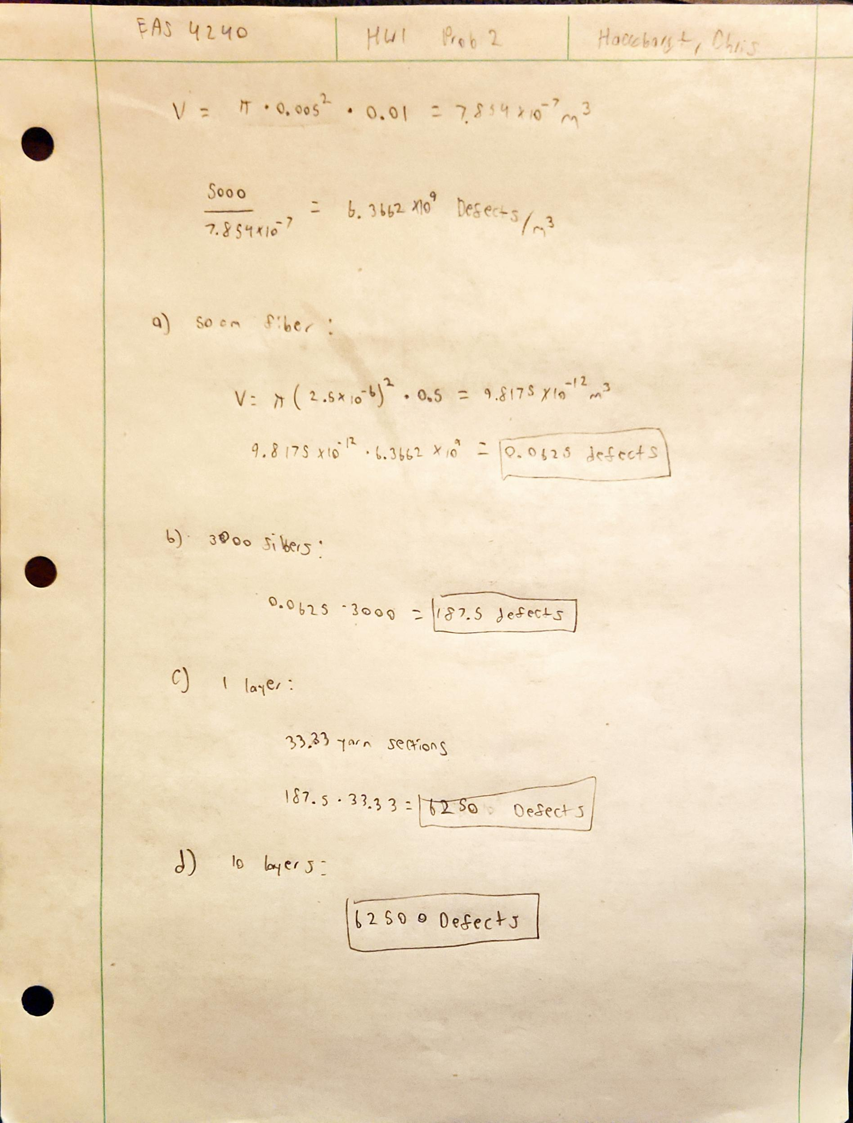

Problem 3:

Sidewalk: concrete

Pavement: asphalt

RC Plane: carbon fiber

Houses: plywood

Code for problem 1:

clc;clear;

length1=0.01;

dia1=0.01;

volume=(pi\*(dia1/2)^2)\*length1;

SA1=(pi\*dia1\*length1)+(2\*pi\*(dia1/2)^2);

SAVratio=SA1/volume;

diameters=logspace(-9,0);

ARs=[];

SAVratios=[];

for i=1:length(diameters)

len=volume/(pi\*(diameters(i)/2)^2);

ARs(i)=len/diameters(1);

SA=(pi\*diameters(1)\*len)+(2\*pi\*(diameters(1)/2)^2);

SAVratios(i)=SA/volume;

end

semilogx(ARs,SAVratios)

xlabel('Aspect Ratio (L/D)')

ylabel('Surface Area to Volume Ratio (SA/V)')