Problem 1:

Theta = 0

Sbar =

1.0e-09 \*

0.0021 -0.0007 0

-0.0007 0.1613 0

0 0 0.1792

Theta = 15

Sbar =

1.0e-09 \*

0.0137 -0.0016 -0.0429

-0.0016 0.1515 -0.0367

-0.0429 -0.0367 0.1756

Theta = 45

Sbar =

1.0e-09 \*

0.0853 -0.0043 -0.0796

-0.0043 0.0853 -0.0796

-0.0796 -0.0796 0.1647

Theta = 90

Sbar =

1.0e-09 \*

0.1613 -0.0007 0

-0.0007 0.0021 0

0 0 0.1792

Problem 2:

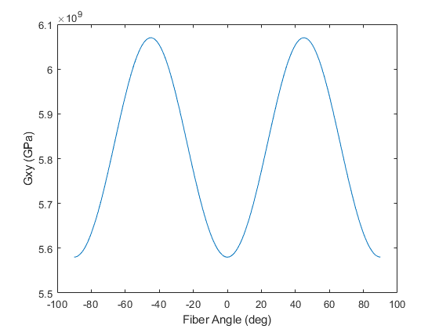

Problem 3:

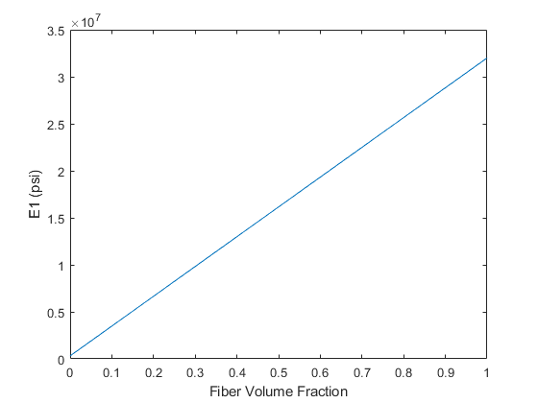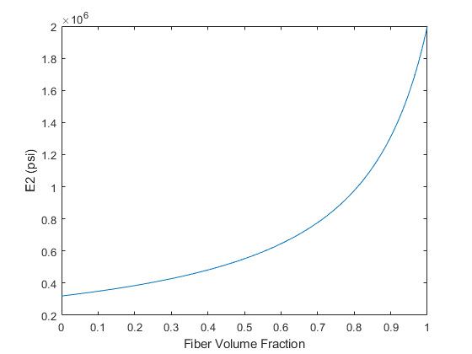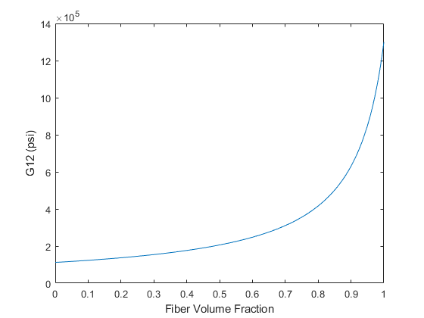

Code:

function Sbar = transReducedComplianceMatrix(E1,E2,G12,v12,theta)

Qbar = transReducedStiffnessMatrix(E1,E2,G12,v12,theta);

Sbar = Qbar^-1;

end

Main Script:

clc;clear;

%Problem 1

%p-100/ERL 1962

E1=468.9e9;

E2=6.2e9;

G12=5.58e9;

v12=0.31;

theta = [0 15 45 90];

for i=1:length(theta)

fprintf('Theta = %g',theta(i))

Sbar = transReducedComplianceMatrix(E1,E2,G12,v12,theta(i));

display(Sbar)

end

%Problem 2

thetas=-90:90;

Ex=E1./(cosd(thetas).^4+(((E1/G12)-(2\*v12)).\*sind(thetas).^2.\*cosd(thetas).^2)+(E1.\*sind(thetas).^4/E2));

Gxy=G12./(sind(thetas).^4+cosd(thetas).^4+2\*((2\*G12/E1)\*(1+2\*v12)+(2\*G12/E2)-1).\*sind(thetas).^2.\*cosd(thetas).^2);

vxy=(v12.\*(sind(thetas).^4+cosd(thetas).^4)-(1+(E1/E2)-(E1/G12)).\*sind(thetas).^2.\*cosd(thetas).^2)./(cosd(thetas).^4+(((E1/G12)-(2\*v12)).\*sind(thetas).^2.\*cosd(thetas).^2)+(E1.\*sind(thetas).^4/E2));

figure

plot(thetas,Ex)

xlabel('Fiber Angle (deg)')

ylabel('Ex (GPa)')

figure

plot(thetas,Gxy)

xlabel('Fiber Angle (deg)')

ylabel('Gxy (GPa)')

figure

plot(thetas,vxy)

xlabel('Fiber Angle (deg)')

ylabel('vxy')

%Problem 3

vf=0:0.001:1;

E1f=32e6;

E2f=2E6;

G12f=1.3e6;

Em=0.32e6;

vm=0.43;

Gm=Em/(2\*(1+vm));

E1=E1f\*vf+Em\*(1-vf);

E2=((vf./E2f)+((1-vf)./Em)).^-1;

G12=((vf./G12f)+((1-vf)./Gm)).^-1;

figure

plot(vf,E1)

xlabel('Fiber Volume Fraction')

ylabel('E1 (psi)')

figure

plot(vf,E2)

xlabel('Fiber Volume Fraction')

ylabel('E2 (psi)')

figure

plot(vf,G12)

xlabel('Fiber Volume Fraction')

ylabel('G12 (psi)')