Part A:

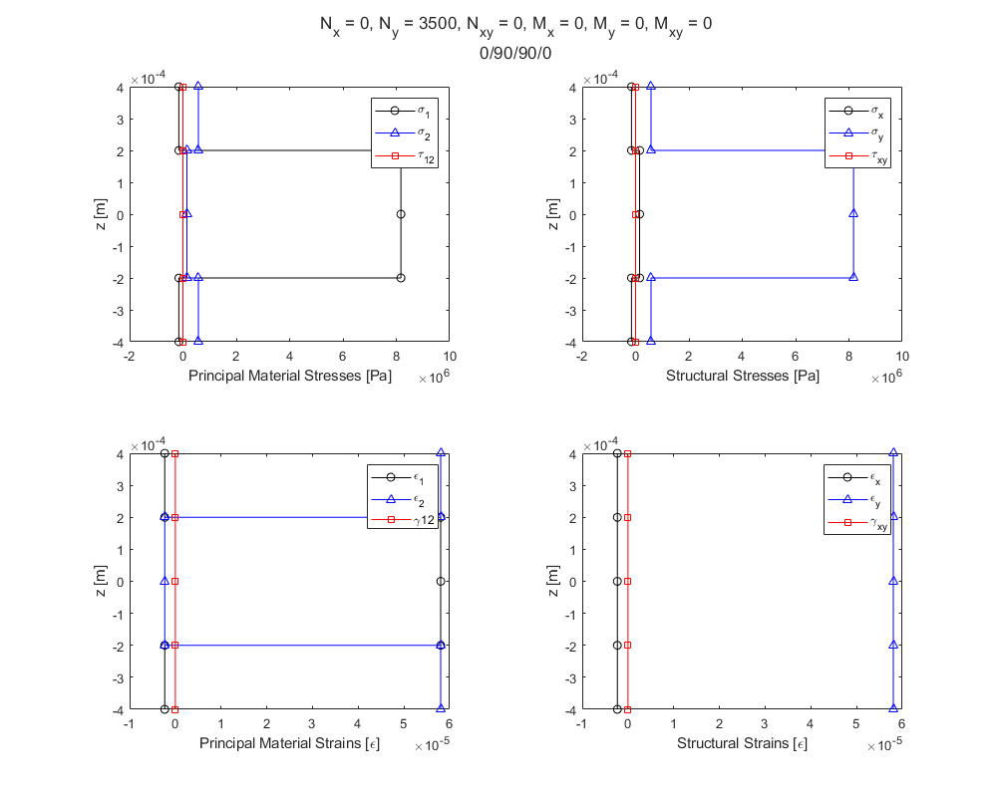

Part B: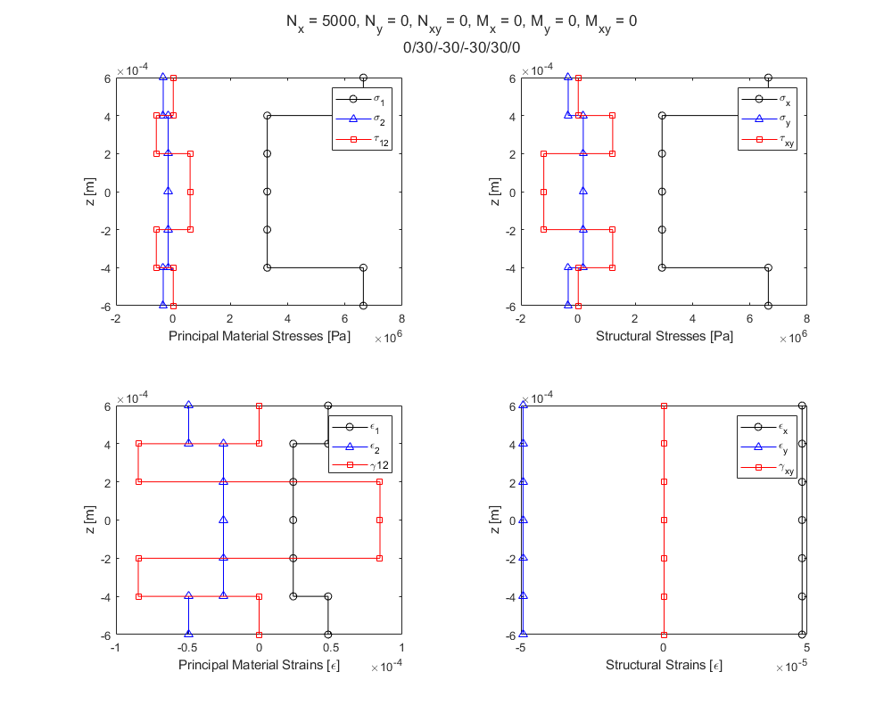

Part C: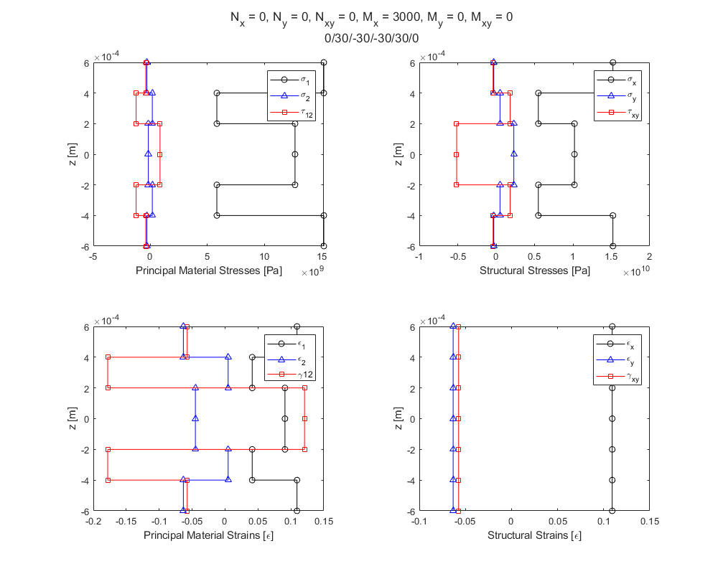

**MAIN:**

clc;clear;close all;

laminate = [140e9,10e9,7e9,0.3,0.0002,0;...

140e9,10e9,7e9,0.3,0.0002,90;...

140e9,10e9,7e9,0.3,0.0002,90;...

140e9,10e9,7e9,0.3,0.0002,0];

%Part a

Nx=0;

Ny=3500;

Nxy=0;

Mx=0;

My=0;

Mxy=0;

forces2StressStrainLaminate(laminate,Nx,Ny,Nxy,Mx,My,Mxy);

%Part B

laminate = [140e9,10e9,7e9,0.3,0.0002,0;...

140e9,10e9,7e9,0.3,0.0002,30;...

140e9,10e9,7e9,0.3,0.0002,-30;...

140e9,10e9,7e9,0.3,0.0002,-30;...

140e9,10e9,7e9,0.3,0.0002,30;...

140e9,10e9,7e9,0.3,0.0002,0];

Nx=5000;

Ny=0;

Nxy=0;

Mx=0;

My=0;

Mxy=0;

forces2StressStrainLaminate(laminate,Nx,Ny,Nxy,Mx,My,Mxy);

%Part C

Nx=0;

Ny=0;

Nxy=0;

Mx=3000;

My=0;

Mxy=0;

forces2StressStrainLaminate(laminate,Nx,Ny,Nxy,Mx,My,Mxy);

**FUNCTIONS:**

function [sigmax,sigmay,tauxy,sigma1,sigma2,tau12,epsx,epsy,gammaxy,eps1,eps2,gamma12]=forces2StressStrainLaminate(laminate,Nx,Ny,Nxy,Mx,My,Mxy)

[E1s,E2s,G12s,v12s,thicknesses,thetas] = laminateReader(laminate);

[epsx0,epsy0,gammaxy0,kx,ky,kxy] = midPlaneStrainsCurvature(Nx,Ny,Nxy,Mx,My,Mxy,thicknesses,thetas,E1s,E2s,G12s,v12s);

[epsx,epsy,gammaxy] = strainLaminateStructural(epsx0,epsy0,gammaxy0,kx,ky,kxy,thicknesses);

[eps1,eps2,gamma12] = strainLaminatePrincipal(epsx,epsy,gammaxy,thetas);

[sigmax,sigmay,tauxy]=strain2stressStructural(epsx,epsy,gammaxy,thetas,E1s,E2s,G12s,v12s);

[sigma1,sigma2,tau12]=stressLaminatePrincipal(sigmax,sigmay,tauxy,thetas);

distances=laminateDistances(thicknesses);

figure

plots = tiledlayout(2,2);

nexttile

plot(sigma1,distances,'k-o',sigma2,distances,'b-^',tau12,distances,'r-square')

xlabel('Principal Material Stresses [Pa]')

ylabel('z [m]')

legend('\sigma_{1}','\sigma_{2}','\tau_{12}')

nexttile

plot(sigmax,distances,'k-o',sigmay,distances,'b-^',tauxy,distances,'r-square')

xlabel('Structural Stresses [Pa]')

ylabel('z [m]')

legend('\sigma_{x}','\sigma_{y}','\tau_{xy}')

nexttile

plot(eps1,distances,'k-o',eps2,distances,'b-^',gamma12,distances,'r-square')

xlabel('Principal Material Strains [\epsilon]')

ylabel('z [m]')

legend('\epsilon_{1}','\epsilon_{2}','\gamma{12}')

nexttile

plot(epsx,distances,'k-o',epsy,distances,'b-^',gammaxy,distances,'r-square')

xlabel('Structural Strains [\epsilon]')

ylabel('z [m]')

legend('\epsilon_{x}','\epsilon_{y}','\gamma_{xy}')

set(gcf,'position',[90,90,1000,800])

titleLine1=['N_{x} = ',num2str(Nx),', N_{y} = ',num2str(Ny),', N_{xy} = ',num2str(Nxy),', M_{x} = ',num2str(Mx),', M_{y} = ',num2str(My),', M_{xy} = ',num2str(Mxy)];

titleLine2=num2str(thetas(1));

for i=2:length(thetas)

titleLine2=[titleLine2,'/',num2str(thetas(i))];

end

title(plots,{titleLine1,titleLine2})

end

function [E1s,E2s,G12s,v12s,thicknesses,thetas] = laminateReader(laminate)

% Creates vectors of elastic properties of laminate where each row is a layer

% and the laminate matrix is:

% E1 E2 G12 v12 thickness theta

% Layer 1 X X X X X X

% Layer 2 X X X X X X

% . X X X X X X

% . X X X X X X

% . X X X X X X

% Layer N X X X X X X

E1s=laminate(:,1);

E2s=laminate(:,2);

G12s=laminate(:,3);

v12s=laminate(:,4);

thicknesses=laminate(:,5);

thetas=laminate(:,6);

end

function [epsx0,epsy0,gammaxy0,kx,ky,kxy] = midPlaneStrainsCurvature(Nx,Ny,Nxy,Mx,My,Mxy,thicknesses,thetas,E1s,E2s,G12s,v12s)

ABDmatrixINV = laminateStiffnessMatrixINV(thicknesses,thetas,E1s,E2s,G12s,v12s);

epsk=ABDmatrixINV*[Nx;Ny;Nxy;Mx;My;Mxy];

epsx0=epsk(1);

epsy0=epsk(2);

gammaxy0=epsk(3);

kx=epsk(4);

ky=epsk(5);

kxy=epsk(6);

end

function [epsx,epsy,gammaxy] = strainLaminateStructural(epsx0,epsy0,gammaxy0,kx,ky,kxy,thicknesses)

distances=laminateDistances(thicknesses);

N=length(distances);

epsx=zeros(1,N);

epsy=zeros(1,N);

gammaxy=zeros(1,N);

for i=1:N

epsx(i)=epsx0+(distances(N)*kx);

epsy(i)=epsy0+(distances(N)*ky);

gammaxy(i)=gammaxy0+(distances(N)*kxy);

end

end

function [eps1,eps2,gamma12] = strainLaminatePrincipal(epsx,epsy,gammaxy,thetas)

N=length(epsx);

eps1=zeros(1,N);

eps2=zeros(1,N);

gamma12=zeros(1,N);

for i=2:2:N

strainTrans=strainTransformationMatrix(thetas(i/2));

principleStrains=strainTrans*[epsx(i);epsy(i);gammaxy(i)];

eps1(i)=principleStrains(1);

eps1(i-1)=eps1(i);

eps2(i)=principleStrains(2);

eps2(i-1)=eps2(i);

gamma12(i)=principleStrains(3);

gamma12(i-1)=gamma12(i);

end

end

function [sigmax,sigmay,tauxy]=strain2stressStructural(epsx,epsy,gammaxy,thetas,E1s,E2s,G12s,v12s)

N=length(epsx);

sigmax=zeros(1,N);

sigmay=zeros(1,N);

tauxy=zeros(1,N);

for i=2:2:N

Qbar = transReducedStiffnessMatrix(E1s(i/2),E2s(i/2),G12s(i/2),v12s(i/2),thetas(i/2));

stress=Qbar*[epsx(i);epsy(i);gammaxy(i)];

sigmax(i)=stress(1);

sigmax(i-1)=stress(1);

sigmay(i)=stress(2);

sigmay(i-1)=stress(2);

tauxy(i)=stress(3);

tauxy(i-1)=stress(3);

end

end

function [sigma1,sigma2,tau12]=stressLaminatePrincipal(sigmax,sigmay,tauxy,thetas)

N=length(sigmax);

sigma1=zeros(1,N);

sigma2=zeros(1,N);

tau12=zeros(1,N);

for i=2:2:N

stressTrans = stressTransformationMatrix(thetas(i/2));

principalStresses = stressTrans*[sigmax(i);sigmay(i);tauxy(i)];

sigma1(i)=principalStresses(1);

sigma1(i-1)=principalStresses(1);

sigma2(i)=principalStresses(2);

sigma2(i-1)=principalStresses(2);

tau12(i)=principalStresses(3);

tau12(i-1)=principalStresses(3);

end

end