Problem 1:

Part a:

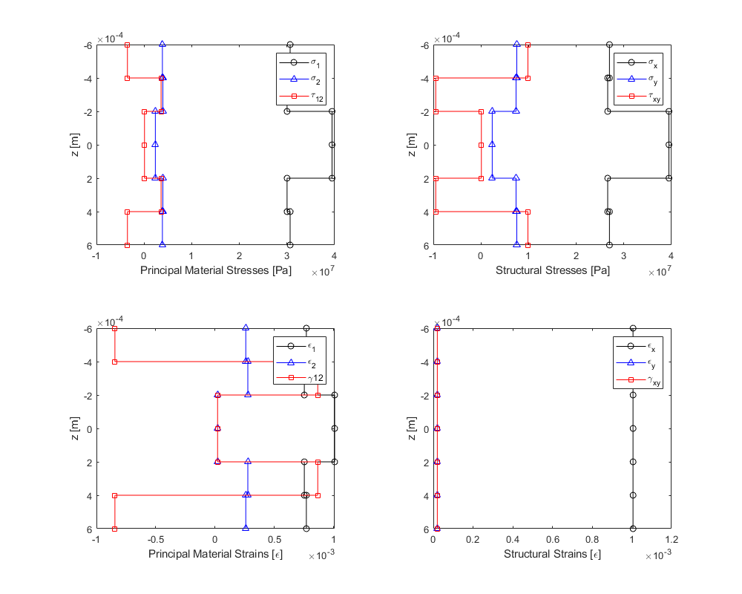

Part b:

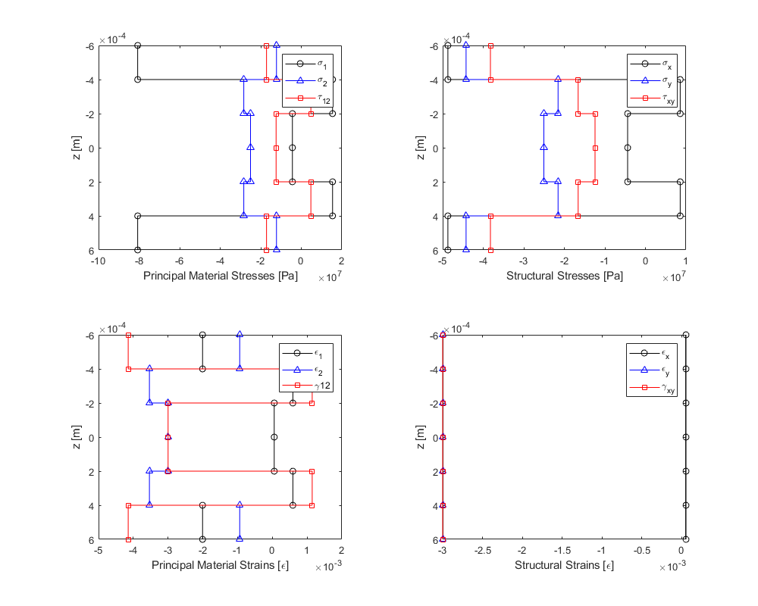

Problem 2:

Part a:

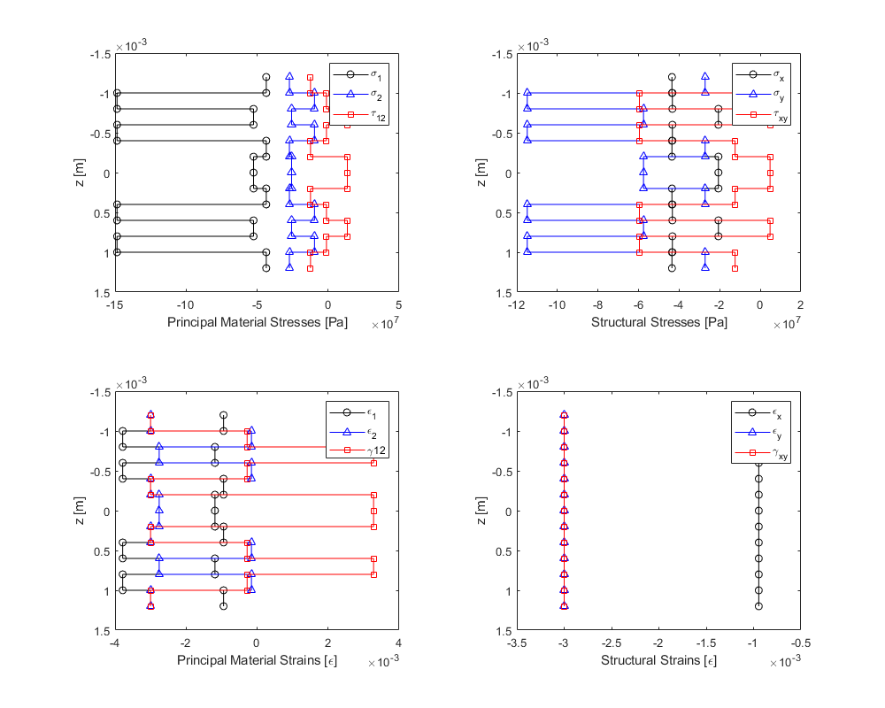

kx = 1.13377e-16, ky =1.11846e-15, kxy = -7.95548e-16

Part b:

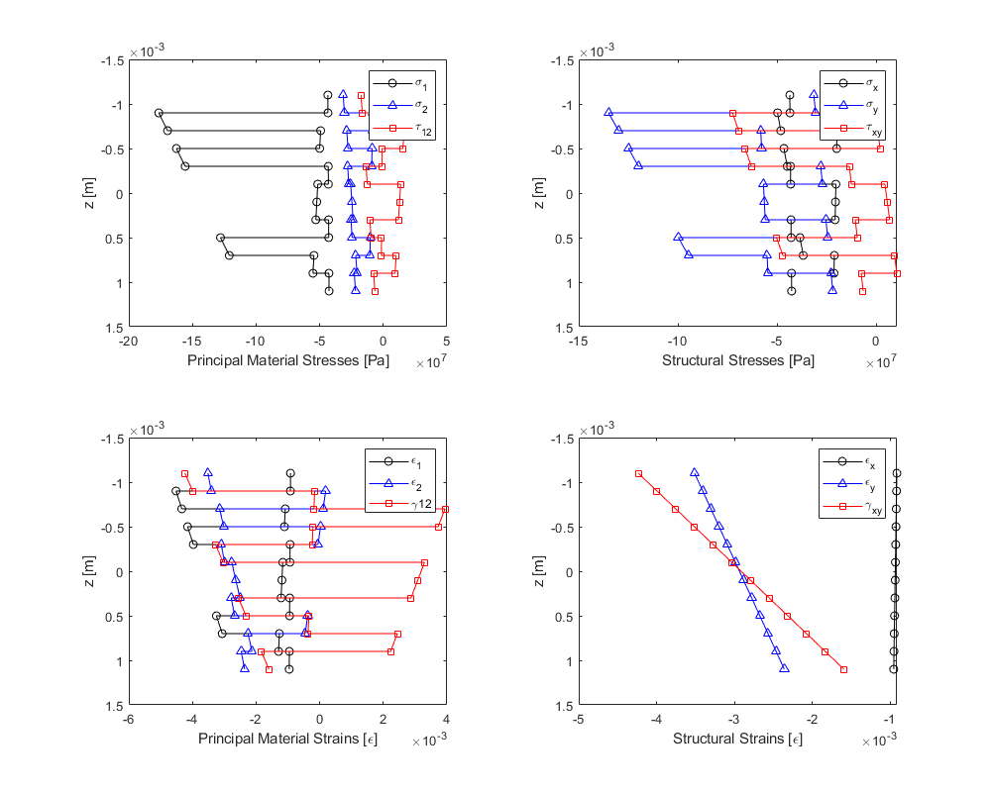

kx = -0.0182805, ky =0.523131, kxy = 1.1992

Main:

clc;clear;

laminate = [38.6e9,8.27e9,4.14e9,0.26,0.0002,30,0,0,0,0,0,6.3e-6,20e-6,20e-6,0.014,0.29,0.29;...

38.6e9,8.27e9,4.14e9,0.26,0.0002,-30,0,0,0,0,0,6.3e-6,20e-6,20e-6,0.014,0.29,0.29;...

38.6e9,8.27e9,4.14e9,0.26,0.0002,0,0,0,0,0,0,6.3e-6,20e-6,20e-6,0.014,0.29,0.29;...

38.6e9,8.27e9,4.14e9,0.26,0.0002,0,0,0,0,0,0,6.3e-6,20e-6,20e-6,0.014,0.29,0.29;...

38.6e9,8.27e9,4.14e9,0.26,0.0002,-30,0,0,0,0,0,6.3e-6,20e-6,20e-6,0.014,0.29,0.29;...

38.6e9,8.27e9,4.14e9,0.26,0.0002,30,0,0,0,0,0,6.3e-6,20e-6,20e-6,0.014,0.29,0.29];

deltaT=0;

epsx0=1000e-6;

epsy0=0;

gammaxy0=0;

kx=0;

ky=0;

kxy=0;

[sigmax,sigmay,tauxy,sigma1,sigma2,tau12,epsx,epsy,gammaxy,eps1,eps2,gamma12] = midplaneStrainsCurvatureTemperature2StressStrainLaminate(laminate,deltaT,epsx0,epsy0,gammaxy0,kx,ky,kxy);

deltaT=-150;

epsx0=1000e-6;

epsy0=0;

gammaxy0=0;

kx=0;

ky=0;

kxy=0;

[sigmax,sigmay,tauxy,sigma1,sigma2,tau12,epsx,epsy,gammaxy,eps1,eps2,gamma12] = midplaneStrainsCurvatureTemperature2StressStrainLaminate(laminate,deltaT,epsx0,epsy0,gammaxy0,kx,ky,kxy);

clear;

laminate = [38.6e9,8.27e9,4.14e9,0.26,0.0002,0,0,0,0,0,0,6.3e-6,20e-6,20e-6,0.014,0.29,0.29;...

38.6e9,8.27e9,4.14e9,0.26,0.0002,60,0,0,0,0,0,6.3e-6,20e-6,20e-6,0.014,0.29,0.29;...

38.6e9,8.27e9,4.14e9,0.26,0.0002,-60,0,0,0,0,0,6.3e-6,20e-6,20e-6,0.014,0.29,0.29;...

38.6e9,8.27e9,4.14e9,0.26,0.0002,60,0,0,0,0,0,6.3e-6,20e-6,20e-6,0.014,0.29,0.29;...

38.6e9,8.27e9,4.14e9,0.26,0.0002,0,0,0,0,0,0,6.3e-6,20e-6,20e-6,0.014,0.29,0.29;...

38.6e9,8.27e9,4.14e9,0.26,0.0002,-60,0,0,0,0,0,6.3e-6,20e-6,20e-6,0.014,0.29,0.29;...

38.6e9,8.27e9,4.14e9,0.26,0.0002,-60,0,0,0,0,0,6.3e-6,20e-6,20e-6,0.014,0.29,0.29;...

38.6e9,8.27e9,4.14e9,0.26,0.0002,0,0,0,0,0,0,6.3e-6,20e-6,20e-6,0.014,0.29,0.29;...

38.6e9,8.27e9,4.14e9,0.26,0.0002,60,0,0,0,0,0,6.3e-6,20e-6,20e-6,0.014,0.29,0.29;...

38.6e9,8.27e9,4.14e9,0.26,0.0002,-60,0,0,0,0,0,6.3e-6,20e-6,20e-6,0.014,0.29,0.29;...

38.6e9,8.27e9,4.14e9,0.26,0.0002,60,0,0,0,0,0,6.3e-6,20e-6,20e-6,0.014,0.29,0.29;...

38.6e9,8.27e9,4.14e9,0.26,0.0002,0,0,0,0,0,0,6.3e-6,20e-6,20e-6,0.014,0.29,0.29];

deltaT=-150;

epsx0=0;

epsy0=0;

gammaxy0=0;

kx=0;

ky=0;

kxy=0;

[sigmax,sigmay,tauxy,sigma1,sigma2,tau12,epsx,epsy,gammaxy,eps1,eps2,gamma12,kx,ky,kxy] = midplaneStrainsCurvatureTemperature2StressStrainLaminate(laminate,deltaT,epsx0,epsy0,gammaxy0,kx,ky,kxy);

fprintf('kx = %g, ky =%g, kxy = %g\n',kx,ky,kxy)

clear;

laminate = [38.6e9,8.27e9,4.14e9,0.26,0.0002,0,0,0,0,0,0,6.3e-6,20e-6,20e-6,0.014,0.29,0.29;...

38.6e9,8.27e9,4.14e9,0.26,0.0002,60,0,0,0,0,0,6.3e-6,20e-6,20e-6,0.014,0.29,0.29;...

38.6e9,8.27e9,4.14e9,0.26,0.0002,-60,0,0,0,0,0,6.3e-6,20e-6,20e-6,0.014,0.29,0.29;...

38.6e9,8.27e9,4.14e9,0.26,0.0002,60,0,0,0,0,0,6.3e-6,20e-6,20e-6,0.014,0.29,0.29;...

38.6e9,8.27e9,4.14e9,0.26,0.0002,0,0,0,0,0,0,6.3e-6,20e-6,20e-6,0.014,0.29,0.29;...

38.6e9,8.27e9,4.14e9,0.26,0.0002,-60,0,0,0,0,0,6.3e-6,20e-6,20e-6,0.014,0.29,0.29;...

38.6e9,8.27e9,4.14e9,0.26,0.0002,-60,0,0,0,0,0,6.3e-6,20e-6,20e-6,0.014,0.29,0.29;...

38.6e9,8.27e9,4.14e9,0.26,0.0002,0,0,0,0,0,0,6.3e-6,20e-6,20e-6,0.014,0.29,0.29;...

38.6e9,8.27e9,4.14e9,0.26,0.0002,60,0,0,0,0,0,6.3e-6,20e-6,20e-6,0.014,0.29,0.29;...

38.6e9,8.27e9,4.14e9,0.26,0.0002,-60,0,0,0,0,0,6.3e-6,20e-6,20e-6,0.014,0.29,0.29;...

38.6e9,8.27e9,4.14e9,0.26,0.0002,0,0,0,0,0,0,6.3e-6,20e-6,20e-6,0.014,0.29,0.29];

deltaT=-150;

epsx0=0;

epsy0=0;

gammaxy0=0;

kx=0;

ky=0;

kxy=0;

[sigmax,sigmay,tauxy,sigma1,sigma2,tau12,epsx,epsy,gammaxy,eps1,eps2,gamma12,kx,ky,kxy] = midplaneStrainsCurvatureTemperature2StressStrainLaminate(laminate,deltaT,epsx0,epsy0,gammaxy0,kx,ky,kxy);

fprintf('kx = %g, ky =%g, kxy = %g',kx,ky,kxy)

Function:

function [sigmax,sigmay,tauxy,sigma1,sigma2,tau12,epsx,epsy,gammaxy,eps1,eps2,gamma12,kx,ky,kxy] = midplaneStrainsCurvatureTemperature2StressStrainLaminate(laminate,deltaT,epsx0,epsy0,gammaxy0,kx,ky,kxy)

[E1s,E2s,G12s,v12s,thicknesses,thetas,longStrengthTen,longStrengthCom,tranStrengthTen,tranStrengthCom,strengthLT,alphax,alphay,alphaxy,betax,betay,betaxy] = laminateReader(laminate);

zs = laminateDistances(thicknesses);

thickness=sum(thicknesses);

distances=zeros(1,length(thicknesses)+1);

distances(1)=-thickness/2;

distances(end)=thickness/2;

N=length(E1s);

for i=2:N

distances(i)=distances(i-1)+thicknesses(i-1);

end

Nxt=0;

Nyt=0;

Nxyt=0;

Mxt=0;

Myt=0;

Mxyt=0;

for i=1:length(E1s)

Qbar = transReducedStiffnessMatrix(E1s(i),E2s(i),G12s(i),v12s(i),thetas(i));

Nxt=Nxt+(Qbar(1,1)*alphax(i)+Qbar(1,2)*alphay(i)+Qbar(1,3)*alphaxy(i))*(distances(i+1)-distances(i));

Nyt=Nyt+(Qbar(1,2)*alphax(i)+Qbar(2,2)*alphay(i)+Qbar(2,3)*alphaxy(i))*(distances(i+1)-distances(i));

Nxyt=Nxyt+(Qbar(1,3)*alphax(i)+Qbar(2,3)*alphay(i)+Qbar(3,3)*alphaxy(i))*(distances(i+1)-distances(i));

Mxt=Mxt+(Qbar(1,1)*alphax(i)+Qbar(1,2)*alphay(i)+Qbar(1,3)*alphaxy(i))*(distances(i+1)^2-distances(i)^2);

Myt=Myt+(Qbar(1,2)*alphax(i)+Qbar(2,2)*alphay(i)+Qbar(2,3)*alphaxy(i))*(distances(i+1)^2-distances(i)^2);

Mxyt=Mxyt+(Qbar(1,3)*alphax(i)+Qbar(2,3)*alphay(i)+Qbar(3,3)*alphaxy(i))*(distances(i+1)^2-distances(i)^2);

end

Nxt=Nxt*deltaT;

Nyt=Nyt*deltaT;

Nxyt=Nxyt*deltaT;

Mxt=Mxt*deltaT;

Myt=Myt*deltaT;

Mxyt=Mxyt*deltaT;

[epsx0t,epsy0t,gammaxy0t,kxt,kyt,kxyt] = midPlaneStrainsCurvature(Nxt,Nyt,Nxyt,Mxt,Myt,Mxyt,laminate);

epsx0=epsx0+epsx0t;

epsy0=epsy0+epsy0t;

gammaxy0=gammaxy0+gammaxy0t;

kx=kx+kxt;

ky=ky+kyt;

kxy=kxy+kxyt;

[epsx,epsy,gammaxy] = strainLaminateStructural(epsx0,epsy0,gammaxy0,kx,ky,kxy,thicknesses);

[eps1,eps2,gamma12] = strainLaminatePrincipal(epsx,epsy,gammaxy,thetas);

[sigmax,sigmay,tauxy]=strain2stressStructural(epsx,epsy,gammaxy,thetas,E1s,E2s,G12s,v12s);

[sigma1,sigma2,tau12]=stressLaminatePrincipal(sigmax,sigmay,tauxy,thetas);

figure

plots = tiledlayout(2,2);

nexttile

plot(sigma1,zs,'k-o',sigma2,zs,'b-^',tau12,zs,'r-square')

xlabel('Principal Material Stresses [Pa]')

ylabel('z [m]')

legend('\sigma_{1}','\sigma_{2}','\tau_{12}')

set(gca, 'YDir','reverse')

nexttile

plot(sigmax,zs,'k-o',sigmay,zs,'b-^',tauxy,zs,'r-square')

xlabel('Structural Stresses [Pa]')

ylabel('z [m]')

legend('\sigma_{x}','\sigma_{y}','\tau_{xy}')

set(gca, 'YDir','reverse')

nexttile

plot(eps1,zs,'k-o',eps2,zs,'b-^',gamma12,zs,'r-square')

xlabel('Principal Material Strains [\epsilon]')

ylabel('z [m]')

legend('\epsilon_{1}','\epsilon_{2}','\gamma{12}')

set(gca, 'YDir','reverse')

nexttile

plot(epsx,zs,'k-o',epsy,zs,'b-^',gammaxy,zs,'r-square')

xlabel('Structural Strains [\epsilon]')

ylabel('z [m]')

legend('\epsilon_{x}','\epsilon_{y}','\gamma_{xy}')

set(gca, 'YDir','reverse')

set(gcf,'position',[90,90,1000,800])

end