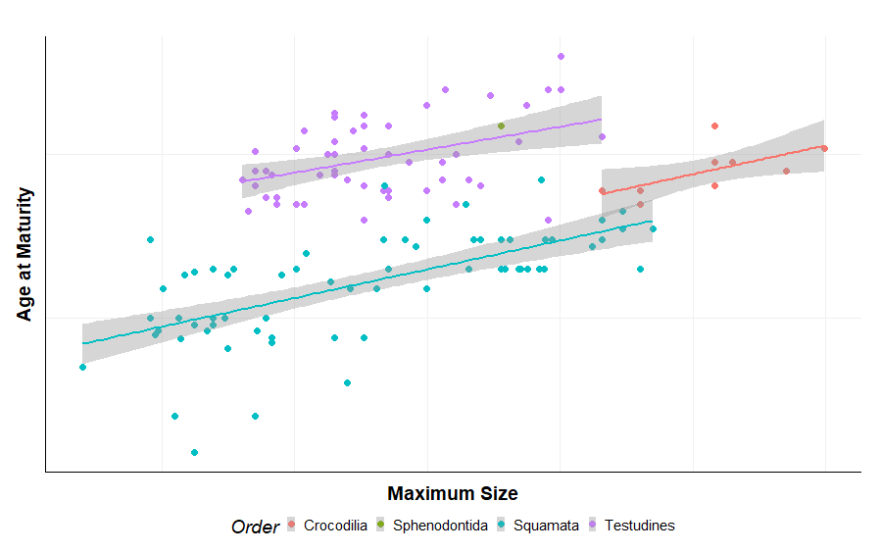

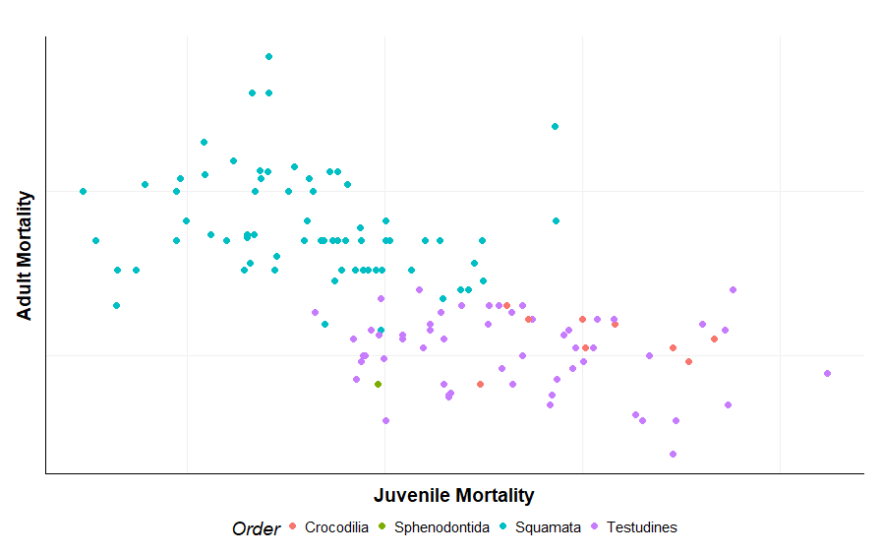

Tinkle et al. (1970) pointed out that early maturing birds, like lizards, may have multiple broods, lay large clutches, have short developmental periods, and have low annual survivorship. Late ma- turing birds have small clutches, single broods per year, long developmental pe- riods, and high adult survivorship. In both lizards and birds there are three ad- aptations associated with delayed matu- rity that counter the potential loss of fit- ness. These are production of larger clutches through longer lifetimes, in- creased parental care, and a longer peri- od of reproduction. Lizard viviparity is considered by Tinkle et al. (1970) to be a component of increased parental care, as Salthe and Mecham (1974) concluded for amphibians. Tinkle and Gibbons (1977) considered that viviparity evolved in reptiles in environments with short breeding seasons and variable conditions during the period of development of the young. They believed that viviparity evolved rarely in tropical reptiles be- cause viviparous species would be at a disadvantage to oviparous ones due to re- stricted fecundity. The longer tropical breeding season is also associated with the frequency of multiple breeding. Tin- kle and Gibbons (1977) also comment on the lack of generalization of many pre- vious theories on the origin and evolu- tion of viviparity, while Shine and Bull (1979) reiterate that the evolution of vi- viparity in reptiles is triggered by cold environments and facilitated by brood- ing.

