Metadata Data Model Summary

For the Open Geoscience Data Models Project

Rachel Heaven & Alan Mackenzie
BGS Database Solutions Team

Contributions from:
Martin Nayembil, Carl Watson, Andrew Marchant

We believe that most readers will imagine the data model described in this document as a physical database, therefore we use the terms ‘Table’ and ‘Column’ where ‘Entity’ and ‘Attribute’ would be more technically correct.

Introduction

Document purpose
This document provides a summary of the Metadata Data Model produced by the BGS for the Open Geoscience Data Models project. It includes descriptions of the main components (also known as tables or entities) which make up the data model; the relationships between these components; and the dictionaries which contain controlled lists of well defined terms that can be used in the main components.
This document does not deal with technical details relating to specific database hardware or software, for those please see the implementation folder in the download.

Simplified data model
In this download we have provided a simplified data model based upon the current BGS Metadata Database. Metadata is “data about data”, describing the data content and/or its technical specification, for example a library catalogue.
The BGS Metadata Database, referred to as the Discovery Metadata, holds the information required to identify a BGS dataset or service, including its standardised resource reference (citation) and information on the metadata itself. This data model is suitable for describing the metadata of resources such as:
- datasets
- dataset series
- digital models
- map services
- non-digital collections and records
These will be primarily geographic datasets but non-geographic data are also accommodated.
We have simplified the model because we want to highlight the essence of the database but not to present an overly complex design. We have removed many features and tables which relate to concepts which are specific to the BGS but which may not be relevant to other organisations.
We hope that this design can provide one example of how you might structure a Metadata data model while highlighting that there are areas which may require further consideration when implementing a metadata database to meet your own specific requirements.

BGS standards and naming conventions
The creation of the model has been carried out by BGS staff using corporate database standards and best practices.
The table and column names have been altered to more generic versions of those in use on the BGS corporate database, however, the names used in this data model conform to the BGS database naming conventions, for example all dictionary names should be prefixed with DIC_.

A brief history of the BGS Metadata Database
The following bullet points are based upon BGS Reports and discussions with current BGS staff.
The current BGS implementation of the data model is an Oracle relational database model designed in 2004 to store and manage catalogue descriptions of BGS datasets, records, collections and digital models. It was designed to:
- accommodate metadata that could conform to ISO 19115 Geographic Information - Metadata standard as well as provide a mapping to the pre-existing Dublin Core standard
- accommodate existing metadata designed against a previous standard (CSDGM by the Federal Geographic Data Committee)
- accommodate new metadata required for digital 3D models and modelling datasets
- accommodate BGS specific requirements for metadata not covered by any existing standard
Since then it has been adapted to also accommodate:
- GIS datasets (e.g. shapefiles)
- map services, conforming to ISO 19119 metadata standard
- requirements for the INSPIRE and UK GEMINI standards as they were published and revised
This metadata data model provides the information necessary for a user to:
- Discover a resource in a search (author, subject, time and place that the data refers to)
- Assess a resource (description, creation date)
- Obtain a resource (access permissions, where to get hold of it, who to contact)
- Use a resource (data file format, units, reference systems)
- Understand the context and quality (original purpose, lineage, usage limitations, quality)
- Assess the quality and currency of the metadata itself (creation date, last updated, metadata author, standard followed)

The BGS metadata workflow
Before we look at the details of the data model, this section will briefly describe a typical workflow that would result in data being entered into the metadata database.
The following workflow steps describe how metadata records are created in BGS.
- Creation of metadata record. A metadata record is initially created using either:
- A public web editing tool provided for use by non-BGS researchers.
- Intranet editing tool for use by BGS staff.
- 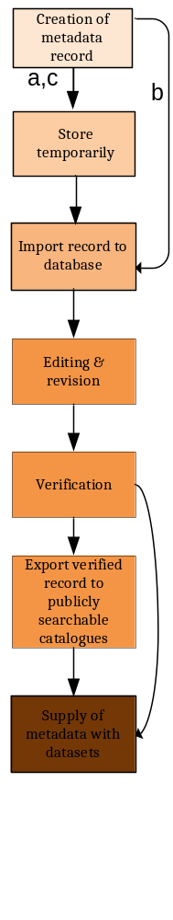ArcGIS desktop editor for use by BGS staff describing GIS datasets.
- Store temporarily.
- Records created using the public web tool are stored temporarily on an external facing database.
- Records created using the intranet editing tool are saved directly to the Oracle database.
- Records created using the ArcGIS editor are stored in a bespoke ESRI-BGS schema xml file in the same folder location as the GIS dataset.
- Import record to database. All records are validated prior to ingestion into the Oracle database. In the case of a) and c) above, the record is imported into the Oracle metadata database using bespoke written data import routines.
- Editing & revision. Further editing and revision may be performed using the intranet editing application. In the case of a) above, this is only allowed by the relevant data manager; in the case of c) above this is only allowed using the original desktop editor and then re-importing the changes, thereby keeping the xml file as the master copy.
- Verification. The record is verified by the relevant data manager and signed off for publication.
- Export verified record to publicly searchable catalogues. Publishable records can be exported from the database for display on the BGS website, and/or other relevant data catalogues such as the Earth Science Academic Archive. They are also published in GEMINI 2.2 xml files and imported by data.gov.uk and UK Location, thereby meeting BGS’s INSPIRE compliance. See the following section, 1.6, for more information on published metadata records.
- Supply of metadata with datasets. When datasets are supplied to users, the GEMINI 2.2 xml file and where applicable the ESRI-BGS xml file are supplied in accompaniment.

Published metadata records
BGS Discovery Metadata is a public website which is derived from the discovery metadata database and provides a range of search and browse facilities as can be seen in the following screen shot. The address for the website is: http://www.bgs.ac.uk/discoverymetadata/
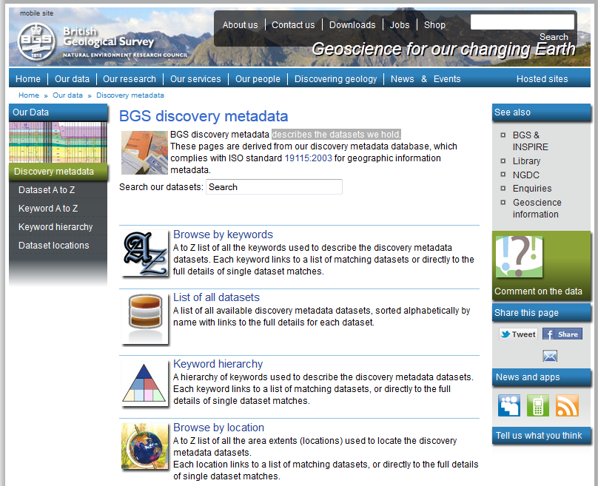
The BGS can group datasets by the project that they are associated with and this means it is possible to create targeted discovery metadata portals, such as The Earth Science Academic Archive (ESAA). The ESAA provides a way to find all Earth Science research datasets that have been deposited with the National Geoscience Data Centre (NGDC). The ESAA website can be found here: http://www.bgs.ac.uk/services/NGDC/ESAA/home.cfm

Further information
A selection of documents and website addresses that provide further information on the history and discovery portals of the BGS metadata database:
- Ault, L. 2007 Corporate Metadata 2006 - 2007. Nottingham, UK, British Geological Survey, 31pp. (OR/07/013) (Unpublished) http://nora.nerc.ac.uk/7582/
- Giles, Jerry; Waters, Robin; Walker, Rob. 2009 How INSPIREd is NERC? In: GSDI 11 World Conference - Spatial Data Infrastructure Convergence: Building SDI Bridges to address Global Challenges, Rotterdam, 15-19 June 2009. GSDI 11 World Conference - Spatial Data Infrastructure Convergence: Building SDI Bridges to address Global Challenges, 1-11. http://nora.nerc.ac.uk/7891/
- The Data Catalogue Service for the Natural Environment Research Council (NERC): http://data-search.nerc.ac.uk/
- MEDIN is a partnership of UK organisations committed to improving access to marine data, partners are both public and private sector and the BGS provide details of relevant datasets to the MEDIN discovery metadata portal. http://portal.oceannet.org/search/full
- The national metadata portal for the United Kingdom (data.gov.uk) includes a section dedicated to location based metadata, this is another facility that receives spatial metadata records from the BGS, it can be accessed here: http://data.gov.uk/location

The Metadata Data Model adapted for the Open Geoscience Data Models project
For more technical details and a more complete “Entity-Relationship” Diagram see the technical documentation that accompanies the implementation code.

This section describes the new and simplified logical design which has been created as part of the Open Geoscience Data Models project.
A more detailed description and entity relationship diagram is available in the implementation download for the model.

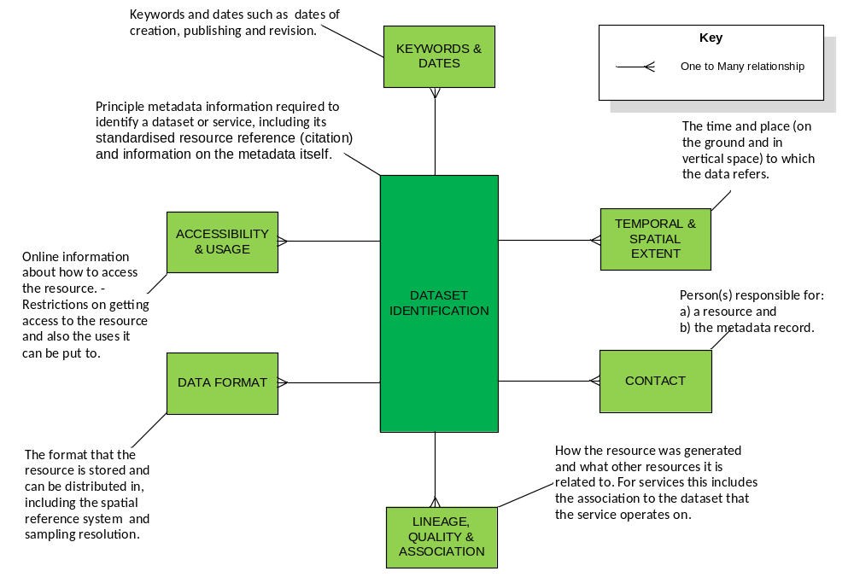Figure 2

Components of the Data Model
Each of the tables in the simplified data model can be further explained by the following figures showing the logical structure of the data model:-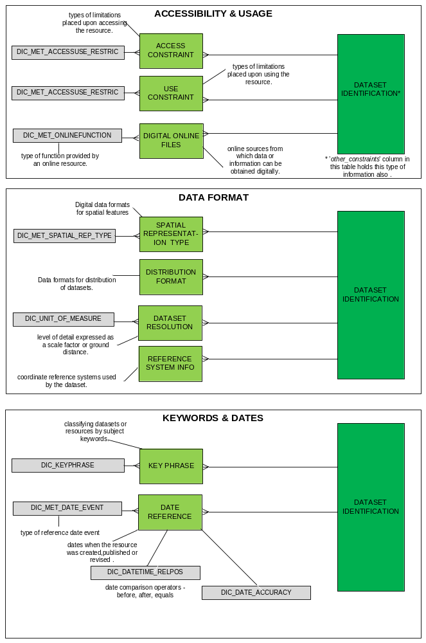
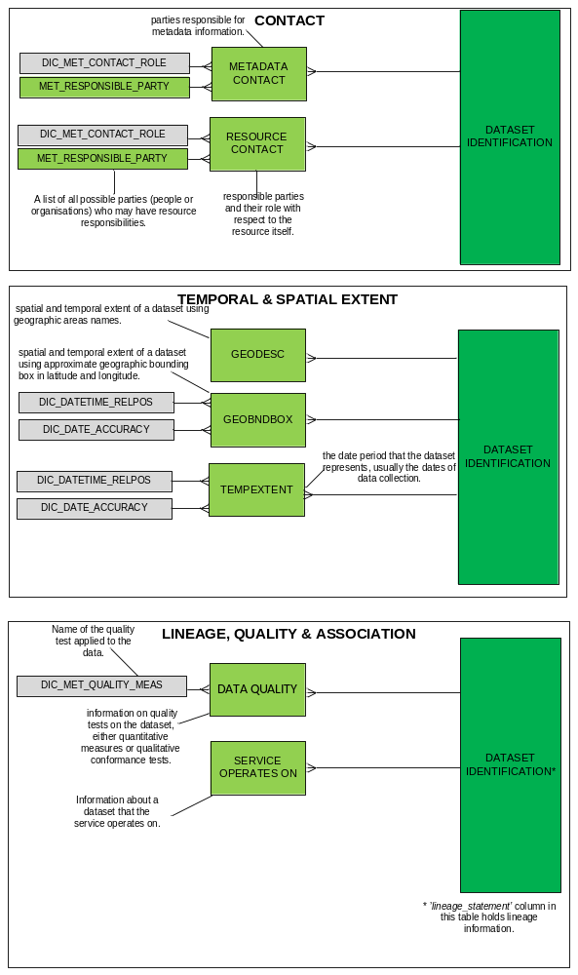

It is standard practice in BGS corporate database design to assign a three letter prefix to table names to indicate the general subject areas to which these tables belong. Therefore, the physical implementation of this data model uses the prefix ‘MET’ to represent Metadata, for example the table shown in the previous diagrams as DATASET IDENTIFICATION is called MET_DATA_IDENT in the MS Access implementation.

Resource Identification, implemented in table DATASET IDENTIFICATION (MET_DATA_IDENT)
This table is used to record the main description of the resource and information about its metadata, and any singular elements of information where only one value is allowed.

Typical information to be captured in this table:
- Title and description of the resource.
- The type of resource, and in the case of a service, what kind of service.
- What metadata standards have been used and date the metadata was entered/updated.
- The lineage, status and frequency of update of the resource.
- Other constraints. This is a description of constraints that compliments that stored in met_constraint.

Dictionaries
Dictionaries are controlled vocabularies, they control the terms we wish to use in describing, and supporting the description of, scientific and other observations. We strongly recommend using controlled dictionaries.
Some of the dictionary items used in the model were derived from the ISO19115 standard and adapted for use by the BGS, this involved adding extra values that satisfied specific BGS requirements.
In the BGS we try to re-use dictionaries across a wide range of databases but some are specific to a given subject area. The dictionary naming conventions help to convey this information through the use of three character codes, all dictionaries are prefixed with DIC_ followed by an optional three character code to represent the specific database or subject area (such as MET for metadata) followed a descriptive name for the dictionary.
For example:
DIC_MET_CONTACT_ROLE contains a list of role types performed by people involved in metadata activities and is only used within the metadata database.
DIC_KEYPHRASE is a BGS wide dictionary containing keyphrases that a user of any BGS system might use as a search term.
The following table shows an example of a dictionary, in this case it describes terms for metadata contact roles:
CODE  (Unique ID in a readable form) | TRANSLATION  (Short description, used in lists etc) | DESCRIPTION  (Full sized description)
001 | Resource Provider | Party that supplies the resource
002 | Custodian | Party that accepts accountability and responsibility for the data and ensures appropriate care and maintenance of the resource.
003 | Owner | Party that owns the resource.
004 | User | Party that uses the resource.
005 | Point of Contact | Party who can be contacted for acquiring knowledge about or acquisition of the resource.
? | notEntered | we have not assigned a value yet (and it might not be applicable)

