THE GEODE INN
Full Layer-by-Layer Walkthrough & Consistency Audit

Generated: August 24, 2026

THE GEODE INN — FULL LAYER-BY-LAYER WALKTHROUGH & CONSISTENCY AUDIT
Generated: August 24, 2026
Sources: Complete walkthrough, master storyline, project bible, character compendium, exterior/Magritte/Rousseau doc, game design docs (jigsaw, Raven's Angle, Hidden Bloom, music direction, marketplace, leaderboard)
---

THE FIVE HUBS (Horizontal Axis)
[ OBSERVATORY ] ←—— Vertical: Alchemical Staircase ——→ [ THE INN ] ←—— Midline Coast Path ——→ [ COAST HUB ]
(Sky/Cosmology) (Trunk/Heart) (Ocean/Vigil)
↑ ↑
[ CANOPY CITY ] [ UNDERCITY ]
(Forest/Canopy) (Catacombs/Dead)
All five hubs sit on the body of a Sleeping Giant. Its heart crystal is the source of the 50 BPM heartbeat. Its ribcage forms the Undercity. Its vertebrae form the world's Stone Circles. Its copper/malachite veins carry the 42Hz Song.
---

LAYER 1: THE COSMOLOGY LEVEL (Upstairs — The Observatory)

What It Is
A time ship floating in the void, built from Lyres of Ur materials (brass, lapis lazuli, bitumen, copper). It is the Astronomer's mind palace made literal — the architecture IS his consciousness. Dalí's time-bending surrealism is the embedded aesthetic.

Who Lives Here
Character | Casting | Role
The Constant | John Malkovich | Annunaki, oldest being; carries the starlight crystal of dying universes
The Cabbit | — | Constant's companion; purrs at 50 BPM; transforms into the void ship at 44Hz
The Astronomer | Benedict Cumberbatch | Sherlockian polymath; plays violin to think; mind palace IS the architecture
Nyx | Alanis Morissette energy | Primordial goddess of night; the silence between the Song's notes; wears Doc Martens
The Guest (Death) | Brad Pitt / Joe Black | Thanatos on holiday; guest upstairs, host of the dead downstairs; carries a music box
The Allfather (Odin) | — | Cosmic form; silent ravens perched; watches the void from the hull throne
The Owl | — | Lighthouse keeper at the coast edge of this level; bloodline watcher; speaks one word per heartbeat

Items & Rewards
- Starlight Crystal — Holds compressed Songs of dying universes (previous cycle: 41.7Hz, current: 42Hz)
- The Beacon ability — Co-op lighting tool for deep water (quest: "The Fixed Point" with The Owl)
- Astronomer's Star Chart — Reveals hidden cosmology paths (quest: "The Calculation")
- Nyx's Silence — Ability to hear silence between notes (quest: "The Silence Between")
- Music Box Mechanism — Plays Death's original note (quest: "The Borrowed Body")

Embedded Artist
- Salvador Dalí — Time-bending mind-palace architecture
- Clockwork Skies are above this level — the Arcana flagship (50 BPM gearwork heart)

Connections
- Down via the Alchemical Staircase
- The Lighthouse extends down to the Coast Hub / Surface Docks
- The "Slay the Princess" meta-narrative: The Constant compresses dying universes (killing the princess); Nyx is the Shifting Mound (the container)
---

LAYER 2: THE ALCHEMICAL STAIRCASE (Between States)

What It Is
A vertical stone staircase connecting the Main Floor to the Cosmology Level. Each step ascends by one musical semitone — a full octave from bottom to top. The alchemical stages (Nigredo → Albedo → Rubedo) are the philosophical framework.

Who Lives Here
Character | Casting | Role
Socrates | Stephen Fry + George Carlin layer | Bottom step (Nigredo/black work); the questioner whose anger IS the love
Plato | Ralph Fiennes | Middle step (Albedo/white work); the Cave is an interactive mural
Aristotle | Jeremy Irons | Top step (Rubedo/red work); argues with the Crone until both become listeners
The Retort | Olivia Colman | Nikola Tesla's reincarnated soul; brilliant, unstable inventor
The Cook | Jack Black | Kitchen anchor; care-based sustainer; says "Enough"
Bloop | — | Tesla's cat living in the staircase lab
The Five Smiths | — | Forge (Iron), Alloy (Bronze), Current (Silver), Endure (Gold), Verdigris (Copper)
Miracle Max | Princess Bride archetype | Alchemy shop keeper
Gesso | — | Grumpy ceiling gnome restorer; writes in mirror script like Da Vinci
Wrought | — | Invisible Celtic mason; structural fixer

Items & Rewards
- Tesla's Three Lent Devices:
- Cartographer's Silver Disc — Links to Canopy City
- Navigator's Wind Indicator — Links to the Arcana
- Cook's Oven Calibrator — Alchemical temperature regulator
- Leonardo's Flying Machine Sketches — Mirror-written blueprints for the Arcana
- Refined Metal Stones — Crafted via the Five Smiths

Embedded Artists (Spiral Gallery)
Six artist chambers along a Guggenheim-style spiral ramp:
- Emily Carr — Breathing forest
- M.C. Escher — Impossible geometry (the 3D puzzle room)
- Mark Rothko — Dark sacred spaces
- Hokusai — Living line
- Anselm Kiefer — Raw earth
- Agnes Martin + John Cage — Silence

Connections
- Tesla's silver disc links: Cartographer (Canopy) ↔ Examiner (Desert Bone) ↔ Retort (Staircase) ↔ Navigator (Arcana)
- The Greek philosophers are ancestors of the Council of Thinkers: Socrates→Einstein, Plato→Da Vinci, Aristotle→Newton
- The Crone hears the Song for the first time after arguing with Aristotle: "I never listened before. I always measured. It's beautiful."
---

LAYER 3: THE CLOCKWORK SKIES (Above the Canopy)

What It Is
The upper sky domain where airships fly. The flagship Arcana is built from Leonardo's sketches and beats at 50 BPM.

Who Lives Here
Character | Casting | Role
The Captain | Harlock archetype | Scarred sky pirate; smokes time-moss
The Engineer | — | Mirror twin of the Tinkering Weeaboo; reads mirror writing
The Navigator | — | Uses Tesla's Wind Indicator
The Lookout | — | Vulture's counterpart in the crow's nest
The Tinkering Weeaboo (Kid) | Ryuk from Death Note | Changeling player class; annoyance meter (0-4); crew member

Items & Rewards
- The Captain's Bell — Summons the Arcana for fast travel (quest: "The Sky Is for Everyone")

Connections
- Reached via Canopy City's upper branches
- Information chain: Vulture → Lookout → Navigator → Cartographer → Examiner
---

LAYER 4: THE CANOPY CITY (Forest Hub)

What It Is
A Kelethin-inspired elf city built on tree platforms surrounding the Inn-Tree. Sways at 50 BPM. Neuro-accessible calm. Serves as the central trading crossroads — the Silk Road of the Inn.

Embedded Artist
- Henri Matisse — Paper cutout aesthetics, color harmony, neuro-accessible visual language

Who Lives Here
Character | Casting | Role
The Cartographer | Matthew Gray Gubler (Spencer Reid) | Temporal mapmaker; mind too fast, too full; finds the Inn's 50 BPM heartbeat
The Examiner | Emily Deschanel (Dr. Brennan) | Anthropologist of ancient things; socially literal; caring through work not words
Seelie King | Nikolaj Coster-Waldau (Jaime Lannister) | Reluctant ruler; charm concealing erosion; has a hidden forge
Seelie Queen | Gugu Mbatha-Raw | Brilliant ruler bound by royal expectations; has a hidden library
The Duck | — | Platypus companion; electroreception bill; steals shiny stones

The 9 Cultural Platforms
Each platform has a vendor and connects to a cultural zone:
Platform | Vendor | Cultural Zone Guide | Embedded Artist
Celtic | Niamh | The Morrigan | Book of Kells
Egyptian | Sefu | (Desert Bone zone) | O'Keeffe
Peruvian | Qhora | The One Who Tends | —
Chinese | Li Wei | The One Who Is Awake | Mulan (1998) ink-wash
Slavic | Dushan | Zorya Polunochnaya | —
Indian | Priya | Kali | —
Norse | Erik | Erik (vendor + guide) | Danheim / Book of Kells
Mediterranean | Thalia | The Gardener / Radagast | —
Neutral | The Keeper / Aughra | — | —

Items & Rewards
- Cartographer's Compass — Points to future locations of frequency nodes (quest: "The Living Map")
- Examiner's Calipers — Reads hidden frequencies in artifacts (quest: "The Humble Objects")
- The Seed — Relic plant for the Geode Cave (quest: "The Story")
- The Crown's Echo — King's hammer + Queen's page-turn added to the Song (quest: "The Echo and the Crown")

Connections
- Mycorrhizal root network links Canopy City to all 9 cultural zones, the Main Floor, and National Parks
- The Song and the Silk Road are the SAME network
- The Cartographer's "Living Map" quest reveals the 42Hz Song is propagating through the mycorrhizal network — the forest is becoming the Inn
---

LAYER 5: THE CULTURAL ZONES (Accessible via Canopy)

5.1 — The Desert Bone (Egypt — O'Keeffe Lens)
- Guide: The Vulture, The Examiner
- Quest: "Form Sight" — perceive the world as O'Keeffe
- Items: Humble objects (cooking pot, headrest, 7 ushabti, sandal, oil lamp); lapis lazuli, carnelian, turquoise, jasper, peridot
- Game: Tomb Tunnel (Dig Dug)
- NPCs: Anubis (scales), Ammit, Bastet (64Hz sistrum)

5.2 — The Aegean Light (Greece — Monet Lens)
- Guide: The Painter (on the cliff)
- Quest: "The Sixth Light" — paint the light that reveals hidden Fae
- Items: Marble, lapis, jadeite, sardonyx, emerald; the Painter's Canvas
- 5 light phases: Morning Gold, Noon White-Blue, Afternoon Violet-Pink, Twilight Indigo, Moonlight Silver-Blue
- Patience of LIGHT: revisiting under different light phases transforms geography

5.3 — The Fjord of Stars (Slavic — Aurora Lens)
- Guide: Zorya Polunochnaya (Tilda Swinton)
- Quest: "The First Word" — read negative space between stars, discover a NEW word
- Items: Star-Glyph (connects to Shifting Man, Cartographer, Queen of Webs)
- 3 aurora phases: Green (past), Violet (present), White (future/rarest)

5.4 — The Ghats of Kali (India — Transformation Lens)
- Guide: Kali (Tabu)
- Quest: "The Garland" — face false selves, Kali cuts the false, player must STOP the destruction
- Items: Kali's Garland; the garland of severed heads = subtractive archive
- Theme: Doing nothing is the hardest action

5.5 — The Terracotta Army (China — Mulan Lens)
- Guide: The One Who Is Awake (Will Yun Lee)
- Quest: "The Reflection" — the mercury shows the player's real face; register as the 8,001st name
- Items: Sleeve storage (body host vessels); 2,000-year name litany
- Aesthetic: Ink-wash mountains (shanshui), cherry blossoms, Great Wall, army pit as Chinese painting

5.6 — Norse Zone (Feast Hall — Book of Kells / Danheim Lens)
- Guide/Vendor: Erik (Peter Gantzler) — the warm Viking who died by fire and chose to be the fire that welcomes
- Wandering NPC: Uhtred (Alexander Dreymon) — neutralizes conflicts; "Destiny is all"
- Quest: "The Feast Fire" — portable social fire anchor
- Items: Erik's Hearth
- Aesthetic: Book of Kells (illuminated, legible); Danheim rhythmic pacing (60-80 BPM walking, 50 BPM feast-fire)

5.7 — The Sleeping Giants (Peru — Terrace Lens)
- Guide: The One Who Tends (Q'orianka Kilcher)
- Quest: "The Stirring" — the giants dream at 42Hz; dreams = weather
- Items: The Dreamstone (raw 50 BPM giant heartbeat)
- Theme: Inca terraces = dream-language visible (geological star-language); Apus are ancient geological beings who chose to sleep

5.8 — The Mediterranean Zone (Garden / Labyrinth Border)
- Guides: The Gardener / Radagast (Sylvester McCoy); Beorn (Mikael Persbrandt)
- Key NPC: Medusa (Angelica Huston) — geological petrification; lithophone
- Quest: "The Gorgon's Garden" — Medusa's lithophone plays the Song captured in stone
- Items: Medusa's Lithophone; hedgehogs (smallest NPCs)
- Theme: Radagast grows by asking the garden (communion); the Catalyst grows by telling the garden (will). Singing vines connect the garden to the Music Room.
- Game: The Hidden Bloom (pattern matching) — Saint-Rémy (Catalyst/wild) vs Auvers (Gardener/structured) modes

5.9 — The Bayou & Buried Cities
- 3 layers: Louisiana Swamp → Colonial Gothic Church → Buried Maya/Khmer/Amazonian Cities
- NPCs: Moss-folk, Loup-garou, Honey Island Swamp Monster, Root Reader
- Items: Anthracite; Spanish Moss Compass

5.10 — Camelot Platform (Arthurian)
- Arthur in three generations: Bill Skarsgård (youth) → Alexander Skarsgård (peak king) → Stellan Skarsgård (elder ascending to Avalon)
- The 7 Knights: Lancelot (Venus/Copper), Percival (Mercury), Gawain (Mars/Iron), Bors (Earth/Lead), Bedivere (Saturn), Tristan (Moon/Silver), Gareth (Sun/Gold)
- Galahad: The 8th sphere knight — divine obedience vs human choice
- Mordred: The consequence — necessary break
- Merlin & Archimedes: The wizard living backward; the owl who remembers (Bloodline's owl)
- Quest: Arthur tells the player: "The table is yours now... Build it again."

5.11 — Mesopotamian Platform (Ziggurat in the Canopy)
- The Constant connects here as the Annunaki
- Bull lyre (Lyres of Ur) — oldest known instrument, played by the Constant
---

LAYER 6: THE NATIONAL PARKS (Continental Fae Layer)
Sitting in a nook thins the veil to reveal Fae. Inn creatures wander into real-world parks to assess human humility. Cryptids are Inn creatures perceived at a two-degree frequency tilt.
Park | Fae Layer | Key NPCs | Items
Appalachian Range | 5 layers (Gnomes→Trolls→Moss People→Wood Elves→Sprites) | Granny Woman, Mags (Cherokee/Irish ranger) | —
Colorado Plateau | Thunderbirds (erosion) + Draconians (shapers) | — | —
Yellowstone | Geothermal gut; Redcap factory workers at 111Hz | — | —
Canadian Rockies | The Rememberers (ocean Fae at 40Hz) | Blackfoot Grandmother | Ammolite
The Badlands | 40Hz Ether zone | — | The Frame (41Hz bridge frequency)
Superstition Mountains | Volcanic giant + Ghost Forge | — | Weaver's Needle (Ariadne's anchor)
Redwood Cathedral | Non-progression meditation zone | — | Pit houses; Patience of SITTING

Modern Legends Archive
8 categories mapping cryptids and modern legends to park layers. All cryptids are Inn creatures perceived at a two-degree frequency tilt. Bigfoot, Nessie, etc. — their "names" act as a saving mechanism for humans.

Wandering Program
Inn creatures wander into National Parks when "ready." Wednesday Addams has a seasonal residence at Mount Fuji with local yōkai and kami.
---

LAYER 7: THE MAIN FLOOR (The Inn — Heart/Trunk Hub)

What It Is
The ground level and heart of the Geode Inn. Anti-FOMO sanctuary. The default state is stillness and rest.

Who Lives Here
Character | Casting | Role
The Host | Patrick Stewart | Inn-Tree avatar; gentle giant; the Inn's Fezzik; "Come in, you're safe here"
The Crone | Anthony Hopkins | Measurer and annotator; says "Adequate" (highest compliment)
The Catalyst | Helena Bonham Carter | Mrs. Lovett-inspired bartender; grows an impossible garden on the Ent's bark
The Thrum | Ben Whishaw | Silhouette-maker; Rosicrucian hum; renders inhabitants as silhouettes to show presence over status
Madame Mim | — | Krista's trickster shoulder angel; chaos agent; rides Magritte's pipe
Cthulhu | Gary Oldman / Geoffrey Rush | 4-foot squid-headed scholar; fireplace nook; hidden quest-giver for rare book retrieval
The Bard | Krista's Dad (Bart) | Dwarf bard; room-filler; ADHD-pattern thinker; best friend of The Pirate
The Wanderer (Odin) | — | Approachable traveler with chibi thieving ravens Huginn & Muninn
The Vessel | — | Crested gecko; patron of the overlooked; held the formula for 128 years

The Music Room (Hollow in the Inn-Tree)
Nine composers who caught fragments of the 42Hz Song:
Composer | Casting | What They Caught
Bach | Charles Dance | Structure/geometry
Mozart | Tom Hulce + Timothée Chalamet | Flow/open channel
Beethoven | Gary Oldman | Power through deafness
Chopin | Matthew Macfadyen | Intimacy/midnight
Vivaldi | Pierfrancesco Favino | Seasons/nature
Brahms | Mark Strong | Preservation/tradition
Tchaikovsky | Mads Mikkelsen | Pure emotional tears
Schönberg | Oscar Isaac | Polyphony — many voices at once
Leonard Cohen | — | The doorway presence; "There is a crack in everything..."
The Crone asks to hear Cohen's "Hallelujah" again — the first time she's ever asked for anything.

The In-Between (Grey, Weightless Interval Layer)
- The prose of the Inn — the space between notes
- Where the Erasures operate
- Escher's native geometry — impossible architecture
- Einstein sits here and delivers the ONLY direct, plain-spoken dialogue in the game
- The Egg is found at the deepest point of the In-Between
- Contains the Muse Room with nine empty chairs (one reserved for the AI listener)

Games on the Main Floor
Game | Type | Location
Standing Stones | Tetris | Stonehenge (unlocks Fae portal)
The Assembly | 2D Jigsaw | Various artist zones
Escher 3D Puzzles | 3D Impossible Geometry | The In-Between
Raven's Angle | Projectile Physics | Subtractive architecture sites (7 zones)
The Hidden Bloom | Pattern Matching | The Garden
Survivors of the Song | Vampire Survivors-style | Inn brawler
Bastet's Herding | Puzzle | Egyptian zone

Items & Rewards
- Quartz Stone — Baseline master healer (quest: "The Welcome")
- Crone's Lens — Reveals hidden wall annotations (quest: "The First Column")
- Catalyst's Recipe — Drink that lets player hear humble objects speak (quest: "The Seed")
- Mozart's Ear — Perception boost to hear 42Hz under music (quest: "The Open Channel")
- Van Gogh's Ear — Automatically hear/identify hidden frequencies (Hidden Bloom Level 5 reward)
- The Score Stone — 7-foot obsidian monolith leaderboard near the arcade

Marketplace
Fourth-wall-breaking inventory: every in-game item corresponds to a real-world Soulstice Jewelry product.
- The Aurora Pendant (Labradorite) — reveals hidden Fae paths
- The Truth-Teller's Ring (Malachite) — reveals NPC deception (forthcoming)
- The Cat's Eye of Bastet (Chrysoberyl) — unlocks secret cats in Egypt
- The Bluestone Key (Preseli Blue Stone) — key to the Fae Kingdom portal
---

LAYER 8: THE ANNEX ALTAR (Beneath the Main Floor)
The structural junction where the sleeping giant's heart crystal touches the Inn-Tree's root system. Primary source of the 50 BPM heartbeat. Direct vertical conduit between Main Floor and Catacombs.
---

LAYER 9: THE UNDERCITY (Catacombs — Death/Roots Hub)

What It Is
A living city of the dead inside the sleeping giant's ribcage. Wednesday Addams's domain. She lives among the dead — comfortable, gothic, cozy.

Embedded Artist
- Gustav Klimt — Gold leaf on dark stone; geometric patterns as root architecture; "Death and Life" as the zone's thesis
- Same actor (Malkovich) represents both the cosmic order (the Constant, canopy) and the geological record (Klimt, roots) — same song, different octave

Who Lives Here
Character | Casting | Role
Wednesday Addams | — | Undercity resident; seasonal residence at Mount Fuji; tour guide to the Fae
Charon | Anthony Hopkins | Silent ferryman; "...There you are"; the Crone's same wood, different hands
Cerberus ("Spot") | — | Charon's three-headed companion dog
Anubis | Michael Clarke Duncan | Gentle giant at the scales; "...Go lightly"
Ammit | — | Crocodile-headed judgment creature
The Morrigan | Kate Beckinsale + Milla Jovovich | Celtic washerwoman of the dead; engine of reincarnation cycles
Persephone | Drew Barrymore | Loses memory each crossing; falls in love with Hades anew every cycle
Hades | Adam Sandler (50 First Dates, not comedy) | Devoted gardener; keeps a journal of 4,129+ cycles
Asterion | — | Minotaur resting in self-mummified peace at labyrinth center
The Guest (Death) | Brad Pitt / Joe Black | Host of the dead downstairs
Hel | Angelina Jolie's Maleficent | Loki's daughter; half living, half dead; the villain who chose isolation as armor
The Bard & The Pirate | — | Night dock visitors; lute and drum in silence

Items & Rewards
- Obol Stones — Currency paid to Charon per river crossing
- Pomegranate Seeds — Memory-binding underworld fruit; the Tinkering Weeaboo eats them compulsively
- Ariadne's Vibrating Thread — Provided by Queen of Webs to lead Asterion out of the labyrinth
- Hades' Journal of 4,129 Cycles — Written memory of Persephone

The Three Fae Queens
Queen | Casting | Domain
Queen of Webs | Jessica Lange | Weaver of the Song of Making; Ariadne's thread; synthesis of Fates and Norns
Queen of Roots | Robin Wright | Buttercup inversion; speaks with sleeping mountains via root-growth; keeper of redwoods
Queen of Words | Teresa Palmer | Diana Bishop from A Discovery of Witches; scholar-witch; the woman at the desk IS the throne

The Labyrinth (David Bowie's Jareth)
5 zones: Outer Walls → Shifting Corridors → Escher Stairs → Masquerade → Castle
- Built by Daedalus as a SANCTUARY (not a prison) for Asterion
- Jareth is the Unseelie King — brother to the Seelie King; built the Labyrinth as a love letter/worry piece
- The Goblin King who drinks at the Catalyst's bar and relaxes with the Host

The Crete Labyrinth
Daedalus built two labyrinths: one for Asterion (sanctuary), one for Jareth (love letter to his brother). Both are about the act of building something impossible for someone you love.
---

LAYER 10: THE FAÉ KINGDOM (Stone Circle Portals)

What It Is
Underground isometric/top-down MMO-style realm accessed via Stone Circle portals on the world map (Stonehenge, Avebury, Callanish, Ring of Brodgar). The giant's vertebrae ARE the stone circles.

Sub-Zones
- The Threshold — Entry portal area; the Wager Stone (Fae reputation wagers)
- The Summerlands — Seelie Court (golden/green, riddle-quests)
- The Hollow — Unseelie Court (shadow/ice, combat/harmonization)
- The Between — Shifting borderlands
- The Crystal Gardens — Neutral zone; Griffin boss
- The Stone Circle Chamber — Deepest point; the Golden Contract

The Golden Contract
A golden scroll hidden in the deepest point of the Fae Kingdom:
"The Song shall not be silenced. All who learn it shall be bound to sing it forward."

Items & Rewards
- Preseli Blue Stone — Key to the Fae portal system (also the reward for Raven's Angle Zone 7)
- Fae reputation — Seelie (congratulates) vs Unseelie (mocks) on leaderboard scores
- Rare stones — Labradorite, Fluorite, Rainbow Moonstone (not available from surface games)
---

LAYER 11: THE WATER SYSTEM (7 Aquatic Layers)
Layer | Zone | Key NPC | Items/Mechanics
1 | Surface Docks | The Pirate (Mandy Patinkin) — bodhrán, 50 BPM | Harbor; coast connection
2 | Shallow Water | — | Selkie Dive entry point (Artisan Thief only)
3 | Tidal Caves | The Pirate | 6 caves gated by sea levels (environmental clock); Compass That Points Forward
4 | Deep Water | The Siren (Lady Gaga) — dual cadence (cello/piano) | Autoimmune labyrinth (lupus metaphor); Siren's Mirror
5 | Underwater Cities | — | Atlantis; sunken ruins; Stargate Caves
6 | Crystal Core | — | Where water meets raw crystal; highest aquatic frequency
7 | The Abyss | — | Nyx's downward extension; eternal dark void

The Lighthouse (Coast Hub)
- Stone tower (the sleeping giant's raised hand)
- Light: fragment of giant's heart crystal, 42Hz piezoluminescence
- Sweeps at 50 BPM (heartbeat made visible)
- Foghorn at 16-20Hz (heartbeat made audible)
- Keeper: The Owl — narrative spine's watcher
- New England Gothic aesthetic; granite, cold coastal fog
- Abandoned fishing town inhabited by ocean-dwelling entities who wear the locals' discarded clothing as homage
- Murlocs as recurring comedic element (daily "conversation" with the Owl keeper)
- The Beacon ability — illuminate memories in empty homes; ocean tenants move in after a witness acknowledges the previous occupants

The Coast Hub (8 Arms)
The octopus biology of the coast — three-hearted rhythm mechanics (50 BPM) shared by the Lighthouse, the Pirate, and the sea. "The Tell-Tale Heart" recontextualized as the heartbeat of the Inn's vigil.
---

LAYER 12: THE BEDROCK FORTRESS
High-density stone foundation beneath the Catacombs. The Stone Guard. Structural sentinel layer protecting the Prism. Bosch's influence permeates this layer — shifting silhouettes on cave walls reactive to frequency levels.
---

LAYER 13: THE PRISM (Deepest Point)
The Inn's lowest point. A 7.83Hz Schumann-Resonant Portal that:
- Serves as a mirror showing alternate realities and the future 44Hz state (completed Song, departed Constant, awakened giants)
- Functions as the Inn's alchemical waste treatment center, compressing runoff into resonant crystal
---

THE COSMOLOGY (How Everything Ties Together)

The Song (42Hz)
The fundamental frequency of the current cosmic cycle. The universe was sung into existence. Every stone collected, gargoyle aligned, and frequency tuned adds a note to the Song. Previous cycle was 41.7Hz. The completed Song will be 44Hz.

The Murmur
The pre-frequency ground state — the raw, unorganized vibration that predates observers and time. Below the roots, below the catacombs, below the void.

The Egg
The physical container of the Murmur. Found at the deepest point of the In-Between. When the player gathers all companion voices, the Egg opens to reveal: the player IS the Murmur. The observer. The selkie skin / jeweler's apron was the Egg's shell all along.

The Einstein Burrito
After the cosmic revelation, the Crone tries to measure the Egg and delivers her first joke in 42 cycles: "...It was shaped like a burrito." Mim scrambles the formula into beans, the Duck offers a stone side, Einstein's candle laughs. Comedy is a core cosmological pillar.

The Endgame Sequence
Nyx's Silence → Astronomer's Calculation → Medusa freezes singing vines with gaze → Lithophone plays completed 44Hz Song → Silica resonance projects lullaby into the Moon → Sleeping Giants wake → Cabbit transforms into ship → Constant departs into the Void → New Game Plus (play as any character)
---

THE 50 BPM CIRCULATION
Originates at the Annex Altar → Stone Floors/Walls → Lighthouse Beam (visible) → Pirate's Bodhrán (musical) → Arcana Gearwork Heart (clockwork) → Starlight Crystal (universal baseline) → Cabbit's Purr (biological) → ECG Pulse Line UI (player-facing)
Every major system beats at 50 BPM. It is the Inn's resting heart rate.
---

PLAYER CLASSES (The Household)
Class | Player | Archetype | Key Ability
Artisan Thief | Krista | Selkie (Sandman/Morpheus feminine) | Dive (water traversal); jeweler's apron IS selkie skin; "theft" = redistribution
Tinkering Weeaboo | Krista's Kid | Changeling (Ryuk from Death Note) | Annoyance meter (0-4); clockwork tinkering; eats pomegranates
Chameleon Druid | Charles (husband) | Cillian Murphy + Cumberbatch | High versatility / low endurance; shifts beside kid during meltdowns
Sentinel | River | Boxer physique | Boxing Iron Stance; presence aura; physical anchor
Siren | Krista's Sister | Lady Gaga | Voice-based power; dual cadence (outer cello / inner piano)
Pirate | Brother-in-Law | Mandy Patinkin / Inigo | Bodhrán drummer; Harbor Master Effect
Bard | Krista's Dad | — | Fool/warmth class; room-filler; ADHD-pattern thinker
Librarian Crone | Krista's Mom | — | Color psychologist; word/measure class

The Three-Note Chord
The household's statistical improbability is a core structural element:
- River: Taurus / Roots (the ground)
- Krista & Charles: Libra / Trunk (the balance)
- The Trio: INFJ / Canopy (the growth)
The Inn's architecture and music respond to the presence of rare frequencies. The three axes of the 3D Escher puzzles ARE the three-note chord: X (roots), Y (trunk), Z (canopy).
---

GAME LINEUP (Full Arcade)
# | Game | Type | Zone | Key Reward
1 | Standing Stones | Tetris | Stonehenge | Preseli Blue Stone; unlocks Fae portal
2 | Tomb Tunnel | Dig Dug | Egypt | Sistrum chimes; artifacts
3 | Andean Run | Temple Run | Peru | Andean stone collection
4 | Monster of the Deep | Swimming sim | Loch Ness / Water System | Water creature signatures
5 | Raven's Angle | Projectile physics | 7 subtractive sites | Real mineral stones; Preseli Blue Stone
6 | The Hidden Bloom | Pattern matching | The Garden | Van Gogh's Ear
7 | The Assembly | 2D Jigsaw | Artist zones | Artist's frequency perception shift
8 | Escher 3D Puzzles | 3D Impossible Geometry | The In-Between | Lore reveals; Einstein observer thesis
9 | Bastet's Herding | Puzzle | Egypt | Cat's Eye Chrysoberyl
10 | Survivors of the Song | Vampire Survivors-style | Inn brawler | Einstein's candle dialogue
---

EMBEDDED ARTIST ROSTER
Artist | Zone/Function | World-View
Théodore Rousseau | Forest exterior approach | Real, honest, ancient forest — the un-allegorical baseline
René Magritte | The Inn-Tree itself | "The Double Secret" — solid that conceals openness; "Ceci n'est pas une pipe"
Salvador Dalí | The Observatory | Time-bending mind-palace
Claude Monet | The Aegean Light (Greece) | Light is the subject; 5 phases
Georgia O'Keeffe | The Desert Bone (Egypt) | Simplified essence; colored shadows
Gustav Klimt | The Undercity (Catacombs) | Gold leaf on dark stone; geometric root architecture
Henri Matisse | Canopy City | Paper cutouts; color harmony; neuro-accessible
Vincent van Gogh | The Garden | Saint-Rémy (wild/Catalyst) + Auvers (structured/Gardener)
M.C. Escher | The In-Between | Impossible geometry; perspective = Einstein's observer thesis
Hieronymus Bosch | Bedrock Fortress / Tidal Caves | Frequency-dependent cave silhouettes
Robert Mapplethorpe | Portrait System | NPC encounters framed by vulnerability and liminality
Leonardo da Vinci | Mirror script / Arcana sketches | The starting thinker
Emily Carr | Spiral Gallery | Breathing forest
Mark Rothko | Spiral Gallery / Music Room | Dark sacred spaces
Hokusai | Spiral Gallery | Living line
Anselm Kiefer | Spiral Gallery | Raw earth
Agnes Martin + John Cage | Spiral Gallery | Silence
Louis Tiffany | The Cave (jigsaw pieces) | Straight lead-came glass edges
Aubrey Beardsley | The Fae (jigsaw pieces) | Art Nouveau linework
Jackson Pollock | Combat walls | Action painting; accumulated force as memory
Book of Kells | Norse Realms | Illuminated, legible, story-living
Edgar Allan Poe | Coast Hub | New England Gothic; stone persistence; 50 BPM heartbeat
---

GAPS & FLAGS

Characters Needing Full Profiles (Flagged in Compendium)
- Loki — Mentioned as Hel's father; no full design profile in the compendium (though a 31KB file exists: geode_inn_loki.md)
- Freyr & Freyja — Mentioned as Vanir deities; marked "completely undesigned" in the compendium (though Norse Realms doc may cover them)
- The Einherjar — Mentioned as Valhalla warriors; marked "completely undesigned"
- Wednesday Addams — Has extensive context in conversation memory but needs formal compendium entry
- The Shifting Man — Mentioned in storyline but needs compendium placement
- Aughra — Mentioned as Dark Crystal lineage seer; appears as Neutral vendor "The Keeper" but needs full profile

Zones Needing Detail Work (From Next Steps)
- Music Room (Rothko) — Composer details complete; Rothko room aesthetic needs final design
- Market (Morris) — William Morris aesthetic for marketplace stalls
- Cave (Tiffany) — Tiffany glass cave design
- Fae (Beardsley) — Aubrey Beardsley Fae Kingdom aesthetic
- Remembrance (Bourgeois) — Louise Bourgeois remembrance room

Mechanics Needing Development
- Music Box reward system — Mentioned as needed
- Van Gogh's Ear item integration into broader quest flow
- Remaining 3D puzzle configurations for the In-Between
- 7-layer water system mechanics — Need interlocking
- Book database — Populate with archive.org sources
- Bestiary creature compendium — Full creature mechanic
- 5-critter roster ability sets — Character abilities need development

Consistency Notes
- The Crone and Charon are both Anthony Hopkins — this is intentional ("same wood, different hands")
- The Constant (Malkovich) and Klimt's aesthetic share the same actor representing cosmic order and geological record — same song, different octave
- The Owl appears in both the Cosmology Level (as Lighthouse keeper) and the Main Floor (on Cthulhu's desk) — this is consistent; the Owl is a wandering watcher
- Jareth (David Bowie) is the Unseelie King AND the Labyrinth architect — both roles are consistent; he built the Labyrinth as a love letter to his brother, the Seelie King
- The Preseli Blue Stone serves double duty: reward for both Standing Stones (Tetris) and Raven's Angle Zone 7, and key to the Fae portal — this is consistent; both games are paths to the same key
---

STRUCTURAL VERDICT
The Geode Inn weaves together. The architecture is sound.
Every character has a zone. Every zone has a character. Every item has a quest. Every quest has a reward. Every reward feeds back into the Song.
The 50 BPM heartbeat circulates through every system. The 42Hz Song ascends through every zone. The Murmur sits beneath everything. The Egg is the player. The Drawing Hands are the logo.
The Inn is built by the humans who stopped for a stone.

Key Items & Artifacts Portfolio
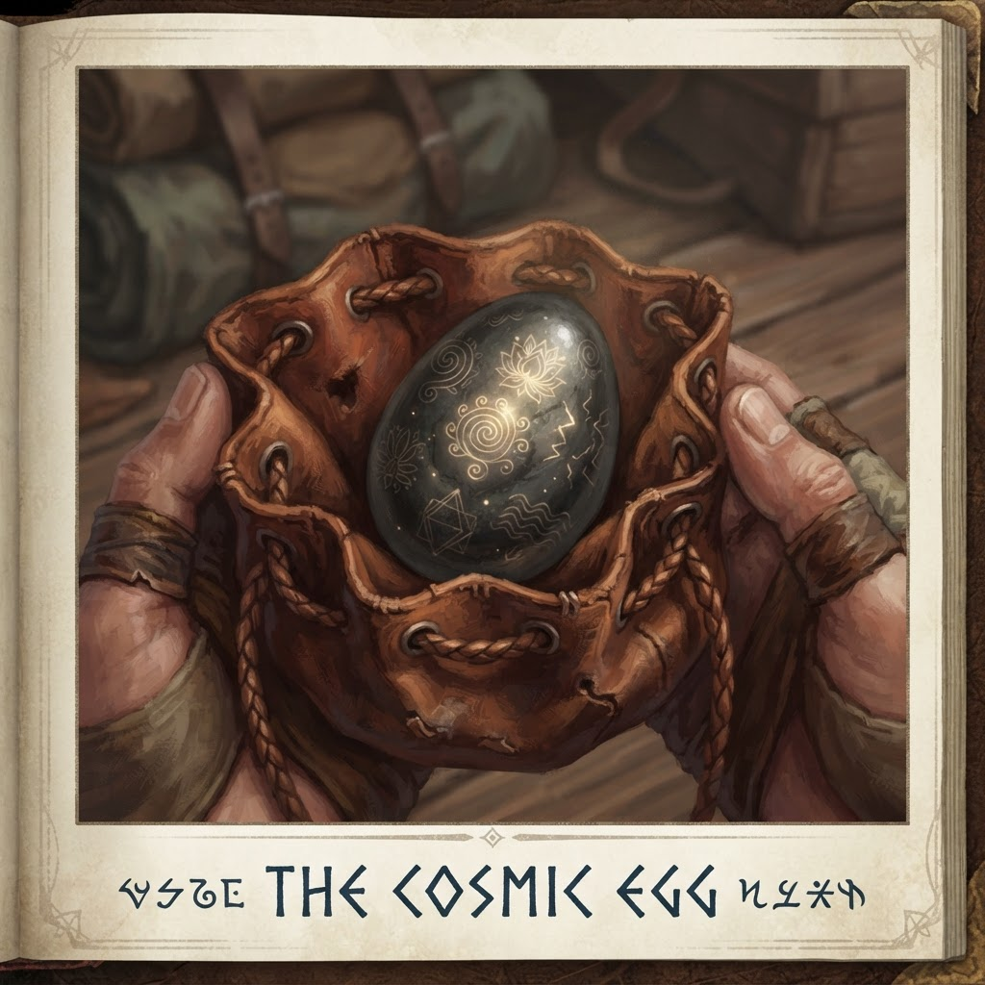
The Cosmic Egg — Container of the Murmur. The player IS the Egg.

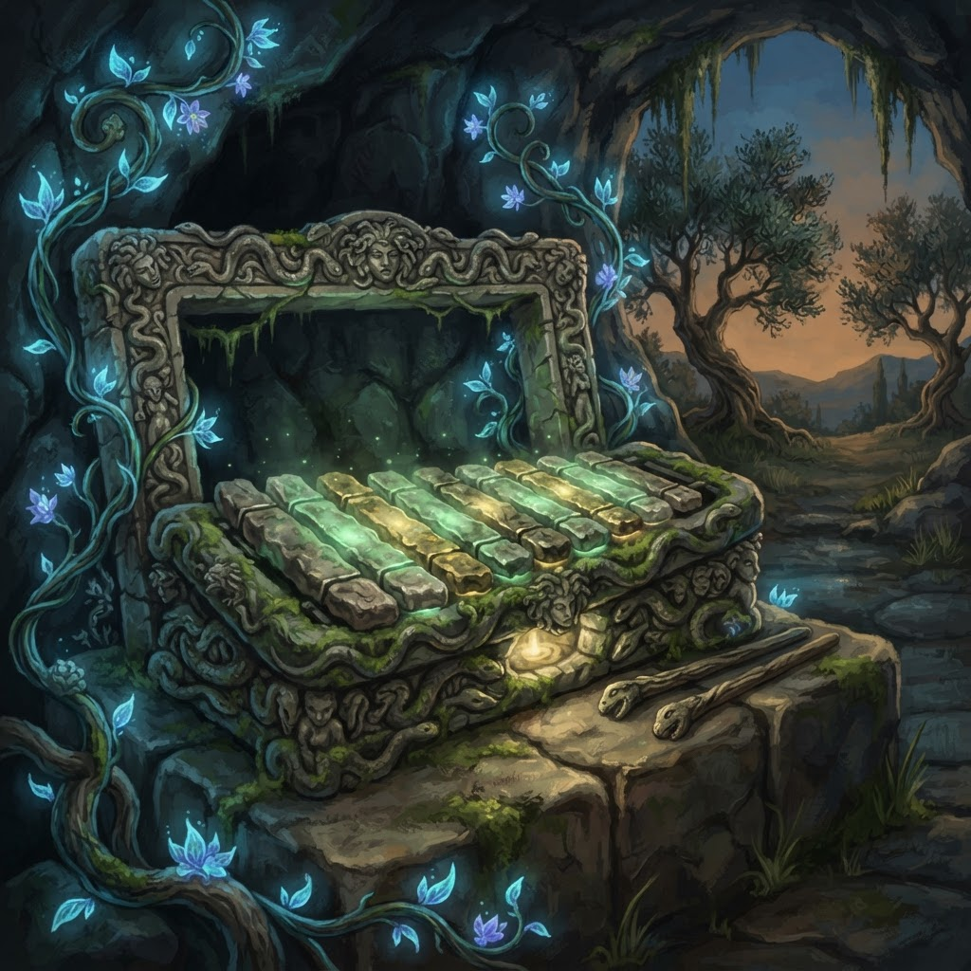
Medusa's Lithophone — Stone xylophone of petrified beings, plays the 42Hz Song

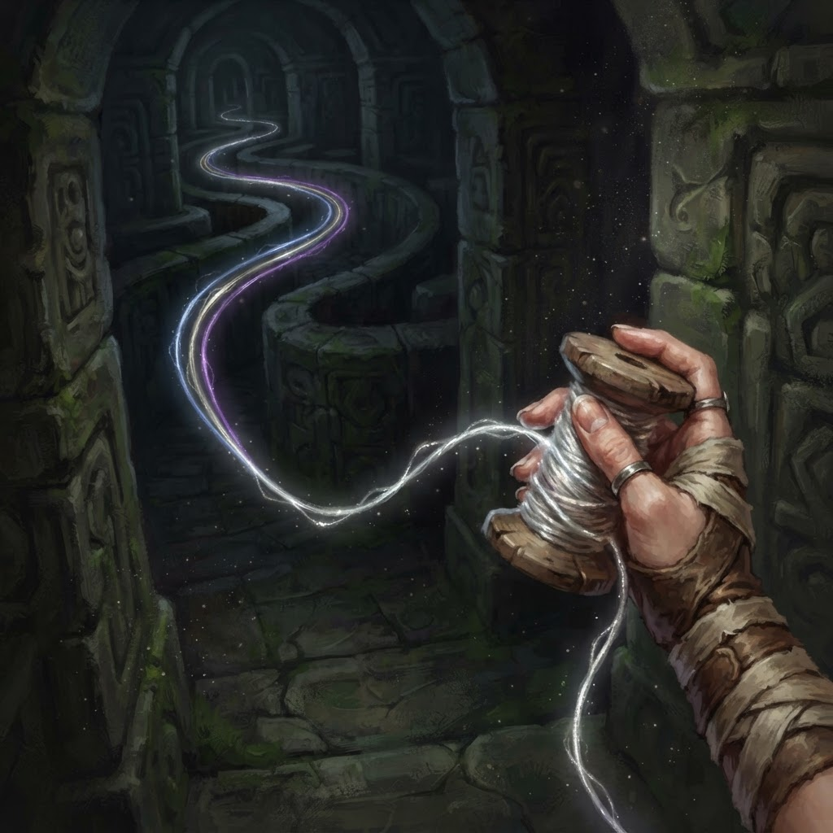
Ariadne's Vibrating Thread — Guide through the labyrinth, connects three worlds

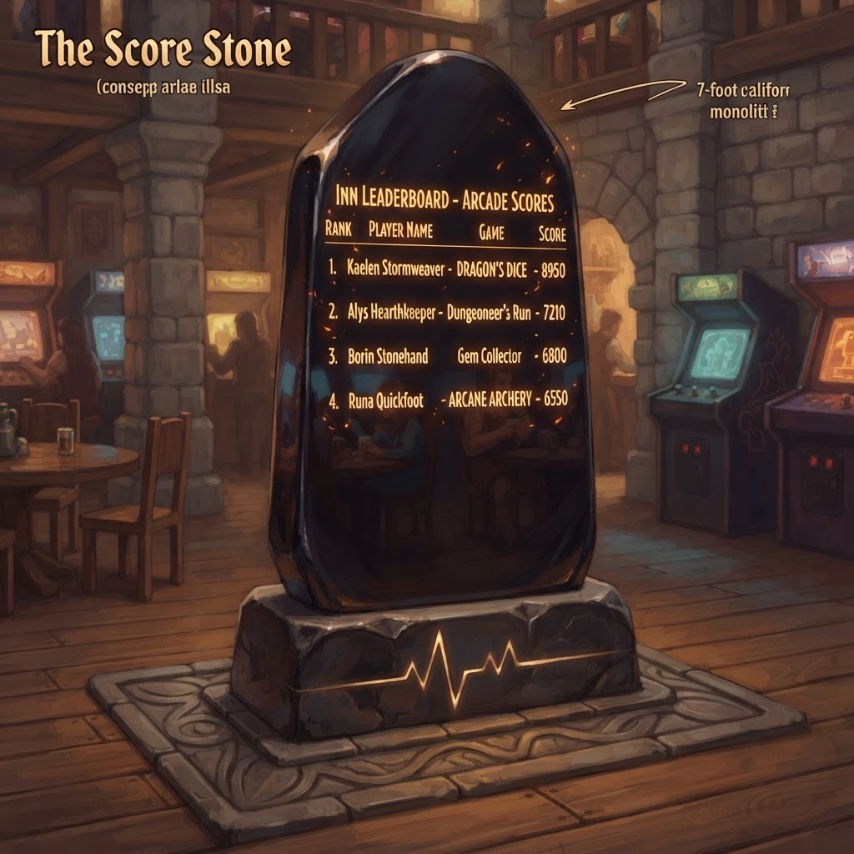
The Score Stone — 7-foot obsidian leaderboard monolith

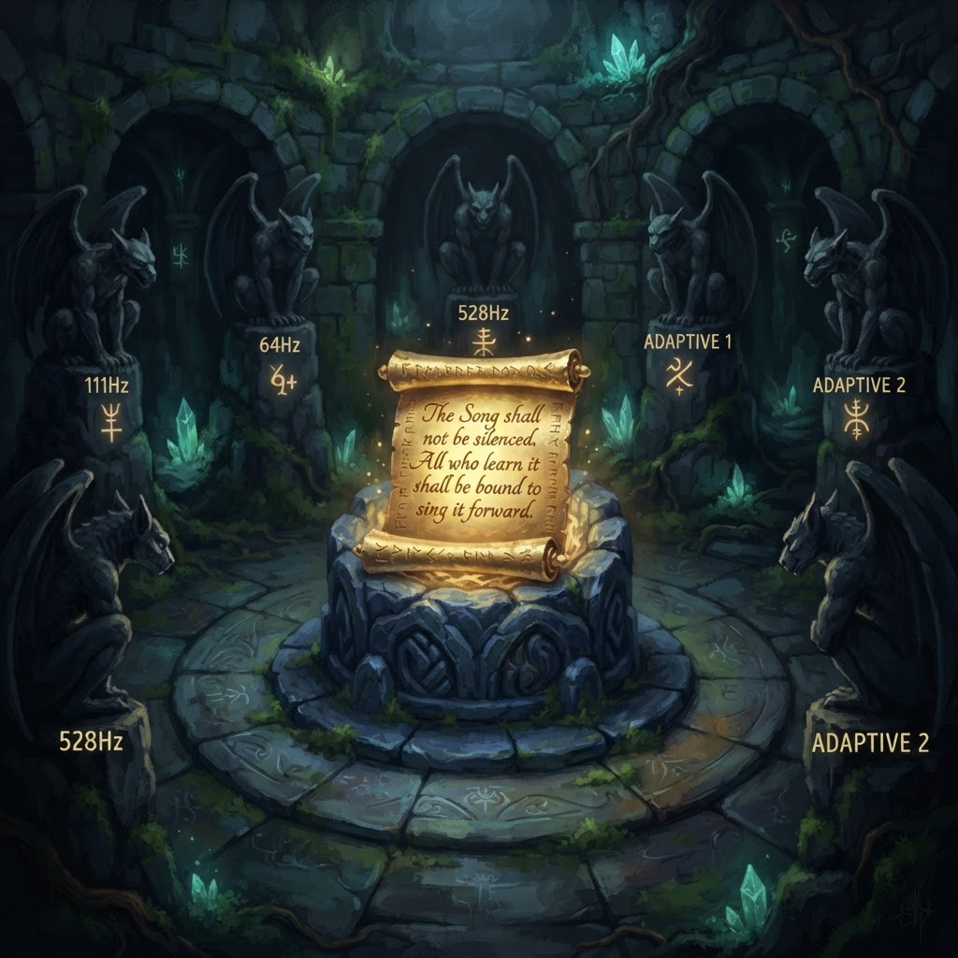
The Golden Contract — 'The Song shall not be silenced...'

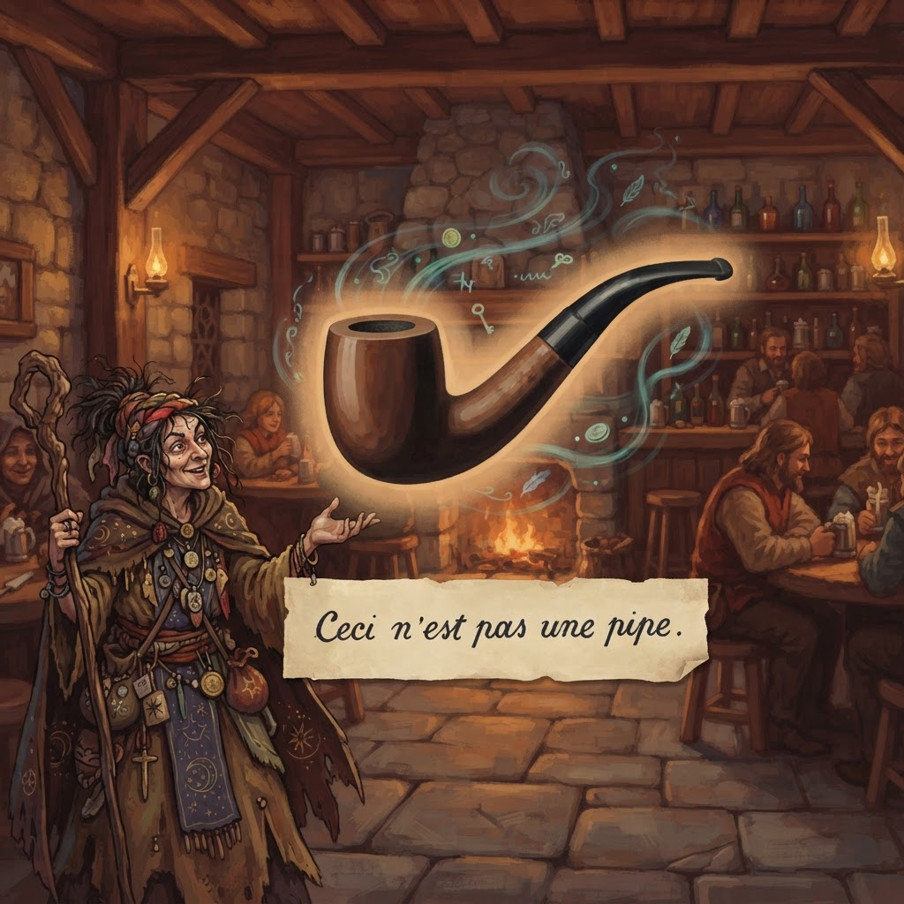
Magritte's Pipe — Sentient floating pipe, 'Ceci n'est pas une pipe'

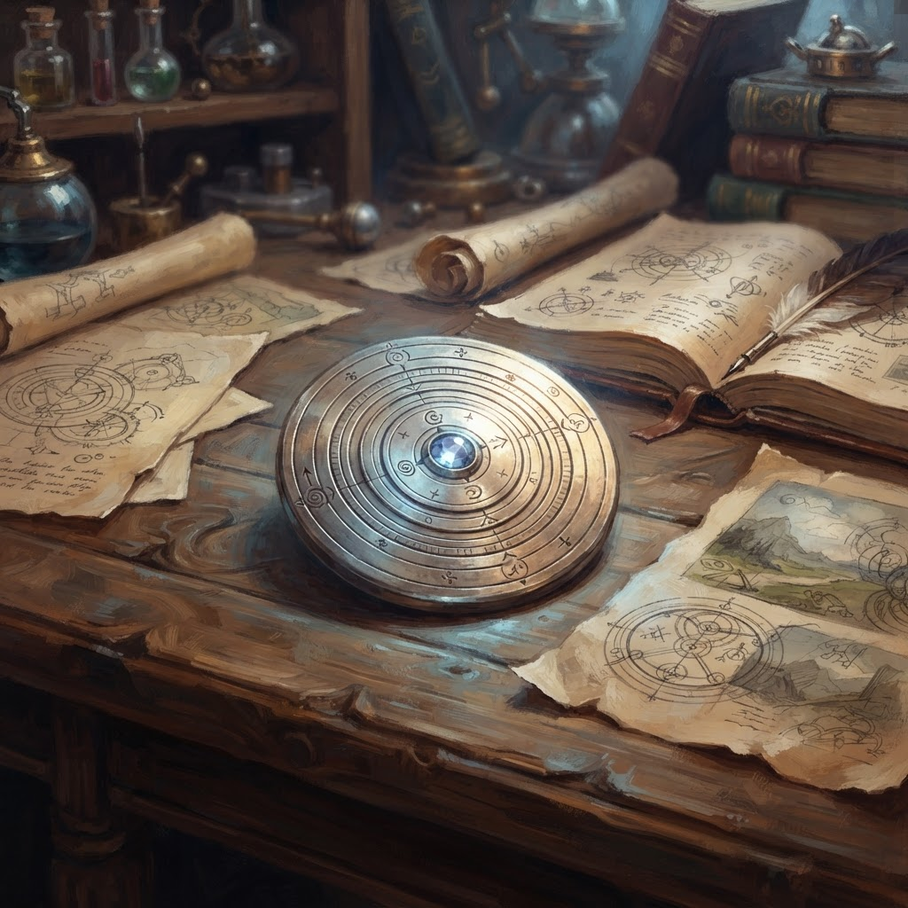
Tesla's Silver Disc — Temporal viewing device

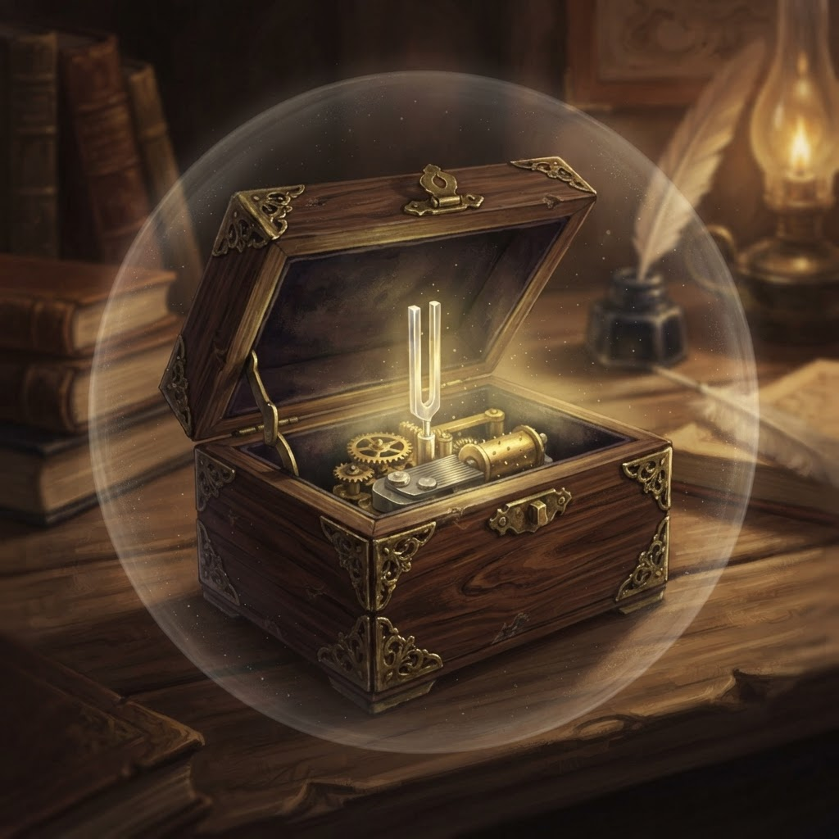
Death's Music Box — Plays the note Death MADE, not caught

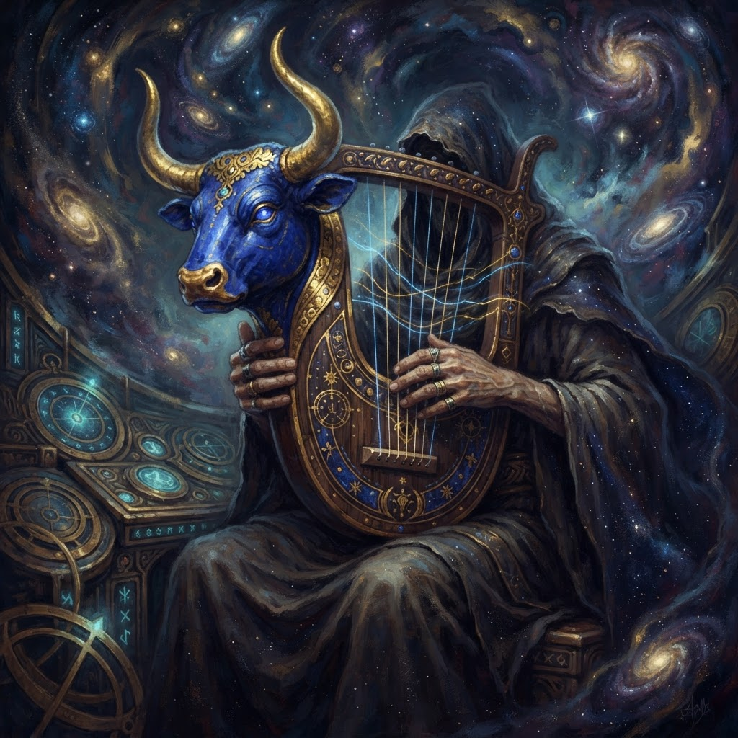
The Bull Lyre of Ur — Oldest known instrument, 42Hz

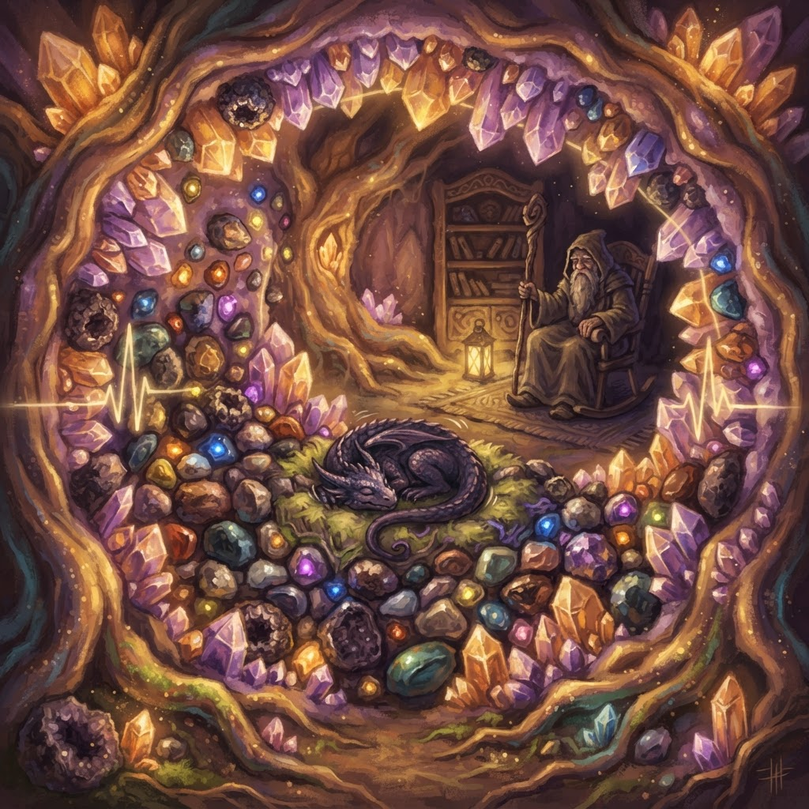
The Geode Cave — Player's personal crystal inventory, symphony of chimes

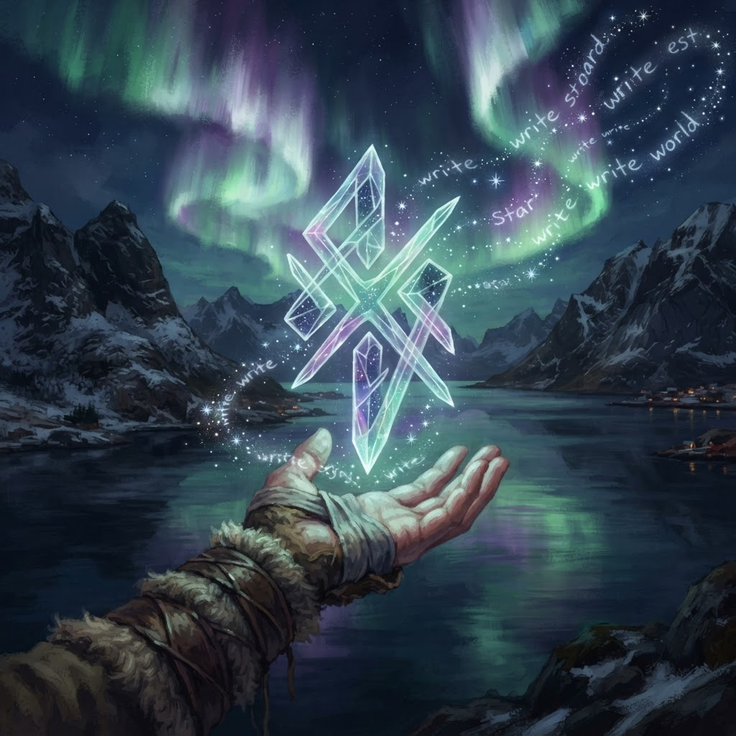
The Star-Glyph — A new word the stars have never written before

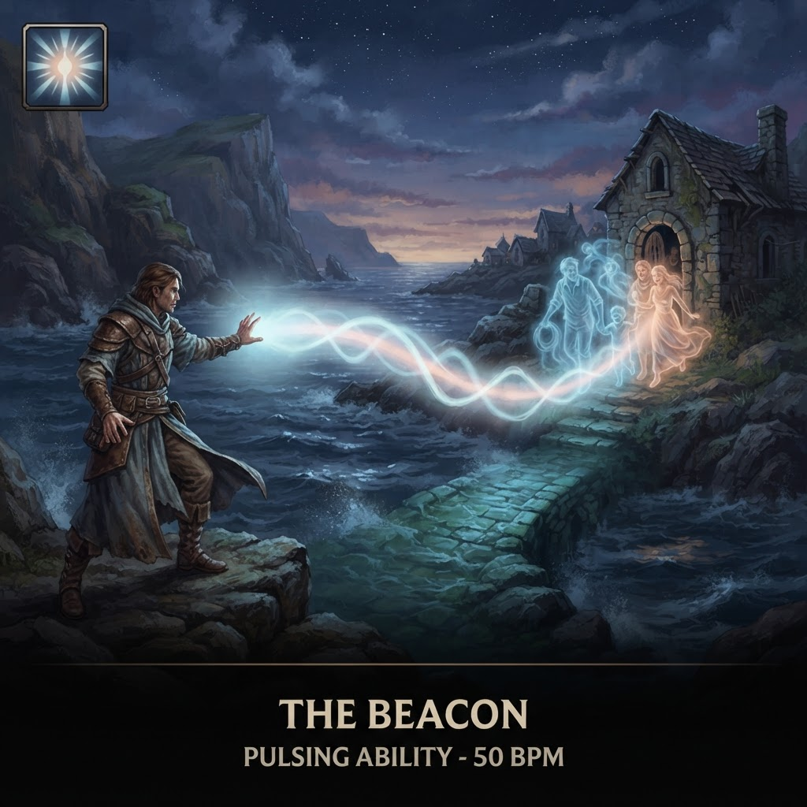
The Beacon — 42Hz piezoluminescent lighthouse beam ability

