internal note
Mathematical Observation Models
M. Jones, T. Hubinek, M. Barbier
Abstract
Description of the new mathematical observation models for LGC2.

Mots-clés : LGC2, modélisation des observations
Key words : LGC2, mathematical observation models

tABLE of contents

1. General mathematic model 1
1.1 Generic observation equation 1
1.2 Point transformations 2
1.2.1 Local Reference Frame Tranformations 2
1.2.1.1 Cartesian Coordinate Transformation 2
1.2.1.2 Homogeneous Coordinates Transformation 2
1.2.1.3 Direct transformation: transformation from the Point reference system (step up) 5
1.2.1.4 Inverse transformation: transformation to the Instrument reference system (step down) 8
1.2.1.5 Covariance matrix transformation 10
1.2.2 Transformation from the CERN Coordinate System (CCS) to Instrument Local Astronomical 11
1.2.2.1 CCS to CERN Geodetic Syxtem (CGRF) 12
1.2.2.2 CGRF to Instrument System Geodetic 13
1.2.2.3 Instrument System Geodetic to Instrument Local Astronomical 15
1.2.2.4 Conclusion 15
2. Polar instrument observation models 17
2.1 Polar measurement (PLR3D) for a TSTN 17
2.1.1 Mathematical Model 17
2.1.2 Partial Derivatives 18
2.1.3 Stochastic model 19
2.1.4 Objects 19
2.2 Polar measurement (UVD) for a CAM 20
2.2.1 Mathematical Model 20
2.2.2 Partial Derivatives 20
2.2.3 Objects 21
2.3 Horizontal dir. + Zenith dist. (UVEC) for a CAM 21
2.3.1 Mathematical Model 21
2.3.2 Mathematical Model 21
2.3.3 Partial Derivatives 21
2.3.4 Objects 22
2.1 Horizontal direction (ANGL) 22
2.1.1 Mathematical Model 22
2.1.2 Partial Derivatives 22
2.1.3 Stochastic model 23
2.1.4 Objects 23
2.2 Zenith distance (ZENI / ZENH / XXXX) 23
2.2.1 Mathematical Model 23
2.2.2 Partial Derivatives 23
2.2.3 Stochastic model 24
2.2.4 Objects 24
2.3 Spatial Distance (DMES / DTHE / XXXX) 25
2.3.1 Mathematical Model 25
2.3.2 Partial Derivatives 25
2.3.3 Stochastic model 25
2.3.4 Objects 26
2.4 Horizontal distance (DHOR) 26
2.4.1 Mathematical Model 26
2.4.2 Partial Derivatives 26
2.4.3 Stochastic model 26
2.4.4 Objects 27
3. Vertical distance measurement models 28
3.1 Vertical distance (DLEV) – Local Reference System 28
3.1.1 Mathematical Model 28
3.1.2 Partial Derivatives 28
3.1.3 Stochastic model 29
3.1.4 Objects 29
3.2 Vertical distance (DVER) – Geodetic Reference System 30
3.2.1 Mathematical Model 30
3.2.2 Partial Derivatives 30
3.2.3 Stochastic model 31
3.2.4 Objects 31
4. offset measurement models 32
4.1 Offset to a Vertical Plane (ECHO) 32
4.1.1 Mathematical Model 32
4.1.2 Partial Derivatives 33
4.1.3 Stochastic model 33
4.1.4 Objects 33
4.2 Offset to a Spatial Line (ECSP) 34
4.2.1 Mathematical Model 34
4.2.2 Partial Derivatives 34
4.2.3 Stochastic model 36
4.2.4 Objects 36
4.3 Offset to a Vertical Line (ECVE) 36
4.3.1 Mathematical Model 37
4.3.2 Partial Derivatives 37
4.3.3 Stochastic model 38
4.3.4 Objects 38
4.4 Offset to a Theodolite Plane (ECTH) 38
4.4.1 Mathematical Model 39
4.4.2 Partial Derivatives 39
4.4.3 Stochastic model 40
4.4.4 Objects 40
5. additional measurement models 41
5.1 5.1 Gyro-Theodolite Azimuth (ORIE) 41
5.1.1 Mathematical Model 41
5.1.2 Partial Derivatives 41
5.1.3 Stochastic model 42
5.1.4 Objects 42
6. Constraint models 43
6.1 6.1 Radial Offset Constraint (RADI) 43
6.1.1 Mathematical Model 43
6.1.2 Partial Derivatives 43
6.1.3 Stochastic model 43
6.1.4 Objects 43
6.2 Orientation Constraint (PDOR) 44
6.2.1 Mathematical Model 44
6.2.2 Partial Derivatives 44
6.2.3 Objects 44
6.3 Point Coordinate 44
6.3.1 Mathematical Model 44
6.3.2 Partial Derivatives 45
6.3.3 Stochastic model 45
6.3.4 Objects 46
7. References 47

General mathematic model

Survey instrument or target:
- position defined in the CCS, or a Local Object Reference (LOR) system
- orientation defined with respect to a Modified Local Astronomical (MLA) system, or a LOR system

Generic observation equation

The mathematical model for an observation can be represented by the following function,

$$F\left(\underline{x}, \underline{l}\right)=0$$

where,
$\underline{x}=\left(x_{1},…,x_{u}\right)$ — vector of unknown parameters
$\underline{l}=\left(l_{1},…, l_{n}\right)$— vector of observations

Alternatively this could be broken down further to give,

$$F_{L}\left({\underline{x}}_{L}, \underline{l}\right)-F_{R}\left(\underline{∆X},{\underline{x}}_{R}\right)=0$$

where,
$x_{K}$ — Observation Unknowns
$x_{R}$ — Observation Reference Frame Unknowns

and X is a function of several parameters,

$$\underline{∆X}=F_{P}\left(X_{T},{\underline{H}}_{T},X_{S},{\underline{H}}_{I}\right)$$

where
$X_{T}$ — target position in Observation Reference Frame
$X_{S}$ — station position in Observation Reference Frame
${\underline{H}}_{T}$— target height
${\underline{H}}_{I}$— instrument height

Now the point coordinates must be transformed into the Observation Reference Frame. Let then be described by the following transformation functions,

$$X_{T}=M_{T}\left({\underline{x}}_{T}\right)$$
$$X_{S}=M_{S}\left({\underline{x}}_{S}\right)$$

Substituting for X_{T} and X_{S} gives,

$$\underline{∆X}=F_{P}\left(M_{T}\left({\underline{x}}_{T}\right),{\underline{H}}_{T},M_{S}\left({\underline{x}}_{S}\right),{\underline{H}}_{I}\right)$$

Point transformations

Local Reference Frame Tranformations

Let us first consider the transformation between two Cartesian local object reference frame LOR1 and LOR2, where the transformation between any two related frames is a simple Helmert transformation, and let the transformation from LOR1 to LOR2 involve a series of transformations through connected reference frames.

Cartesian Coordinate Transformation
In Cartesian coordinates the transformation between the reference frames can be defined as follows,

$$x_{LOR1}=x_{0}=l_{0}{·R}_{0}·x_{0}+T_{0}$$

$$x_{1}=l_{1}{·R}_{1}·x_{0}+T_{1}$$
and,
$$X_{LOR2}^{ }=x_{n}=l_{n}·R_{n}·x_{n-1}+T_{n}$$

where,
$$x_{i}=point coordinate vector \\ l_{i}=transformation scale factor$$

$$R_{i}\left(ω,φ,κ\right)=3D Rotation Matrix=\left(\begin{matrix}r_{i,11} & r_{i,12} & r_{i,13} \\ r_{i,21} & r_{i,22} & r_{i,23} \\ r_{i,31} & r_{i,32} & r_{i,33}\end{matrix}\right)$$
$$T_{i}=3D translation vector=\left(\begin{matrix}t_{i,1} \\ t_{i,2} \\ t_{i,3}\end{matrix}\right)$$
and,

$${l_{0}=1,{ R}_{0}=\left(\begin{matrix}1 & 0 & 0 \\ 0 & 1 & 0 \\ 0 & 0 & 1\end{matrix}\right),T}_{0}=\left(\begin{matrix}0 \\ 0 \\ 0\end{matrix}\right)$$

We can therefore write,
$$X_{LOR2}^{ }=x_{n}=\prod_{i=n}^{0}{{l_{i}·R}_{i}·}x_{0}+\sum_{m=1}^{n}{\left(\prod_{i=n}^{m}{{l_{i}·R}_{i}}\right)·T_{m-1}}+T_{n}$$

Homogeneous Coordinates Transformation
In homogeneous coordinates the transformation between the reference frames can be defined more simply as follows,

Let the points have homogeneous coordinates,

$${x_{i}^{h}}_{ }=\left[\begin{matrix}\begin{matrix}x_{i}^{h} \\ y_{i}^{h}\end{matrix} \\ \begin{matrix}z_{i}^{h} \\ w_{i}\end{matrix}\end{matrix}\right]$$
And let,
$$x_{0}^{h}=\left[\begin{matrix}\begin{matrix}x_{0}^{ } \\ y_{0}^{ }\end{matrix} \\ \begin{matrix}z_{0}^{ } \\ 1\end{matrix}\end{matrix}\right]$$

Then we can write,
$$X_{LOR2}^{h}=\prod_{i=n}^{0}{M_{i}}{·x_{0}^{h}}_{ }$$

Where,
$$M_{i}=\left[\begin{matrix}\begin{matrix}r_{i,11} & r_{i,12} & r_{i,13} \\ r_{i,21} & r_{i,22} & r_{i,23} \\ r_{i,31} & r_{i,32} & r_{i,33}\end{matrix} & \begin{matrix}t_{i,1}/l_{i} \\ t_{i,2}/l_{i} \\ t_{i,3}/l_{i}\end{matrix} \\ \begin{matrix}0 & 0 & 0\end{matrix} & 1/l_{i}\end{matrix}\right]$$

Let,
$$M_{j,m}=\prod_{i=j}^{m}{M_{i}}=\left[\begin{matrix}\begin{matrix}M_{jm,11} & M_{jm,12} & M_{jm,13} \\ M_{jm,21} & M_{jm,22} & M_{jm,23} \\ M_{jm,31} & M_{jm,32} & M_{jm,33}\end{matrix} & \begin{matrix}M_{jm,14} \\ M_{jm,24} \\ M_{jm,34}\end{matrix} \\ \begin{matrix}0 & 0 & 0\end{matrix} & M_{jm,44}\end{matrix}\right]$$

Then,
$$X_{LOR2}^{h}=M_{n,0}·x_{0}^{h}$$

Above, the general transformation model was described. However, from implementation point of view, it is necessary to define direction in the tree, which includes local frames, and to distinguish between paths up and down.
We define step up to be represented by$M_{i}^{ }$ and step down $M_{i}^{-1}$by $($which is inverse of the step up) and introduce following labelling for determining path in the tree:

${}_{P}^{ }{M_{0}^{ }}$— Identity transformation in the Point object reference.
${}_{P}^{ }{M_{i}^{ }}$ — i-th step up from the Point object reference (path up is unambiguous).
${}_{I}^{ }{{M_{0}^{ }}^{-1}}$— Identity transformation in the Instrument object reference.
${}_{I}^{ }{M_{i}^{-1 }}$— Inverse of i-th step up from the Instrument object reference (i.e. its step down).
${}_{I}^{ }{M_{i}^{ }}$—i-th step up from the Instrument object reference (path up is unambiguous).

Considering this, for a path which gives us from the Point local reference to the Instrument local reference, we get (see illustration on Figure below),

- n-steps up,
$${}_{P}^{ }{M_{n,0}^{ }}=\prod_{i=n}^{0}{{}_{P}^{ }{M_{i}^{ }}}$$
- m-steps down,
$${}_{I}^{ }{M_{0,m}^{* }}=\prod_{i=0}^{m}{{}_{I}^{ }{{M_{i}^{ }}^{-1}}}$$

Note that transformation to CCS requires only steps up.

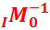
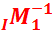
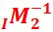

Then,
 | $$M={}_{I}^{ }{M_{0,m}^{* }}·{}_{P}^{ }{M_{n,0}^{ }}=\left[\begin{matrix}M_{11} & M_{12} & M_{13} & M_{14} \\ M_{21} & M_{22} & M_{23} & M_{24} \\ M_{31} & M_{32} & M_{33} & M_{34} \\ 0 & 0 & 0 & M_{44}\end{matrix}\right]$$ | (1.1)

Finally,
$X_{LOR2}^{h}={}_{I}^{ }{M_{0,m}^{* }}·{}_{P}^{ }{M_{n,0}^{ }}·x_{0}^{h}=M·x_{0}^{h}$

$$X_{LOR2}^{h}=\left[\begin{matrix}\begin{matrix}M_{11}x_{0}+M_{12}y_{0}+M_{13}z_{0}+M_{14} \\ M_{21}x_{0}+M_{22}y_{0}+M_{23}z_{0}+M_{24} \\ M_{31}x_{0}+M_{32}y_{0}+M_{33}z_{0}+M_{34}\end{matrix} \\ M_{44}\end{matrix}\right]=\left[\begin{matrix}{\frac{1}{L}·X}_{LOR2} \\ {\frac{1}{L}·Y}_{LOR2} \\ {\frac{1}{L}·Z}_{LOR2} \\ \frac{1}{L}\end{matrix}\right]=\frac{1}{L}·\left[\begin{matrix}X_{LOR2} \\ Y_{LOR2} \\ Z_{LOR2} \\ 1\end{matrix}\right]$$

$L={}_{I}^{ }{l_{0}^{*}}·…·{}_{I}^{ }{l_{m}^{*}}·{}_{P}^{ }{l_{n}}·…·{}_{P}^{ }{l_{0}}$ , is the transformation scale factor.

In Cartesian coordinates form (first three coordinates represent point in Cartesian c.), we have:

$$X_{LOR2}={L·X}_{LOR2}^{h}=\left[\begin{matrix}X_{LOR2} \\ Y_{LOR2} \\ Z_{LOR2} \\ 1\end{matrix}\right]$$

Giving the following partial derivatives,
$$\frac{∂X_{LOR2}}{∂x_{0}}=L·\left[\begin{matrix}\begin{matrix}M_{11} \\ M_{21} \\ M_{31}\end{matrix} \\ 0\end{matrix}\right]$$

$$\frac{∂X_{LOR2}}{∂y_{0}}=L·\left[\begin{matrix}\begin{matrix}M_{12} \\ M_{22} \\ M_{32}\end{matrix} \\ 0\end{matrix}\right]$$

$$\frac{∂X_{LOR2}}{∂z_{0}}=L·\left[\begin{matrix}\begin{matrix}M_{13} \\ M_{23} \\ M_{33}\end{matrix} \\ 0\end{matrix}\right]$$

Direct transformation: transformation from the Point reference system (step up)
Following the convention [1], a transformation is written as below:
$$M_{i}=\left(\begin{matrix}\cos{κ_{i}}·\cos{φ_{i}} & \sin{κ_{i}·\cos{φ_{i}}} & -\sin{φ_{i}} & t_{1}/l_{i} \\ -\sin{κ_{i}·\cos{ω_{i}+}}\cos{κ_{i}·\sin{φ_{i}}}·\sin{ω_{i}} & \cos{κ_{i}}·\cos{ω_{i}}+\sin{κ_{i}·\sin{φ_{i}}·sin{ω_{i}}} & \cos{φ_{i}·\sin{ω_{i}}} & t_{2}/l_{i} \\ \sin{κ_{i}·\sin{ω_{i}+}}\cos{κ_{i}·\sin{φ_{i}}}·\cos{ω_{i}} & -\cos{κ_{i}}·\sin{ω_{i}}+\sin{κ_{i}·\sin{φ_{i}}·cos{ω_{i}}} & \cos{φ_{i}·\cos{ω_{i}}} & t_{3}/l_{i} \\ 0 & 0 & 0 & 1/l_{i}\end{matrix}\right)$$

For the transformation parameters we note that,

For $1≤k<n$ ,
$${}_{P}^{ }{M_{n,0}^{ }}={}_{P}^{ }{M_{n,k+1}^{ }}·{}_{P}^{ }{M_{k,k}^{ }}·{}_{P}^{ }{M_{k-1,0}^{ }}$$
$$X_{LOR2}^{h}={}_{I}^{ }{M_{0,m}^{* }}·\left({}_{P}^{ }{M_{n,k+1}^{ }}·{}_{P}^{ }{M_{k,k}^{ }}·{}_{P}^{ }{M_{k-1,0}^{ }}\right)·x_{0}^{h}$$

In Cartesian coordinates form,

$$X_{LOR2}=\left({}_{I}^{ }{l_{0}^{*}}·…·{}_{I}^{ }{l_{m}^{*}}\right)·\left({}_{I}^{ }{M_{0,m}^{* }}\right)·\left({}_{P}^{ }{l_{n}}·…·{}_{P}^{ }{l_{0}}\right)·\left({}_{P}^{ }{M_{n,k+1}^{ }}·{}_{P}^{ }{M_{k,k}^{ }}·{}_{P}^{ }{M_{k-1,0}^{ }}\right){·x_{0}^{h}}_{ }=\left({}_{I}^{ }{l_{0}^{*}}·…·{}_{I}^{ }{l_{m}^{*}}·{}_{P}^{ }{l_{n}}·…·{}_{P}^{ }{l_{0}}\right)·\left({}_{I}^{ }{M_{0,m}^{* }}\right)·\left({}_{P}^{ }{M_{n,k+1}^{ }}·{}_{P}^{ }{M_{k,k}^{ }}·{}_{P}^{ }{M_{k-1,0}^{ }}\right)·x_{0}^{h}=L·({}_{I}^{ }{M_{0,m}^{* }})·\left({}_{P}^{ }{M_{n,k+1}^{ }}·{}_{P}^{ }{M_{k,k}^{ }}·{}_{P}^{ }{M_{k-1,0}^{ }}\right)·x_{0}^{h}$$

If$k=n$ , then

$${}_{P}^{ }{M_{n,k+1}^{ }}=identity transformation=I$$

Case $k=0$ is not considered, since it is an identity transformation.
Giving the following partial derivatives,

Angle partial derivatives:
$$\frac{∂X_{LOR2}}{∂{}_{P}^{ }{ω_{k}}}=L·{}_{I}^{ }{M_{0,m}^{* }}·{}_{P}^{ }{M_{n,k+1}^{ }}·\left[\begin{matrix}\frac{∂{}_{P}^{ }{r_{k,11}}}{∂{}_{P}^{ }{ω_{k}}} & \frac{∂{}_{P}^{ }{r_{k,12}}}{∂{}_{P}^{ }{ω_{k}}} & \begin{matrix}\frac{∂{}_{P}^{ }{r_{k,13}}}{∂{}_{P}^{ }{ω_{k}}} & 0\end{matrix} \\ \frac{∂{}_{P}^{ }{r_{k,21}}}{∂{}_{P}^{ }{ω_{k}}} & \frac{∂{}_{P}^{ }{r_{k,22}}}{∂{}_{P}^{ }{ω_{k}}} & \begin{matrix}\frac{∂{}_{P}^{ }{r_{k,23}}}{∂{}_{P}^{ }{ω_{k}}} & 0\end{matrix} \\ \begin{matrix}\frac{∂{}_{P}^{ }{r_{k,31}}}{∂{}_{P}^{ }{ω_{k}}} \\ 0\end{matrix} & \begin{matrix}\frac{∂{}_{P}^{ }{r_{k,32}}}{∂{}_{P}^{ }{ω_{k}}} \\ 0\end{matrix} & \begin{matrix}\frac{∂{}_{P}^{ }{r_{k,33}}}{∂{}_{P}^{ }{ω_{k}}} & 0 \\ 0 & 0\end{matrix}\end{matrix}\right]·{}_{P}^{ }{M_{k-1,0}^{ }}·x_{0}^{h}=$$
$$=L·{}_{I}^{ }{M_{0,m}^{* }}·{}_{P}^{ }{M_{n,k+1}^{ }}··\left[\begin{matrix}0 & 0 & 0 & 0 \\ \sin{{}_{P}^{ }{ω_{k}}·\sin{{}_{P}^{ }{κ_{k}}+\cos{{}_{P}^{ }{ω_{k}}}·\cos{{}_{P}^{ }{κ_{k}}}·}}\sin{{}_{P}^{ }{φ_{k}}} & -\sin{{}_{P}^{ }{ω_{k}}·\cos{{}_{P}^{ }{κ_{k}}+\cos{{}_{P}^{ }{ω_{k}}}·\sin{{}_{P}^{ }{κ_{k}}}·}}\sin{{}_{P}^{ }{φ_{k}}} & \cos{{}_{P}^{ }{ω_{k}}}·\cos{{}_{P}^{ }{φ_{k}}} & 0 \\ \cos{{}_{P}^{ }{ω_{k}}·\sin{{}_{P}^{ }{κ_{k}}-\sin{{}_{P}^{ }{ω_{k}}}·\cos{{}_{P}^{ }{κ_{k}}}·}}\sin{{}_{P}^{ }{φ_{k}}} & -\cos{{}_{P}^{ }{ω_{k}}·\cos{{}_{P}^{ }{κ_{k}}-\sin{{}_{P}^{ }{ω_{k}}}·\sin{{}_{P}^{ }{κ_{k}}}·}}\sin{{}_{P}^{ }{φ_{k}}} & -\sin{{}_{P}^{ }{ω_{k}}}·\cos{{}_{P}^{ }{φ_{k}}} & 0 \\ 0 & 0 & 0 & 0\end{matrix}\right].·$$
$${}_{P}^{ }{M_{k-1,0}^{ }}·x_{0}^{h}$$

$$\frac{∂X_{LOR2}}{∂{}_{P}^{ }{φ_{k}}}=L·{}_{I}^{ }{M_{0,m}^{* }}·{}_{P}^{ }{M_{n,k+1}^{ }}·\left[\begin{matrix}\frac{∂{}_{P}^{ }{r_{k,11}}}{∂{}_{P}^{ }{φ_{k}}} & \frac{∂{}_{P}^{ }{r_{k,12}}}{∂{}_{P}^{ }{φ_{k}}} & \begin{matrix}\frac{∂{}_{P}^{ }{r_{k,13}}}{∂{}_{P}^{ }{φ_{k}}} & 0\end{matrix} \\ \frac{∂{}_{P}^{ }{r_{k,21}}}{∂{}_{P}^{ }{φ_{k}}} & \frac{∂{}_{P}^{ }{r_{k,22}}}{∂{}_{P}^{ }{φ_{k}}} & \begin{matrix}\frac{∂{}_{P}^{ }{r_{k,23}}}{∂{}_{P}^{ }{φ_{k}}} & 0\end{matrix} \\ \begin{matrix}\frac{∂{}_{P}^{ }{r_{k,31}}}{∂{}_{P}^{ }{φ_{k}}} \\ 0\end{matrix} & \begin{matrix}\frac{∂{}_{P}^{ }{r_{k,32}}}{∂{}_{P}^{ }{φ_{k}}} \\ 0\end{matrix} & \begin{matrix}\frac{∂{}_{P}^{ }{r_{k,33}}}{∂{}_{P}^{ }{φ_{k}}} & 0 \\ 0 & 0\end{matrix}\end{matrix}\right]·{}_{P}^{ }{M_{k-1,0}^{ }}·x_{0}^{h}=$$
$$=L·{}_{I}^{ }{M_{0,m}^{* }}·{}_{P}^{ }{M_{n,k+1}^{ }}.$$
$$·\left[\begin{matrix}-\cos{{}_{P}^{ }{κ_{k}}}.\sin{{}_{P}^{ }{φ_{k}}} & -\sin{{}_{P}^{ }{κ_{k}}}.\sin{{}_{P}^{ }{φ_{k}}} & -\cos{{}_{P}^{ }{φ_{k}}} & 0 \\ \cos{{}_{P}^{ }{κ_{k}}}·\cos{{}_{P}^{ }{φ_{k}}}.\sin{{}_{P}^{ }{ω_{k}}} & \sin{{}_{P}^{ }{κ_{k}}}·\cos{{}_{P}^{ }{φ_{k}}}.\sin{{}_{P}^{ }{ω_{k}}} & -\sin{{}_{P}^{ }{ω_{k}}}·\sin{{}_{P}^{ }{φ_{k}}} & 0 \\ \cos{{}_{P}^{ }{κ_{k}}}·\cos{{}_{P}^{ }{φ_{k}}}.\cos{{}_{P}^{ }{ω_{k}}} & \sin{{}_{P}^{ }{κ_{k}}}·\cos{{}_{P}^{ }{φ_{k}}}.\cos{{}_{P}^{ }{ω_{k}}} & -\cos{{}_{P}^{ }{ω_{k}}}·\sin{{}_{P}^{ }{φ_{k}}} & 0 \\ 0 & 0 & 0 & 0\end{matrix}\right].$$
$$·{}_{P}^{ }{M_{k-1,0}^{ }}·x_{0}^{h}$$

$$\frac{∂X_{LOR2}}{∂{}_{P}^{ }{κ_{k}}}=L·{}_{I}^{ }{M_{0,m}^{* }}·{}_{P}^{ }{M_{n,k+1}^{ }}·\left[\begin{matrix}\frac{∂{}_{P}^{ }{r_{k,11}}}{∂{}_{P}^{ }{κ_{k}}} & \frac{∂{}_{P}^{ }{r_{k,12}}}{∂{}_{P}^{ }{κ_{k}}} & \begin{matrix}\frac{∂{}_{P}^{ }{r_{k,13}}}{∂{}_{P}^{ }{κ_{k}}} & 0\end{matrix} \\ \frac{∂{}_{P}^{ }{r_{k,21}}}{∂{}_{P}^{ }{κ_{k}}} & \frac{∂{}_{P}^{ }{r_{k,22}}}{∂{}_{P}^{ }{κ_{k}}} & \begin{matrix}\frac{∂{}_{P}^{ }{r_{k,23}}}{∂{}_{P}^{ }{κ_{k}}} & 0\end{matrix} \\ \begin{matrix}\frac{∂{}_{P}^{ }{r_{k,31}}}{∂{}_{P}^{ }{κ_{k}}} \\ 0\end{matrix} & \begin{matrix}\frac{∂{}_{P}^{ }{r_{k,32}}}{∂{}_{P}^{ }{κ_{k}}} \\ 0\end{matrix} & \begin{matrix}\frac{∂{}_{P}^{ }{r_{k,33}}}{∂{}_{P}^{ }{κ_{k}}} & 0 \\ 0 & 0\end{matrix}\end{matrix}\right]·{}_{P}^{ }{M_{k-1,0}^{ }}·x_{0}^{h}=$$
$$=L·{}_{I}^{ }{M_{0,m}^{* }}·{}_{P}^{ }{M_{n,k+1}^{ }·}$$
$$·\left[\begin{matrix}-\sin{{}_{P}^{ }{κ_{k}}}.\cos{{}_{P}^{ }{φ_{k}}} & \cos{{}_{P}^{ }{κ_{k}}}.\cos{{}_{P}^{ }{φ_{k}}} & 0 & 0 \\ -\sin{{}_{P}^{ }{κ_{k}}}·\sin{{}_{P}^{ }{φ_{k}}}.\sin{{}_{P}^{ }{ω_{k}}}-\cos{{}_{P}^{ }{κ_{k}}}.\cos{{}_{P}^{ }{ω_{k}}} & \cos{{}_{P}^{ }{κ_{k}}}·\sin{{}_{P}^{ }{φ_{k}}}.\sin{{}_{P}^{ }{ω_{k}}}-\sin{{}_{P}^{ }{κ_{k}}}.\cos{{}_{P}^{ }{ω_{k}}} & 0 & 0 \\ -\sin{{}_{P}^{ }{κ_{k}}}·\sin{{}_{P}^{ }{φ_{k}}}.\cos{{}_{P}^{ }{ω_{k}}}+\cos{{}_{P}^{ }{κ_{k}}}.\sin{{}_{P}^{ }{ω_{k}}} & \cos{{}_{P}^{ }{κ_{k}}}·\sin{{}_{P}^{ }{φ_{k}}}.\cos{{}_{P}^{ }{ω_{k}}}+\sin{{}_{P}^{ }{κ_{k}}}.\sin{{}_{P}^{ }{ω_{k}}} & 0 & 0 \\ 0 & 0 & 0 & 0\end{matrix}\right].$$
$$·{}_{P}^{ }{M_{k-1,0}^{ }}·x_{0}^{h}$$

Translation partial derivatives:

$$\frac{∂X_{LOR2}}{∂{}_{P}^{ }{t_{k,1}}}=L·{}_{I}^{ }{M_{0,m}^{* }}·{}_{P}^{ }{M_{n,k+1}^{ }}·\left[\begin{matrix}\begin{matrix}0 & 0 & 0 & 1/{}_{P}^{ }{l_{k}} \\ 0 & 0 & 0 & 0 \\ 0 & 0 & 0 & 0 \\ 0 & 0 & 0 & 0\end{matrix}\end{matrix}\right]··{}_{P}^{ }{M_{k-1,0}^{ }}·x_{0}^{h}$$

$$\frac{∂X_{LOR2}}{∂{}_{P}^{ }{t_{k,2}}}=L·{}_{I}^{ }{M_{0,m}^{* }}·{}_{P}^{ }{M_{n,k+1}^{ }}·\left[\begin{matrix}\begin{matrix}0 & 0 & 0 & 0 \\ 0 & 0 & 0 & 1/{}_{P}^{ }{l_{k}} \\ 0 & 0 & 0 & 0 \\ 0 & 0 & 0 & 0\end{matrix}\end{matrix}\right]··{}_{P}^{ }{M_{k-1,0}^{ }}·x_{0}^{h}$$

$$\frac{∂X_{LOR2}}{∂{}_{P}^{ }{t_{k,3}}}=L·{}_{I}^{ }{M_{0,m}^{* }}·{}_{P}^{ }{M_{n,k+1}^{ }}·\left[\begin{matrix}\begin{matrix}0 & 0 & 0 & 0 \\ 0 & 0 & 0 & 0 \\ 0 & 0 & 0 & 1/{}_{P}^{ }{l_{k}} \\ 0 & 0 & 0 & 0\end{matrix}\end{matrix}\right]··{}_{P}^{ }{M_{k-1,0}^{ }}·x_{0}^{h}$$

Scale factor partial derivatives:

$$\frac{∂X_{LOR2}}{∂{}_{P}^{ }{l_{k}}}=\left({}_{I}^{ }{l_{0}^{*}}·…·{}_{I}^{ }{l_{m}^{*}}·{}_{P}^{ }{l_{n}}·…·{}_{P}^{ }{l_{k+1}}·1·{}_{P}^{ }{l_{k-1}}·…{}_{P}^{ }{l_{0}}\right)·{}_{I}^{ }{M_{0,m}^{* }}·{}_{P}^{ }{M_{n,k+1}^{ }}·\left[\begin{matrix}\begin{matrix}0 & 0 & 0 & \frac{-1}{{\left({}_{P}^{ }{l_{k}}\right)}^{2}} \\ 0 & 0 & 0 & \frac{1}{{\left({}_{P}^{ }{l_{k}}\right)}^{2}} \\ 0 & 0 & 0 & \frac{-1}{{\left({}_{P}^{ }{l_{k}}\right)}^{2}} \\ 0 & 0 & 0 & \frac{-1}{{\left({}_{P}^{ }{l_{k}}\right)}^{2}}\end{matrix}\end{matrix}\right]·{}_{P}^{ }{M_{k-1,0}^{ }}·x_{0}^{h}$$

Inverse transformation: transformation to the Instrument reference system (step down)

For$1≤k<m$,

$${}_{I}^{ }{M_{0,m}^{* }}={}_{I}^{ }{M_{0,k-1}^{* }}·{}_{I}^{ }{M_{k,k}^{* }}·{}_{I}^{ }{M_{k+1,m}^{* }}$$
$$X_{LOR2}^{h}=\left({}_{I}^{ }{M_{0,k-1}^{* }}·{}_{I}^{ }{M_{k,k}^{* }}·{}_{I}^{ }{M_{k+1,m}^{* }}\right){·{}_{P}^{ }{M_{n,0}^{ }}·x_{0}^{h}}_{ }$$

In Cartesian form,

$$X_{LOR2}=\left({}_{I}^{ }{l_{0}^{*}}·…·{}_{I}^{ }{l_{m}^{*}}\right)·\left({}_{I}^{ }{M_{0,k-1}^{* }}·{}_{I}^{ }{M_{k,k}^{* }}·{}_{I}^{ }{M_{k+1,m}^{* }}\right){·\left({}_{P}^{ }{l_{n}}·…·{}_{P}^{ }{l_{0}}\right)·\left({}_{P}^{ }{M_{n,0}^{ }}\right)·x_{0}^{h}}_{ }==\left({}_{I}^{ }{l_{0}^{*}}·…·{}_{I}^{ }{l_{m}^{*}}·{}_{P}^{ }{l_{n}}·…·{}_{P}^{ }{l_{0}}\right)·\left({}_{I}^{ }{M_{0,k-1}^{* }}·{}_{I}^{ }{M_{k,k}^{* }}·{}_{I}^{ }{M_{k+1,m}^{* }}\right)·{}_{P}^{ }{M_{n,0}^{ }}·x_{0}^{h}=L·\left({}_{I}^{ }{M_{0,k-1}^{* }}·{}_{I}^{ }{M_{k,k}^{* }}·{}_{I}^{ }{M_{k+1,m}^{* }}\right)·({}_{P}^{ }{M_{n,0}^{ }})·x_{0}^{h}$$

If$k=m$ , then

$${}_{I}^{ }{M_{k+1,m}^{* }}=identity transformation=I$$

Case $k=0$ is not considered, since it is an identity transformation.
Note that inverse transformation of,

$${}_{ }^{ }{{M_{i,i}^{ }=M}_{i}^{ }}=\left[\begin{matrix}\begin{matrix}r_{i,11} & r_{i,12} & r_{i,13} \\ r_{i,21} & r_{i,22} & r_{i,23} \\ r_{i,31} & r_{i,32} & r_{i,33}\end{matrix} & \begin{matrix}t_{i,1}/l_{i} \\ t_{i,2}/l_{i} \\ t_{i,3}/l_{i}\end{matrix} \\ \begin{matrix}0 & 0 & 0\end{matrix} & 1/l_{i}\end{matrix}\right]$$

Is,
$${}_{ }^{ }{M_{i,i}^{*}=M_{i}^{-1}}=\left[\begin{matrix}\begin{matrix}{}_{ }^{ }{r_{i,11}^{*}} & {}_{ }^{ }{r_{i,12}^{*}} & {}_{ }^{ }{r_{i,13}^{*}} \\ {}_{ }^{ }{r_{i,21}^{*}} & {}_{ }^{ }{r_{i,22}^{*}} & {}_{ }^{ }{r_{i,23}^{*}} \\ {}_{ }^{ }{r_{i,31}^{*}} & {}_{ }^{ }{r_{i,32}^{*}} & {}_{ }^{ }{r_{i,33}^{*}}\end{matrix} & \begin{matrix}t_{i.1}^{*} \\ t_{i.2}^{*} \\ t_{i.2}^{*}\end{matrix} \\ \begin{matrix}0 & 0 & 0\end{matrix} & 1/{l_{i}^{*}}\end{matrix}\right]=\left[\begin{matrix}\begin{matrix}r_{i,11} & r_{i,21} & r_{i,31} \\ r_{i,12} & r_{i,22} & r_{i,32} \\ r_{i,13} & r_{i,23} & r_{i,33}\end{matrix} & \begin{matrix}{{-(r}_{i,11}·t}_{i,1}+r_{i,21}·t_{i,2}+r_{i,31}·t_{i,3}) \\ {{-(r}_{i,12}·t}_{i,1}+r_{i,22}·t_{i,2}+r_{i,32}·t_{i,3}) \\ {{-(r}_{i,13}·t}_{i,1}+r_{i,23}·t_{i,2}+r_{i,33}·t_{i,3})\end{matrix} \\ \begin{matrix}0 & 0 & 0\end{matrix} & l_{i}\end{matrix}\right]$$

To simplify the inverse transformation is written with the same parameters as the direct transformation.

Let,

$$R^{-1}=\left(\begin{matrix}\cos{κ_{i}}·\cos{φ_{i}} & -\sin{κ_{i}·\cos{ω_{i}+}}\cos{κ_{i}·\sin{φ_{i}}}·\sin{ω_{i}} & \sin{κ_{i}·\sin{ω_{i}+}}\cos{κ_{i}·\sin{φ_{i}}}·\cos{ω_{i}} \\ \sin{κ_{i}·\cos{φ_{i}}} & \cos{κ_{i}}·\cos{ω_{i}}+\sin{κ_{i}·\sin{φ_{i}}·sin{ω_{i}}} & -\cos{κ_{i}}·\sin{ω_{i}}+\sin{κ_{i}·\sin{φ_{i}}·cos{ω_{i}}} \\ -\sin{φ_{i}} & \cos{φ_{i}·\sin{ω_{i}}} & \cos{φ_{i}·\cos{ω_{i}}}\end{matrix}\right)$$

Angle partial derivatives:

$$\frac{∂{{}_{I}^{ }R}_{k}^{-1}}{∂{}_{I}^{ }{ω_{k}^{}}}=\left(\begin{matrix}\frac{∂{}_{I}^{ }{r_{k,11}^{*}}}{∂{}_{I}^{ }{ω_{k}^{}}} & \frac{∂{}_{I}^{ }{r_{k,12}^{*}}}{∂{}_{I}^{ }{ω_{k}^{}}} & \begin{matrix}\frac{∂{}_{I}^{ }{r_{k,13}^{*}}}{∂{}_{I}^{ }{ω_{k}^{}}}\end{matrix} \\ \frac{∂{}_{I}^{ }{r_{k,21}^{*}}}{∂{}_{I}^{ }{ω_{k}^{}}} & \frac{∂{}_{I}^{ }{r_{k,22}^{*}}}{∂{}_{I}^{ }{ω_{k}^{}}} & \begin{matrix}\frac{∂{}_{I}^{ }{r_{k,23}^{*}}}{∂{}_{I}^{ }{ω_{k}^{}}}\end{matrix} \\ \begin{matrix}\frac{∂{}_{I}^{ }{r_{k,31}^{*}}}{∂{}_{I}^{ }{ω_{k}^{}}}\end{matrix} & \begin{matrix}\frac{∂{}_{I}^{ }{r_{k,32}^{*}}}{∂{}_{I}^{ }{ω_{k}^{}}}\end{matrix} & \begin{matrix}\frac{∂{}_{I}^{ }{r_{k,33}^{*}}}{∂{}_{I}^{ }{ω_{k}^{}}}\end{matrix}\end{matrix}\right)=\left(\begin{matrix}{RO}_{11} & {RO}_{12} & {RO}_{13} \\ {RO}_{21} & {RO}_{22} & {RO}_{23} \\ {RO}_{31} & {RO}_{32} & {RO}_{33}\end{matrix}\right)=$$
$$=\left(\begin{matrix}0 & \sin{{}_{I}^{ }{ω_{k}^{}}·\sin{{{}_{I}^{ }κ}_{k}^{}+\cos{{}_{I}^{ }{ω_{k}^{}}}·\cos{{{}_{I}^{ }κ}_{k}^{}}·}}\sin{{{}_{I}^{ }φ}_{k}^{}} & \cos{{}_{I}^{ }{ω_{k}^{}}·\sin{{{}_{I}^{ }κ}_{k}^{}-\sin{{}_{I}^{ }{ω_{k}^{}}}·\cos{{{}_{I}^{ }κ}_{k}^{}}·}}\sin{{{}_{I}^{ }φ}_{k}^{}} \\ 0 & -\sin{{}_{I}^{ }{ω_{k}^{}}·\cos{{{}_{I}^{ }κ}_{k}^{}+\cos{{}_{I}^{ }{ω_{k}^{}}}·\sin{{{}_{I}^{ }κ}_{k}^{}}·}}\sin{{{}_{I}^{ }φ}_{k}^{}} & -\cos{{}_{I}^{ }{ω_{k}^{}}·\cos{{{}_{I}^{ }κ}_{k}^{}-\sin{{}_{I}^{ }{ω_{k}^{}}}·\sin{{{}_{I}^{ }κ}_{k}^{}}·}}\sin{{{}_{I}^{ }φ}_{k}^{}} \\ 0 & \cos{{}_{I}^{ }{ω_{k}^{}}·\cos{{{}_{I}^{ }φ}_{k}^{}}} & -\sin{{}_{I}^{ }{ω_{k}^{}}·\cos{{{}_{I}^{ }φ}_{k}^{}}}\end{matrix}\right)$$

$$\frac{∂{{}_{I}^{ }R}_{k}^{-1}}{∂{}_{I}^{ }{φ_{k}^{}}}=\left(\begin{matrix}\frac{∂{}_{I}^{ }{r_{k,11}^{*}}}{∂{}_{I}^{ }{φ_{k}^{}}} & \frac{∂{}_{I}^{ }{r_{k,12}^{*}}}{∂{}_{I}^{ }{φ_{k}^{}}} & \begin{matrix}\frac{∂{}_{I}^{ }{r_{k,13}^{*}}}{∂{}_{I}^{ }{φ_{k}^{}}}\end{matrix} \\ \frac{∂{}_{I}^{ }{r_{k,21}^{*}}}{∂{}_{I}^{ }{φ_{k}^{}}} & \frac{∂{}_{I}^{ }{r_{k,22}^{*}}}{∂{}_{I}^{ }{φ_{k}^{}}} & \begin{matrix}\frac{∂{}_{I}^{ }{r_{k,23}^{*}}}{∂{}_{I}^{ }{φ_{k}^{}}}\end{matrix} \\ \begin{matrix}\frac{∂{}_{I}^{ }{r_{k,31}^{*}}}{∂{}_{I}^{ }{φ_{k}^{}}}\end{matrix} & \begin{matrix}\frac{∂{}_{I}^{ }{r_{k,32}^{*}}}{∂{}_{I}^{ }{φ_{k}^{}}}\end{matrix} & \begin{matrix}\frac{∂{}_{I}^{ }{r_{k,33}^{*}}}{∂{}_{I}^{ }{φ_{k}^{}}}\end{matrix}\end{matrix}\right)=\left(\begin{matrix}{RP}_{11} & {RP}_{12} & {RP}_{13} \\ {RP}_{21} & {RP}_{22} & {RP}_{23} \\ {RP}_{31} & {RP}_{32} & {RP}_{33}\end{matrix}\right)==\left(\begin{matrix}-\sin{{{}_{I}^{ }φ}_{k}^{}·\cos{{{}_{I}^{ }κ}_{k}^{}}} & -\sin{{{}_{I}^{ }φ}_{k}^{}}·\sin{{}_{I}^{ }{ω_{k}^{}}}·\cos{{{}_{I}^{ }κ}_{k}^{}} & \cos{{{}_{I}^{ }φ}_{k}^{}}·\cos{{{}_{I}^{ }κ}_{k}^{}·cos{{}_{I}^{ }{ω_{k}^{}}}} \\ -\sin{{{}_{I}^{ }φ}_{k}^{}·\sin{{{}_{I}^{ }κ}_{k}^{}}} & \sin{{{}_{I}^{ }φ}_{k}^{}·\sin{{{}_{I}^{ }κ}_{k}^{}·\sin{{}_{I}^{ }{ω_{k}^{}}}}} & \cos{{{}_{I}^{ }φ}_{k}^{}·\sin{{{}_{I}^{ }κ}_{k}^{}·\cos{{}_{I}^{ }{ω_{k}^{}}}}} \\ -\cos{{{}_{I}^{ }φ}_{k}^{}} & -sin{{}_{I}^{ }{ω_{k}^{}}·\sin{{{}_{I}^{ }φ}_{k}^{}}} & -\sin{{{}_{I}^{ }φ}_{k}^{}·\cos{{}_{I}^{ }{ω_{k}^{}}}}\end{matrix}\right)$$

$$\frac{∂{{}_{I}^{ }R}_{k}^{-1}}{∂{}_{I}^{ }{κ_{k}^{}}}=\left(\begin{matrix}\frac{∂{}_{I}^{ }{r_{k,11}^{*}}}{∂{}_{I}^{ }{κ_{k}^{}}} & \frac{∂{}_{I}^{ }{r_{k,12}^{*}}}{∂{}_{I}^{ }{κ_{k}^{}}} & \begin{matrix}\frac{∂{}_{I}^{ }{r_{k,13}^{*}}}{∂{}_{I}^{ }{κ_{k}^{}}}\end{matrix} \\ \frac{∂{}_{I}^{ }{r_{k,21}^{*}}}{∂{}_{I}^{ }{κ_{k}^{}}} & \frac{∂{}_{I}^{ }{r_{k,22}^{*}}}{∂{}_{I}^{ }{κ_{k}^{}}} & \begin{matrix}\frac{∂{}_{I}^{ }{r_{k,23}^{*}}}{∂{}_{I}^{ }{κ_{k}^{}}}\end{matrix} \\ \begin{matrix}\frac{∂{}_{I}^{ }{r_{k,31}^{*}}}{∂{}_{I}^{ }{κ_{k}^{}}}\end{matrix} & \begin{matrix}\frac{∂{}_{I}^{ }{r_{k,32}^{*}}}{∂{}_{I}^{ }{κ_{k}^{}}}\end{matrix} & \begin{matrix}\frac{∂{}_{I}^{ }{r_{k,33}^{*}}}{∂{}_{I}^{ }{κ_{k}^{}}}\end{matrix}\end{matrix}\right)=\left(\begin{matrix}{RK}_{11} & {RK}_{12} & {RK}_{13} \\ {RK}_{21} & {RK}_{22} & {RK}_{23} \\ {RK}_{31} & {RK}_{32} & {RK}_{33}\end{matrix}\right)=$$
$$=\left(\begin{matrix}-\sin{{{}_{I}^{ }κ}_{k}^{}·\cos{{{}_{I}^{ }φ}_{k}^{}}} & -\cos{{{}_{I}^{ }κ}_{k}^{}·\cos{{}_{I}^{ }{ω_{k}^{}}-\sin{{{}_{I}^{ }κ}_{k}^{}}·}}\sin{{{}_{I}^{ }φ}_{k}^{}·sin{{}_{I}^{ }{ω_{k}^{}}}} & -\sin{{{}_{I}^{ }κ}_{k}^{}}·\sin{{{}_{I}^{ }φ}_{k}^{}}.\cos{{}_{I}^{ }{ω_{k}^{}}} \\ \cos{{{}_{I}^{ }κ}_{k}^{}·\cos{{{}_{I}^{ }φ}_{k}^{}}} & -\sin{{{}_{I}^{ }κ}_{k}^{}·\cos{{}_{I}^{ }{ω_{k}^{}}+\cos{{{}_{I}^{ }κ}_{k}^{}}·\sin{{{}_{I}^{ }φ}_{k}^{}}·}}\sin{{}_{I}^{ }{ω_{k}^{}}} & \sin{{{}_{I}^{ }κ}_{k}^{}·\sin{{}_{I}^{ }{ω_{k}^{}}+\cos{{{}_{I}^{ }κ}_{k}^{}}·}}\sin{{{}_{I}^{ }φ}_{k}^{}}·\cos{{}_{I}^{ }{ω_{k}^{}}} \\ 0 & 0 & 0\end{matrix}\right)$$

Giving the following partial derivatives,

$$\frac{∂X_{LOR2}}{∂{}_{I}^{ }{ω_{k}^{}}}=L·{}_{I}^{ }{M_{0,k-1}^{* }}·\left[\begin{matrix}{RO}_{11} & {RO}_{12} & {RO}_{13} & -({RO}_{11}·{{}_{I}^{ }t}_{k,1}^{ }+{RO}_{12}·{{}_{I}^{ }t}_{k,2}^{ }+{RO}_{13}·{{}_{I}^{ }t}_{k,3}^{ }) \\ {RO}_{21} & {RO}_{22} & {RO}_{23} & \begin{matrix}-({RO}_{21}·{{}_{I}^{ }t}_{k,1}^{ }+{RO}_{22}·{{}_{I}^{ }t}_{k,2}^{ }+{RO}_{23}·{{}_{I}^{ }t}_{k,3}^{ })\end{matrix} \\ \begin{matrix}{RO}_{31}\end{matrix} & {RO}_{32} & {RO}_{33} & \begin{matrix}-({RO}_{31}·{{}_{I}^{ }t}_{k,1}^{ }+{RO}_{32}·{{}_{I}^{ }t}_{k,2}^{ }+{RO}_{33}·{{}_{I}^{ }t}_{k,3}^{ })\end{matrix} \\ 0 & \begin{matrix}0\end{matrix} & \begin{matrix}0\end{matrix} & 0\end{matrix}\right]·{}_{I}^{ }{M_{k+1,m}^{* }}·{}_{P}^{ }{M_{n,0}^{ }}·x_{0}^{h}$$

$$\frac{∂X_{LOR2}}{∂{}_{I}^{ }{φ_{k}^{}}}=L·{}_{I}^{ }{M_{0,k-1}^{* }}·\left[\begin{matrix}{RP}_{11} & {RP}_{12} & \begin{matrix}{RP}_{13} & -({RP}_{11}·{{}_{I}^{ }t}_{k,1}^{ }+{RP}_{12}·{{}_{I}^{ }t}_{k,2}^{ }+{RP}_{13}·{{}_{I}^{ }t}_{k,3}^{ })\end{matrix} \\ {RP}_{21} & {RP}_{22} & \begin{matrix}{RP}_{23} & -({RP}_{21}·{{}_{I}^{ }t}_{k,1}^{ }+{RP}_{22}·{{}_{I}^{ }t}_{k,2}^{ }+{RP}_{23}·{{}_{I}^{ }t}_{k,3}^{ })\end{matrix} \\ \begin{matrix}{RP}_{31} \\ 0\end{matrix} & \begin{matrix}{RP}_{32} \\ 0\end{matrix} & \begin{matrix}{RP}_{33} & -({RP}_{31}·{{}_{I}^{ }t}_{k,1}^{ }+{RP}_{32}·{{}_{I}^{ }t}_{k,2}^{ }+{RP}_{33}·{{}_{I}^{ }t}_{k,3}^{ }) \\ 0 & 0\end{matrix}\end{matrix}\right]·{}_{I}^{ }{M_{k+1,m}^{* }}·{}_{P}^{ }{M_{n,0}^{ }}·x_{0}^{h}$$
$$\frac{∂X_{LOR2}}{∂{}_{I}^{ }{κ_{k}^{}}}=L·{}_{I}^{ }{M_{0,k-1}^{* }}·\left[\begin{matrix}{RK}_{11} & {RK}_{12} & \begin{matrix}{RK}_{13} & -({RK}_{11}·{{}_{I}^{ }t}_{k,1}^{ }+{RK}_{12}·{{}_{I}^{ }t}_{k,2}^{ }+{RK}_{13}·{{}_{I}^{ }t}_{k,3}^{ })\end{matrix} \\ {RK}_{21} & {RK}_{22} & \begin{matrix}{RK}_{23} & -({RK}_{21}·{{}_{I}^{ }t}_{k,1}^{ }+{RK}_{22}·{{}_{I}^{ }t}_{k,2}^{ }+{RK}_{23}·{{}_{I}^{ }t}_{k,3}^{ })\end{matrix} \\ \begin{matrix}{RK}_{31} \\ 0\end{matrix} & \begin{matrix}{RK}_{32} \\ 0\end{matrix} & \begin{matrix}{RK}_{33} & -({RK}_{31}·{{}_{I}^{ }t}_{k,1}^{ }+{RK}_{32}·{{}_{I}^{ }t}_{k,2}^{ }+{RK}_{33}·{{}_{I}^{ }t}_{k,3}^{ }) \\ 0 & 0\end{matrix}\end{matrix}\right]·{}_{I}^{ }{M_{k+1,m}^{* }}·{}_{P}^{ }{M_{n,0}^{ }}·x_{0}^{h}$$

Translation partial derivatives:

$$\frac{∂X_{LOR2}}{∂{{}_{I}^{ }t}_{k,1}^{}}=L·{}_{I}^{ }{M_{0,k-1}^{* }}·\left[\begin{matrix}0 & 0 & 0 & -\cos{κ_{i}}·\cos{φ_{i}} \\ 0 & 0 & 0 & -\cos{κ_{i}}·\sin{φ_{i}} \\ 0 & 0 & 0 & \sin{φ_{i}} \\ 0 & 0 & 0 & 0\end{matrix}\right]·{}_{I}^{ }{M_{k+1,m}^{* }}·{}_{P}^{ }{M_{n,0}^{ }}·x_{0}^{h}$$

$$\frac{∂X_{LOR2}}{∂{{}_{I}^{ }t}_{k,2}^{}}=L·{}_{I}^{ }{M_{0,k-1}^{* }}·\left[\begin{matrix}0 & 0 & 0 & -(-\sin{κ_{i}·\cos{ω_{i}+}}\cos{κ_{i}·\sin{φ_{i}}}·\sin{ω_{i}}) \\ 0 & 0 & 0 & -(\cos{κ_{i}·\cos{ω_{i}+}}\sin{κ_{i}·\sin{φ_{i}}}·\sin{ω_{i}}) \\ 0 & 0 & 0 & -(\cos{φ_{i}}·\sin{ω_{i}}) \\ 0 & 0 & 0 & 0\end{matrix}\right]·{}_{I}^{ }{M_{k+1,m}^{* }}·{}_{P}^{ }{M_{n,0}^{ }}·x_{0}^{h}$$

$$\frac{∂X_{LOR2}}{∂{{}_{I}^{ }t}_{k,3}^{}}=L·{}_{I}^{ }{M_{0,k-1}^{* }}·\left[\begin{matrix}0 & 0 & 0 & -(\sin{κ_{i}·\sin{ω_{i}+}}\cos{κ_{i}·\sin{φ_{i}}}·\cos{ω_{i}}) \\ 0 & 0 & 0 & -(-\cos{κ_{i}·\sin{ω_{i}+}}\sin{κ_{i}·\sin{φ_{i}}}·\cos{ω_{i}}) \\ 0 & 0 & 0 & -(\cos{φ_{i}}·\cos{ω_{i}}) \\ 0 & 0 & 0 & 0\end{matrix}\right]·{}_{I}^{ }{M_{k+1,m}^{* }}·{}_{P}^{ }{M_{n,0}^{ }}·x_{0}^{h}$$

Scale factor partial derivatives:

$$\frac{∂X_{LOR2}}{∂{}_{I}^{ }{l_{k}^{}}}=({}_{I}^{ }{l_{0}^{*}}·…·{}_{I}^{ }{l_{k+1}^{*}}·1·{}_{I}^{ }{l_{k-1}^{*}}·…·{}_{I}^{ }{l_{m}^{*}}·{}_{P}^{ }{l_{n}}·…{}_{P}^{ }{l_{0}})·{}_{I}^{ }{M_{0,k-1}^{* }}·\left[\begin{matrix}\begin{matrix}0 & 0 & 0 \\ 0 & 0 & 0 \\ 0 & 0 & 0\end{matrix} & \begin{matrix}0 \\ 0 \\ 0\end{matrix} \\ \begin{matrix}0 & 0 & 0\end{matrix} & 1\end{matrix}\right]·{}_{I}^{ }{M_{k+1,m}^{* }}·{}_{P}^{ }{M_{n,0}^{ }}·x_{0}^{h}$$

Covariance matrix transformation
If covariance matrix of a point is given we also need to transform this matrix.
Covariance matrix of a point$X=\left(\begin{matrix}x \\ y \\ z\end{matrix}\right)$, defined in a local object reference, is:
 | $$Σ_{X}=E\left[\left(X-E(X)\right)·{\left(X-E(X)\right)}^{T}\right]=\left(\begin{matrix}σ_{x}^{2} & σ_{x,y} & σ_{x,z} \\ σ_{x,y} & σ_{y}^{2} & σ_{y,z} \\ σ_{x,z} & σ_{y,z} & σ_{z}^{2}\end{matrix}\right)$$ | (1.2)
Transformed covariance matrix of the point in CCS must have form:

$$Σ_{X_{CCS}}=E\left[\left(X_{CCS}-E(X_{CCS})\right)·{\left(X_{CCS}-E(X_{CCS})\right)}^{T}\right]$$

Translation part of the transformation does not affect the covariance matrix, it is affected only by rotation and scaling.

Rotation part of the transformation, extracted from (1.1):

$$M_{ }^{R}=\left[\begin{matrix}M_{11} & M_{12} & M_{13} \\ M_{21} & M_{22} & M_{23} \\ M_{31} & M_{32} & M_{33}\end{matrix}\right]$$

Scale factor, extracted from (1.1):
$$l=\frac{1}{M_{44}}$$

The transformation can be then expressed (without translation part):

 | $$X_{CCS}=\left(l·M_{ }^{R}\right)· X$$ | (1.3)
Substituting (1.3) into (1.2) and applying the properties of the expectation, in particular

$$E\left(l·M_{ }^{R}·X\right)=l·M_{ }^{R}·E(X)$$

We immediately get

$$Σ_{X_{CCS}}=\left(l·M_{ }^{R}\right)·E\left[\left(X-E\left(X\right)\right)· {\left(X-E\left(X\right)\right)}^{T}\right]·{\left(l·M_{ }^{R}\right)}^{T}$$

And finally, we get the relation between $Σ_{X}$and$Σ_{X_{CCS}}$:

 | $$Σ_{X_{CCS}}=(l·M_{ }^{R})·Σ_{X}·{\left(l·M_{ }^{R}\right)}^{T}$$ | (1.4)

Transformation from the CERN Coordinate System (CCS) to Instrument Local Astronomical
Transformation chain to transform a point form the CCS to Instrument local astronomical includes three transformations:

- CCS -> CGRF, ${\left(x_{i},y_{i},z_{i}\right)}^{CCS}→{\left(x_{i},y_{i},z_{i}\right)}^{CGRF},$via $A^{*}$which requires geodetic ellipsoidal coordinates of the initial point of the CCS ($P_{0}$) --${ φ}_{0},λ_{0}$, its azimuth $A_{Z}$and its false and geodetic Cartesian coordinates.
- CGRF -> Instrument System Geodetic, ${\left(x_{i},y_{i},z_{i}\right)}^{CGRF}→ {\left(x_{i},y_{i},z_{i}\right)}^{LG} ,$via $B_{i}^{*}$ which requires${\left(x_{i},y_{i},z_{i}\right)}^{CGRF}$and the ellipsoidal coordinates $φ_{i}^{ }, λ_{i}^{ }$of this point in the CGRF.
- Instrument System Geodetic -> Instrument Local Astronomical,
${\left(x_{i},y_{i},z_{i}\right)}^{LG}→ {\left(x_{i},y_{i},z_{i}\right)}^{ILA}$, via $C_{i}^{*}$ which requires angles $ξ_{i}, { η}_{i}$ and $∆A_{i}$(${ η}_{i},φ_{i}^{ }$).

Prerequisites:

- $P_{0}$ — is a principal, or initial, point of the CCS, located at the centre of the PS accelerator (the origin is by definition the centre of the line from P2 to P1).
False coordinates, at the$P_{0}$, in meters are defined to be:

 | $$X_{P_{0}}=\left(\begin{matrix}2000.00000 \\ 2097.79265 \\ 2433.66000\end{matrix}\right)$$ | (2.1)

The geodetic ellipsoidal coordinates ($φ_{0}, λ_{0}, h_{0}$) of $P_{0}$ are defined to be:

 | $$\left(\begin{matrix}φ_{0} \\ λ_{0} \\ h_{0}\end{matrix}\right)=\left(\begin{matrix}51.3692 gon \\ 6.72124 gon \\ 433.65921 metres\end{matrix}\right)$$ | (2.2)
The azimuth of the CCS Y-axis is defined to be:

 | $$A_{Z}=37.77864 gon$$ | (2.3)
- GRS80 reference ellipsoid is defined:
 | Semi-major axis: $a_{GRS80}=6 378 137.0 m$  Semi-minor axis: $b_{GRS80}≈ 6 356 752.314 140 m$  Eccentricity: $e^{2}=\frac{a^{2}-b^{2}}{a^{2}}$  Second eccentricity: $e^{'}=\sqrt{\frac{e^{2}}{1-e^{2}}}$ | (2.4)

CCS to CERN Geodetic Syxtem (CGRF)
The CCS is a local geodetic system and the CGRF is a geodetic reference system. Based on (Jones, 2000), the transformation of a point in CCS ($X_{CCS,cc})$ to CGRF ($X_{CGRF,cc}$) can be expressed (in Cartesian coordinates) as :

 | $$X_{CGRF,cc}=A_{cc}^{*}·\left(X_{CCS,cc}-X_{P_{0},cc}\right)+X_{cc}^{GC},$$ | (2.5)
Where:
$A_{cc}^{*}=R_{z}\left(π-λ_{0}\right)·R_{y}\left(\frac{π}{2}-φ_{0}\right)·R_{z}\left(\frac{π}{2}\right)·R_{z}\left(- A_{z}\right)$ – is a rotation matrix. The parameters $φ_{0},λ_{0}$ and the azimuth $A_{Z}$ are well-defined (2.2, 2.3) and therefore it can be seen as constant:

 | $A_{cc}^{*}=\left(\begin{matrix}-\cos\left(-A_{z}\right)·\sin{λ_{0}-\sin\left(-A_{z}\right)·\cos{λ_{0}·\sin{φ_{0}}}} & -\cos{λ_{0}}·\sin{φ_{0}}·\cos\left(-A_{z}\right)+\sin{λ_{0}·\sin\left(-A_{z}\right)} & \cos{λ_{0}·\cos{φ_{0}}} \\ \cos\left(-A_{z}\right)·\cos{λ_{0}-\sin\left(-A_{z}\right)·\sin{λ_{0}·\sin{φ_{0}}}} & -\sin{λ_{0}}·\sin{φ_{0}}·\cos\left(-A_{z}\right)-\cos{λ_{0}·\sin\left(-A_{z}\right)} & \sin{λ_{0}·\cos{φ_{0}}} \\ \sin\left(-A_{z}\right)·\cos{φ_{0}} & \cos\left(-A_{z}\right)·\cos{φ_{0}} & \sin{φ_{0}}\end{matrix}\right)= =\left(\begin{matrix}0.3142167651 & -0.6542800175 & 0.6878847891 \\ 0.8669698182 & 0.4930005365 & 0.0728958522 \\ -0.3868218696 & 0.5734702517 & 0.7221500616\end{matrix}\right)$ =  $$= \left(\begin{matrix}a_{1,1} & a_{1,2} & a_{1,3} \\ a_{2,1} & a_{2,2} & a_{2,3} \\ a_{3,1} & a_{3,2} & a_{3,3}\end{matrix}\right)$$ | (2.6)

- $X_{P_{0},cc}$—false coordinates at the$P_{0}$, in metres (2.1).
- $X_{cc}^{GC}$—geodetic Cartesian coordinates of the$P_{0}$. Transformation of this point from the geodetic ellipsoidal coordinates to the geodetic Cartesian coordinates (using GRS80 reference ellipsoid (2.4), where $ϑ$ Is a prime vertical radius of curvature, at latitude$φ_{0}$:

$$ϑ_{GRS80, P0}=\frac{{a_{GRS80}}^{2}}{{\left(1-e^{2}·\sin^{2}{φ_{0}}\right)}^{\frac{1}{2}}}≈6389299.669619136$$

Is:
$$X_{cc}^{GC}=\left(\begin{matrix}\left(ϑ+h\right)·\cos{φ}·\cos{λ} \\ \left(ϑ+h\right)·\cos{φ}·\sin{λ} \\ \left(ϑ·(1-e^{2})+h\right)·sin{φ}\end{matrix}\right)=$$
$\left|\begin{matrix}φ:=φ_{0}, λ:=λ_{0},h:=h_{0} \\ ϑ≔ϑ_{GRS80, P0} \\ a≔a_{GRS80}, b≔b_{GRS80}\end{matrix}\right|$=$\left(\begin{matrix}4395400.363781726 \\ 465785.056735627 \\ 4583458.226013717\end{matrix}\right)=\left(\begin{matrix}x^{GC} \\ y^{GC} \\ z^{GC}\end{matrix}\right)$

Equation (2.5) can be rewritten in homogeneous coordinates:

 | $$X_{CGRF}=A^{*}·X_{CCS}$$ | (2.7)
$$\frac{{∂X}_{CGRF}}{∂*}=A^{*}·\frac{{∂X}_{CCS}}{∂*}$$
Symbol * can stand for:$x_{0};y_{0}; z_{0}; ω_{j};φ_{j};k_{j; }t_{j,1};t_{j,2};t_{j,3};l_{j}$.
Where:
$$A^{*}=\left[\begin{matrix}\begin{matrix}a_{1,1} & a_{1,2} & a_{1,3} \\ a_{2,1} & a_{2,2} & a_{2,3} \\ a_{3,1} & a_{3,2} & a_{3,3}\end{matrix} & \begin{matrix}t_{A,1}+x^{GC} \\ t_{A,2}+y^{GC} \\ t_{A,3}+z^{GC}\end{matrix} \\ \begin{matrix}0 & 0 & 0\end{matrix} & 1\end{matrix}\right]$$

$$\left(\begin{matrix}t_{A,1} \\ t_{A,2} \\ t_{A,3}\end{matrix}\right)=A_{cc}^{*}·{(- X}_{P_{0},cc})=\left(\begin{matrix}a_{1,1} & a_{1,2} & a_{1,3} \\ a_{2,1} & a_{2,2} & a_{2,3} \\ a_{3,1} & a_{3,2} & a_{3,3}\end{matrix}\right)·\left(\begin{matrix}-2000.00000 \\ - 2097.79265 \\ - 2433.66000\end{matrix}\right)$$

CGRF to Instrument System Geodetic
Is a transformation from a geodetic reference system to a local geodetic system which requires ellipsoidal coordinates $φ_{i}^{ }, λ_{i }^{ }$of the origin of local geodetic system into which we transform (typically coordinates of the instrument)${ X}_{orig,CGRF}$. These ellipsoidal coordinates can be obtained from the geodetic Cartesian coordinates of the point either via iterative algorithm described in ( (Jones, 2000) , page 8) or with use of closed form approximation:
 | $$γ=\arctan\left(\frac{Z·a}{\sqrt{X^{2}+Y^{2}}·b}\right)$$  $$λ= arctan\left(\frac{Y}{X}\right)$$  $$φ=arctan\left(\frac{Z+e^{'2}·b·\sin^{3}{γ}}{\sqrt{X^{2}+Y^{2}}-e^{2}·a·\cos^{3}{γ}}\right)$$  $$h=\frac{\sqrt{X^{2}+Y^{2}}}{\cos{φ}}-ϑ$$ | (2.8)
Where $a,b, e^{'}$define reference ellipsoid, we use (2.4), $ϑ$ is a prime vertical radius of curvature and $X,Y,Z$ are geodetic Cartesian coordinates of the origin in CGRF.
Test of differences between these two methods was conducted and the differences were less than ${10}^{-8}m$ (in Cartesian coordinates), (Zwiener, 2011).
Although, $φ_{i}^{ }, λ_{i}^{ }$are functions of the unknown elements of$X_{CCS,cc}=\left(\begin{matrix}x \\ y \\ z\end{matrix}\right)$, they will be treated as constants. Still, these values should be recalculated in each iteration of the adjustment process.

For${ h}_{i}^{ }$, we have:

$$\frac{∂{ h}_{i}^{ }}{∂*}=\frac{X_{CGRF}}{\cos{φ_{i}^{ }}·\sqrt{{X_{CGRF}}^{2}+{Y_{CGRF}}^{2}}}·\frac{{∂X}_{CGRF}}{∂*}+\frac{Y_{CGRF}}{\cos{φ_{i}^{ }}·\sqrt{{X_{CGRF}}^{2}+{Y_{CGRF}}^{2}}}·\frac{{∂Y}_{CGRF}}{∂*}$$

Symbol * can stand for:$x_{0};y_{0}; z_{0}; ω_{j};φ_{j};κ_{j; }t_{j,1};t_{j,2};t_{j,3};l_{j}$.

The transformation can be expressed (in Cartesian coordinates) as:

$$X_{LG,cc}=B_{i,cc}^{*}·{(X}_{CGRF,cc}-X_{orig,cc}^{GC})$$

Where
$$B_{i,cc}^{*}={(R_{z}\left(π-λ_{i}^{ }\right)·R_{y}\left(\frac{π}{2}-φ_{i}^{ }\right)·R_{z}\left(\frac{π}{2}\right))}^{T}=\left(\begin{matrix}-\sin{λ_{i}^{ }} & \cos{λ_{i}^{ }} & 0 \\ -\cos{λ_{i}^{ }}·\sin{φ_{i}^{ }} & -\sin{λ_{i}^{ }·\sin{φ_{i}^{ }}} & \cos{φ_{i}^{ }} \\ \cos{λ_{i}^{ }}·\cos{φ_{i}^{ }} & \cos{φ_{i}^{ }}·\sin{λ_{i}^{ }} & \sin{φ_{i}^{ }}\end{matrix}\right)=\left(\begin{matrix}b_{i,11} & b_{i,12} & b_{i,13} \\ b_{i,21} & b_{i,22} & b_{i,23} \\ b_{i,31} & b_{i,32} & b_{i,33}\end{matrix}\right)$$

In homogenous coordinates we get:

$$X_{LG}=B_{i}^{*}·X_{CGRF}$$

Where
$$B_{i}^{*}=\left[\begin{matrix}b_{i,11} & b_{i,12} & b_{i,13} & t_{B,1} \\ b_{i,21} & b_{i,22} & b_{i,23} & t_{B,2} \\ b_{i,31} & b_{i,32} & b_{i,33} & t_{B,3} \\ 0 & 0 & 0 & 1\end{matrix}\right]$$

$$\left(\begin{matrix}t_{B,1} \\ t_{B,2} \\ t_{B,3}\end{matrix}\right)=B_{i,cc}^{*}·{(-X}_{cc}^{GC})=-\left(\begin{matrix}b_{i,11}·x_{orig}^{GC}+b_{i,12}·y_{orig}^{GC} \\ b_{i,21}·x_{orig}^{GC}+b_{i,22}·y_{orig}^{GC}+b_{i,23}·z_{orig}^{GC} \\ b_{i,31}·x_{orig}^{GC}+b_{i,32}·y_{orig}^{GC}+b_{i,33}·z_{orig}^{GC}\end{matrix}\right)$$

The transformation from the CCS to the Instrument System Geodetic is then:

$$X_{LG}=B_{i}^{*}·A^{*}·X_{CCS}$$

$$\frac{{∂X}_{LG}}{∂*}=B_{i}^{*}·A^{*}·\frac{{∂X}_{CCS}}{∂*}$$

Symbol * can stand for:$x_{0};y_{0}; z_{0}; ω_{j};φ_{j};κ_{j; }t_{j,1};t_{j,2};t_{j,3};l_{j}$.

Instrument System Geodetic to Instrument Local Astronomical
This is a transformation from a local geodetic system to a local astronomical system (see (Jones, 2000)). It requires angles $ξ_{i}, { η}_{i}$ of the local system origin which can be obtained from the grid and $∆A_{i}={ η}_{i}·\tan{φ_{i}^{ }}.$

Rotation part of this transformation is:

$$C_{i,cc}^{*}=\left(\begin{matrix}1 & { η}_{i}·\tan{φ_{i}^{ }} & {-η}_{i} \\ {-η}_{i}·\tan{φ_{i}^{ }} & 1 & -ξ_{i} \\ { η}_{i} & ξ_{i} & 1\end{matrix}\right)$$

In homogenous coordinates we get:

$$X_{ILA}=C_{i}^{*}·X_{LG}$$

Where
$$C_{i}^{*}=\left(\begin{matrix}1 & { η}_{i}·\tan{φ_{i}^{ }} & {- η}_{i} & 0 \\ {-η}_{i}·tan{φ_{i}^{ }} & 1 & -ξ_{i} & 0 \\ { η}_{i} & ξ_{i} & 1 & 0 \\ 0 & 0 & 0 & 1\end{matrix}\right)$$

Conclusion
Based on concepts described above we finally conclude with formula for a point transformation from the CCS to a local instrument astronomical:

$${X_{ILA}=C}_{i}^{*}·B_{i}^{*}·A^{*}·X_{CCS}$$
Partial derivatives:
$$\frac{ {∂X}_{ILA}}{∂*}=C_{i}^{*}·B_{i}^{*}·A^{*}·\frac{{∂X}_{CCS}}{∂*}$$

Symbol * can stand for:$x_{0};y_{0}; z_{0}; ω_{j};φ_{j};κ_{j; }t_{j,1};t_{j,2};t_{j,3};l_{j}$.

For a transformation from a local system we get:

$${X_{ILA}=C}_{i}^{*}·B_{i}^{*}·A^{*}·M·x_{0}^{h}$$

Covariance matrix transformation:

Applying the same principle for transforming covariance matrix, as described in the section Point Transformations, and noting that none of the three transformations described above includes scale factor, we get a relationship between the covariance matrix in a local system $Σ$ and covariance matrix in Instrument Local Astronomical$Σ_{ILA}$:

$${{{Σ_{ILA}=(C}_{i,cc}^{*}·B}_{i,cc}^{*}·A}_{cc}^{*}·{(l·M}_{ }^{R}))·Σ·{\left({{C_{i,cc}^{*}·B}_{i,cc}^{*}·A}_{cc}^{*}·{(l·M}_{ }^{R})\right)}^{T}$$

Polar instrument observation models
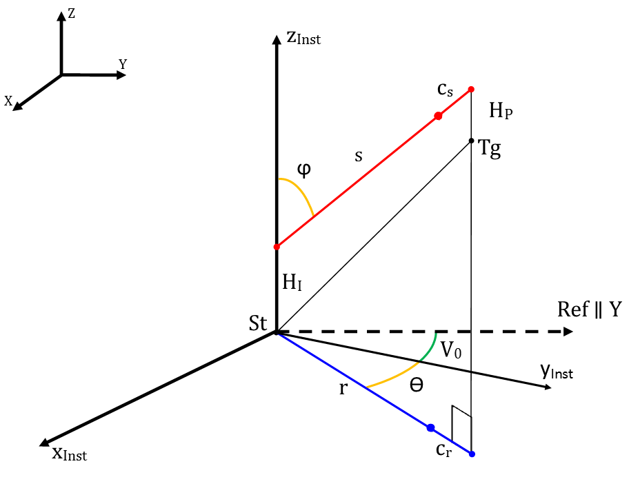

Polar measurement (PLR3D) for a TSTN
This measurement is made in the Instrument Local Astronomical System (ILA).
If ${ Z}_{Tg}$is not vertical, $H_{P}$has to be zero.

Mathematical Model

$$\left(-\begin{matrix}\cos{θ} & \sin{θ} & 0 \\ \sin{θ} & \cos{θ} & 0 \\ 0 & 0 & 1\end{matrix}\right)\left(\begin{matrix}1 & 0 & 0 \\ 0 & \cos{φ} & \sin{φ} \\ 0 & -sin{φ} & \cos{φ}\end{matrix}\right)\left(\begin{matrix}0 \\ 0 \\ s+c_{s}\end{matrix}\right)$$
$$-\left(\begin{matrix}\cos{V_{0}} & -\sin{V_{0}} & 0 \\ \sin{V_{0}} & \cos{V_{0}} & 0 \\ 0 & 0 & 1\end{matrix}\right)\left(\begin{matrix}\cos{Ry} & 0 & \sin{Ry} \\ 0 & 1 & 0 \\ -sinRy & 0 & \cos{Ry}\end{matrix}\right)\left(\begin{matrix}1 & 0 & 0 \\ 0 & \cos{Rx} & -\sin{Rx} \\ 0 & \sin{Rx} & \cos{Rx}\end{matrix}\right)\left(\begin{matrix}X_{Tg}-X_{St} \\ Y_{Tg}-Y_{St} \\ {(Z}_{Tg}+H_{P})-(Z_{St}+H_{I})\end{matrix}\right)=0$$

$$F= \left(s+c_{s}\right).\left(\begin{matrix}\sin{θ}·sin{φ } \\ \cos{θ}·sin{φ} \\ \cos{φ}\end{matrix}\right)-A\left(\begin{matrix}X_{Tg}-X_{St} \\ Y_{Tg}-Y_{St} \\ {(Z}_{Tg}+H_{P})-(Z_{St}+H_{I})\end{matrix}\right)=0$$

Where,
$$A=\left(\begin{matrix}\cos{V_{0}}.\cos{Ry} & -sin{V_{0}}.\cos{Rx}+\sin{R_{x}}.cos{V_{0}}.\sin{Ry} & \sin{V_{0}}.\sin{Rx}+\cos{R_{x}}.cos{V_{0}}.\sin{Ry} \\ \sin{V_{0}}.\cos{Ry} & \cos{V_{0}}.\cos{Rx}+\sin{R_{x}}.sin{V_{0}}.\sin{Ry} & -cos{V_{0}}.\sin{Rx}+\cos{R_{x}}.sin{V_{0}}.\sin{Ry} \\ -\sin{Ry} & \sin{Rx}.\cos{Ry} & \cos{Rx}.\cos{Ry}\end{matrix}\right)$$

Partial Derivatives

For the Station coordinates:
$$\frac{∂F}{∂*}=A·\left(\begin{matrix}\frac{∂X_{St}}{∂*} \\ \frac{∂Y_{St}}{∂*} \\ \frac{∂Z_{St}}{∂*}\end{matrix}\right)$$
Where:
 | Symbol * can stand for:$x_{0,St};y_{0,St}; z_{0,St}; ω_{j,St};φ_{j,St};κ_{j,St; }t_{j,1,St};t_{j,2,St};t_{j,3,St};l_{j,St}$. | (2.9)
For the Target coordinates:
$$\frac{∂F}{∂*}= -A·\left(\begin{matrix}\frac{∂X_{Tg}}{∂*} \\ \frac{∂Y_{Tg}}{∂*} \\ \frac{∂Z_{St}}{∂*}\end{matrix}\right)$$
Where:

 | * can stand for:$x_{0,Tg}; y_{0,Tg}; z_{0,Tg}; ω_{j,Tg};φ_{j,Tg};κ_{j,Tg};t_{j,1,Tg};t_{j,2,Tg};t_{j,3,Tg};l_{j,Tg}$. | (2.10)
For the additional parameters:

$$\frac{∂F}{∂V_{0}}= -\left(\begin{matrix}-sin{V_{0}}.\cos{Ry} & -cos{V_{0}}.\cos{Rx}-\sin{R_{x}}.sin{V_{0}}.\sin{Ry} & \cos{V_{0}}.\sin{Rx}-\cos{R_{x}}.sin{V_{0}}.\sin{Ry} \\ \cos{V_{0}}.\cos{Ry} & -sin{V_{0}}.\cos{Rx}+\sin{R_{x}}.cos{V_{0}}.\sin{Ry} & \sin{V_{0}}.\sin{Rx}+\cos{R_{x}}.cos{V_{0}}.\sin{Ry} \\ 0 & 0 & 0\end{matrix}\right)\left(\begin{matrix}X_{Tg}-X_{St} \\ Y_{Tg}-Y_{St} \\ {(Z}_{Tg}+H_{P})-(Z_{St}+H_{I})\end{matrix}\right)$$

$$\frac{∂F}{∂c_{s}}= \left(\begin{matrix}\sin{θ}·sin{φ } \\ \cos{θ}·sin{φ} \\ \cos{φ}\end{matrix}\right)$$

$$\frac{∂F}{∂Rx}=-\left(\begin{matrix}0 & \sin{V_{0}}.\sin{Rx}+\cos{R_{x}}.cos{V_{0}}.\sin{Ry} & \sin{V_{0}}.\cos{Rx}-\sin{R_{x}}.cos{V_{0}}.\sin{Ry} \\ 0 & -cos{V_{0}}.sin+\cos{R_{x}}.sin{V_{0}}.\sin{Ry} & -cos{V_{0}}.\cos{Rx}-\sin{R_{x}}.sin{V_{0}}.\sin{Ry} \\ 0 & \cos{Rx}.\cos{Ry} & -sin{Rx}.\cos{Ry}\end{matrix}\right)\left(\begin{matrix}X_{Tg}-X_{St} \\ Y_{Tg}-Y_{St} \\ {(Z}_{Tg}+H_{P})-(Z_{St}+H_{I})\end{matrix}\right)$$

$$\frac{∂F}{∂Ry}=-\left(\begin{matrix}-cos{V_{0}}.\sin{Ry} & \sin{R_{x}}.cos{V_{0}}.\cos{Ry} & \cos{R_{x}}.cos{V_{0}}.\cos{Ry} \\ -\sin{V_{0}}.\sin{Ry} & \sin{R_{x}}.sin{V_{0}}.\cos{Ry} & \cos{R_{x}}.sin{V_{0}}.\cos{Ry} \\ -\cos{Ry} & -sin{Rx}.\sin{Ry} & -cos{Rx}.\sin{Ry}\end{matrix}\right)\left(\begin{matrix}X_{Tg}-X_{St} \\ Y_{Tg}-Y_{St} \\ {(Z}_{Tg}+H_{P})-(Z_{St}+H_{I})\end{matrix}\right)$$

For the observed measurements:

$$\frac{∂F}{∂θ}=\left(s+c_{s}\right). \left(\begin{matrix}\cos{θ}·sin{φ } \\ -sin{θ}·sin{φ} \\ 0\end{matrix}\right)$$

$$\frac{∂F}{∂φ} =\left(s+c_{s}\right). \left(\begin{matrix}\sin{θ}·cos{φ } \\ \cos{θ}·cos{φ} \\ -sin{φ}\end{matrix}\right)$$

$$\frac{∂F}{∂s}= \left(\begin{matrix}\sin{θ}·sin{φ } \\ \cos{θ}·sin{φ} \\ \cos{φ}\end{matrix}\right)$$

Stochastic model
For all the document, the stochastic model is calculated with the law of standard deviation propagation:
$$σ_{l}^{2}=\sum_{i}{({\frac{∂l}{∂x_{i}})}^{2}σ_{i}^{2}}.$$
Where:
$x_{i}$ -- Parameters with their standard deviation${ σ}_{i}^{ }$.
$σ_{l}^{ }$ -- Standard deviation of the observation.

Then we suppose that:
$σ_{m}$ Is the standard deviation relative to the instrument and material (for example ppm for a distance metre).
$σ_{CSt}$ Is the standard deviation relative to the centring of the instrument (in XY plan, both part are equal).
$σ_{CTg}$ Is the standard deviation relative to the centring of the target (in XY plan, both part are equal).

For PLR3D measurement, ${σ_{θ}}^{2}, {σ_{φ}}^{2} and {σ_{s}}^{2}$are described below in ANGL, ZEND and DIST.

Objects
Adjustable needed:
- Point – for the Station and the Target
- Angle – for the $V_{0}$
- Scalar -- Instrument height $H_{I}$
Simple objects (not adjustable):
- Angle – for the $θ$ and $φ$
- Scalar – for the $s$
- Scalar – target height $H_{P}$
- Scalar – for the standard deviations

Polar measurement (UVD) for a CAM
For the camera, the instrument can only rotate freely around the Z axis.
The measurement is described by a unit vector (i j k s) pointing in a direction of Z-axis, where i, j and s are observations, and k a real to have a unit vector:
- i, is the offset in x between the direction station – target at the target point and the Z axis
- j, is the offset in y between the direction station – target at the target point and the Z axis
- S is the distance station- target

Mathematical Model

$$F= \left(s+c_{s}\right).\left(\begin{matrix}i \\ j \\ k\end{matrix}\right)-\left(\begin{matrix}X_{Tg}-X_{St} \\ Y_{Tg}-Y_{St} \\ {(Z}_{Tg}+H_{P})-(Z_{St})\end{matrix}\right)=0$$

Partial Derivatives
For the Station coordinates:
$$\frac{∂F}{∂*}= \left(\begin{matrix}\frac{∂X_{St}}{∂*} \\ \frac{∂Y_{St}}{∂*} \\ \frac{∂Z_{St}}{∂*}\end{matrix}\right)$$

For the Target coordinates:
$$\frac{∂F}{∂*}= -\left(\begin{matrix}\frac{∂X_{Tg}}{∂*} \\ \frac{∂Y_{Tg}}{∂*} \\ \frac{∂Z_{St}}{∂*}\end{matrix}\right)$$
Where:

 | * can stand for:$x_{0,Tg}; y_{0,Tg}; z_{0,Tg}; ω_{j,Tg};φ_{j,Tg};κ_{j,Tg};t_{j,1,Tg};t_{j,2,Tg};t_{j,3,Tg};l_{j,Tg}$. | (2.10)

For the additional parameters:
$$\frac{∂F}{∂c_{s}}= \left(\begin{matrix}i \\ j \\ k\end{matrix}\right)$$

For the observed measurements:

$$\frac{∂F}{∂i}=\left(s+c_{s}\right). \left(\begin{matrix}1 \\ 0 \\ 0\end{matrix}\right)$$

$$\frac{∂F}{∂j} =\left(s+c_{s}\right). \left(\begin{matrix}0 \\ 1 \\ 0\end{matrix}\right)$$

$$\frac{∂F}{∂s}= \left(\begin{matrix}i \\ j \\ k\end{matrix}\right)$$

Objects
Adjustable needed:
- Point – for the Station and the Target
- Scalar – for k
Simple objects (not adjustable):
- Scalar – for the $i, j and s$
- Scalar – target height $H_{P}$
- Scalar – for the standard deviations

Horizontal dir. + Zenith dist. (UVEC) for a CAM

Mathematical Model
For the camera, the instrument can only rotate freely around the Z axis.
The measurement is described by a unit vector (i j k) pointing in a direction of Z-axis, where i and j are observations, and k a real to have a unit vector:
- i, is the offset in x between the direction station – target at the target point and the Z axis
- j, is the offset in y between the direction station – target at the target point and the Z axis

Mathematical Model
$$F= -\left(\begin{matrix}i \\ j\end{matrix}\right)+\frac{k}{{(Z}_{Tg}+H_{P})-(Z_{St})}.\left(\begin{matrix}X_{Tg}-X_{St} \\ Y_{Tg}-Y_{St}\end{matrix}\right)=0$$

Partial Derivatives
For the Station coordinates:
$$\frac{∂F}{∂*}=-\frac{k}{{(Z}_{Tg}+H_{P})-(Z_{St})}* \left(\begin{matrix}-\frac{1}{{(Z}_{Tg}+H_{P})-(Z_{St})}.\frac{∂Z_{Tg}}{∂*}+\frac{∂X_{Tg}}{∂*} \\ -\frac{1}{{(Z}_{Tg}+H_{P})-(Z_{St})}.\frac{∂Z_{Tg}}{∂*}+\frac{∂Y_{Tg}}{∂*} \end{matrix}\right)$$

For the Target coordinates:
$$\frac{∂F}{∂*}=\frac{k}{{(Z}_{Tg}+H_{P})-(Z_{St})}* \left(\begin{matrix}-\frac{1}{{(Z}_{Tg}+H_{P})-(Z_{St})}.\frac{∂Z_{Tg}}{∂*}+\frac{∂X_{Tg}}{∂*} \\ -\frac{1}{{(Z}_{Tg}+H_{P})-(Z_{St})}.\frac{∂Z_{Tg}}{∂*}+\frac{∂Y_{Tg}}{∂*} \end{matrix}\right)$$
Where:

 | * can stand for:$x_{0,Tg}; y_{0,Tg}; z_{0,Tg}; ω_{j,Tg};φ_{j,Tg};κ_{j,Tg};t_{j,1,Tg};t_{j,2,Tg};t_{j,3,Tg};l_{j,Tg}$. | (2.10)

For the observed measurements:

$$\frac{∂F}{∂i}=\left(\begin{matrix}-1 \\ 0\end{matrix}\right)$$

$$\frac{∂F}{∂j} = \left(\begin{matrix}0 \\ -1\end{matrix}\right)$$

Objects
Adjustable needed:
- Point – for the Station and the Target
- Scalar – for k
Simple objects (not adjustable):
- Scalar – for the $i and j$
- Scalar – target height $H_{P}$
- Scalar – for the standard deviations

Horizontal direction (ANGL)
This measurement is made in the Modified Local Astronomical System (MLA).

Mathematical Model
$$θ= \tan^{-1}\left(\frac{X_{Tg}-X_{St}}{Y_{Tg}-Y_{St}}\right)-V_{0}$$

Partial Derivatives
For the Station coordinates:
$$\frac{∂θ}{∂*}=-\frac{\left(Y_{Tg}-Y_{St}\right)}{D^{2}}·\frac{∂X_{St}}{∂*}+\frac{\left(X_{Tg}-X_{St}\right)}{D^{2}}·\frac{∂Y_{St}}{∂*}$$

Where
$$D^{2}={\left(X_{Tg}-X_{St}\right)}^{2}+{\left(Y_{Tg}-Y_{St}\right)}^{2}$$

Where (2.9).
For the Target coordinates:
$$\frac{∂θ}{∂*}=\frac{\left(Y_{Tg}-Y_{St}\right)}{D^{2}}·\frac{∂X_{Tg}}{∂*}+\frac{\left(X_{St}-X_{Tg}\right)}{D^{2}}·\frac{∂Y_{Tg}}{∂*}$$

Where (2.10).
For the additional parameters:
$$\frac{∂θ}{∂V_{0}}= -1$$

Stochastic model
$${σ_{θ}}^{2}={σ_{m}}^{2}+\frac{1}{D^{2}}\left({σ_{CTg}}^{2}+{σ_{CSt}}^{2}\right)$$

And $σ_{m}$represents the standard deviation of the measured vertical angle.

Objects
Adjustable needed:
- Point – for the Target and Station
- Angle – for the $V_{0}$
Simple objects (not adjustable):
- Angle – for the $θ$
- Scalar - $for the standard deviations σ_{m}, σ_{V0}, σ_{CSt}, σ_{CTg}$

Zenith distance (ZENI / ZENH / XXXX)
This measurement is made in the Modified Local Astronomical System (MLA).
If ${ Z}_{Tg}$is not vertical, $H_{P}$has to be zero.

Mathematical Model
$$φ= \cos^{-1}\left(\frac{\left(Z_{Tg}+H_{P}\right)-\left(Z_{St}+H_{I}\right)}{D_{XYZ}}\right)$$

Where
$$D_{XYZ}=\sqrt{{\left(X_{Tg}-X_{St}\right)}^{2}+{\left(Y_{Tg}-Y_{St}\right)}^{2}+{\left[\left(Z_{Tg}+H_{P}\right)-\left(Z_{St}+H_{I}\right)\right]}^{2}}$$

Partial Derivatives
For the Station coordinates:

$$\frac{∂φ}{∂*}=\left(\frac{-\left(X_{Tg}-X_{St}\right)·\left[\left(Z_{Tg}+H_{P}\right)-\left(Z_{St}+H_{I}\right)\right]}{{\left(D_{XYZ}\right)}^{3}·\sin{φ}}\right)∙\frac{∂X_{St}}{∂*}+\left(\frac{-\left(Y_{Tg}-Y_{St}\right)·\left[\left(Z_{Tg}+H_{P}\right)-\left(Z_{St}+H_{I}\right)\right]}{{\left(D_{XYZ}\right)}^{3}·\sin{φ}}\right)∙\frac{∂Y_{St}}{∂*} +$$
$$\left(\frac{1}{D_{XYZ}·\sin{φ}}-\frac{{\left[\left(Z_{Tg}+H_{P}\right)-\left(Z_{St}+H_{I}\right)\right]}^{2}}{{\left(D_{XYZ}\right)}^{3}·\sin{φ}}\right)∙\frac{∂Z_{St}}{∂*}$$

Where (2.9).

For the Target coordinates:

$$\frac{∂φ}{∂*}=\left(\frac{\left(X_{Tg}-X_{St}\right)·\left[\left(Z_{Tg}+H_{P}\right)-\left(Z_{St}+H_{I}\right)\right]}{{\left(D_{XYZ}\right)}^{3}·\sin{φ}}\right)·\frac{∂X_{Tg}}{∂*}+\frac{\left(Y_{Tg}-Y_{St}\right)·\left[\left(Z_{Tg}+H_{P}\right)-\left(Z_{St}+H_{I}\right)\right]}{{\left(D_{XYZ}\right)}^{3}·\sin{φ}}·\frac{∂Y_{Tg}}{∂*}+\left(-\frac{1}{D_{XYZ}·\sin{φ}}+\frac{{\left[\left(Z_{Tg}+H_{P}\right)-\left(Z_{St}+H_{I}\right)\right]}^{2}}{{\left(D_{XYZ}\right)}^{3}·\sin{φ}}\right)∙\frac{∂Z_{Tg}}{∂*}$$

Where (2.10).

For the additional parameters

$$\frac{∂φ}{∂H_{I}}= \frac{1}{D_{XYZ}·\sin{φ}}-\frac{{\left[\left(Z_{Tg}+H_{P}\right)-\left(Z_{St}+H_{I}\right)\right]}^{2}}{{\left(D_{XYZ}\right)}^{3}·\sin{φ}}$$

Stochastic model
$${σ_{φ}}^{2}={σ_{m}}^{2}+\frac{\left[{\left(X_{Tg}-X_{St}\right)}^{2}+{\left(Y_{Tg}-Y_{St}\right)}^{2}\right]·{\left[\left(Z_{Tg}+H_{P}\right)-\left(Z_{St}+H_{I}\right)\right]}^{2}}{{{(\left(D_{XYZ}\right)}^{3}·\sin{φ})}^{2}}\left({σ_{CTg}}^{2}+{σ_{CSt}}^{2}\right)+{\left(-\frac{1}{D_{XYZ}·\sin{φ}}+\frac{{\left[\left(Z_{Tg}+H_{P}\right)-\left(Z_{St}+H_{I}\right)\right]}^{2}}{{\left(D_{XYZ}\right)}^{3}·\sin{φ}}\right)}^{2}({σ_{Hi}}^{2}+{σ_{Hp}}^{2})$$

And $σ_{m}$represents the standard deviation of the measured zenith distance.

Objects
Adjustable needed:
- Point – for the Station and Target
- Scalar -- Instrument height $H_{I}$
Simple objects (not adjustable):
- Scalar -- target height $H_{P}$
- Angle – for the $φ$
- Scalar – for the standard deviations

Spatial Distance (DMES / DTHE / XXXX)
This measurement is made either in the Modified Local Astronomical System (MLA) or in the CCS, both cases are possible.
If ${ Z}_{Tg}$is not vertical, $H_{P}$has to be zero.

Mathematical Model
$$s= \sqrt{{\left(X_{Tg}-X_{St}\right)}^{2}+{\left(Y_{Tg}-Y_{St}\right)}^{2}+{\left[\left(Z_{Tg}+H_{P}\right)-\left(Z_{St}+H_{I}\right)\right]}^{2}}-c_{s}$$

Partial Derivatives
Let
$$D=\sqrt{{\left(X_{Tg}-X_{St}\right)}^{2}+{\left(Y_{Tg}-Y_{St}\right)}^{2}+{\left[\left(Z_{Tg}+H_{P}\right)-\left(Z_{St}+H_{I}\right)\right]}^{2}}$$

For the Station coordinates:

$$\frac{∂s}{∂*}= \frac{-\left(X_{Tg}-X_{St}\right)}{D}·\frac{∂X_{St}}{∂*}+\left(\frac{-\left(Y_{Tg}-Y_{St}\right)}{D}·\frac{∂Y_{St}}{∂*}\right)+\left(- \frac{\left(Z_{Tg}+H_{P}\right)-\left(Z_{St}+H_{I}\right)}{D}·\frac{∂Z_{St}}{∂*}\right)$$

Where (2.9).

For the Target coordinates:

$$\frac{∂s}{∂*}= \frac{\left(X_{Tg}-X_{St}\right)}{D}·\frac{∂X_{Tg}}{∂*}+\frac{\left(Y_{Tg}-Y_{St}\right)}{D}·\frac{∂Y_{Tg}}{∂*}+\frac{\left(Z_{Tg}+H_{P}\right)-\left(Z_{St}+H_{I}\right)}{D}·\frac{∂Z_{Tg}}{∂*}$$

Where (2.10).

For the additional parameters
$$\frac{∂s}{∂H_{I}}= - \frac{\left(Z_{Tg}+H_{P}\right)-\left(Z_{St}+H_{I}\right)}{D}$$
$$\frac{∂s}{∂c_{s}}= -1$$

Stochastic model
$${σ_{s}}^{2}={σ_{m}}^{2}+{\left(\frac{\left(Z_{Tg}+H_{P}\right)-\left(Z_{St}+H_{I}\right)}{D}\right)}^{2}({σ_{Hi}}^{2}+{σ_{Hp}}^{2})+\frac{{\left(Y_{Tg}-Y_{St}\right)}^{2}+{\left(X_{St}-X_{Tg}\right)}^{2}}{D^{2}}\left({σ_{CTg}}^{2}+{σ_{CSt}}^{2}\right)$$

And $σ_{m}$represents the standard deviation of the measured distance and the ppm error
$${σ_{m}}^{}= {σ_{obs}(mm)}^{}+{s(km)}^{}*{σ_{ppm}(mm)}^{}$$

Objects
Adjustable needed:
- Point – for the Station and Target
- Scalar – $c_{s}$ (specific for a pair instrument - target)
- Scalar – Instrument height $H_{I}$

Simple objects (not adjustable):
- Scalar – target height $H_{P}$
- Scalar– for the $s$
- Scalar – for the standard deviations

Horizontal distance (DHOR)
This measurement is made in the Modified Local Astronomical System (MLA).

Mathematical Model
$$r= \sqrt{{\left(X_{Tg}-X_{St}\right)}^{2}+{\left(Y_{Tg}-Y_{St}\right)}^{2}}-c_{r}$$

Partial Derivatives
Let
$$D=\sqrt{{\left(X_{Tg}-X_{St}\right)}^{2}+{\left(Y_{Tg}-Y_{St}\right)}^{2}}$$

For the Station coordinates:
$$\frac{∂r}{∂*}= \frac{-\left(X_{Tg}-X_{St}\right)}{D}·\frac{∂X_{St}}{∂*}+\frac{-\left(Y_{Tg}-Y_{St}\right)}{D}·\frac{∂Y_{St}}{∂*}$$
Where (2.9).

For the Target coordinates:
$$\frac{∂r}{∂*}= \frac{\left(X_{Tg}-X_{St}\right)}{D}·\frac{∂X_{Tg}}{∂*}+\frac{\left(Y_{Tg}-Y_{St}\right)}{D}·\frac{∂Y_{Tg}}{∂*}$$
Where (2.10).

For the additional parameters
$$\frac{∂r}{∂c_{r}}= -1$$

Stochastic model
$${σ_{r}}^{2}={σ_{m}}^{2}+\left({σ_{CTg}}^{2}+{σ_{CSt}}^{2}\right)$$

And $σ_{m}$represents the standard deviation of the measured distance and the ppm error
$${σ_{m}}^{}= {σ_{obs}(mm)}^{}+{r(km)}^{}*{σ_{ppm}(mm)}^{}$$

Objects
Adjustable needed:
- Point – for the Station and Target
- Scalar -- for the $c_{r}$
Simple objects (not adjustable):
- Scalar -- for the$r$
- Scalar – for the standard deviations

Vertical distance measurement models

Vertical distance (DLEV) – Local Reference System
This measurement made in the Modified Local Astronomical System (MLA).
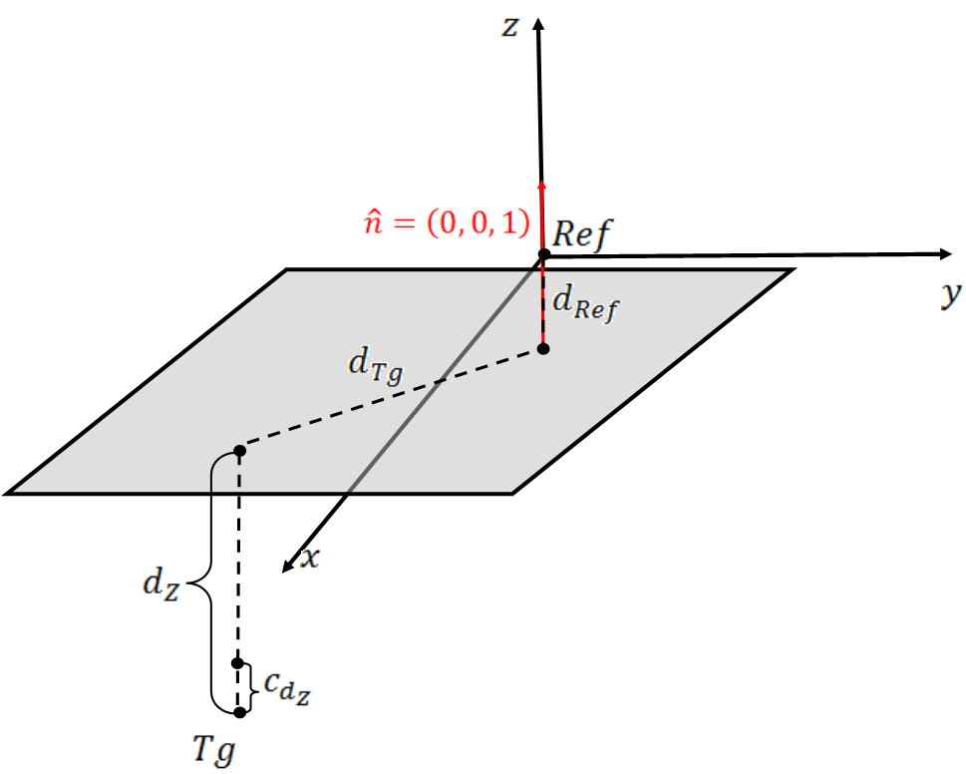

Mathematical Model
$$d_{Z}=1·\left(Z_{Ref}-Z_{Tg}\right)+d_{ref}-c_{d_{z}}- d_{Tg}.\tan{ε_{collimation}}$$

Where

$ε_{collimation}$: Collimation angle

In this mathematical model we assume orientation of the normal vector $\hat{n}$ to be as is represented on a drawing above.

Partial Derivatives
For the Target coordinates
$$\frac{∂d_{z}}{∂*}=- \frac{∂Z_{St}}{∂*}$$
Where (2.9).

For the additional parameters:
$$\frac{∂d_{z}}{∂c_{d_{z}}}=-1$$

$$\frac{∂d_{z}}{∂d_{ref}}=1$$

$$\frac{∂d_{z}}{∂ε_{collimation}}=-d.(1+\tan^{2}\left(ε_{collimation}\right))$$

$$\frac{∂d_{z}}{∂d_{Tg}}=-\tan{ε_{collimation}}$$

Stochastic model
$${σ_{dz}}^{2}=({σ_{vert dist}}^{}+{d_{Tg}}^{}*{σ_{ppm}}^{})²+{σ_{offset of the staff}}^{2}$$

Objects
Adjustable needed:
- Plane – consisting of:
- Point – for the Reference point, fixed
- 3Dvector – known normal vector of the plane $\hat{n}=\left(\begin{matrix}0 & 0 & 1\end{matrix}\right)$, fixed
- Scalar – for the reference point distance ($d_{Tg}$) – variable
- Point – for the Station
- Scalar – for the constants $c_{d_{z}}$ , $d_{ref}, ε_{collimation} and d_{Z}$
Simple objects (not adjustable):
- Scalar – for the standard deviations

Vertical distance (DVER) – Geodetic Reference System
This measurement is made in the geodetic reference system, CGRF.
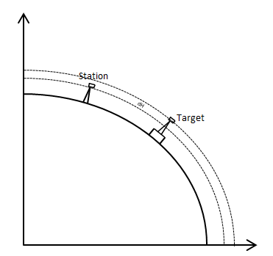

Mathematical Model
$$dH= H_{Tg}-H_{St}-c_{dH}$$

Partial Derivatives
For the Station coordinates:
$$\frac{∂dH}{∂*}=-\frac{∂H_{St}}{∂*}=\frac{∂h_{St}}{∂*}$$

Where (2.9).

And,
$$H_{St}=h_{St}-N$$

Where $h_{St}$ is a third geodetic ellipsoidal coordinate (h) of the station. Cartesian coordinates of the point can be expressed as:
$$\left(\begin{matrix}X_{ }^{h} \\ Y_{ }^{h} \\ Z_{ }^{h} \\ w\end{matrix}\right)=A^{*}·M· x_{0,St}^{h}$$

$$\left(\begin{matrix}X \\ Y \\ Z\end{matrix}\right)=\frac{1}{w}·\left(\begin{matrix}X_{ }^{h} \\ Y_{ }^{h} \\ Z_{ }^{h}\end{matrix}\right)$$

$h_{St}$ Is then obtained from this Cartesian coordinates using equation (2.8).

For the Target coordinates:
$$\frac{∂dH}{∂*}=\frac{∂H_{Tg}}{∂*}=\frac{∂h_{Tg}}{∂*}$$

Where (2.10).

And,
$$H_{Tg}=h_{Tg}-N$$

Where $h_{St}$ is a third coordinate (h) of the target in the ellipsoidal coordinates. Cartesian coordinates of the point can be expressed as:
$$\left(\begin{matrix}X_{ }^{h} \\ Y_{ }^{h} \\ Z_{ }^{h} \\ w\end{matrix}\right)=A^{*}·M· x_{0,Tg}^{h}$$

$$\left(\begin{matrix}X \\ Y \\ Z\end{matrix}\right)=\frac{1}{w}·\left(\begin{matrix}X_{ }^{h} \\ Y_{ }^{h} \\ Z_{ }^{h}\end{matrix}\right)$$

$h_{Tg}$ Is then obtained from this Cartesian coordinates using equation (2.8).

For the additional parameters:
$$\frac{∂dH}{∂c_{dH}}= -1$$

Stochastic model
$${σ_{dH}}^{2}={σ_{m}}^{2}$$
And $σ_{m}$represents the standard deviation of the observed value.

Objects
Adjustable needed:
- Point (with x and y coordinates excluded from the adjustment) – for Station and Target
- Scalar – for $the$ $c_{dH}$
Simple objects (not adjustable):
- Scalar – for the $dH$
- Scalar – for the standard deviations

offset measurement models

Offset to a Vertical Plane (ECHO)
This measurement made in the Modified Local Astronomical System (MLA).

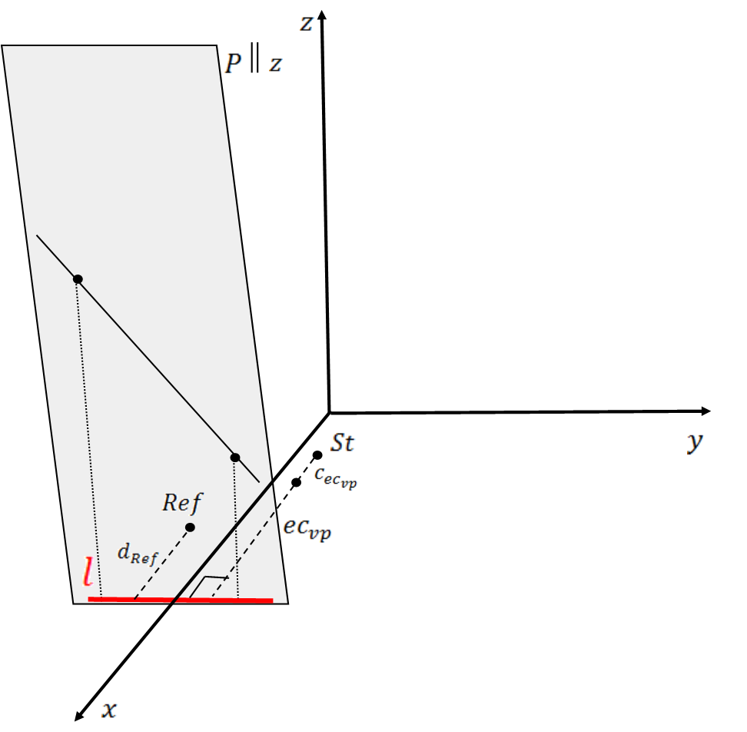

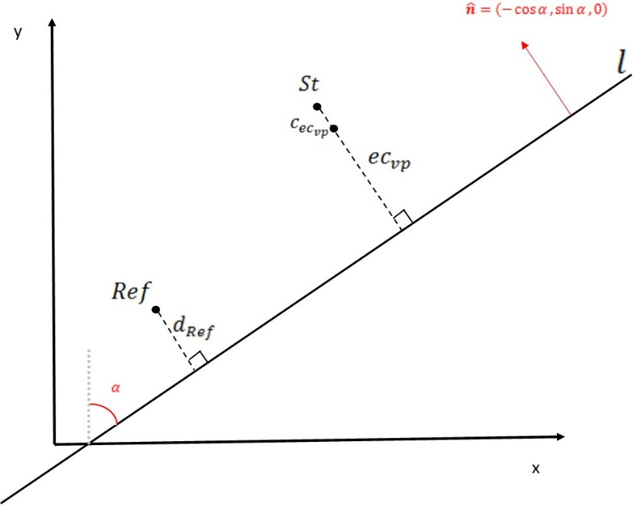

Mathematical Model
$${ec}_{vp}=-\cos{α}·\left(X_{St}-X_{Ref}\right)+\sin{α}·\left(Y_{St}-Y_{Ref}\right)+d_{Ref}-c_{{ec}_{vp}}$$

In this mathematical model we assume orientation of the normal vector $\hat{n}$ to be as is represented on a drawing above.

Partial Derivatives
For the Station coordinates:
$$\frac{∂{ec}_{vp}}{∂*}=-\cos{α}·\frac{∂X_{St}}{∂*}+\sin{α}·\frac{∂Y_{St}}{∂*}$$
For the Reference coordinates:
$$\frac{∂{ec}_{vp}}{∂*}=\cos{α}·\frac{∂X_{Ref}}{∂*}-\sin{α}·\frac{∂Y_{Ref}}{∂*}$$

Where (2.9).

For the $\hat{n}$ vector elements:
$$\frac{∂{ec}_{vp}}{∂α}={\sin{α} (X}_{St}-X_{Ref})+\cos{α} (Y_{St}-Y_{Ref})$$

For the Reference point distance:
$$\frac{∂{ec}_{vp}}{∂d_{Ref}}=1$$

For the additional parameters:
$$\frac{∂{ec}_{vp}}{∂c_{ec_{vp}}}=-1$$

Stochastic model
$${σ_{{ec}_{vp}}}^{2}={σ_{m}}^{2}+{σ_{CSt}}^{2}$$
And $σ_{m}$represents the standard deviation of the observed value and the ppm.
$${σ_{m}}^{}={σ_{inst}}^{}+ec*{σ_{ppm}}^{}$$

Objects
Adjustable needed:
- Plane consisting of:
- Point – for the Reference point
- 3Dvector – normal vector of the plane $\hat{n}$
- Scalar– for the reference point distance $d_{Ref}$ and the angle $α$

- Point (z-coordinate fixed, i.e. excluded from the adjustment) -- for the Station
- Scalar– for the $c_{{ec}_{vp}}$
Simple objects (not adjustable):
- Scalar – for ${ec}_{vp}$
- Scalar– for the standard deviations

Offset to a Spatial Line (ECSP)
This measurement is made in the CERN Cartesian System (CCS).
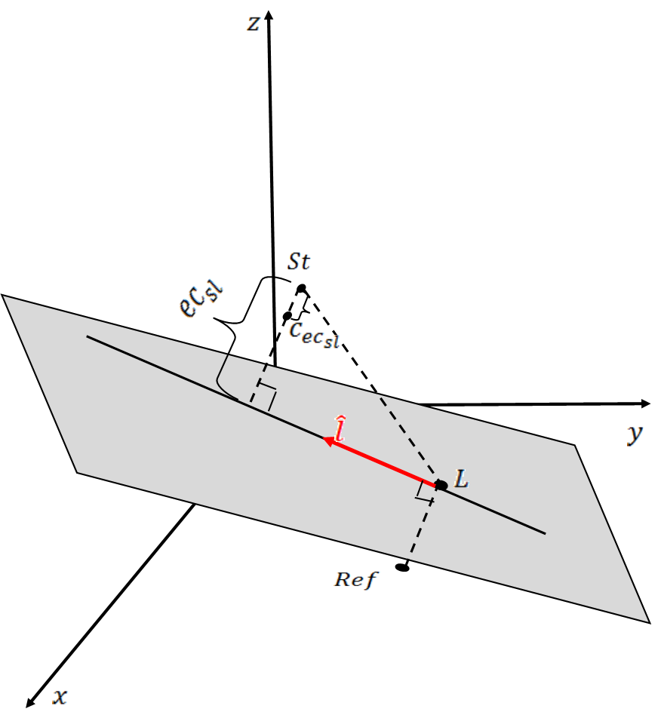

Mathematical Model
$${ec}_{sl}=\left|\left(x_{St}-x_{L}\right)×\hat{l}\right|- c_{{ec}_{sl}}$$
$${Constr1=(x}_{Ref}-x_{L})· \hat{l}=0$$

Where
$x_{St}=\left(\begin{matrix}X_{St} \\ Y_{St} \\ Z_{St}\end{matrix}\right), x_{L}=\left(\begin{matrix}X_{L} \\ Y_{L} \\ Z_{L}\end{matrix}\right),\hat{l}=\left(\begin{matrix}-\sin{α }\sin{β} \\ \cos{α }\sin{β} \\ \cos{β}\end{matrix}\right)$

Partial Derivatives
$$\left(x_{St}-x_{L}\right)×\hat{l}=\left(\begin{matrix}\cos{β}\left(Y_{St}-Y_{L}\right)-\cos{α }\sin{β}\left(Z_{St}-Z_{L}\right) \\ \sin{α }\sin{β}\left(Z_{St}-Z_{L}\right)+ \cos{β}\left(X_{St}-X_{L}\right) \\ \cos{α }\sin{β}\left(X_{St}-X_{L}\right)+\sin{α }\sin{β}\left(Y_{St}-Y_{L}\right)\end{matrix}\right)=\left(\begin{matrix}iCoeff \\ jCoeff \\ kCoeff\end{matrix}\right)$$

Let
$T=\sqrt{{iCoeff}^{2}+{jCoeff}^{2}+{kCoeff}^{2}}$

We see that,
$${ec}_{sl}=T- c_{{ec}_{sl}}$$

For the Station coordinates:

$$\frac{∂{ec}_{sl}}{∂*}=\frac{- jcoeff·\cos{β}+kcoeff·\cos{α }\sin{β}}{T}· \frac{∂X_{St}}{∂*}+\frac{ icoeff·\cos{β}-kcoeff·(-\sin{α }\sin{β})}{T}·\frac{∂Y_{St}}{∂*}+$$
$$\frac{- icoeff·\cos{α }\sin{β}+jcoeff·(-\sin{α }\sin{β})}{T}·\frac{∂Z_{St}}{∂*}$$

Where (2.9).

For the line point coordinates:

$$\frac{ ∂{ec}_{sl}}{∂*}=\frac{ jcoeff·\cos{β}-kcoeff·\cos{α }\sin{β}}{T}· \frac{∂X_{L}}{∂*}+\frac{- icoeff·\cos{β}+kcoeff·(-\sin{α }\sin{β})}{T}· \frac{∂Y_{L}}{∂*}+$$
$$\frac{ icoeff·\cos{α }\sin{β}-jcoeff·(-\sin{α }\sin{β})}{T}· \frac{∂Z_{L}}{∂*}$$

Where * can stand for:$x_{0,L}; y_{0,L}; z_{0,L}; ω_{j,L};φ_{j,L};κ_{j,L; }t_{j,1,L};t_{j,2,L};t_{j,3,L};l_{j,L}$.

For the $\hat{l}$ vector elements:

$$\frac{ ∂{ec}_{sl}}{∂l}=\frac{jcoeff·\left(Z_{St}-Z_{L}\right)+kcoeff·\left(Y_{L}-Y_{St}\right)}{T}$$

$$\frac{∂{ec}_{sl}}{∂m}=\frac{icoeff·\left(Z_{L}-Z_{St}\right)+kcoeff·\left(X_{St}-X_{L}\right)}{T}$$

$$\frac{∂{ec}_{sl}}{∂n}=\frac{icoeff·\left(Y_{St}-Y_{L}\right)+jcoeff·\left(X_{L}-X_{St}\right)}{T}$$

For the additional parameters:
$$\frac{∂{ec}_{sl}}{∂c_{e,sl}}=-1$$

Constraint derivatives:
Constraint1:

For the line point coordinates:

$$\frac{∂Constr1}{∂*}=\sin{α }\sin{β}·\frac{∂X_{L}}{∂*}-\cos{α }\sin{β}·\frac{∂Y_{L}}{∂*}-\cos{β}·\frac{∂Z_{L}}{∂*}$$

Where * can stand for:$x_{0,L}; y_{0,L}; z_{0,L}; ω_{j,L};φ_{j,L};κ_{j,L; }t_{j,1,L};t_{j,2,L};t_{j,3,L};l_{j,L}$.

For the $\hat{l}$ vector elements:
$$\frac{∂Constr1}{∂α}=-\cos{α }\sin{β}\left( X_{Ref}-X_{L}\right)-\sin{α }\sin{β}(Y_{Ref}-Y_{L})$$

$$\frac{∂Constr1}{∂β}=-\sin{α }\cos{β}\left( X_{Ref}-X_{L}\right)+\cos{α }\cos{β}\left(Y_{Ref}-Y_{L}\right)-\sin{β}(Z_{Ref}-Z_{L})$$

Stochastic model
$${σ_{{ec}_{Sl}}}^{2}={σ_{m}}^{2}+\left({\left(\frac{ jcoeff·n-kcoeff·m}{T}\right)}^{2}+{\left(\frac{- icoeff·n+kcoeff·l}{T}\right)}^{2}\right){σ_{CSt}}^{2}$$

And $σ_{m}$represents the standard deviation of the observed value and the ppm error
$${σ_{m}}^{}= {σ_{obs}}^{}+{ec}^{}*{σ_{ppm}}^{}$$

Objects
Adjustable needed:
- Point – for the Station
- Line, consisting of:
- Point – for a line point ($x_{L}$)
- Point – for the fixed reference point $x_{Ref}$
- 3D vector – line vector $\hat{l}$
- Scalar – for the $c_{{ec}_{sl}}$
Simple objects (not adjustable):
- Scalar – for the ${ec}_{sl}$
- Scalar – for the standard deviations

Offset to a Vertical Line (ECVE)
This measurement is made in the Modified Local Astronomical System (MLA).
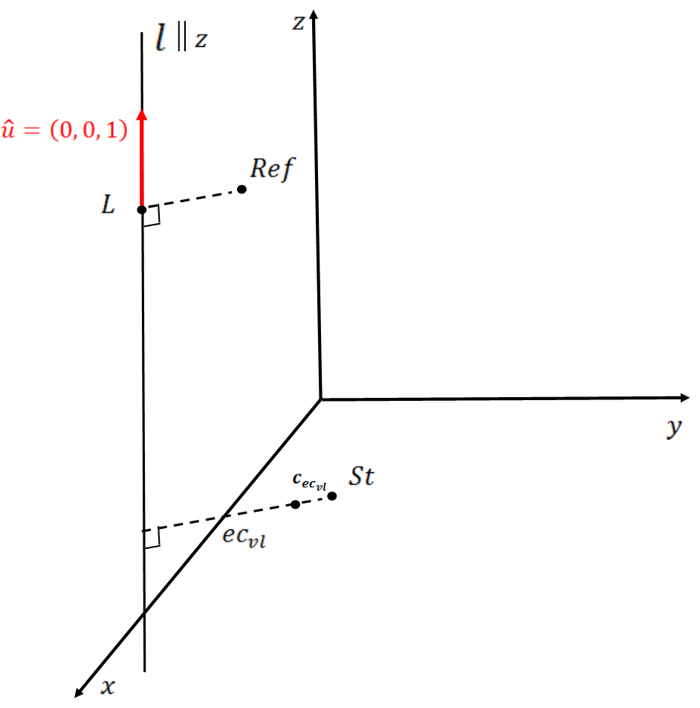

Mathematical Model
Model 1:
No point on the line is known or measured.

${ec}_{vl}= \sqrt{{\left(X_{L}-X_{St}\right)}^{2}+{\left(Y_{L}-Y_{St}\right)}^{2}}-c_{{ec}_{vl}}$

$$Constr=Z_{Ref}-Z_{L}=0$$

Model 2:
A point on the line, X_{L}, is known or measured.

${ec}_{vl}= \sqrt{{\left(X_{L}-X_{St}\right)}^{2}+{\left(Y_{L}-Y_{St}\right)}^{2}}-c_{{ec}_{vl}}$

Partial Derivatives
For the Model 1 and the Model 2:
Let
$$D=\sqrt{{\left(X_{L}-X_{St}\right)}^{2}+{\left(Y_{L}-Y_{St}\right)}^{2}}$$

For the Station coordinates:

$$\frac{∂{ec}_{vl}}{∂*}= \frac{X_{St}-X_{L}}{D}·\frac{∂X_{St}}{∂*}+\frac{Y_{St}-Y_{L}}{D}·\frac{∂Y_{St}}{∂*}$$

Where (2.9)

For the line point coordinates:

$$\frac{∂{ec}_{vl}}{∂*}=\frac{X_{L}-X_{St}}{D}·\frac{∂X_{L}}{∂*}+\frac{Y_{L}-Y_{St}}{D}·\frac{∂Y_{L}}{∂*}$$

Where * can stand for:$x_{0,L}; y_{0,L}; z_{0,L}; ω_{j,L};φ_{j,L};κ_{j,L; }t_{j,1,L};t_{j,2,L};t_{j,3,L};l_{j,L}$.

For the additional parameters:
$$\frac{∂{ec}_{vl}}{∂c_{{ec}_{vl}}}= -1$$

Constraint derivatives (for Model1 only):

For the line point coordinates:

$$\frac{∂Constr}{∂*}= - \frac{∂Z_{L}}{∂*}$$

Where * can stand for:$x_{0,L}; y_{0,L}; z_{0,L}; ω_{j,L};φ_{j,L};κ_{j,L; }t_{j,1,L};t_{j,2,L};t_{j,3,L};l_{j,L}$.

Stochastic model
$${σ_{ {ec}_{vl}}}^{2}={σ_{m}}^{2}+\frac{{\left(Y_{St}-Y_{L}\right)}^{2}+{\left(X_{St}-X_{L}\right)}^{2}}{D^{2}}{σ_{CSt}}^{2}$$

And $σ_{m}$represents the standard deviation of the observed value and the ppm error
$${σ_{m}}^{}= {σ_{obs}}^{}+{ec}^{}*{σ_{ppm}}^{}$$

Objects
Adjustable:
- Point – for the Station
- Line, consisting of:
- Point – line point $L$
- 3D vector – line vector $\hat{u}$ is known (0,0,1)
- Point – reference point (for Model 1 only)
- Scalar – for a $c_{{ec}_{vl}}$
Simple objects:
- Scalar– for a${ec}_{vl}$
- Scalar– for the standard deviations

Offset to a Theodolite Plane (ECTH)
This measurement is made in the Modified Local Astronomical System (MLA).

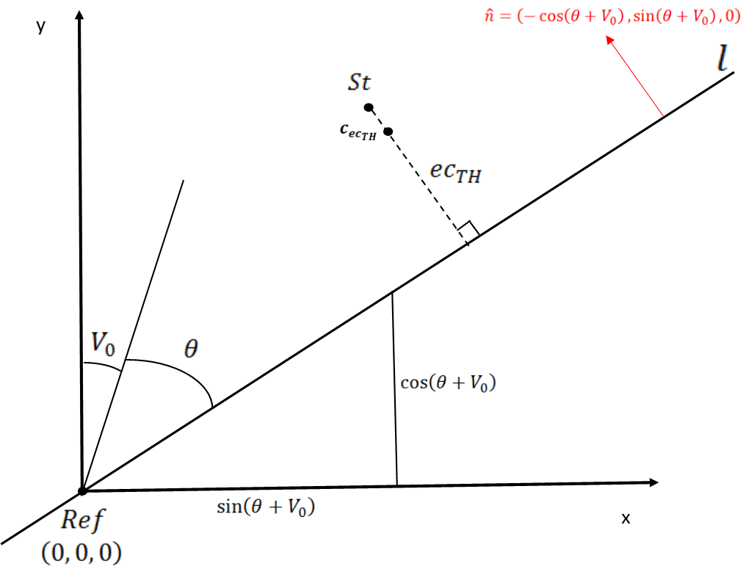

Mathematical Model
$${ec}_{TH}=-\cos\left(θ+V_{0}\right)·\left(X_{St}-X_{Ref}\right)+\sin\left(θ+V_{0}\right)·\left(Y_{St}-Y_{Ref}\right)-c_{{ec}_{TH}}$$

Partial Derivatives
For the Station coordinates:

$$\frac{∂{ec}_{TH}}{∂*}=-\cos\left(θ+V_{0}\right)·\frac{∂X_{St}}{∂*}+\sin\left(θ+V_{0}\right)·\frac{∂Y_{St}}{∂*}$$

Where (2.9).

For the Reference point coordinates:

$$\frac{∂{ec}_{TH}}{∂*}=\cos\left(θ+V_{0}\right)·\frac{∂X_{Ref}}{∂*}-\sin\left(θ+V_{0}\right)· \frac{∂Y_{Ref}}{∂*}$$

Where * can stand for:$x_{0,Ref}; y_{0,Ref}; z_{0,Ref}; ω_{j,Ref};φ_{j,Ref};κ_{j,Ref; }t_{j,1,Ref};t_{j,2,Ref};t_{j,3,Ref};l_{j,Ref}$.

For the angles:
$$\frac{∂{ec}_{TH}}{∂θ}=\sin\left(θ+V_{0}\right)·\left(X_{St}-X_{Ref}\right)+\cos\left(θ+V_{0}\right)·\left(Y_{St}-Y_{Ref}\right)$$

$$\frac{∂{ec}_{TH}}{∂V_{0}}=\sin\left(θ+V_{0}\right)·\left(X_{St}-X_{Ref}\right)+\cos\left(θ+V_{0}\right)·\left(Y_{St}-Y_{Ref}\right)$$

For the additional parameters:
$$\frac{∂{ec}_{TH}}{∂c_{{ec}_{TH}}}= -1$$

Stochastic model
$${{σ_{{ec}_{TH}}}_{ }}^{2}={σ_{m}}^{2}+{(cos\left(θ+V_{0}\right)}^{2}+{\sin\left(θ+V_{0}\right)}^{2}){{ σ}_{CSt}}^{2}$$

And $σ_{m}$represents the standard deviation of the measured offset and the ppm error
$${σ_{m}}^{}= {σ_{meas_offset}}^{}+{ec}^{}*{σ_{ppm}}^{}$$

Objects
Adjustable:
- Point – for the Station and Reference point
- Angle – for the $V_{0}$
- Scalar – for the $c_{{ec}_{TH}}$
Simple objects:
- Angle – for the $θ$
- Scalar – for the ${ec}_{TH}$
- Scalar – for the standard deviations

additional measurement models

5.1 Gyro-Theodolite Azimuth (ORIE)
This measurement is made in the Local Astronomical System (LA) and, therefore, it involves different transformation than most of the other observation equations, which are defined in MLA.
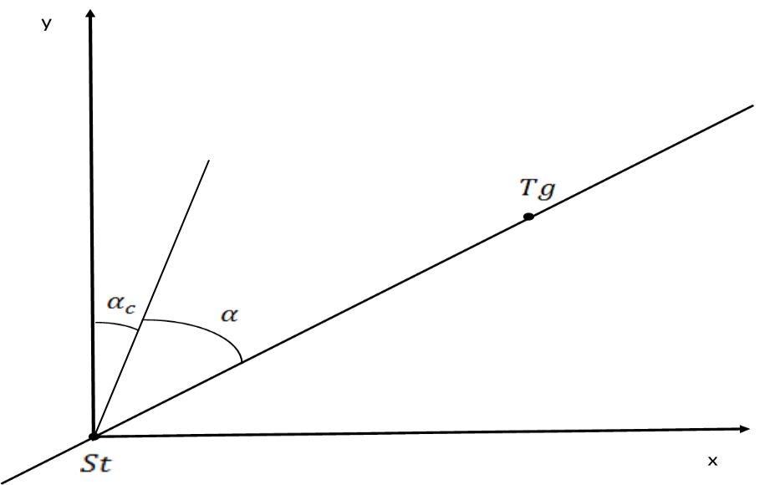

Mathematical Model
$$α=\tan^{-1}\left(\frac{X_{Tg}-X_{St}}{Y_{Tg}-Y_{St}}\right)-α_{c}$$

Partial Derivatives
For the Station coordinates:

$$\frac{∂α}{∂*}=-\frac{\left(Y_{Tg}-Y_{St}\right)}{D^{2}}·\frac{∂X_{St}}{∂*}+\frac{\left(X_{Tg}-X_{St}\right)}{D^{2}}·\frac{∂Y_{St}}{∂*}$$

Where
$$D^{2}={\left(X_{Tg}-X_{St}\right)}^{2}+{\left(Y_{Tg}-Y_{St}\right)}^{2}$$

Where (2.9).

For the Target coordinates:

$$\frac{∂α}{∂*}=\frac{\left(Y_{Tg}-Y_{St}\right)}{D^{2}}·\frac{∂X_{Tg}}{∂*}+\frac{\left(X_{St}-X_{Tg}\right)}{D^{2}}·\frac{∂Y_{Tg}}{∂*}$$
Where (2.10).

For the additional parameters:

$$\frac{∂α}{∂α_{c}}= -1$$

Stochastic model
$${σ_{α}}^{2}={σ_{m}}^{2}+{σ_{αc}}^{2}+\frac{{\left(Y_{Tg}-Y_{St}\right)}^{2}+{\left(X_{St}-X_{Tg}\right)}^{2}}{D^{4}}\left({σ_{CTg}}^{2}+{σ_{CSt}}^{2}\right)$$

By default ${σ_{αc}}^{2}=0$
And $σ_{m}$is the standard deviation of the observed value

Objects
Adjustable:
- Point – for the Station and Target
- Angle – for $α_{c}$
Simple objects:
- Angle – for $α$
- Scalar – for the standard deviations

Constraint models

6.1 Radial Offset Constraint (RADI)
This measurement is made in the CERN Cartesian System (CCS).
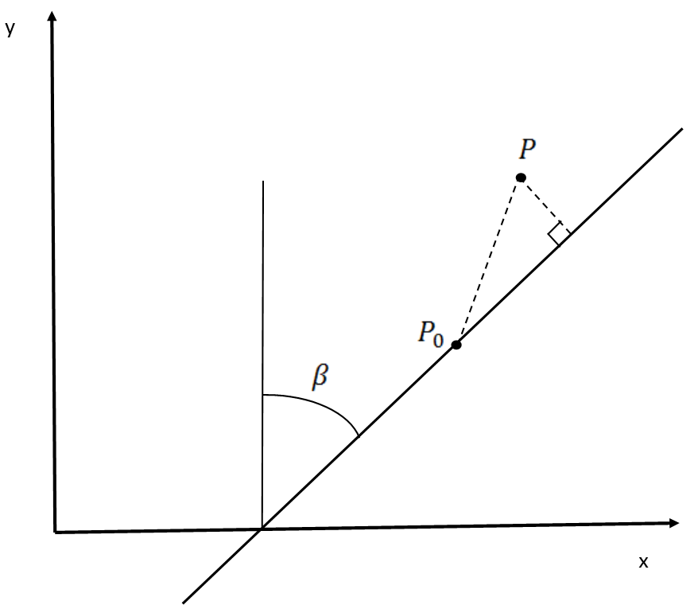

Mathematical Model
$$F=-\cos\left(β\right)·\left(X_{P}-X_{P_{0}}\right)+\sin\left(β\right)·\left(Y_{P}-Y_{P_{0}}\right)=0$$

Partial Derivatives
For the point P coordinates:$$\frac{∂F}{∂*}=-\cos\left(β\right)·\frac{∂X_{P}}{∂*}+\sin\left(β\right)·\frac{∂Y_{P}}{∂*}$$

Where * can stand for:$x_{0,P}; y_{0,P}; z_{0,P}; ω_{j,P};φ_{j,P};κ_{j,P; }t_{j,1,P};t_{j,2,P};t_{j,3,P};l_{j,P}$.

For the $β$ angle:
$$\frac{∂F}{∂β}= \sin\left(β\right)·\left(X_{P}-X_{P_{0}}\right)+\cos\left(β\right)·\left(Y_{P}-Y_{P_{0}}\right)$$

Stochastic model
$${σ_{F}}^{2}={σ_{CP}}^{2}$$

Objects
Adjustable:
- Point – $P_{0}$ and P and points
- Angle – $β$ angle
Simple objects:
- Scalar – for the standard deviations

Orientation Constraint (PDOR)
This measurement is made in the CERN Cartesian System (CCS).

Mathematical Model
$$β=\tan^{-1}\left(\frac{X_{P}-X_{CALA}}{Y_{P}-Y_{CALA}}\right)$$

Partial Derivatives
For the point P coordinates:
$$\frac{∂β}{∂*}=\frac{\left(Y_{P}-Y_{CALA}\right)}{D^{2}}·\frac{∂X_{P}}{∂*}+\frac{\left(X_{CALA}-X_{P}\right)}{D^{2}}·\frac{∂Y_{P}}{∂*}$$

Where
$$D^{2}={\left(X_{P}-X_{CALA}\right)}^{2}+{\left(Y_{P}-Y_{CALA}\right)}^{2}$$

Objects
Adjustable needed:
- Point – for the P point
- Point – for the $x_{CALA}$ point (all coordinates fixed)
Simple objects (not adjustable):
- Angle – for the $β$
- Scalar – for the standard deviations
Where * can stand for:$x_{0,P}; y_{0,P}; z_{0,P}; ω_{j,P};φ_{j,P};κ_{j,P; }t_{j,1,P};t_{j,2,P};t_{j,3,P};l_{j,P}$.

Point Coordinate
This measurement is given in the CCS or one of the Local Object Reference (LOR) systems.

$$X_{P}=X_{P,0}$$

Mathematical Model
In 3D space:
$${F=(X_{P}-X_{P,0})}^{2}+{(Y_{P}-Y_{P,0})}^{2}+{{(Z}_{P}-Z_{P,0})}^{2}=0$$

In 2D space:
$${F=(X_{P}-X_{P,0})}^{2}+{(Y_{P}-Y_{P,0})}^{2}=0$$

In 1D space:
$${F=(Z_{P}-Z_{P,0})}^{2}=0$$

Partial Derivatives
In 3D space:
$$\frac{∂F}{∂*}=2·\left(X_{P}-X_{P,0}\right)·\frac{∂X_{P}}{∂*}+2·\left(Y_{P}-Y_{P,0}\right)·\frac{∂Y_{P}}{∂*}+2·\left(Z_{P}-Z_{P,0}\right)·\frac{∂Z_{P}}{∂*}$$

Where * can stand for:$x_{0,P}; y_{0,P}; z_{0,P}; ω_{j,P};φ_{j,P};κ_{j,P; }t_{j,1,P};t_{j,2,P};t_{j,3,P};l_{j,P}$.

For the measured coordinates,
$$\frac{∂F}{∂X_{P,0}}=-2·\left(X_{P}-X_{P,0}\right)$$

$$\frac{∂F}{∂Y_{P,0}}=-2·\left(Y_{P}-Y_{P,0}\right)$$

$$\frac{∂F}{∂Z_{P,0}}=-2·\left(Z_{P}-Z_{P,0}\right)$$

In 2D space:
$$\frac{∂F}{∂*}=2·\left(X_{P}-X_{P,0}\right)·\frac{∂X_{P}}{∂*}+2·\left(Y_{P}-Y_{P,0}\right)·\frac{∂Y_{P}}{∂*}$$

Where * can stand for:$x_{0,P}; y_{0,P}; ω_{j,P},t_{j,1,P};t_{j,2,P};l_{j,P}$.

For the measured coordinates,
$$\frac{∂F}{∂X_{P,0}}=-2·\left(X_{P}-X_{P,0}\right)$$

$$\frac{∂F}{∂Y_{P,0}}=-2·\left(Y_{P}-Y_{P,0}\right)$$

In 1D space:
$$\frac{∂F}{∂*}=2·\left(Z_{P}-Z_{P,0}\right)·\frac{∂Z_{P}}{∂*}$$

Where * can stand for:$z_{0,P};t_{j,1,P};l_{j,P}$.

For the measured coordinate,
$$\frac{∂F}{∂Z_{P,0}}=-2·\left(Z_{P}-Z_{P,0}\right)$$

Stochastic model
For point coordinate, standard deviation are used to fill in the weight matrix of unknowns.
For X and Y components, the value is $σ={\frac{1}{2}σ_{CP}}^{ }$
And 0 for the Z component.

Objects
- (3D, 2D and 1D) points

References
[1] Jones, M. ( 1999). The RxRyRz matrix. Geneva: EST-SU Internal Note, EDMS Document No. 107903, CERN.
[2] Jones, M. ( 2000). Spatial Transformations: Transformations Between the Geodetic and Astronomical Reference & Coordinate Systems. Geneva: EST-SU Internal Note, EDMS Document No. 107907, CERN.
[3] Soler, T., & Chin, M. (1985). On Transformation Of Covariance Matrices Between Local Cartesian Systems and Commutative Diagrams. Washington, D.C.: ASP-ACSM.
[4] Zwiener, J. (2011). 3-D Integrated Network Adjustment with a Parametric Height Reference Surface.

