**Executive Summary**

It has been found that the majority of shipping material defects originate in the packaging area. This is true for both normal defects and significant defects requiring re-work before they can be loaded for shipping. The packaging defects are a result of inadequate time allotted for double stack packaging. Packaging teams do not have enough time to implement proper packaging procedures or do a quality inspection before stacks are moved to the shipping warehouse. It is recommended that an additional packaging team be added to each shift. Another possible solution is to implement a permanent shipping dock auditor. During the data gathering phase of this report, it was noted that the number of defects was declining; a result of the packaging teams receiving feedback from the auditing/data gathering process. This solution would cost less than the additional packaging teams, but will only *indirectly* reduce defect production. The auditor solution will also decrease the amount of repair time available for correcting significant defects, adding to the risk of shipping trucks leaving late.

**Problem Statement and Purpose**

It has been found that a significant number of shipping material defects exist, and are being identified by customers. It is not known at which stage in the shipping process these defects are originating, or how they are forming. The majority of the defects are insignificant to the quality of the product; however, some have been identified by the customers and provide enough cause for concern.

The Purpose of this report is to identify where defects are originating, why they are forming, and recommend possible solutions to prevent defect creation.

**Methodology**

The data analysed in this report was gathered over a period of two weeks. At the beginning of each day shift, the previous day’s shift’s double stacks were inspected. The shipping schedule was acquired and the loads were checked in order of when they would be leaving the factory. This allowed time for significant defects to be repaired prior to being loaded.

Each double stack, consisting of two module cartons, was inspected. Because of space limitations, there was not enough room between stacks too inspect all four sides of each skid. The skids were inspected based on the following criteria: carton damage, strap damage/presence, shrink wrap damage, corner protector positioning, label damage, and skid damage; where the last two criteria, label damage and skid damage, often resulted in significant defects. All defects were recorded. Details recorded were: defect name, load number, probable origin of defect, and date. The gathered data was input to Excel for analysis.

**Results**

The distribution of origin of defect can be seen in figure 1.

Figure 1: Origin of defects

The number of defects identified per day can be seen in figure 2.

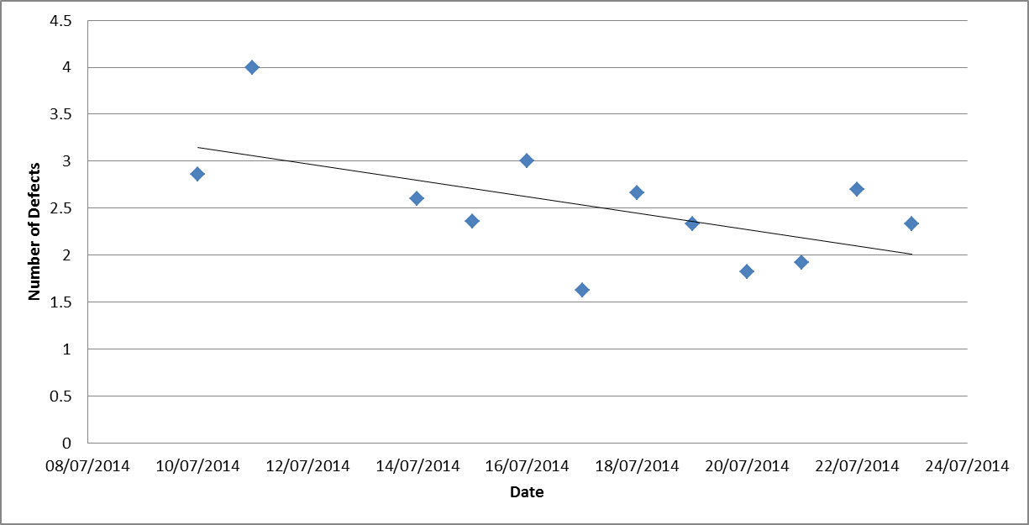

Figure 2: Number of defects Identified per Day

**Discussion and Recommendations**

There are a number of important points that should be discussed regarding the listed figures.

It can be seen in Figure 1 that most of the defects are originating from the packaging phase of the production process. It can also be assumed that half of the defects included in the “Either” column originated from the packaging process. It is important to note that the “label damage” significant defects can only be prevented in the packaging area and the “skid damage” significant defect can be caused by improper forklift positioning or by inadequate skid inspection during packaging. As the majority of both significant and normal defects originate from packaging, it is recommended that the packaging process be improved.

After discussing possible causes and changes with the packaging team leader, the quality department recommends adding an additional packaging team per shift. This reduces the number of double stacks each team will need to package in a shift; providing more time to ensure the double stacks are packaged correctly and more time to inspect for defects. Inspecting before the double stacks are moved to the shipping warehouse will also allow time to correct any identified significant defects; before they need to be loaded on to the shipping trailers.

Figure 2 shows that while the dock audit was taking place, the number of defects decreased without any other strategies being implemented. This was a result of defective skids being returned to the packaging area where packaging teams became aware of the errors. Considering this reduction in defect production as well as the increased chance that any produced defects are caught before shipping, implementing a permanent dock auditor position should be considered as a solution. This would require fewer new positions than additional packaging teams, but would delay when the defects are caught and increases the risk of trucks leaving late.

**Conclusion**

The Quality department recommends two possible solutions. Adding a packaging team to each shift will increase time allowed for proper packaging procedures and for double stack inspecting prior to double stacks being moved to the shipping warehouse. Implementing a permanent shipping dock auditor will require fewer new positions than adding additional packaging teams, but will allow for less time to correct significant defects and will have an indirect, feedback dependent, effect on defect production.

**Appendix**

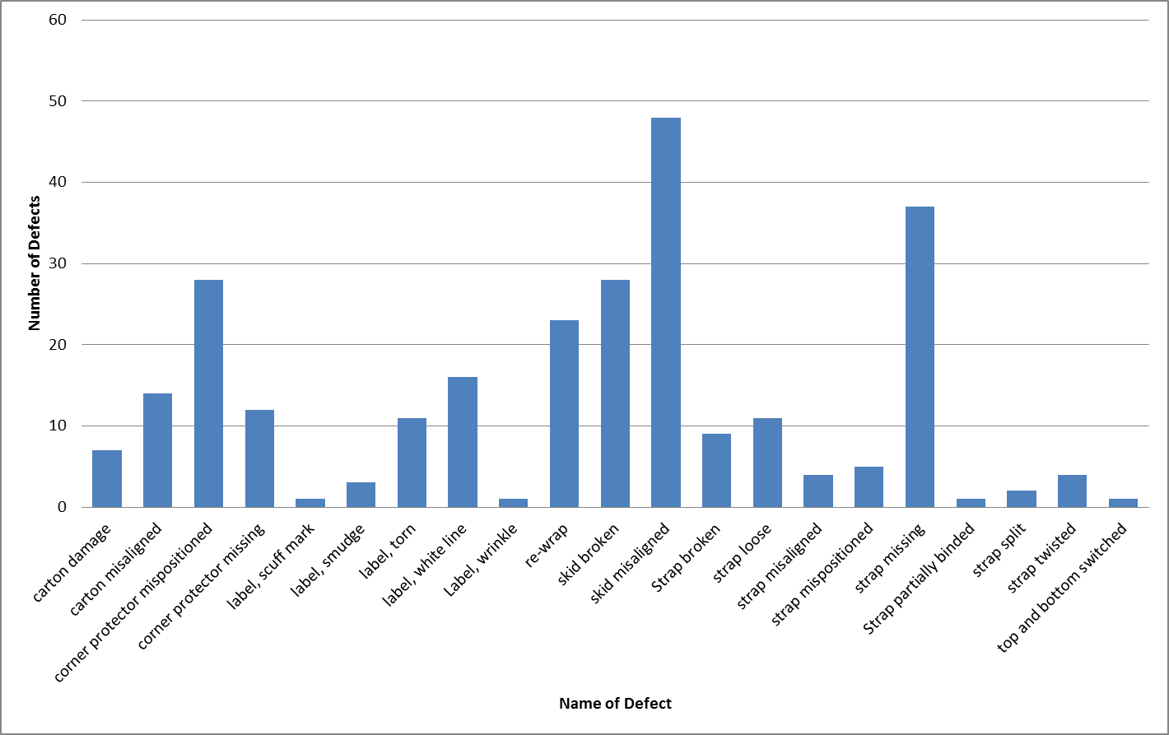

Figure 3: Types and quantity of defects identified over a two weeks period