Simon Wroblewski

CMSI 402

February 20, 2019

**Homework #2**

**5.1**

Component-based architecture is thought of as a collection of loosely coupled parts of code (each with their specified purpose) which provides services to each other via an interface. They are also developed and retained independently of one another, however each component interacts directly with all the others and cannot run without them. Service-oriented architecture is similar to a component-based architecture except the pieces are referred to as “services” which (different from component- based) can be implemented separately from each other. A “service” is a program that runs on its own and brings some sort of service to its clients.

**5.2**

Since the component is a computer and the scores are stored on the phone, no database is needed. I would choose a component-based architecture for this application because both the data and opponent are local to the phone.

**5.4**

I would choose a web service-oriented architecture would work well for this so that both opponents can communicate via the internet.

**5.6**

The ClassyDraw application can store its data in files for the OS to manage so I would choose a file-based system.

**5.8**

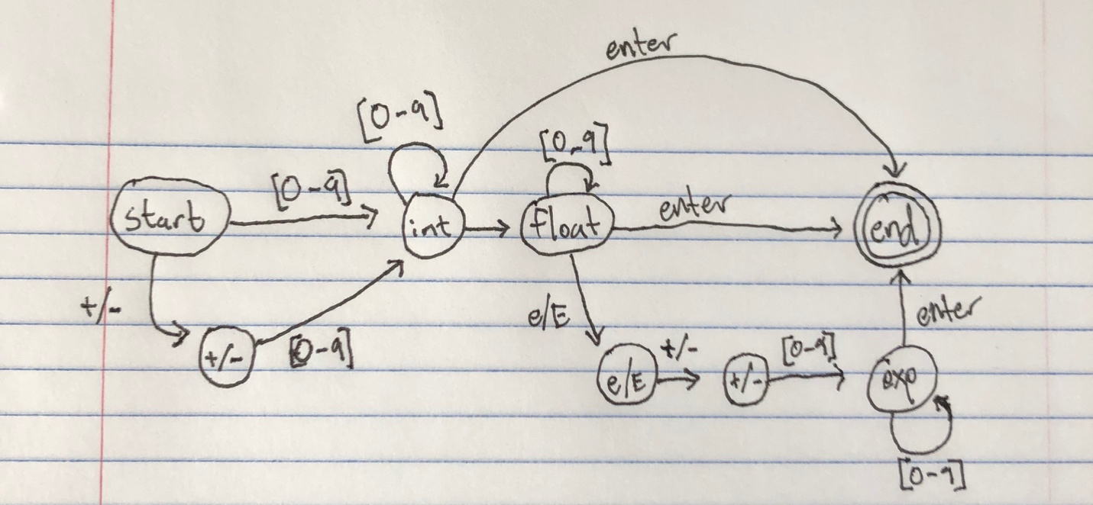

**6.1**

The class “Line” is necessary for any characters/ symbols so it is inherited by Text, Rectangle, Star, and Ellipse. The line class should have the properties the other classes will need such ass color, thickness, shadow, and border. The other classes can use that line to create shapes and implement other properties.

**6.2**

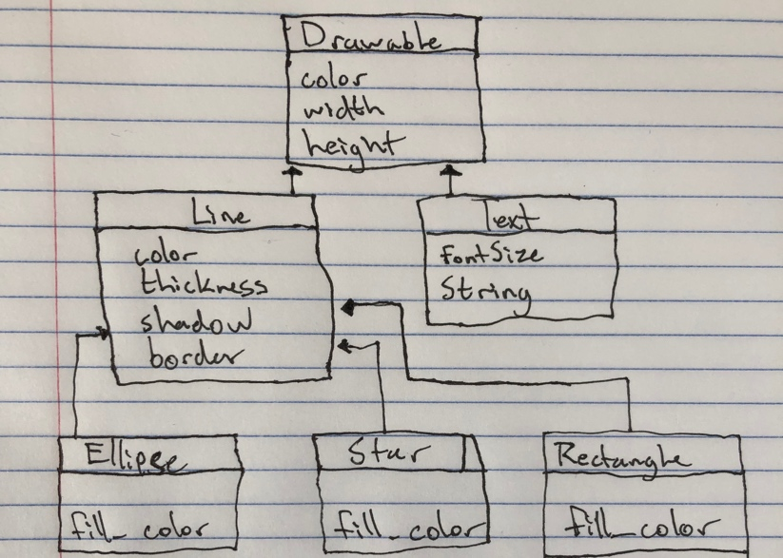

**6.3**

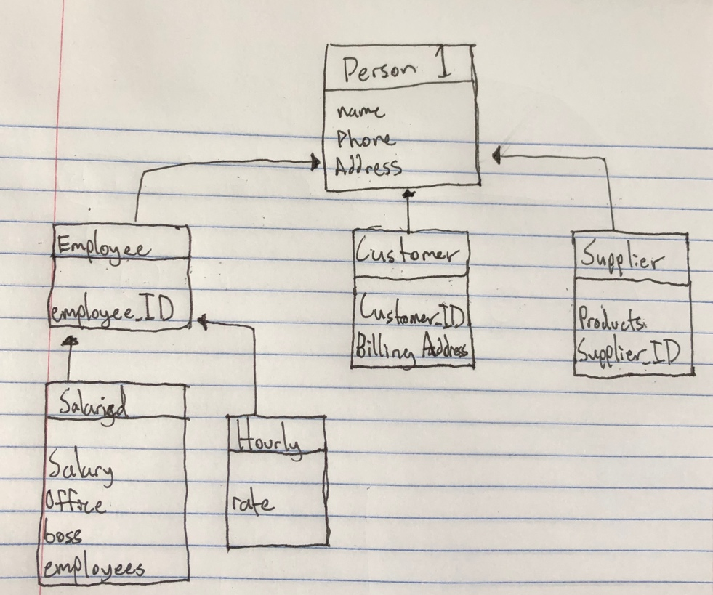

**6.6**

The boss property is empty at the executive level and the employee property is empty at the starting level