

**Canadian Federation of University Women - Saskatoon Inc.**



P.O. Box 7405, Saskatoon, SK S7K 4J3

[www.cfuw-saskatoon.org](http://www.cfuw-saskatoon.org)

***Spring 2018 Newsletter***

**Upcoming CFUW events**

**Sunday, March 11, 2018**

**International Women’s Day**

McClure United Church, 4025 Taylor Street East

Time: 2:00- 4:00 pm (Doors open at 1:30)

**Monday, April 2 2018**

**Resolutions**



**Monday, May 7, 2018**

**100th Anniversary Gala Banquet**

**Speaker: Dr. Beth Bilson**

Saskatoon Inn

Cocktails: 5:30 pm, Dinner: 6:30pm

Tickets: $50

Available at McNally Robinson or contact Mae Popoff @ 306.373.2991 maepopoff@hotmail.com

**Monday, June 4, 2018**

**AGM….more info to come.**

2 *Spring 2018*

|  |  |  |  |
| --- | --- | --- | --- |
| **Board & Committee Chairs**  **President** Mary Rowan  **Past President** Janie Charbonneau  **Vice-President** Kathy Cram  **Treasurer** Angie Schmidt  **Secretary** Penny-Lynn Micklewright  **(general meetings)**  **Secretary** Gerlinde Sarkar  **(board meetings)**    **Membership** Gerlinde Sarkar    **Program** Freda Toffolo    ***Committee Chairs:***  **Archives** Margaret Hendry  **Book Sale** Alverta Polson  **Council of Women** Jean Thompson    **Newsletter Editors** Tracy Muggli    **Scholarship** Ferne Wagner    **Publicity**  Malaika Charbonneau  Janie Charbonneau    **Social** Verna Sagansky    **100th Anniversary**  Marlene Chatterson  **CFUW Rep- U of S Senate:** Victoria Neufeldt    *A world of empowered women isn’t one where men are marginalized. It’s a world where everybody thrives……*Purima Mane, President and CEO of Pathfinders International |  | ***President’s Message***  Our club is 100 years old! Let the celebrations begin!  Our International Women’s Day Celebration will take place on March 11th, at two in the afternoon. It will be a fun event for the whole family so please join us. This will take the place of the evening meeting on March 5th.  Our April 2nd we will deal with the proposed resolutions. There are three this year.  *Resolution 1* Fair and Non-Discriminatory Management of Refugees and Asylum Seekers.  *Resolution 2* Ending Youth Homelessness  *Resolution 3* Education to serve as a vehicle for social justice for vulnerable children living in closed religious communities.  May 7th will be our Gala, Banquet. Make sure to get your tickets early. Our AGM is scheduled for June 4th this year so that we don’t have to deal with any business at our Anniversary Celebration  As you have been informed, the GWI dues for the 2018 GWI financial year are being paid in two installations, one by January 1, 2018, that was paid by CFUW on December 20, 2017, and the other dues increase by June 30, 2018. The Articles and Bylaws of CFUW will not allow it to pass a dues increase at an AGM in time to make this payment. For those members wishing to make a voluntary fee payment for GWI, they may give the amount of $8.40 to the club treasurer at the April meeting or send a cheque to CFUW Saskatoon at P.O. box 7405 Saskatoon Sk. S7K 4J3. The National Office needs the payment from our Club by April 30th.  The National Office would like to send email information directly to Club members and are asking for our email list. Please contact me if you would not like your email information shared.  *Respectfully submitted, Mary Rowan, President* |  |

3 *Spring 2018*

|  |  |
| --- | --- |
| ***Membership Committee***  Since our last newsletter went out in December, one new member joined: Lavina Carter. Please welcome her to the club. Her contact information is lavina.carter@shaw.ca , phone: 306.955.2333, address: 112 Lindsay Drive, Saskatoon, SK. S7H 4B4. Pleas add this to your directory. Also, please make a correction to Shirley Haines’ email address. Her email address should be gandshaines@sasktel.net  We now have 74 members, so our total paid membership number is the same as last year (not including the scholarship recipients we paid for last year). If any of you have not yet received your membership list booklet, please let me know and I will send it to you. Also, if there are any errors, please inform me.  As always, if you know of any potential new members, please invite them to our meetings. If you have any questions about the activities of our many interest groups, or you are not getting notices from the conveners of the interest groups for which you have signed up on your membership form, feel free to contact me at (306) 374-3006 or at gerlinde.sarkar@gmail.com  *Respectfully submitted,*  *Gerlinde Sarkar, Membership chair*  ***Awards***  CFUW-Saskatoon has established a new award, the Saskatchewan Polytechnic Bursary. Two bursaries of $1,000 each will be awarded for the first time this fall (September 2018) to mark the 100th anniversary of our club. The SK Polytechnic bursaries are intended to encourage and recognize Saskatchewan female students in programs underrepresented by women.  Application and Selection will be handled by the Saskatchewan Polytechnic Donor and Alumni Relations Office. A link to the application form will be provided to CFUW-Saskatoon by this office and will also be posted on the CFUW-Saskatoon website. The application will be open in the spring, for awards in the fall.    To be eligible to apply for the CFUW-Saskatoon Polytechnic Bursary, a student must  • Be a female student  • Be enrolled full-time at Saskatchewan Polytechnic Saskatoon campus in year one of a diploma program that has less than 30% female enrolment.  To be eligible to receive the CFUW-Saskatoon Bursary, a student must  • Have successfully completed year one of the program  • Be enrolled in year two of the program  *Submitted by Janie Charbonneau, Chair of the Saskatchewan Polytechnic bursary committee*   Report for CFUW Saskatoon Inc. fall ne |  |

***Plea for Booksale Volunteers!***

***The current book sale committee members will be retiring after the 2018 sale. Some of these women have worked on the sale for 50 years! Many thanks to Alverta Polson, Dorma Guedo, Alison Philips, Marilyn Loken, and Phyllis Umpherville for all their hard work.***

***Please contact Mary Rowan if you are interested in supporting our major fundraiser by donating your time throughout the year in preparation of the sale and at the sale itself.***

*4 Spring 2018*

***Saskatoon Council of Women***

The Saskatoon Women’s Hall of Fame was on display at the Heritage Festival in February. There was considerable interest in the stories of the thirty-nine women who have been inducted since it was established in 1996.

The Council of Women is partnering with CFUW, International Women of Saskatoon and U of S International Women’s Movement to recognize International Women’s Day in March.

*Respectfully submitted, Jean Thompson*

***Scholarship Committee***

The C.F.U.W. Saskatoon Graduate Scholarships application deadline was January 31, 2018. Thirty-five applications have been received from Master’s and Ph.D. students.

There are five scholarships available, four of $1500 and one of $5000 value, as set by the 2017-18 Budget.

The committee members, Dorma Guedo, Eleanor Ritchie, Mary Rowan, and I, are presently reviewing the applications. Selection will occur on March 13.

Awards are distributed by the last week of March.

*Submitted by Ferne Wagner, Scholarship Chair*

***CFUW Saskatchewan Council News***

The 2018 AGM and Workshop for CFUW Clubs of the Saskatchewan Council will be held in Saskatoon on Saturday May 26 at St Martin’s United Church.

Many details have to be settled: we need a lunch time speaker; suggestions for our workshop that would be of interest to our members and if the suggestions come with the name of a facilitator that would be a wonderful bonus. And finally, we need to cater lunch. Does anyone know of a caterer who might provide us with an interesting menu? Please contact me – Margaret Hendry at 306-373-8693 or 306-881-8693 or by email at [margaret.hendry@shaw.ca](mailto:margaret.hendry@shaw.ca) I look forward to all suggestions and will do my best to put together an interesting day.

Saskatchewan needs a new Regional Director. I am finishing my second two-year term. The deadline for nominations is February 28, 2018. At this point I have received no interested queries so we may need an extension. Please consider this position. It is interesting and a chance to visit all Saskatchewan clubs and share in their activities. There are three conference calls through the year and one face-to-face meeting at the national AGM each year. The term is for two years but this of course depends on individual circumstances. An RD is eligible to serve two terms. I have found it interesting and rewarding and have especially enjoyed meeting members of other clubs. Please think about this and contact me for any further information.

*Submitted by Margaret Hendry*

## International Women's Day is powered by the collective efforts of all

Collective action and shared ownership for driving gender parity is what makes International Women's Day successful. Gloria Steinem, world-renowned feminist, journalist and activist [once explained](https://www.seattletimes.com/opinion/herersquos-to-the-memory-of-gloria-steinem-and-the-other-women-who-struggled-for-equality/) "The story of women's struggle for equality belongs to no single feminist nor to any one organization but to the collective efforts of all who care about human rights." So make International Women's Day your day and do what you can to truly make a positive difference for women.

Taken from: https://www.internationalwomensday.com/

*5 Spring 2018*

**CFUW SASKATOON’S 100TH ANNIVERSARY COMMITTEE REPORT**

Tickets for the Gala Dinner on May 7, 2018 are on sale and can be purchased from Mae Popoff at 306 373-2991, maepopoff1@hotmail.com or at McNally Robinson (cash preferred as they charge us for visa use). They will also be for sale at our International Women’s Day Event March 11th at McClure Church.

As the AGM has been postponed until June, we urge you to bring husbands, partners, adult children and friends to help us celebrate 100 years as a Club. We are limited to 80 tickets so get your tickets early.

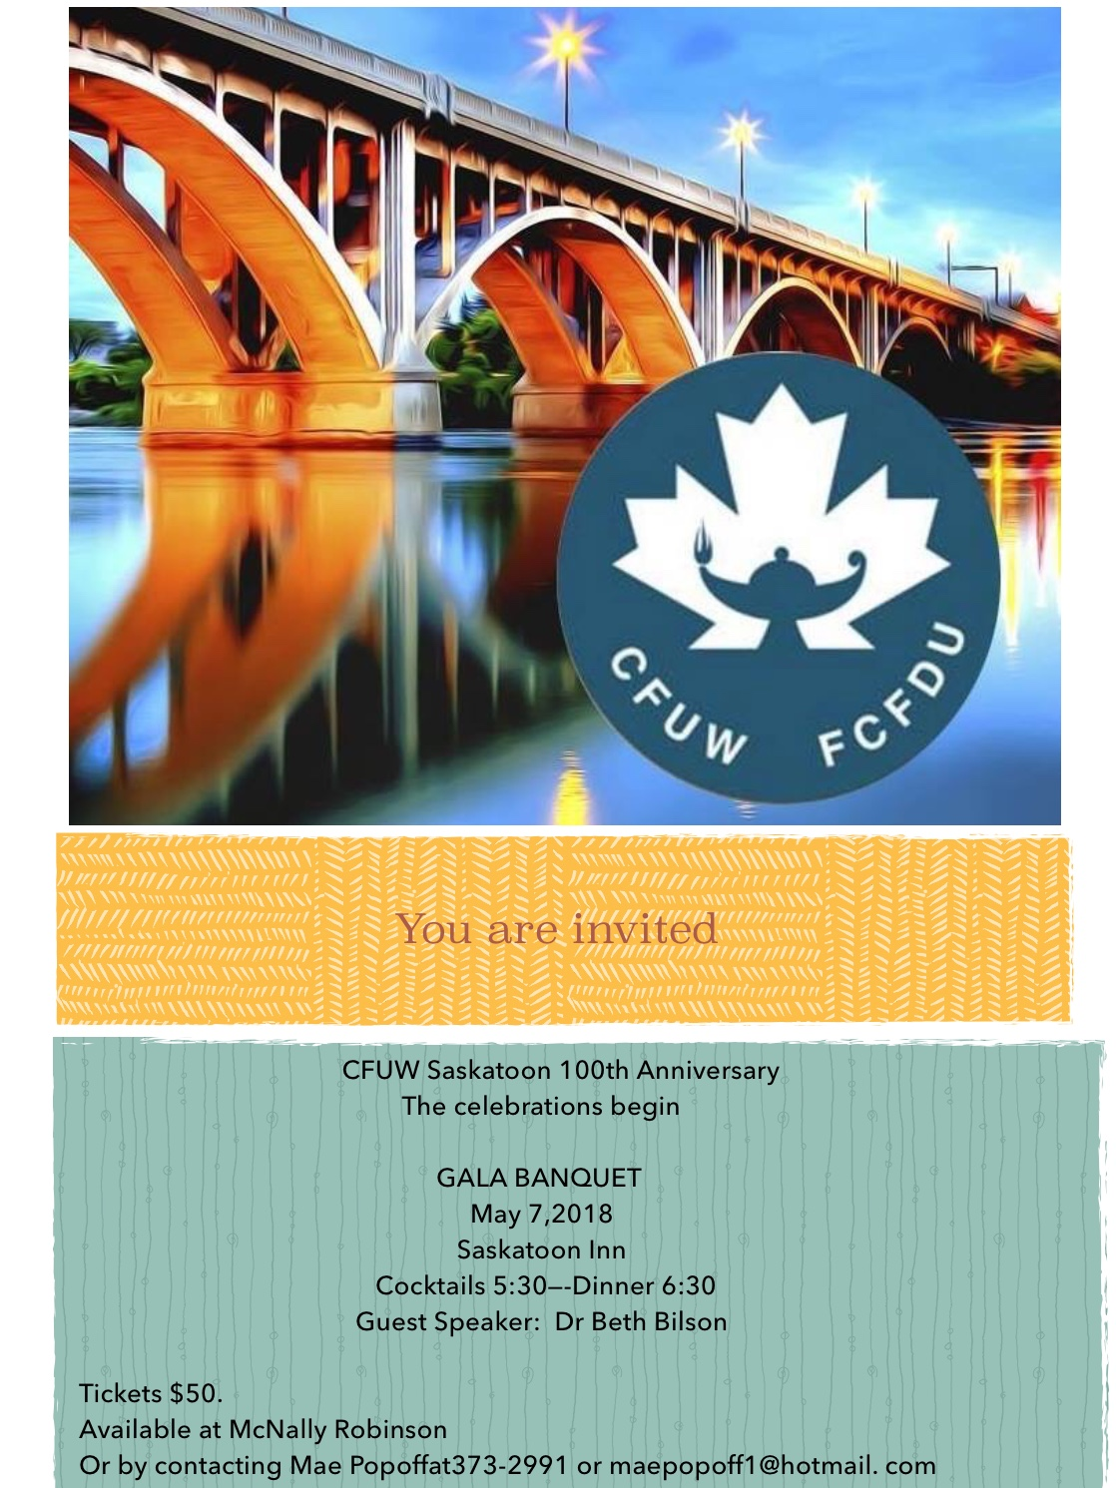

*6 Spring 2018*

**January Luncheon**

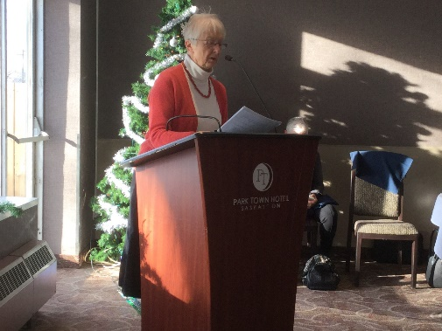

Guest speaker Peggy Sarjeant

Saskatoon Heritage Society, speaking about War Brides

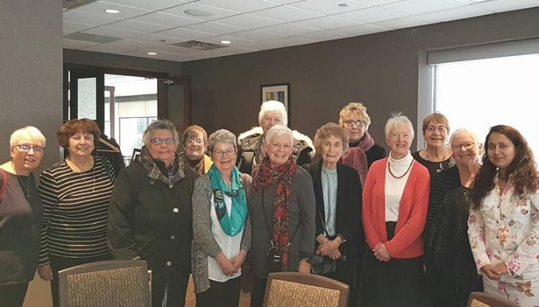

**INTERNATIONAL WOMEN’S DAY**

