

**Canadian Federation of University Women - Saskatoon Inc.**

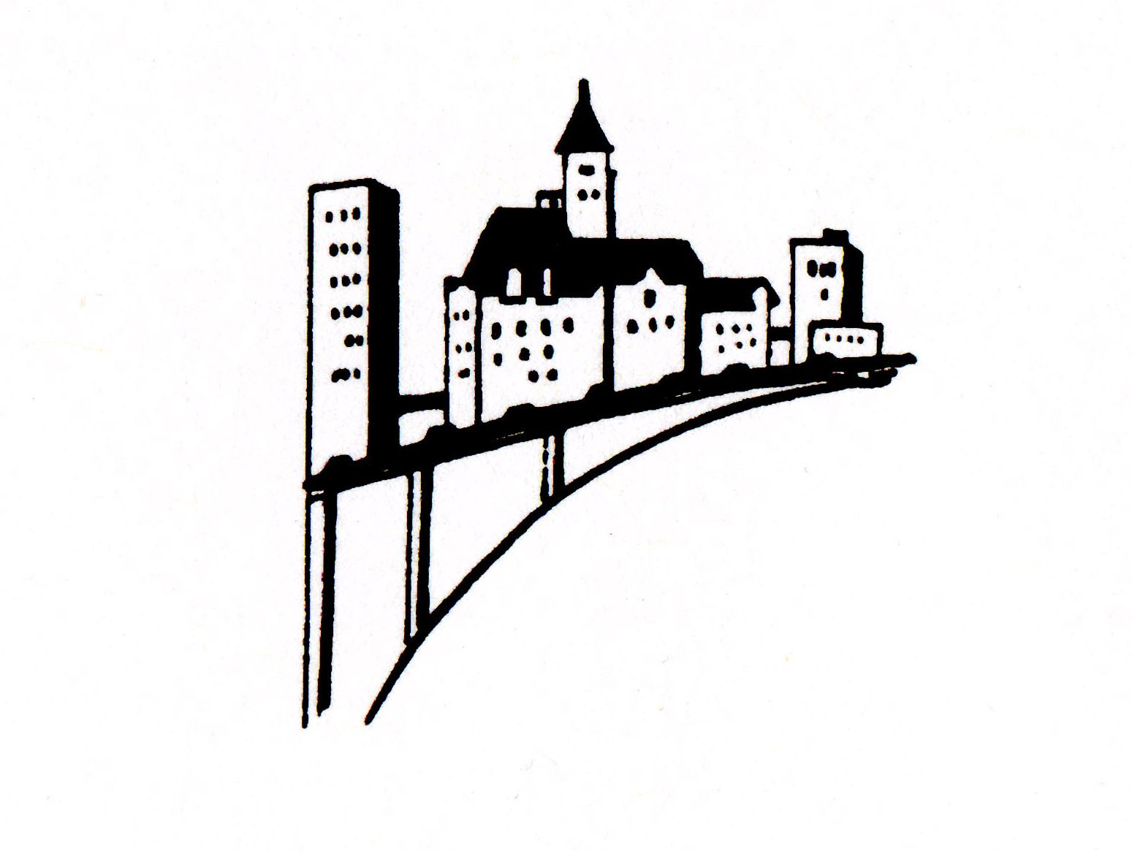

P.O. Box 7405, Saskatoon, SK S7K 4J3

[www.cfuw-saskatoon.org](http://www.cfuw-saskatoon.org)

***December 2015 Newsletter***

**Upcoming CFUW events**

**Monday December 7th, 2015**

W. A. Edwards Family Centre, 333-4th Ave. North

Time: 7:30 – 9:30 pm

Our Program committee promises an entertaining evening with a game and poetry recitations

*Please bring something sweet or savory. It is always a pleasure to sample everyone’s offerings… and bring a friend!*

**Saturday, January 9th, 2016 (January meeting)**

Parktown Hotel

Speaker: Lori Blondeau, Artist

Time: 11:30 - 2pm

Topic: Indigenous Women in the Arts

Tickets: $25 available from Cathy Fry at the Christmas Social

2 *December/15*

|  |  |  |  |
| --- | --- | --- | --- |
| **Board & Committee Chairs**  **President** Janie Charbonneau  **Past President** Gerlinde Sarkar  **Vice-President** Alix Tumback  **Treasurer** Michelle Rogers  **Secretary** Victoria Neufeldt  **(general meetings)**  **Secretary** Angela Schmidt  **(board meetings)**    **Membership** Marlene Chatterson  Dorma Guedo  Melinda Waltz  Rita Priestley  **Program** Freda Toffelo  Penny-Lynn Micklewright  Sherry Smith  Phyllis Austman  ***Convenors:***  **Book Sale** Alverta Polson  **Council of Women** Jean Thompson  Ruth Robinson  **Newsletter Editor** Tracy Muggli  Gerlinde Sarkar    **Scholarship** Mary McKay    **Publicity**  Malaika Charbonneau  Sherry Smith  **Archives** Margaret Hendry    **Social** Myrt Ryhorchuk  Cathy Fry  Donna Jean Gerrier  *A world of empowered women isn’t one where men are marginalized. It’s a world where everybody thrives.*  Purima Mane,  President and CEO of Pathfinders International |  | ***President’s Message***  Greetings!  Snow has finally found us in Saskatoon. It's time to take advantage of all the stimulating adventures that winter has to offer, or, to cozy up by a fire and read a good book.    These past months have been both busy and rewarding. All Interest Groups are in full swing and we had another successful Mammoth Book Sale. Thank you to Alverta, the Book Sale Committee and all the volunteers for a job well done.    The Resolutions for 2016 have been sent out. I will be forwarding the resolutions so you can familiarize yourselves with them for our discussion in February.    Our Christmas Social is on December 7th, Monday 7:30 – 9:30 PM at the Edwards Family Centre. Our Program Committee promises an entertaining evening with a game and poetry recitation. Everyone is to bring something sweet or savoury. It is always a pleasure to sample everyone's offerings.    ***Donations***  Again this year, we are asking you to make a donation to the less fortunate:   Lighthouse: - scarves, tuques, mitts, socks, men’s underwear  - disposable razors, toothbrush and toothpaste                       - feminine products, small bottles of shampoo  Friendship Inn: -nonperishable foods, (e.g. canned vegetables, meats and fish, whole grain cereal and whole grain pasta), 100% fruit juice (no sugar added), diapers, infant formula, and of course  cash donations are always welcome.  I will also take donations of cat and dog food to the SPCA.  All donations will be delivered to charities within a week.    **Biographies**  Last newsletter I put out a call for mini biographies from our members. Are you still working on them? If you need any clarification please email or telephone me.  Your stories will be an invaluable resource for all women, learning first hand of the challenges and rewards of your education and careers.    **Bon Voyage**  Our past president will be in Australia with her sons for three months. We will think of her often as we slip, slide and shiver through a Saskatoon winter. Have a great holiday Gerlinde!  Also, congratulations ***Gerlinde*** on her being selected for a ***Women in Leadership Award****.* You've earned it.    Merry Christmas to all and let’s make 2016 a great year for CFUW-Saskatoon.  *Janie Charbonneau*  *President* |  |

3 *December/15*

|  |  |
| --- | --- |
| Report for CFUW Saskatoon Inc. fall ne ***SCHOLARSHIP COMMITTEE REPORT***  Scholarship Awards Reception  The Honours Night, Monday October 5th, provided a wonderful opportunity to meet and congratulate the aspiring students who had been chosen to receive a 2015 scholarship. The evening was a fine success as several of the awardees had a representative speak on their behalf! It was good to meet these fine students and hear of their studies.  Thank you to all who attended the Scholarship awards night.  *Respectfully submitted, Mary McKay - chair*  C:\Users\Sarkar\Pictures\scholarship recipients.jpg  **In the photo above from L-R are**  **Michael Olaopa (Royal West Bursary)**  **Lauren Achtemichuk (Rowles Ugrad.)**  **Leanne Jaeb (Carolyn Hartney Ugrad.)**  **Mary McKay (Scholarship Chair)**  **Serena Cockwill (Mary Hallett Ugrad.)**  **Anya Pogorelova (Harriet Kaplan Ugrad.)**  **Felicitas Egunyu (Newstead Doctoral)**  **The students unable to attend:**  **Sydney Fortowsky (Marie I. Gillespie Ugrad)**  **Siqingaowa (Jacqueline McKenzie Newstead Ugrad)**  **Sarah Grummett (Bennee Fine Arts Ugrad)**  **Zhaoqin Li (Dr. Jean Murray Memorial Grad.)**  **Marie-Christine Dugal (Dorothea Friebel Grad.)**  **Veronica Norbury (Bennee Grad.)**  **Coralee Thomas (Jacqueline McKenzie Newstead Grad** | ***Special Interest Groups***  The various **Book Clubs** are up and running and enjoying a good turnout and lively discussions.  The **Art Appreciation** group enjoyed the art show of the Painter’s Club at the Westminster United Church and purchased a painting that will be presented to a school.  The **Adventures in Dining** group had a number of very enjoyable meetings. We sampled Indian food at Spicy Bite, Burmese at the Golden Pagoda and enjoyed a home cooked meal featuring French cuisine in November.  C:\Users\Sarkar\Pictures\Adventures in Dining group.jpg  The **International Relations Group** will host a Potluck lunch in partnership with the Graduate Student Association on December 6th from 11 – 2pm at the Graduate Students Commons. The purpose is to get to know immigrant women and students here in Saskatoon. Everyone is welcome to attend (See additional info items). **Travel group** will meet on December 3rd at 7:30 and will talk about Costa Rica. Angie Schmidt shared photos and experiences of her trip to Peru at the last meeting.  ***If anyone has signed up for a group and have not received meeting notices, please let me know.***  *Gerlinde Sarkar, Past President*    ***Membership Committee Report***  Nearly all membership renewals are in. Please welcome our new members at our meetings and interest groups.  Terri Chappell, Malaika Charbonneau, Michelle Rogers, Sherry Smith, Alix Tumback. Mae Popoff, Rita Mirwald,  Mildred Kerr, 720 13th St. E., Saskatoon S7H 0L9, Telephone 652 -9379  Email: [kerr.ludd@sasktel.net](mailto:kerr.ludd@sasktel.net)  Please add Mildred Kerr’s info to your membership booklet. If any info in the booklet is incorrect, contact me at 978-9784 or mchatterson@sasktel.net.  If members wish to invite friends/acquaintances/potential members to interest groups, please contact interest group coordinators to facilitate. It is often a shared interest that will encourage someone to join CFUW.  Thanks go to Melinda Waltz for sending out sympathy, get well and congratulatory cards to members. Please let her know if one is needed. Thanks go to Dorma Guedo who is updating our former member index card file so we can invite them to our 100th year anniversary celebration.  *Marlene Chatterson, Membership Committee Chair* |

*4 December/15*

**In Memoriam**

**Sheila Rodger (1934 – 2015)**

**We were saddened by the passing of a long time CUFW-Saskatoon member Sheila Rodger on August 13, 2015. Sheila was born in Edinburgh, Scotland in 1934. She came to Canada in 1960 at the age of 26. She briefly taught in Moose Jaw before coming to Saskatoon. She taught English and Latin at Aden Bowman Collegiate, Saskatoon. She was also involved in drama production. Sheila travelled a lot and collected many things, particularly bulls (she born under the sign of Taurus) and chimney sweeps.**

**We would like to share this autobiographical poem written by Sheila.**

**Scotland 1934 – 1960**

**Edinburgh, the beautiful city**

**Edinburgh the festival city**

**With the castle running through it**

**Between the hills and the sea**

**Home and family, school and friends**

**But – the wintery shadow of John Know**

**Conformity**

**And I hear the wind.**

**Canada 1960 – 1990**

**I have fallen in love with Canadian names –**

**Saskatchewan, Moose Jaw, Saskatoon –**

**The prairies, the sky, the friendly people,**

**Room to expand**

**Again, home and school and friends**

**And the wind blows more freely.**

**Canada 1990 - ?**

**To travel, to think, to do,**

**To enjoy family and friends**

**Until**

**Yours is the Kingdom. So be it.**

**(I still hear the wind)**

[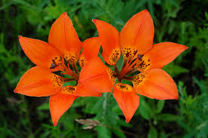](http://www.google.ca/imgres?imgurl=http://farm4.staticflickr.com/3538/3696694600_3c1e787396_b.jpg&imgrefurl=https://www.inaturalist.org/taxa&h=681&w=1024&tbnid=fDqaVCRwC0jIVM:&docid=LMNtJmsjC8ggDM&ei=MUxRVvaCD8asogSr9o3ICA&tbm=isch&ved=0ahUKEwi23-mGoKPJAhVGlogKHSt7A4kQMwh1KFIwUg)

**15 FEMALE FEDERAL CABINET MINISTERS!**

Canadians voted October 19th and many women were elected into the House of Commons. Unfortunately not as many as we wished. However, the new PM has taken a great step in placing fifteen women into ministerial roles.  
  
When PM Justin Trudeau was asked why he choose a 50% male and 50% female cabinet he spoke the words that have become a global sound bite: "Because it's 2015!"  
  
Here are our new female cabinet ministers! Take the time to send a note of congratulations and welcome them to the leadership of our country.

1. Hon. Carolyn Bennett, Minister of Indigenous and Northern Affairs
2. Hon. Jody Wilson-Raybould, Minister of Justice, Attorney General of Canada
3. Hon. Judy Foote, Minister of Public Services and Procurement
4. Hon. Chrystia Freeland, Minister of International Trade
5. Hon. Jane Philpott, Minister of Health
6. Hon. Marie-Claude Bibeau, Minister of International Development and La Francophonie
7. Hon. Mélanie Joly, Minister of Canadian Heritage
8. Hon. Diane Lebouthillier, Minister of National Revenue
9. Hon. Catherine McKenna, Minister of Environment and Climate Change
10. Hon. MaryAnn Mihychuk, Minister of Employment, Workforce Development and Labour
11. Hon. Maryam Monsef, Minister of Democratic Institutions
12. Hon. Carla Qualtrough, Minister of Sport and Persons with Disabilities
13. Hon. Kirsty Duncan, Minister of Science
14. Hon. Patricia Hajdu, Minister of Status of Women
15. Hon. Bardish Chagger, Minister of Small Business and Tourism

**Issues and Action Corner**

**Graduate Women International News**

**Women Graduates-USA launches guide to action for the Ratification of the United Nations Convention on the Rights of the Child**

The Convention on the Rights of the Child (CRC), unanimously adopted by the United Nations General Assembly (UNGA) in 1989, supports children’s right to survival, protection, and right to education, as well as other social and cultural rights. Despite having an active role in drafting the convention, the United States is the only UN member not to have ratified the CRC. Women Graduates USA (WG-USA) has taken the lead in passing a resolution asking its members to urge the US Government to ratify this convention by November 20 2015, and has created a [website with information](http://graduatewomen.us2.list-manage.com/track/click?u=4f440ac475f57015275a1f6eb&id=0c97cd4de7&e=df75c497f1) about the CRC and letter templates. Interested parties are encouraged to use the available templates to write to President Obama urging him to move forward with the CRC, and commit to this vital legislation.

***Additional Interest Items***

**You are invited……**

To **READ Saskatoon’s Annual Merry Mixer** on Thursday, November 26, 6:30 p.m. at the Honey Bun Café on 2nd Ave. This event honours literacy volunteers, board members, supporters, adult learners and literacy champions. For more details and to register, please visit: <https://www.readsaskatoon.com/events/details/2015-read-saskatoon-volunteer-appreciation.html>

We look forward to seeing you on the 26th.

**Canadian Club of Saskatoon**

Tuesday, December 8th

Speaker: Jeff O’Brien, City Archivist

Topic: Christmas in Saskatoon over the years

Where: Western Development Museum

Register 11:30, Lunch 12:00

Cost for non-members $25

Contact President Laura Van Loon at 306-931-6790

For details go to website [www.saskatooncanadianclub.org](http://www.saskatooncanadianclub.org)

**Sunday Dec 6th Potluck Lunch from 11 – 2 pm**

CFUW-Saskatoon International Group and Graduate Student Association, U of S

Where: Graduate Students Common at the U of S. It is the old Emmanuel St Chad building on the northeast corner of Wiggins and College.

**Everyone is encouraged to share stories about special festivals**

**Purpose:** to bridge the divide between recent immigrant and those of us who have been here a little longer. Men are also welcome.

**SCOA/Saskatoon Public Library/Saskatoon Community Foundation presents:**

A workshop for older adults and caregivers:

Topic: Online banking, financial abuse, fraud awareness and how to avoid new bank fees.

Presenter: Affinity Credit union

January 26th

7:00 pm – 8:30 pm

Francis Morrison Library

Speaker: Jeff O’Brien, City Archivist

Topic: Christmas in Saskatoon over the years

Where: Western Development Museum

Register 11:30, Lunch 12:00

Cost for non-members $25

Contact President Laura Van Loon at 306-931-6790

For details go to website [www.saskatooncanadianclub.org](http://www.saskatooncanadianclub.org)

**Canadian Club of Saskatoon**

Wednesday, January 13th, 2016

Speaker: Dr. Maurice Moloney, SK Global Institute for Food Security

Topic: Food Security Christmas in Saskatoon over the years

Where: Sheraton Cavalier

Register 11:30; Lunch 12:00

Cost for non-members $25

December 6th is the 26th anniversary of the Montreal Massacre of 14 women at the Montreal Polytechnique who were so brutally killed in 1989. We encourage participation in events that commemorate this day planned by other groups such as the YWCA Rose Campaign. This day reminds us of the violence against women and girls that still exists today in Canada and around the globe.

Canadian Federation of University Women-Saskatoon

(International Group)

In partnership with

Graduate Students Association, U of S

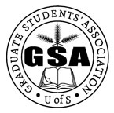

Invite You To A

Potluck Lunch

11 am to 2 pm

Dec. 6, 2015

Grad Students Commons

**(Emmanuel St. Chad building - 1337 College Drive)**

Get to know each other, share your experiences in Canada, learn about other cultures, and share childhood memories of special holidays.

For more information, call: 306-374-3006