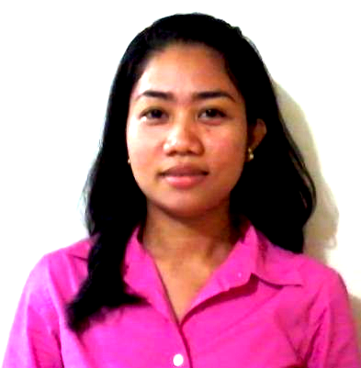
CRISTY MAE Z. MISAJON
307A Hamilton Lakeview Manor, Bagong Calzada Street,
Brgy. Ususan, Taguig City 1632 Philippines
Contact Nos.: (632) 929-5880341
Email: cristymaemisajon@yahoo.com

EDUCATION

2008 – present Jose Rizal University, Mandaluyong City
Bachelor of Science in Information Technology

2006 – 2008 Habihan School, Quezon City
Residence and Institution Services and Management

2002 – 2006 General Leandro Fullon National School, Antique
High School Diploma

1996 – 2002 M. Buyco Elementary School, Antique

ORGANIZATION/AFFILIATION

OJT Batch 2014 Officer, Secretary, 2013 - present
Computer Society, 2009 - present
JRU Student Ambassadors, 2011 –-2012
Management Society, 2009 - 2012
Mathematics Society, 2009 - 2012
ASH (Association of Students in History), 2009 – 2012

COMPUTER SKILLS

Multimedia(Image/Graphics/Video/Subtitle Editors): Windows Movie Maker, Avidemux, Subtitle Edit, Aegisub, Photoshop CS6, Adobe Flash CS6, Corel Draw
Programming: Html/css, JavaScript, PHP, MySQL, Vb.Net

SEMINARS ATTENDED

Online Marketing
Jose Rizal University Auditorium
80 Shaw Boulevard, Mandaluyong City
December 2013

Web Development
Jose Rizal University
80 Shaw Boulevard, Mandaluyong City
September 2013

Software Quality Assurance
Jose Rizal University
80 Shaw Boulevard, Mandaluyong City
September 2013

Incontro Romano 2012 National Congress
Tanglaw University Center West Triangle, Quezon City
March 2012

Project Management Seminar
Jose Rizal University
80 Shaw Boulevard, Mandaluyong City
September 2009

Personality Development
Tanglaw University Center
West Triangle, Quezon City
February 2008

REFERENCES

Name : Angela I. Villate
Contact No. : 535 –7368 / 09473357888
Position : Administratrix
Company : Calayan Cultural Center
Relationship : Employer

Name : Kai E. Nabatar
Contact No. : 09284384342
Position : Academic Director, Punlaan School
Company : Foundation for Professional Training, Inc.
Relationship : School Directress

Name : Maria Luisa Z. Saba
Contact No. : 531 – 8031
Position : Dean for Student Affairs
Company : Jose Rizal University
Relationship : University Dean

I certify that the above information are true and correct to the best of my ability.

___________________
Cristy Mae Z. Misajon
Applicant

