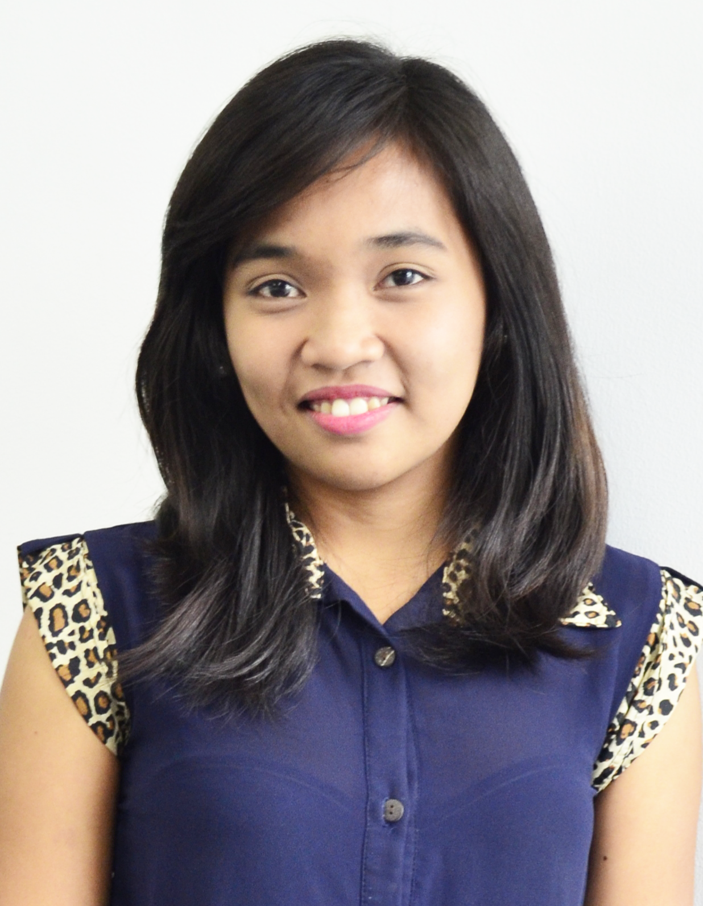
REGINA MARIE SUBOL DINEROS
2954 F A Bautista St. Punta Sta. Ana, Metro Manila
(+63)922-689-7321
reginadineros@yahoo.com

EDUCATION

Tertiary
20010 - Present Jose Rizal University
Shaw Blvd., Mandaluyong City
Bachelor of Science in Information and Technologies

Secondary
2006 - 2010 Mataasnakahoy National School
Mataasnakahoy, Batangas

Primary
2000 - 2006 Mataasnakahoy Elementary School
Mataasnakahoy, Batangas

ORGANIZATION/AFFILIATION

June 2010-March 2013
JRU ComSoc (Computer Society)
- Staff

SKILLS AND QUALIFICATIONS

- Highly Computer Literate, Software skills includes Microsoft office, Visual Basic, VB.Net, Notepad ++; Programming Language includes PHP, SQL, MYSQL, HTML, Java.
- Communication: English, Filipino

REFERENCES

Name : Eva S. Perez
Telephone No. : 0949-5326347

Name : Maria Luisa Z. Saba
Telephone No. : 531 – 8031
Position : Dean for Student Affairs
Company : Jose Rizal University
Relationship : University Dean, Mentor

I certify that the above information are true and correct to the best of my ability.

_____________________
Regina Marie S. Dineros
Applicant

