OJT Final Requirement:

STEP 1: Insert all the documents inside clear book

- 1st Page - CheckList Form (get copy from OJT officer)
- 2nd Page - TitlePage/Picture (softcopy format posted in Facebook)
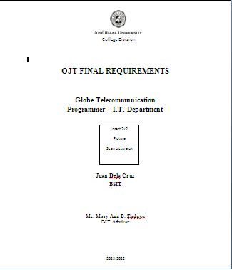
- 3rd Page - Sub Title (PORTFOLIO) (Center, Font Size 20)

- 4th Page - Curriculum Vitae
- 5th Page - Certificate of Completion (486 hrs.)
- 6th Page - Evaluation of the Trainee from the Company (please don’t open the envelop, if we
receive open envelop consider 3.5)
- 7th Page - Sub Title (REFLECTION) (Center, Font Size 20)
- 8th Page - Reflection
- 9th Page - Acceptance Letter (looks like stub)
- 10th Page - Waiver
- 11th Page - Sub Title (WEEKLY ACCOMPLISHMENT REPORTS) (Center, Font Size 20)
- 12th Page - Weekly Accomplishment Reports (June)
- 13th Page - Weekly Accomplishment Reports (July)
- 14th Page - Weekly Accomplishment Reports (August)
- 15th Page - Weekly Accomplishment Reports (September and October)
- 16th Page- Company Profile
- 17th Page - Original or Photocopy Seminar Certificate
- 18th Page - Sub-Title (TIME SHEET/TIME CARD/BIOMETRIC REPORT) (Center, Font Size 20)
- 19th Page (back to back) - Front (JUNE),Back(JULY)
- 20th Page (back to back) - Front(August), Back(September and October)

STEP 2: Look for OJT representative to check your Clear Book and SIGN in

STEP 3: You proceed to Ms. Carina Bautista for final signature of your checklist
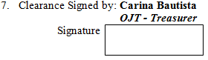

Note: Ms. Carina Bautista have the right to refuse to sign your checklist if you have unpaid collectibles.

STEP 4: Submit your CLEAR BOOK to your ADVISER together with your CHECKLIST FORM signed
by the CHECKER (OJT representative) and MS. CARINA BAUTISTA

