Step by Step procedures on how configure the LP-8186 AP/Router on Globe connection.
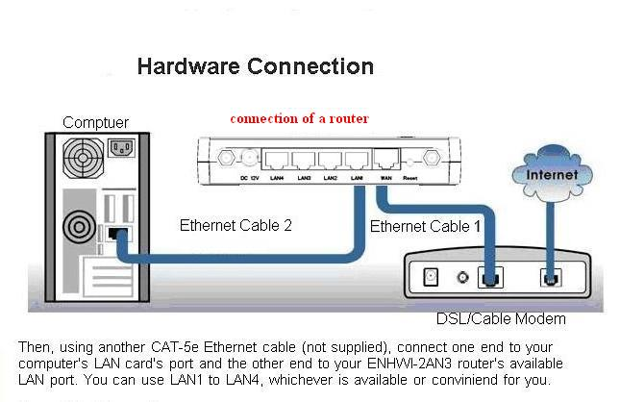
- SET WIRING CONNECTION: MODEM – ROUTER - COMPUTER
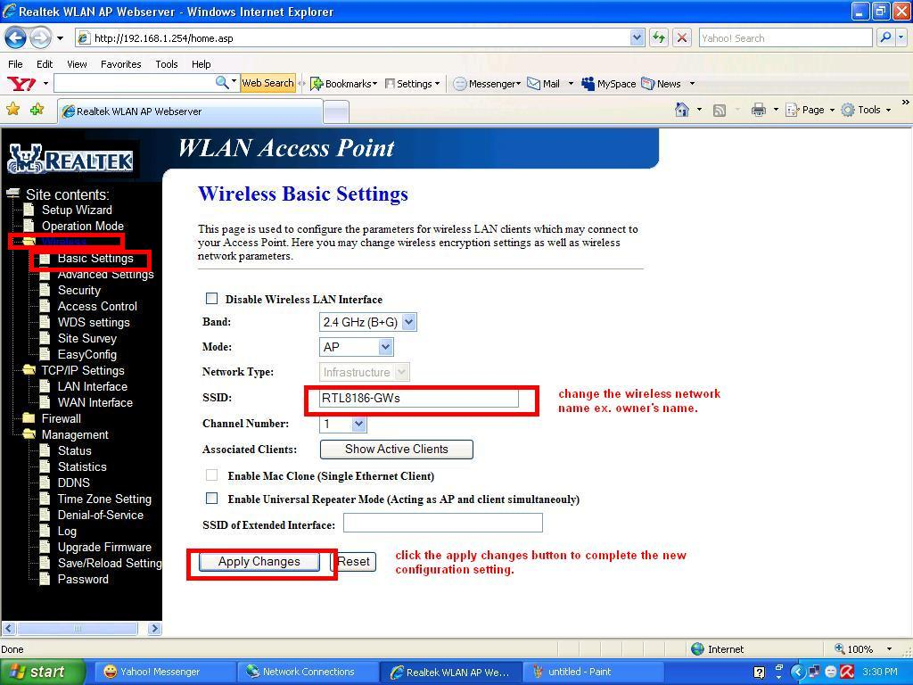
- Open an Internet browser such as Internet Explorer, Mozilla Firefox, Opera, Netscape Navigator, Maxton, or Safari for windows. On the browser’s URL Address bar, type the default IP address of the router which is 192.168.1.254 (may actually depend on the model.. so it is better to check for the IP address written at the back of the unit), and then press “Enter key”. The router interface will appear.

- Click Wireless then click Basic Settings.
- On SSID field, put any word that will serve as Network name of the router.
- Click “Apply Changes” button and wait again for 15 seconds for the router to restart and initialize.

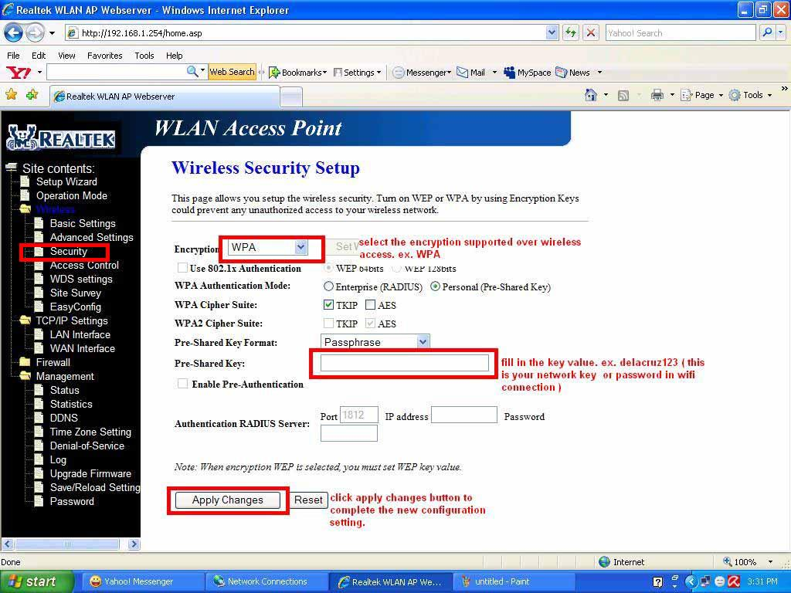
- Click Security.
(Note: you can choose whatever type of Encryption you want to use. In this sample WPA was used. You can fill any word (letters and Numbers) that you want with this field, Just Remember the word you filled in this field, because this will serve as the password for your wireless connection)

- Next click on the TCP/IP Setting then LAN Interface and change the IP Address and DHCP Client Range. Then click “Apply Changes” button and wait for 15 seconds for the router to restart and initialize. Shown below:

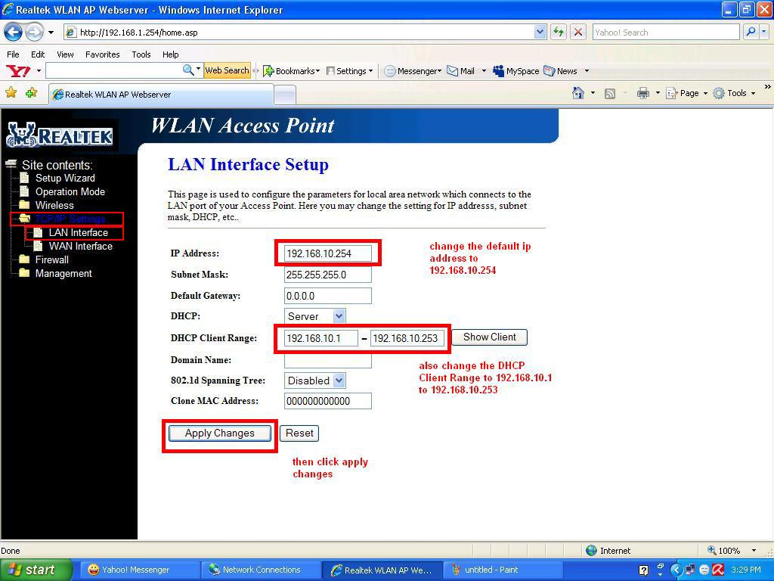
- On the browser’s URL Address bar, type the IP address of the router which is 192.168.10.254, and then press “Enter key”.

- Now click on the Management and click on “Status”, to check if your WAN Configuration has an IP address and that you're PC already connected to Internet. Shown below:
