**How to crack ftp server [ file transert protocol ] using hydra**

oleh [Back|Track - Linux](http://www.facebook.com/BackTrack.linuxr3) ([Catatan](http://www.facebook.com/profile.php?id=351182771578096&sk=notes)) pada 31 Mei 2013 pukul 5:08

first choose a website and scan it by nmap if the website Contains port 21 enabled that's mean he is a ftp server

nmap xxxxxxxxx

type ping { adress of website ]

the ip of website will appear

ps: just type it like this for ex : facebook.com without http://www.

follow

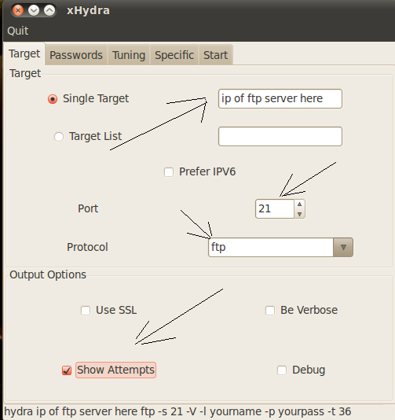  
  
  
  
  
  
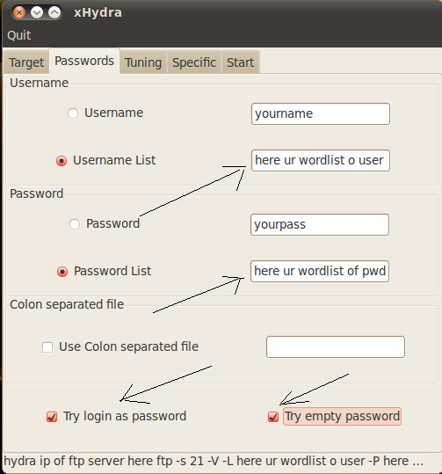  
  
  
  
  
  
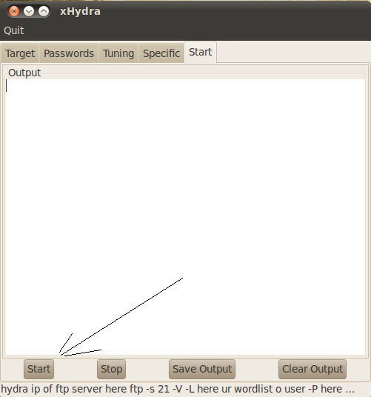  
  
  
then the cracking will start and hydra willl ind the authentication of ftp server