Analytics Anticipated

Data Science In F.W. Taylor’s *The Principles of Scientific Management*

Students of analytics might be persuaded by the hype surrounding our profession that analytics is something entirely new—a bold vision of the 21st century, no less! Frederick Winslow Taylor’s *The Principles of Scientific Management* should convince us otherwise, and offers us a stark vision of both the aspirations and moral quandaries inherent in its pursuit.

Taylor’s work is unquestionably modern. He trusts experiment over tradition. He recognizes his employees as individuals, seeking to match them with work suited to their temperment and talents. He believes men are driven by incentives, and those incentives must be crafted to make best use of each worker. He uses the limited tools of his time—slide rules in place of neural networks—to seek efficiency in every aspect of his world.

Taylor’s *Principles*, however, extend to the treatment of his workers only through the veil of his own condescention. Workers, in Taylor’s view, are either too uneducated or too stupid to understand how to best go about their work. Craftsmanship is a symptom of mismanagement: Taylor seeks to separate men from their skills as efficiently as possible. His proudest example involves causing a man to lift a 92-pound chunk of iron 1,156 times per day—a 280% increase in labor—for a 60% increase in pay. Echoing the colonialism common among his contemporaries, Taylor even claims that systematic exploitation leads to moral improvement of the worker.

Before we castigate Taylor for his views—the ease with which he avoids what seems to us the grip of ethical conundra—we might remember that hallmark of modernity Taylor lacks: The euphemisms our age uses to disguise its indifference. How is Taylor’s pig iron handler different from the picker walking a warehouse floor, his every movement tracked by sensors more precise than any stopwatch? We—our profession—are Taylor’s progeny, and time will wear away any disguise our language may afford to lay bare our common prejudice.

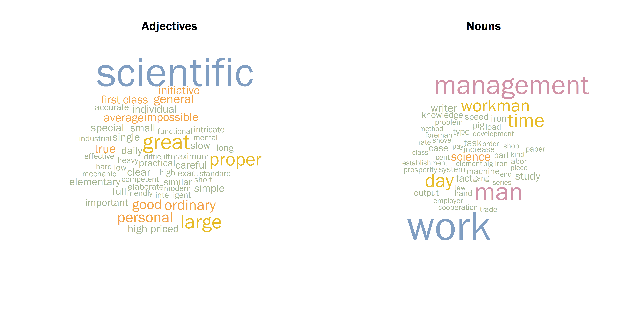

Figure 1: Word clouds of adjectives and nouns by frequency as identified by the Apache OpenNLP toolkit. Stopwords used by Chris Buckley and Gerard Salton in the SMART information retrieval system at Cornel University have been removed. Note that word clouds are relatively difficult to interpret and have low information density compared with equivalent sets of bar charts or Cleveland dot plots. Notwithstanding the shortcomings of this visualization, part-of-speech tagging appears highly effective in extracting major themes from *The Principles of Scientific Management*.