**✅ Here’s Your 5-Day Weekly Cardio Plan**

Each day = 1 unique **5-exercise HIIT(high-intensity interval training) circuit**.  
**Format**:

* 40 seconds work, 20 seconds rest
* 4 rounds (optional: 3 rounds for a shorter day)(start date: 07/14/2025)
* Total time: ~20 minutes

**🗓️ Monday: Explosive HIIT (Your Current Set + Core Add-ons)**

1. **Burpees**

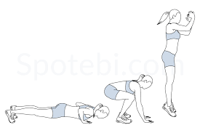

1. **High Knees**

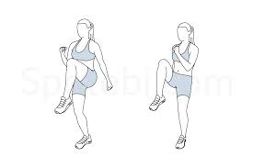

1. **Jump Squats**



1. **Mountain Climbers (fast)**

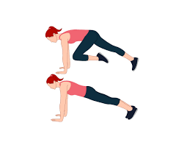

1. **Plank Jacks**

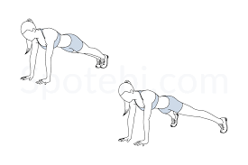

1. **Pelvic Tilts (add after burpees for core activation)**

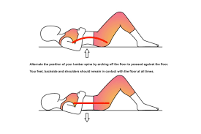

1. **Heel Taps**

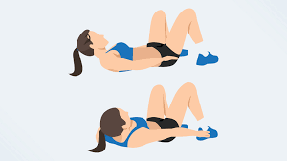

**🗓️ Tuesday: Core + Cardio Burn (Expanded with More Core Moves)**

1. **Jumping Lunges/with twists (or reverse lunges if knees sensitive)**

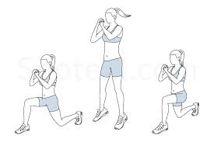

1. **Skater Jumps (side to side)**

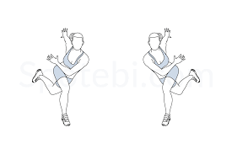

1. **V-Ups**

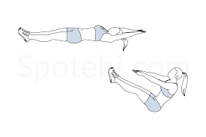

1. **Bicycle Crunches (fast tempo)**

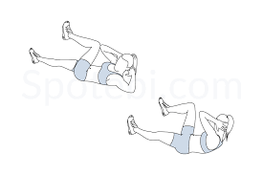

1. **Hollow Body Hold (advanced: rock slightly)**

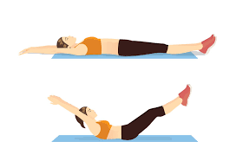

1. **Russian Twists (add after Hollow Body Hold)**

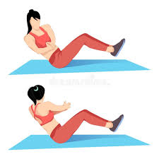

1. **Oblique Crunches (side crunches)**

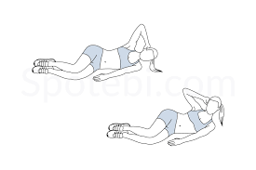

**🗓️ Wednesday: Athletic Agility + Core Stability Mix**

1. **Lateral High Knees (step side, drive knee up)**

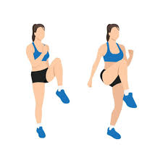

1. **In & Out Squat Jumps (feet narrow → wide → jump)**

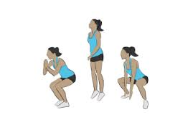

1. **Bear Crawls (forward/backward 4 steps)**

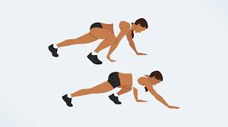

1. **Plank to Push-Up**

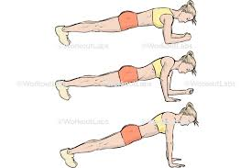

1. **Broad Jump → Shuffle Back**

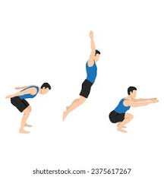

1. **Bird Dog (faster tempo for challenge)**

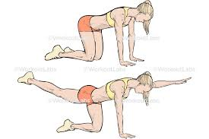

1. **Glute Bridge March**

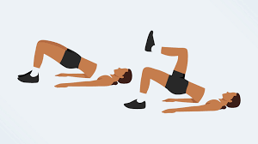

**🗓️ Thursday: Upper Body + Core Sweat + Oblique Focus**

1. **Push-Up to Shoulder Tap**

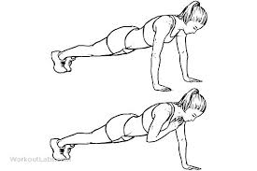

1. **Tuck Jumps**

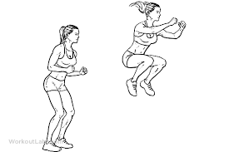

1. **Side Plank Hip Dips (switch sides halfway)**

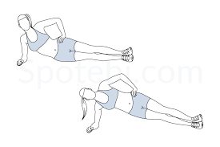

1. **Mountain Climbers (cross-body)**

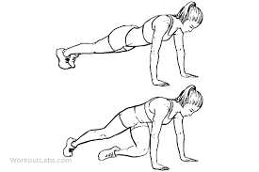

1. **Jumping Jacks (fast pace or power jacks)**

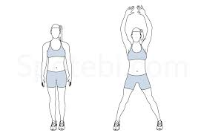

1. **Scissor Kicks**

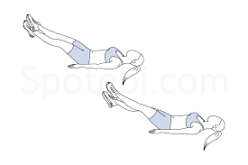

1. **Reverse Crunches**

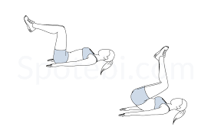

**🗓️ Friday: Total Body HIIT Ladder + Core Burn**

1. **Burpee + Jump Lunge**

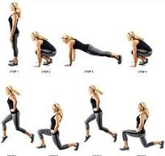

1. **Flutter Kicks**

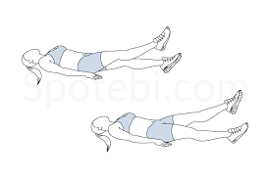

1. **Sumo Squat Pulse + Jump**

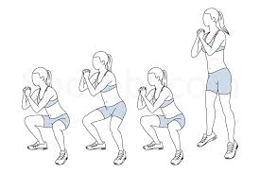

1. **Plank Side Walk**



1. **Jump Rope (or pretend jump rope, fast tempo)**

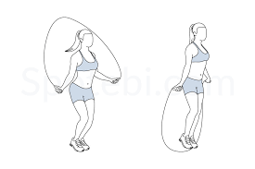

1. **Standing side Crunches**

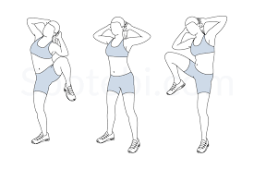

1. **Leg Raises with a Pulse Up**

