PLP Academy

Assignment 1: Setting Up My Development Environment

Geoffrey Yogo

[geoffreyyogo@gmail.com](mailto:geoffreyyogo@gmail.com)

June 19, 2024

**Setting Up My Developer Environment**

**Objective:** This document provides a comprehensive guide to setting up a robust developer environment for software engineering projects. The steps cover the installation and configuration of necessary tools and technologies.

**1. Introduction**

This document aims to guide you through setting up a developer environment conducive to coding, debugging, version control, and collaboration. By following these steps, you will have a robust workspace ready for software development projects.

**2. Selecting Your Operating System (OS)**

I already had Windows 11 installed on my computer.

**3. Installing a Text Editor or Integrated Development Environment (IDE)**

**Visual Studio Code (VS Code) Installation:**

I already had VS Code installed on my computer. I did not want to redo the installation because my current VS Code app has numerous plug-ins and extensions, some of which I might lose if I uninstalled VS Code for reinstallation.

**4. Setting Up Version Control System**

**Git Installation and Configuration:**

1. **Download Git:**
   * Visit the https://git-scm.com/download/win
   * Download the Git installer.
2. **Install Git:**
   * Run the Git installer.
   * Follow the setup wizard, choosing the default options unless you have specific preferences.
   * Ensure "Use Git from the command line and also from 3rd-party software" is selected.
   * Complete the installation.
3. **Configure Git:**
   * Open Git Bash.
   * Set your username and email:

git config --global user.name "geoffreyyogo"

git config --global user.email "geoffreyyogo@gmail.com"

1. **Create a GitHub Account:**
   * I already had a GitHub account.
2. **Initialize a Git Repository:**
   * Create a project directory:

mkdir demo

cd demo

* + Initialize the repository and make the first commit:

git init

echo "This is my first repository" >> README.md

git add README.md

git commit -m "my third commit"

Here is the link to the repository: <https://github.com/geoffreyyogo/demo>

**5. Installing Necessary Programming Languages and Runtimes**

I already had Python Installed, but I had followed the following steps during installation.

**Python Installation:**

1. **Download Python:**
   * Visit https://www.python.org/downloads/
   * Download the latest version of Python.
2. **Install Python:**
   * Run the installer.
   * Check "Add Python to PATH".
   * Click "Install Now" and follow the installation process.
3. **Verify Installation:**
   * Open Command Prompt or git bash as an administrator and type:

python --version

pip --version

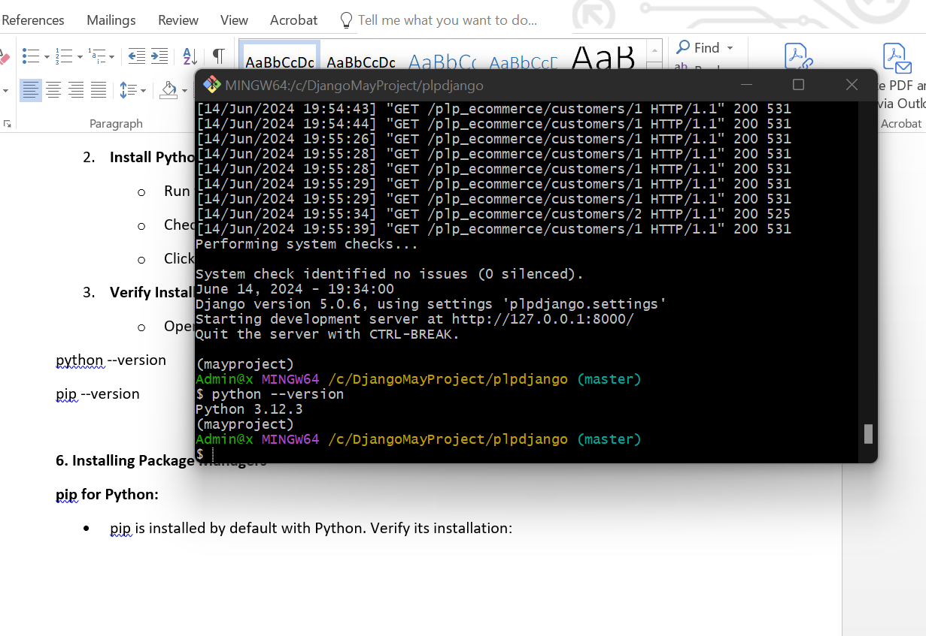

**6. Installing Package Managers**

**pip for Python:**

* pip is installed by default with Python. Verify its installation:

pip --version

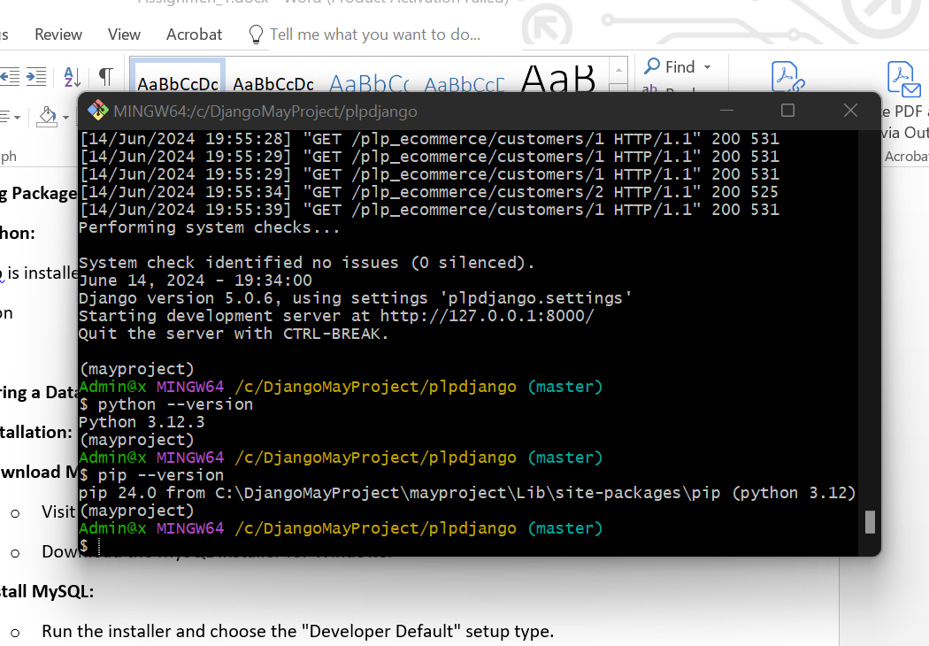

**7. Configuring a Database (MySQL)**

**MySQL Installation:**

1. **Download MySQL:**
   * Visit the https://dev.mysql.com/downloads/windows/installer/5.7.html
   * Download the MySQL Installer for Windows.
2. **Install MySQL:**
   * Run the installer and choose the "Developer Default" setup type.
   * Follow the setup wizard, configuring the root password and any other options as needed.
   * Complete the installation.
   * Use the command “mysql --version” to check the version

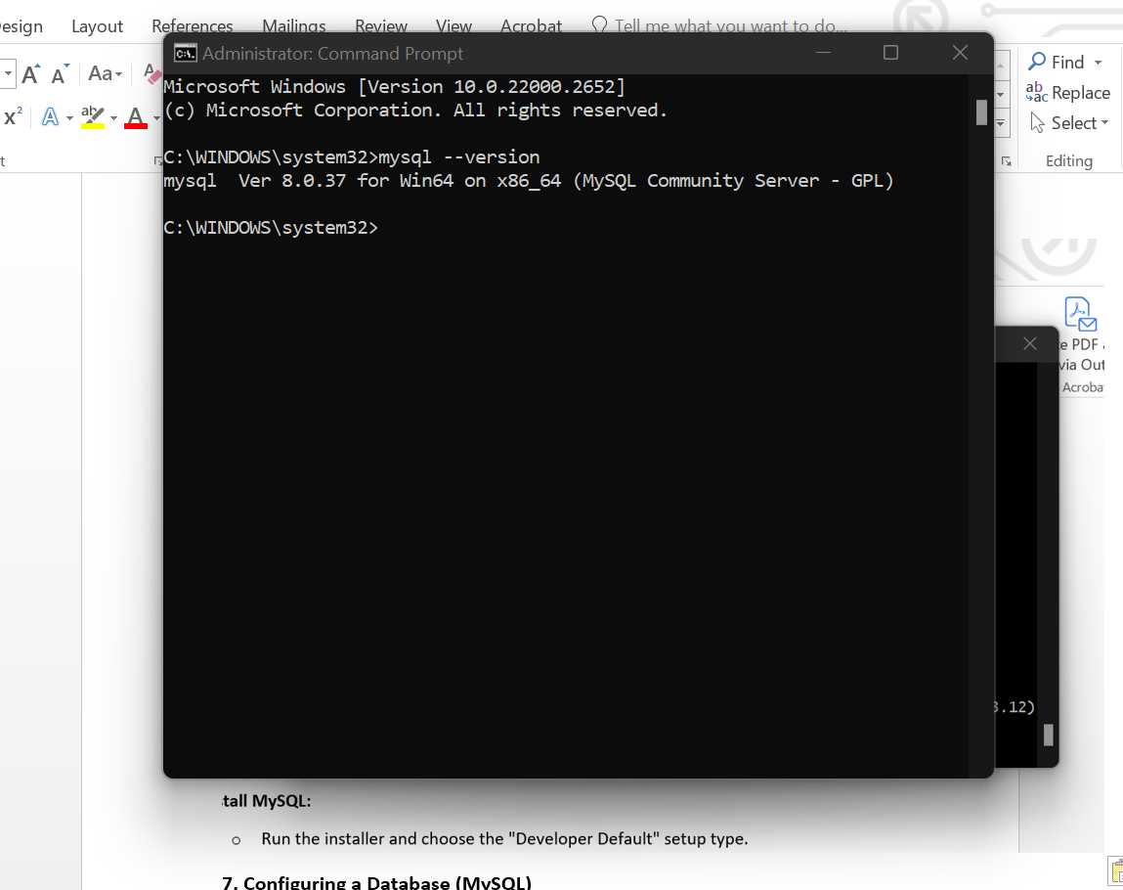

**8. Setting Up Development Environments and Virtualization (Optional)**

**Docker Installation (Optional):**

1. **Download Docker Desktop:**
   * Visit the Docker Desktop page.
   * Download the installer for Windows.
2. **Install Docker Desktop:**
   * Run the installer.
   * Follow the installation instructions and restart your machine if prompted.

**9. Exploring Extensions and Plugins**

**Enhancing VS Code:**

1. **Open Extensions View:**
   * Launch VS Code.
   * Press Ctrl+Shift+X to open the Extensions view.
2. **Install Useful Extensions:**
   * **Python Extension:**
     + Search for "Python" by Microsoft and install it.
   * **GitLens Extension:**
     + Search for "GitLens" by GitKraken and install it.
   * **Prettier Extension:**
     + Search for "Prettier - Code formatter" by Prettier and install it.

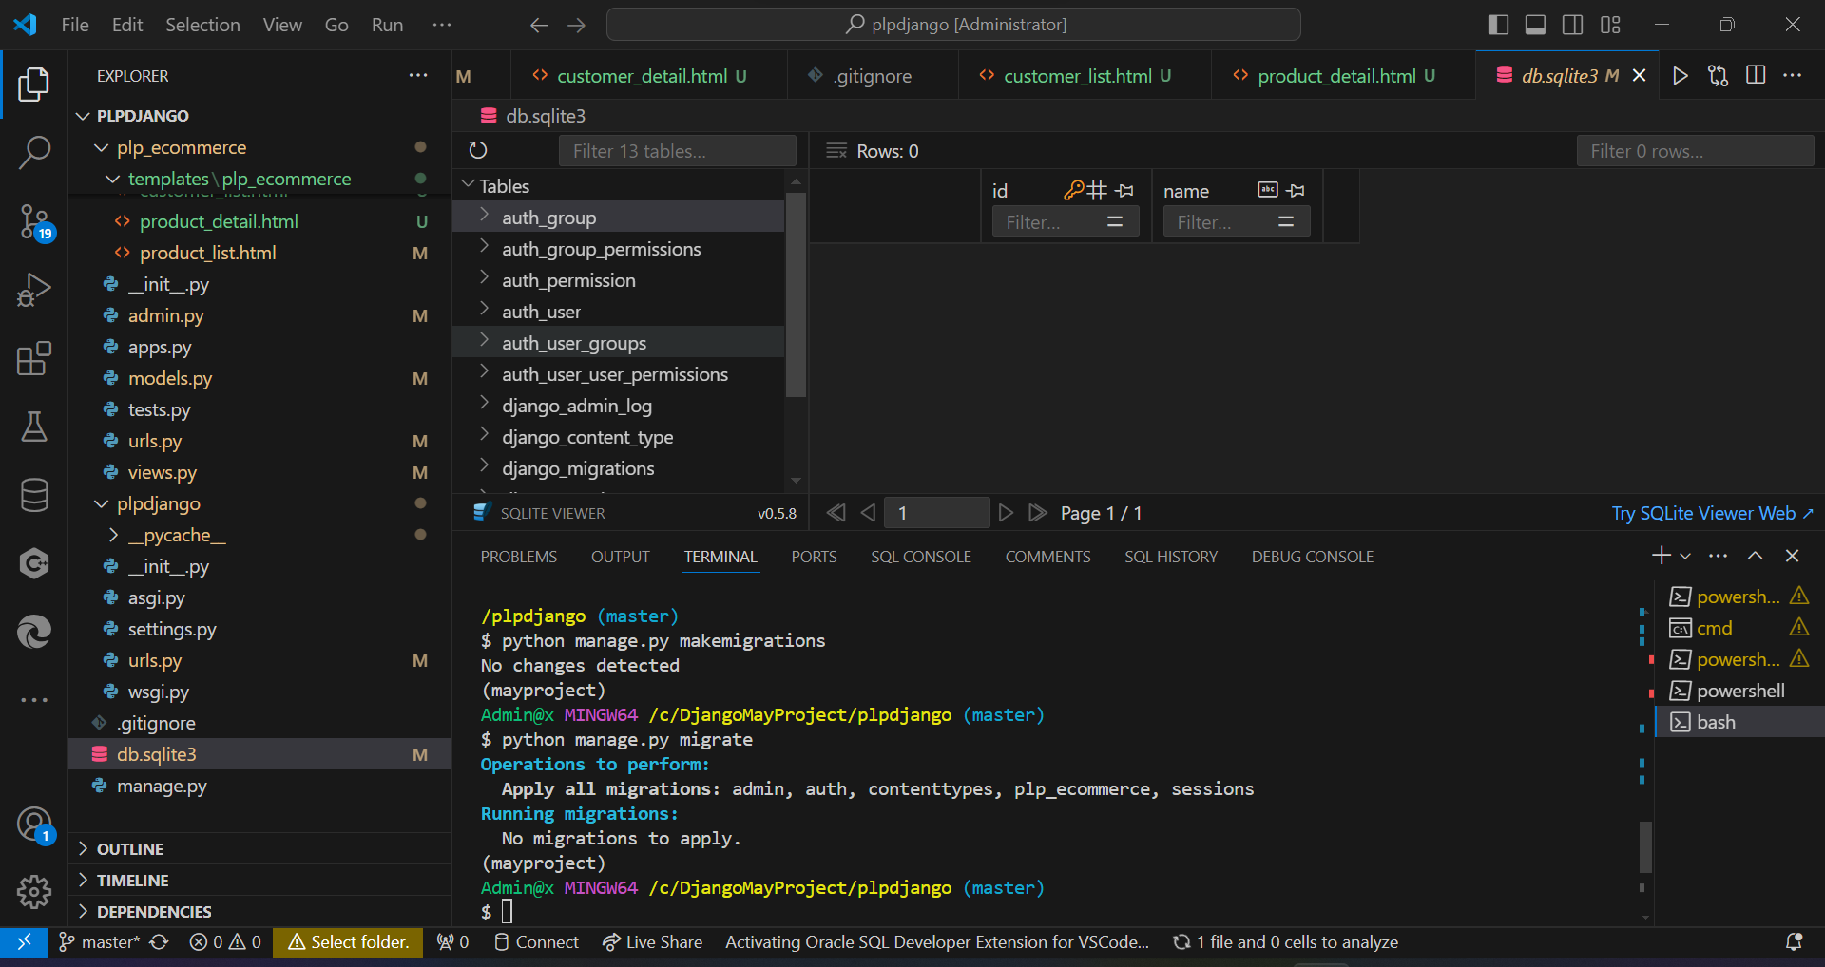

**11. Reflection on Challenges and Solutions**

During the setup process, I encountered several challenges. One significant issue was configuring Git and ensuring it worked seamlessly with VS Code. Initially, there were issues with Git recognizing my credentials, which was resolved by correctly setting the global username and email configuration in Git Bash.

Another challenge was setting up MySQL. The default configuration did not match my requirements, and I had to reconfigure the root password and other settings to ensure it worked correctly with my projects. Troubleshooting online resources and community forums helped me navigate these issues.

The overall process improved my understanding of setting up a comprehensive developer environment and prepared me for future projects. Documenting each step also provided a valuable reference for future setups and troubleshooting.