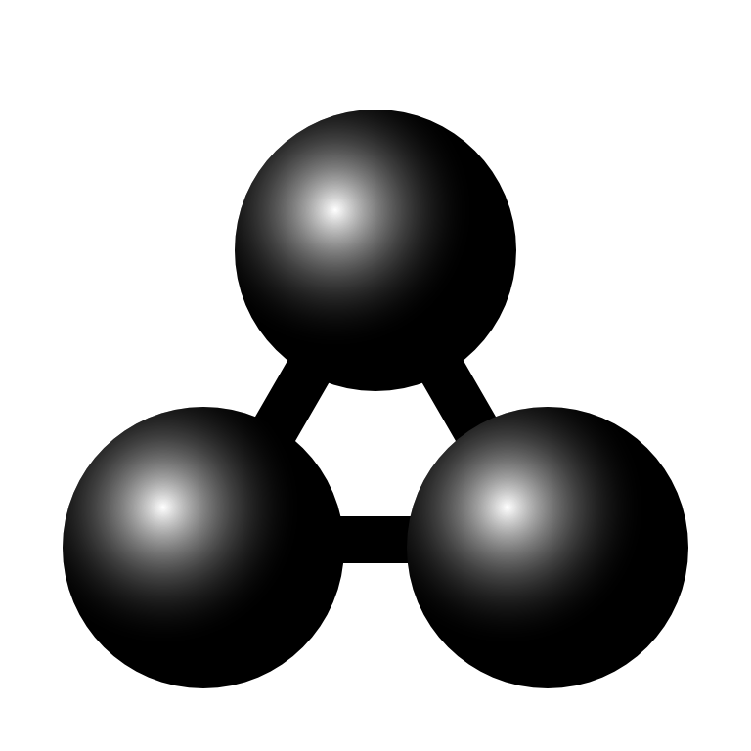

MolView manual

This is the manual for MolView version 2.2

MolView can be found at [molview.org](http://molview.org/)

# Table of Contents

Table of Contents 2

1. Drawing structural formulas 3

Top toolbar 3

Left toolbar 3

Right toolbar 3

2. Finding structures 4

3. 3D model 5

Reset 5

Representation 5

Background 5

Engines 5

Model transformation 6

Crystallography 6

4. Advanced tools 7

Link 7

Export 7

Information card 7

Spectroscopy 7

Advanced search 8

5. Spectroscopy 9

Export data 9

6. Custom GLmol display 10

Biological assemlby 10

Chain representation 10

Chain coloring 10

Fog and clipping 10

7. Advanced Jmol functions 11

Clear 11

Calculations 11

Measurement 11

Render mode 12

1. 1. Drawing structural formulas

You can draw structural formulas using the Sketcher component.

* 1. Top toolbar

The top toolbar contains all general editing tools. The *2D to 3D* tool converts the structural formula into a 3D molecule which is displayed in the model window.



*Top toolbar, from left to right: delete all, erase, undo, redo, move atoms/bonds, center view, rectangle select, lasso select, clear selection, clean structural formula, 2D to 3D conversion*

* 1. Left toolbar

In the left toolbar, you can select a tool you want to use in order to modify or extend the structural formula. You can draw a carbon chain using the chain tool (11th button in image) Just click a start point or atom and drag a chain.



*Left toolbar (rotated), from left to right: single bond, double bond, triple bond, up/down bond, benzene, cyclopropane/butane/pentane/hexane/heptane, chain, charge+, charge-*

* 1. Right toolbar

The right toolbar contains some common elements and a periodic table tool in case you want to use another element. You can select an atom and click an existing atom in order to replace it with the selected atom. Note that you can only replace existing atoms. In order to add an atom, you will first have to add a new bond using the tools from the left toolbar.



*Right toolbar (rotated), from left to right: hydrogen, carbon, nitrogen, oxygen, sulfur, phosphorus, fluorine, iodine, chlorine, bromine, table of elements, info (about dialog)*

1. 2. Finding structures

You can load structures from large databases like PubChem via the search bar located on the right side of the menubar. Just type what you are looking for and find it in the autocomplete dropdown or click one of the search categories listed below to perform a more extensive search.

* **Compounds:** small molecules from the PubChem database
* **Macromolecules:** biological macromolecules from the RCSB database
* **Crystals:** crystal structures from the Open Crystallography Database

You can also enter a PubChem CID via *Compounds*, a PDB ID via *Macromolecules* or a COD ID via *Crystals*. It is also possible to enter a SMILES, InChi or InChiKey string in the search field.

You can show or hide search results using the leftmost button (contains an eye) Note that *Macromolecules* search is absent on mobile devices which do not support WebGL since they can't display macromolecules anyway.



*Search bar, from left to right: input field, fast search, compounds search (PubChem), macromolecules search (RCSB) and crystals search (COD)*

1. 3. 3D model

You can find the general 3D *Model* menu in the menubar.

* 1. Reset

This function sets the model position, zoom and rotation back to default.

* 1. Representation

You can choose from a list of different molecule representations including; ball and stick, stick, van der Waals spheres, wireframe and lines. Macromolecules are automatically drawn using ribbons.

* 1. Background

You can switch between a black and a white model background. The default background is black (exported images from GLmol or ChemDoodle have a transparent background)

* 1. Engines

You can choose from three different render engines: **GLmol**, **Jmol** and **ChemDoodle**. GLmol is used as default render engine. GLmol and ChemDoodle are based on WebGL, a browser technology to support 3D graphics. If WebGL is not available in your browser, Jmol wil be used for all rendering.

MolView automatically switches to:

1. **Jmol** if you execute functions from the Jmol menu
2. **GLmol** if you load macromolecules and WebGL is available

*(due to significant higher performance)*

1. **ChemDoodle** if you load a crystal structure and WebGL is available

*(GLmol cannot render crystal structures)*

You might want to switch back to GLmol when you do no longer need Jmol or ChemDoodle since GLmol has a better performance.

Note that macromolecules are drawn slightly different in each engine. ChemDoodle provides the finest display. You should, however, avoid using ChemDoodle for very large macromolecules.

* 1. Model transformation

You can rotate, translate and zoom the 3D model using a mouse. Use the right button for rotation, the middle button for translation (except for ChemDoodle) and the scrollwheel for zooming. On touch devices, you can rotate the model using one pointer and scale the model using multi-touch.

* 1. Crystallography

You can load an array of crystal cells (2x2x2 or 1x3x3) or a single unit cell when viewing crystal structures.

1. 4. Advanced tools

You can find the *Tools* menu in the menubar. This menu contains several utility functions.

* 1. Link

You can embed or share a specific compound, biomolecule or crystal using the provided URL or HTML code. Note that the linked structure is the one which is currently displayed in the model window. You can also copy the URL from the adress bar in order to link to the current structure.

* 1. Export

Export options in the Export menu:

* **Structural formula image:** PNG snapshot from sketcher *(transparent background)*
* **3D model image:** PNG snapshot from model window

*(transparent background in GLmol and ChemDoodle)*

* **SDF file:** exports a MDL Molfile from the 3D model

*(displayed if the 3D model is a common molecule)*

* **PDB file:** exports a Protein Data Bank file from the 3D model

*(displayed if the 3D model is a macromolecule)*

* **CIF file:** exports a Crystallographic Information File from the 3D model

*(displayed if the 3D model is a crystal structure)*

* 1. Information card

This function collects and displays information about the current structural formula in the Sketcher. You can also find a database reference for the current 3D model.

* 1. Spectroscopy

This method shows a dialog where you can view spectra related to the structural formula from the sketcher. More details are covered in chapter 5.

* 1. Advanced search

You can perform three types of advanced search based on the structural formula from the sketcher.

1. **Similarity search:** search for compounds with a similar structural formula
2. **Substructure search:** search for compounds with the current structure as subset
3. **Superstructure search:** search for compounds with the current structure as superset
4. 5. Spectroscopy

The Spectroscopy menu item is located under *Model > Chemical data* in the menubar. This menuitem shows the spectroscopy dialog where you can choose from a number of spectra (if available)

1. H1-NMR prediction
2. Mass spectrum
3. IR spectrum
   1. Export data

The spectroscopy dialog allows you to export two kind of files from the current spectrum:

* **PNG image:** snapshot from interactive spectrum
* **JCAMP file:** JCAMP-DX file of the current spectrum

1. 6. Custom GLmol display

The GLmol render engine contains some custom display functions for macromolecules. These functions are located under the *GLmol* menu in the menubar.

* 1. Biological assemlby

Some macromolecules are only a small unit (asymmetric unit) from a much larger structure (biological unit) This function allows you to view the full biological unit.

* 1. Chain representation

GLmol offers five different chain representations.

1. **Ribbon:** draws ribbon diagram *(default representation)*
2. **Cylinder and plate:** solid cylinders for α-helices and solid plates for β-sheets
3. **C-alpha trace:** lines between central carbon atom in amino-acids *(very fast rendering)*
4. **B-factor tube:** tube were thickness is calculated from the B-factor *(thermal motion)*
5. **Bonds:** all bonds are displayed as lines
   1. Chain coloring

You can choose from five chain coloring methods.

1. **Secondary structures:** different colors for α-helices, β-sheets, etc.
2. **Spectrum:** chain colored with full color spectrum *(blue-green-red)*
3. **Chain:** each chains gets a different color
4. **B-factor:** blue for low B-factor and red for high B-factor *(if provided)*
5. **Polarity:** colors polar amino-acids red and non polar amino-acids white
   1. Fog and clipping

When you are viewing large structures, like proteins, it can be useful to hide a certain part using fog or clipping. GLmol offers a few options to do this.

1. **Fog:** you can move the fog forward by dragging the mouse **up** while holding the **right** mousebutton and vice versa.
2. **Clipping plane:** you can move a frontal clipping plane into the structure by dragging the mouse to the **left** while holding the **right** mousebutton and vice versa.
3. 7. Advanced Jmol functions

Jmol offers some advanced functions. You can find them in the *Jmol* menu in the menubar. Note that all functions (except for render modes) are disabled when viewing proteins.

* 1. Clear

Clears all executed calculations and measurements.

* 1. Calculations

You can perform the following Jmol calculations in Jmol:

* **MEP surface lucent/opaque:** calculates and projects molecular electrostatic potential on a translucent or opaque on van der Waals surface
* **Charge:** calculates and draws the atomic charge as labels
* **Bond dipoles:** calculates and draws the individual bond dipoles
* **Overall dipole:** calculates and draws the netto bond dipole
* **Energy minimization:** executes an MMFF94 energy minimization

(note that this function only executes a maximum of 100 minimization steps at a time)

* 1. Measurement

You can do distance, angle and torsion measurements using Jmol. You can select one of these measurement modes via the *Jmol* menu *(click selected mode again to deselect)* Select atoms using the right mouse button.

* **Distance:** distance between two atoms in **nm** *(select two atoms)*
* **Angle:** angle between two bonds in **deg** *(select three atoms)*
* **Torsion:** torsion between four atoms in **deg** *(select four atoms)*

Note that the resolved 3D model is only an approach of the real molecule, this means you have to execute an **Energy minimization** in order to do reliable measurements.

* 1. Render mode

In Jmol, you can switch between different render modes in order to speed up performance or to increase quality.

There are three render modes:

1. **Everything:** slowest but best quality
2. **Normal:** average speed and quality
3. **Minimal:** fastest but least quality