PLP Guidance V2.0

Concern Notes and Subject Reports

The following guidance will explain how a subject teacher or personal tutor can use the PLP in Moodle to add concerns and subject reports.

IMPORTANT

(1): For this to work, teachers need to have a moodle course for each of their teaching sets, and tutors need to have a moodle course for their tutor group. Also they must ensure that all their students are enrolled in these moodle courses (See Appendix 1 for guidance on how to enrol a student into your moodle course)

(2): At the start of term I created a large number of empty courses and hopefully assigned the right person as lecturer, but if you find that you are missing a course please follow the instructions in Appendix 2.
If you have more courses than you need, please get in touch, detailing the courses that you want deleted.

Concern Notes

To add a concern for a student that you teach or tutor, the quickest method is as follows:

Login to moodle and go into the course containing the student.

In the Personal Learning Plan block in the right hand column, click on “Reports”
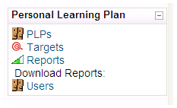
You will see a tabular layout summarising the various types of reports available via the PLP. For example, you can see below that “Henry Testman” has 0 concerns at present. (The figure in brackets gives the number of concerns added in the past week).

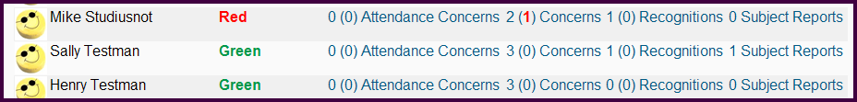

Suppose you need to add a concern for failing to hand in homework.

Since this is not an attendance concern, you would use the second column which is for “general” concerns. Clicking on concerns in the second column in the Henry Testman row gives this screen:

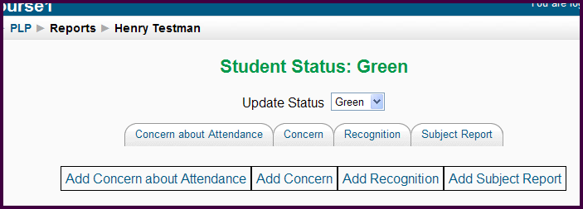

Now click on “Add Concern”

If the concern relates to a specific course, click in the “Course Related” check box at the top, and then select the appropriate course from the drop down list. Then fill in the concern note as usual.

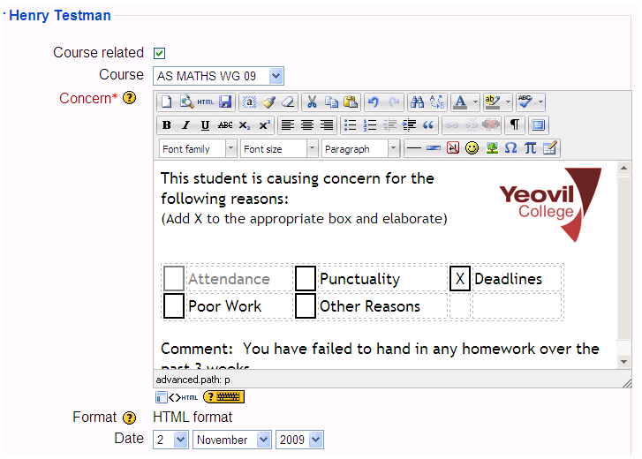

Then click “Save Changes”

As shown below, Henry now has 4 concern notes, and the red (2) indicates that two are recent (in the last seven days)
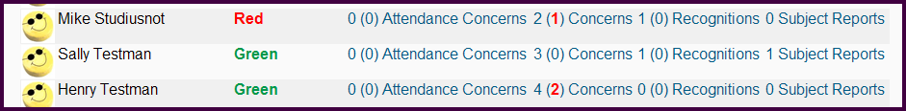

You can use the same procedure to add Attendance Concerns, Recognition Notes (and Subject Reports for the next round of reports)

The alternative way of adding any of these components to a students PLP is to click on PLPs in the “Personal Learning Plan” block and then choose “view PLP” alongside the appropriate student

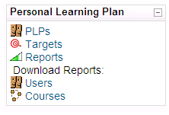

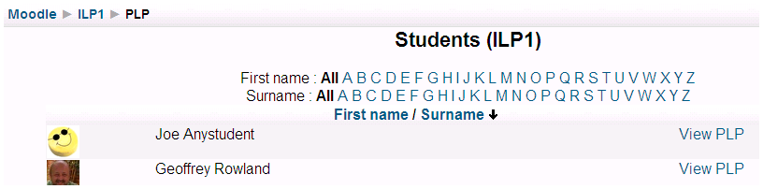

This will show the full PLP for that student, from where you can access all the sections

- Student info
- Targets (added by student, teacher or tutor)
- Concerns (added by teacher or tutor)
- Recognitions (added by teacher or tutor)
- Subject Reports (added by teacher)
- Programme Reviews (added by tutor)

Programme Review

This has 3 boxes – one each for
- Students
- Tutors
- CQMs

To access programme review as a student, go into your PLP by clicking on MY PLP in any of your courses.

You will be able to edit the “Students comments” box – please follow the guidance shown in green below the comments box

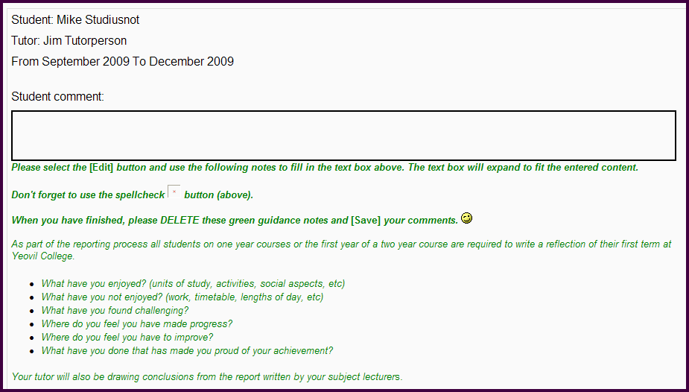

To access it as a tutor, go into your tutor group course, and click on PLPs in the “personal learning plan” block

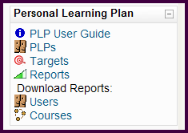

Then click on View PLP alongside the required student:

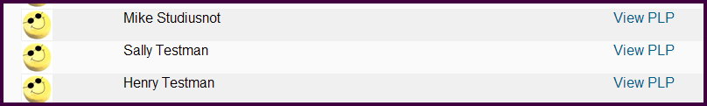

As for a student, the tutor will be able to edit the comments in the “Tutor comments” box, and a CQM will be able to edit the “CQM comments” box.

To print a programme review, from the students PLP click on the “Programme Review” heading



This will open the programme review on it’s own so that it’s easy to print. The edit buttons and green guidance notes should not print out.

For future reference - Subject Reports

These are not being entered online for the majority of our students in this round of reporting, but the intention is to switch to online reporting for the next round.

Subject teachers can add subject reports in a similar way to adding concerns – simply click in the “subject reports” column instead of the “concerns column” then click “add subject report”

Note:
- Teachers can add subject reports but not progress reviews
- Tutors can add progress reviews but not subject reports

This means that if you are a tutor, when you are in your tutor group course in moodle you will not be able to add subject reports since your role is “tutor” and only teachers can add subject reports. You will however be able to add progress reviews.

The initial screen for entering a report looks like this:

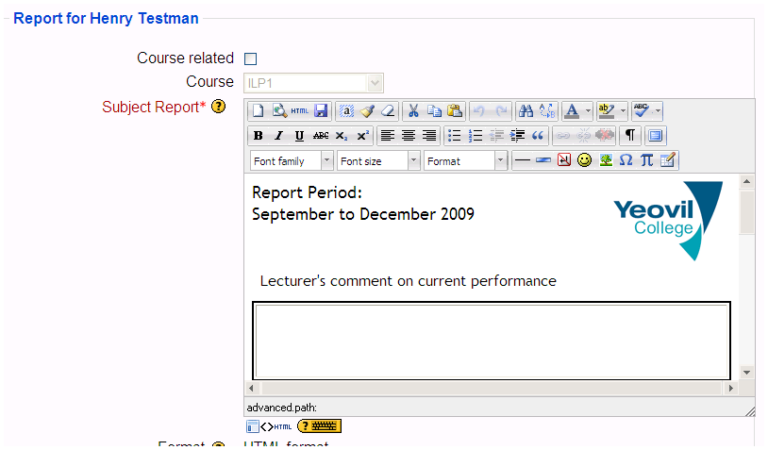

You can enter text in this view if you wish, or if you prefer to see it full screen click on the button indicated below:
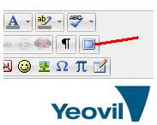

You will then have a much larger area to work with.

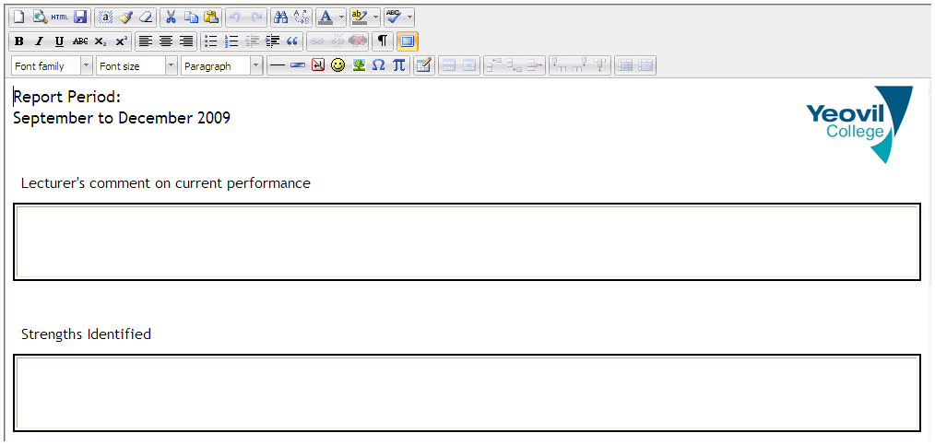

To save your report, either:
- click on the save (floppy disk) button in the top toolbar
- or click on the “full screen” button again to go back to the normal view, from where you can click “save changes”.

APPENDIX 1: Enrolling students on your moodle course

There are 2 methods

Method 1 – Enrolment Key

This simply involves you telling the students what the enrolment key for your course is, The students will then need to enter the enrolment key when asked for it (when they click on your course in moodle). They will find your course by going to the moodle front page and navigating through the categories.

To set the enrolment key for your course, go into the course and then click “Settings” in the admin block on the left. Scroll down until you see a box labelled “Enrolment Key”. Delete whatever is currently in there (just some random numbers) and type in the phrase you wish to use. You can click “unmask” to check what you’ve typed.
Scroll to the bottom and save changes.

Method 2 – “Assign Roles”

This involves you adding each student one at a time. Click “assign roles” in the admin menu for the course
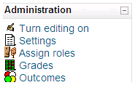

Choose the “student” role:

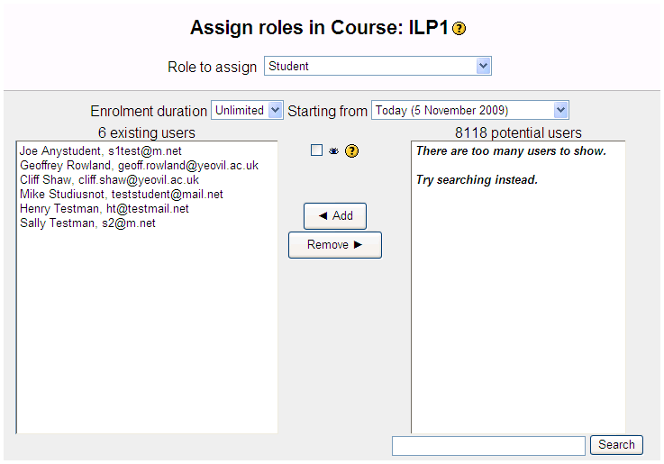

Now use the search box at the bottom right to find each student, eg to find “Sarah Trout” you could type “sarah t”

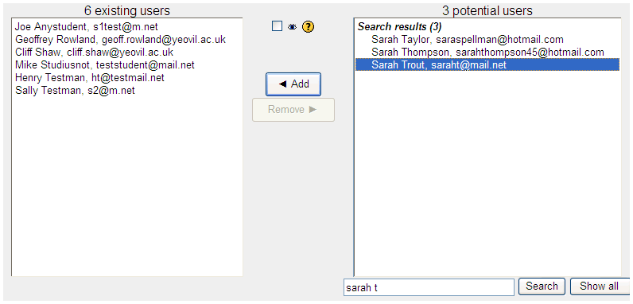

Click on the name and then click the “Add” arrow to add her to your course. (You can use the “Remove” arrow to remove students.)

APPENDIX 2: New Course Request

I have enabled a system that should help with course requests – it works as follows

Log into moodle and then click on the “all courses” link at the bottom of the “My Courses” block in MyMoodle

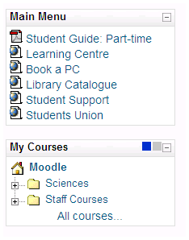

Scroll down to the bottom of the rather cluttered screen and you will see a link “Request a Course”

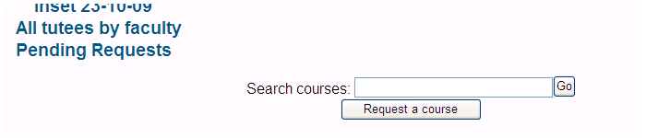

Alternatively, this link will take you straight to the course request screen:

http://moodle.yeovil.ac.uk/course/request.php

When you click on this link, you will be asked to provide information – and please make sure you provide the following

- Full Name of course starting with the level of the qualification, then the subject, then column letter, then 2009-10
eg AS Psychology (Col C) 2009-10
- A short name for the course eg AS-PSYCH (C) 09 (max 50 chars)
- Supporting info to help me put it in the right place
- The enrolment key you wish to use for your course

You will receive an email via moodle once the course is approved and created.

